CONTINUATION □
SUPPLEMENT

McCormick was in a class with Dylan, but she did not know him and never talked to him.

She did not know Harris either, but had seen him at school.

She reported having no prior knowledge of this incident. She did not see anything during

the incident, only heard it.

McCormick reported that a friend of hers, Patrice Doyle ran back into the school to look for

A friend, she (Doyle) told her that she saw somebody “shot”- Doyle has been interviewed.

Control #

Disposition: Case open

JC-001- 001001

MENDRALLA, A.

JC-001-001002

c1.. ,.ficat1on ' Fint D
CONTINUATION □ |  | Reporting Agency Reporting Officer Case Report No
SUPPLEMENT | V | JCSO WEBB | 99-7625-PP
Connecting Case Report No |  | Victim Name Original Report | Date This Report
#3508 COLUMBINE 05-27-99

WITNESS:

MENDRALLA, AMANDA, DOB/09-21-82
5200 S. Estes St.
Littleton, Colorado 80123
(303) 932-9713

INVESTIGATION:

On 05-27-99, I interviewed Amanda Mendralla. The purpose of this lead was to determine Amanda"s whereabouts during 5th period. as records reflected she had this period free. During the telephone interview with Amanda, she told me she was away from the school during the time of the incident. She left the school at approximately 11:15 after leaving her History class, which was in the library of Columbine High School that day. When the period ended, at approximately 11:10, she left by going downstairs through the lunch room. I asked her if she had seen anything unusual in the cafeteria as she walked through and she said she had not. I asked her if she specifically had seen a large duffle bag laying anywhere in the cafeteria and she said that she had not. I asked her if she saw anyone dressed in a suspicious manner in the cafeteria and she said she had not. She then walked to her vehicle, which is parked in space 439 in the junior lot This is a Dodge Neon, red in color. I asked her if while she was walking to her vehicle, if she had seen anyone suspicious in the lot and she said she had not. I specifically asked her if she had seen anyone in trench coats. She said no. however, as she was leaving the lot, she saw Dylan Klebold driving into the lot, driving his black BMW, dressed in a black t-shirt. He was alone and driving very fast. She said she had made a comment to her friend Brittany how fast Dylan was driving. He was coming from the south, headed north on Pierce, when he turned into the lot. I asked her to identify Brittany and she said this was Brittany Duran, a fellow student that she had 4th hour together with. She said that they then left the school grounds and were not made aware of the incident until later when they attempted to return to the school I asked Amanda if she had seen anything else that would be of interest to law enforcement and she said she could not think of anything at this time.

DISPOSITION: Lead closed.

JC-001-001003

MILLER, M

JC-001-001004

Transcript of handwritten statement by Melissa Miller:

I was in the student parking lot when there was a loud noise in the direction of a door leading inside the school.

We turned around to see smoke. There were 2 white males wearing black trench-coats and carrying long black

guns at the top of the stairs. They fired several shots, seemingly at random, and I know at least 2 people were

injured. Two more bombs went off. The bombs were long and cylindrical with silver caps on both ends. They

smoked before they went off. They fired several shots, and I think 1 more person was injured. Then they blasted

the doors, I think, and went inside. When they went inside, we heard more shots and 2 of my friends and I ran

across the soccer field. We got to the first open house and dialed 911.

The first bomb I saw go off was thrown by one of the 2 men. The next 2 that I saw, I didn’t see thrown.

I only saw them hit the ground near me. I recognized the 2 as students of Columbine. I had a clear view of

their faces and there were no

JC-001-001005

Page
of
_ Pages Case#-------

Summary of Statement (cont.)

Masks when I saw them. I do not know their names, but I’ve seen them around

Columbine.

If I saw these 2 again, I would definitely be able to recognize at least one of them.

I am pretty sure I would be able to recognize both, but I got a VERY good look at

the tallest of the two.

.

JC-001- 001006

JEFFERSON COUNTY DISTRICT ATTORNEY'S OFFICE

SUPPLEMENTAL REPORT

Defendant: Date: Deputy D.A.:

4-22-99
Docket Number:
Case Number: 99A062
Investigator: J.Burkhalter

********************************************************************

Melissa Miller, dob 6-11-84 7991 W. Quarto Dr.
Littleton, CO. 80128
Ph. 303-933-1362

Ms. Miller was contacted at her home by this investigator for a follow up interview concerning her first interview given on 4-20-99.

Ms. Miller was present with her mother and read her previous statement. She stated this is what occurred and she still remembers it quite well.

Ms. Miller stated the same statement as her original and was asked to elaborate about some details in her statement. The following questions were asked of Ms. Miller:

Q. You mentioned seeing the bombs. Can you describe them?
A. About 6", white or gray cylinder.

Q. Do you know why they smoked?
A. I assumed they were somehow lit.

Q. Can you describe who threw the bombs?
A. A white male, teenager, wearing a black coat. He looked like 5'8" with brown short hair. He used his right hand and threw bombs at the school. His gun had a sling and it was two handled.

l JC-001- 001007

The second guy was taller about 2 or 4" more, Chin length sandy

blond hair with a trench coat. and his coat was closed.
He was lanky and his gun was long

Ms. Miller stated she saw three bombs thrown. She stated the bombs were in something like a box or bag on the ground at their feet. Ms. Miller stated she heard individual shots, possibly 20 to 25.

Ms. Miller stated the two suspects went into the school and she

heard more shots and screaming. suspects.
She stated she only saw two

Ms. Miller went onto say when she was outside hiding from the two suspects, she saw Anne Marie Hochhalter get shot and go down on the sidewalk. She stated she thinks she was shot in the stomach. She also saw a boy shot in the leg.

Ms. Miller stated when all this was happening a student was driving toward them in the parking lot in a pickup truck, Red and Gray with

one male driver. took off.
The suspect threw a bomb toward the truck and he

Ms. Miller stated after the suspects went into the school she and her friends left and ran to a home in the neighborhood.

Ms. Miller stated she doesn’t know what the initials stand for.

Ms. Miller stated she has heard of Brian (John) Savage when asked and thinks maybe he is a junior.

When asked if she has talked to the press, Ms. Miller stated she talked to Channel 4 but only gave her reaction and no details.

Ms. Miller stated she left a black backpack outside and it will have her name inside the backpack.

JC-001- 001008

MOHRBACHER, K.

JC-001-001009

CONTINUATION □  SUPPLEMENT X | Reporting Agency  JCSO |  | Reporting Officer  PETERSON | Case Rcport No  99-7625-WW
Connecting Case Report No |  | Victim Name Original Report |  | Da1e This Report  06-11-99
X FIRST DEGREE MURDER |  |  |  | Recommend Case: Review D  Closure D

WITNESSES:
Kristi Mohrbacher. dob/08-31-82 6551 West Calhoun Place Littleton, Colorado 80123
(303)797-8117
Student at Columbine High School

Kathryn Mohrbacher, dob/02-11-51 same as above
Work: 5660 Greenwood Plaza Boulevard, Suite #510 Englewood, Colorado 80110
{303)771-1117

Robert Mohrbacher, dob/08-18-53 same as above
'ork: 5601 York Street Denver, Colorado 80216
(303)795-29! 1 ext. 15

INVESTIGATION:
On 06-11-99, at about 0830 hours, I responded to 6551 West Calhoun Place to contact and interview Kristi Mohrbacher who is a student at Columbine High School. This interview was in reference to the shooting that occurred at the school on 04-20-99

I interviewed Kristi Mohrbacher in the presence of her mother, Kathryn Mohrbacher Kristi Mohrbacher told me on 04-20-99, at about 1125 to l 130 hours, she got out of her math class, which is on the second level of the school, and is Mr. Smith's class, however, he was not present on 04-20-99, and they had a substitute teacher. Kristi showed me where this class is located on the map/diagram I had of the layout of Columbine High School. She said this class is in the southeast comer of the school, and said she was with Katie Carpenson, Eric Buckner, Yu Mekuria, Kelly Norden, and James Norden. Kristi said when they exited this classroom, they walked up the hallway to the east doors to exit the school. These doors are facing east towards South Pierce Street, and are south of the main doors of the administrative offices. Kristi estimated the time they exited the school doors to be approximately 1130 hours, on 04-20-99. Kristi said up to this point she did not hear any shots or explosions, and did not recall

JC-001-001010

CONTINUATION 0  SUPPLEMENT X | Reporting Agency  JCSO |  | Reporting Officer  PETERSON | Case Report No  99-7625-WW
Connecting Case Report No |  | Victim Name Original Report |  | Date This Report  06-11-99
X FIRST DEGREE MURDER |  |  |  | Recommend Case Review □  Closure □

anything out of the ordinary. Kristi said they walked across South Pierce Street and into the soccer fields at Leawood Park. Kristi said while in the soccer fields, some Columbine High School teachers told them to go back further, and Kristi said she overheard a student say there had been a shooting at Columbine High School. Kristi said she then heard two loud explosions coming from, what she believed, was the west side of the school, outside of the cafeteria. Kristi said she thought the explosions were some type of a senior prank. Kristi said she then left Leawood Park and went with Kevin Forslund to Eric Buckner's apartment in West Lake Greens, and called her mother, Kathryn Mohrbacher. Kathryn said this call came to her at about 1150 hours, on 04-20-99.

Kristi told me that while she was in Leawood Park or prior to that, she did not see any suspects outside of the school. She also said she did not see any suspects inside the school through the windows or door windows at the school. on the east side of the building.

I asked Kristi about Dylan Klebold, Eric Harris, and the Trench Coat Mafia group. Kristi said during her Freshman year at Columbine High School, she had Nate Dykeman in her gym weight lifting class. She described him as "dorky," and said he would wear sports team t-shirts to school. Kristi was unable to provide information about Klebold or Harris.

Kristi said in either late 1997 or early 1998, she was seated in the school's cafeteria. She said she was at a table, and said she saw Joe Stair and Eric Dutro, who were near the stairway, in the cafeteria. Kristi said they were '·grabbing each other:' She said a student and a jock by the name of Rocky Hoffschneider (who graduated in 1998), "went off on them," calling Stair and Dutro "fags," and harassing them. Kristi said Stair and Dutro began to get defensive, and Hoffschneider was near them by the stairs. Kristi said there were several other students who had gathered around this disturbance. Kristi said a Columbine High School teacher broke the disturbance up, and then either Dutro or Stair {she could not remember which one) walked up to the table that Kristi was sitting at with her friends, and began pointing to different students at the table saying, "Satan loves you," and would go to the next student and say, "Satan loves you." Kristi said this continued with several students. Kristi also said that Stair would always be wearing a trench coat.

Kathryn said Hoffschneider graduated from Columbine High School in 1998. She said if there was a specific student or person that the Trench Coat Mafia would have wanted to retaliate against or target, it would have been Hoffschneider. She said

JC-001- 001011

CONTINUATION □  SUPPLEMENT X | JCSO |  | PETERSON | 99-7625-WW
Connecting Case Report No |  | Victim Name Original Report |  | Date This Report  06-11-99
'"  X FIRST DEGREE MURDER |  |  |  | Recommend Case: Review □  Closure □  I I

Hoffschneider was always picking on people and harassing them. Apparently, he had racially intimidated a Jewish student at the school. Kristi said Hoffschneider played football at Columbine High School during the years he attended the school. She said Hoffschneider got some scholarship offers from colleges and universities to play football; however, she said Hoffschneider stabbed somebody nine times, so the scholarship offers were canceled.

Kristi said Alex Marsh associated with the Trench Coat Mafia. She said after the shooting on 04-20-99, when the Columbine High School students were attending Chatfield High School, Marsh said in a class something to the effect that she wished she could have been a part of the shooting because she would have laughed while the people were being shot. Kristi said some teachers escorted Marsh out of the classroom; however, she did return the next day. Kristi said Marsh is also very defensive. She said in one of the classes, the subject of' “jocks" came up in their conversations, and Marsh got very defensive, and began saying something to the effect of how much the jocks were jerks, etc...

Kristi said a girl by the name of Courtney Van Dell was a student at Columbine High School. It is unknown for certain if Van Dell is a Trench Coat Mafia associate or not. Kristi said Van Dell had pitch black hair, would wear heavy black make-up under her eyes, and wore devil's horns on her head. Kristi said when Van Dell went to gym class, she was told she could not wear the devil's horns, so she became very upset.

Kathryn said in about the summer of 1998, her neighbor, Janet Dubois, who lives close to her on the same block, was in her front yard when she saw some young boys running fast into another neighbor's house. The house the boys ran into was the Wisher family's house. Kathryn said Dubois then saw two other males who were chasing the other boys. Kathryn said Dubois later saw the pictures of Dylan Klebold and Eric Harris through the media, and recognized the photographs of these two as the same two who were chasing the other boys to the Wisher residence. Kathryn said the boys chasing the other boys, told Dubois that they were chasing them because they had just "robbed" the Blackjack Pizza. Kathryn said Dubois was asked where the first juveniles had ran, and Dubois told the chasers that the two males they were chasing went into another house and pointed out the Wisher residence to them. The chasers went to the Wisher residence, but nobody would come to the door. Kathryn said later an explosive device made out of fireworks was detonated in Dubois' mailbox. Kathryn said Dubois believes it was the boys that
ran into the Wisher residence that detonated the device as retaliation for her telling their chasers where they had ran.

JC-001-001012

CONTINUATION D SUPPLEMENT | Reporting Agency  JCSO |  | PETERSON | Case Report No  99-7625-WW
Connecting Case Report No "  - |  | Victim Name Original Report |  | Date This Report  06-11-99
X FIRST DEGREE MURDER |  |  |  | Recommend Case: Review 0  Closure □  I I

Kristi said where she parked her vehicle in the student parking lot at the school, there was a vehicle that would park next to hers that may have been driven by a Trench Coat Mafia associate. She described this vehicle as a light blue "boxy" older model vehicle. She said it had a "Rammstein" sticker on it, which is a German band. She said the driver of this vehicle was a male, skinny in build, and would wear sunglasses most of the time. She said the driver may have been Tad Boles; however, she was not certain. She said she would see several students who she thought to be Trench Coat Mafia students hanging around in the same area of the parking lot. She said they made her fee! uneasy due to the fact they would stand in a group and stare at her as she walked to her car.

I asked Kristi if she had seen "the thought of the day" on 04-20-99, over the Rebel News Network (RNN). She said she did see it, and remembered it to be "You would rather not be here." Kristi said she did not know of anybody with a double pierced eyebrow.

Due to the fact during prior interviews at the Mohrbacher residence, I had left several business cards, I verbally advised Kristi to contact me if she had any problems or felt she had any other information that she had learned that may be pertinent to this case. She said she would contact me in this future if this occurred.

DISPOSITION: Case remains open, pending further investigation.

JC-001-001013

MONTE, BIJEN

JC-001-001014

.

JEFFERSON COUNTY SHERIFF'S DEPARTMENT
CASE #99-7625

INTERVIEW WITH
BIJENMONTE

CONDUCTED BY:
AGENT J. MEANS, CBI-DENVER AGENT R- S. MUNDINE, CBI-DENVER
AGENT IN CHARGE M. WILSON, CBI-DENVER COLORADO BUREAU OF INVESTIGATION REQ.#991-0185
JC-001-001015

WITNESS:

INTERVIEWERS:

DATE/TIME OF
INTERVIEW:

PLACE OF
INTERVIEW:

ASSIGNMENT SYNOPSIS:
Control Number
BIJEN LIANN MONTE, Columbine High School student, DOB 6/13/82, 5'-02", 113lbs, blond hair, blue eyes, 7039 Portland Ave., Littleton, Colorado, 80128, (303) 979-7337.

Agent JERRY W. MEANS and Agent IUCKY S. MUNDINE,
Colorado Bureau of lnvestigation, 690 Kipling Street, Denver, Colorado, 80215, (303) 239-421 I.

April 30, 1999, at approximately 04:00 p.m.

7039 Portland Ave., Littleton, Colorado, 80128.

An interview was conducted with Jennifer Rose FALBO, DOB 7/23/82, of 4994 S. Parfet Ct., Littleton, Colorado on April 29, 1999. During the interview FALBO stated she had contacted her friend, Bijen MONTE after the incident at Columbine High School to see if MONTE was ok. FALBO stated MONTE was near the cafeteria when the shooting began and she saw -----------
with a gun.
Bijen MONTE was contacted by phone on April 30, 1999, by the Reporting Agent. MONTE was asked if she attends Columbine High School and she stated she does, and was present when the incident occurred on April 20, 1999. MONTE stated she was near the cafeteria when the shooting started and she saw one of the gunmen. She stated the gunman she saw was not one of the guys identified on television. MONTE was requested by the Reporting Agent to contact her mother and an interview was scheduled for the afternoon of April 30, 1999.

Agent MUNDINE and the Reporting Agent interviewed Bijen MONTE at approximately 04:00 p.m on April 30, 1999. The witness's mother, Linda A. MONTE, wk. (303) 705-3731, was present, and gave permission for the interview. Bijen MONTE provided the following information:

HISTORY

- She is a junior at Columbine High School and met the following TRENCH COAT MAFIA members in 1997.
-Cory FRIESEN
-Charles PHILLIPS

JC-001-001016

-Eric DUTRO
-Brian SARGENT
-Chris MORRIS
-Pat MCDUFFEE
-Joe STAIR

- She stated she had never met Dylan KLEBOLD or Eric
HARRIS.

- She knows Robyn Anderson because she dated Pat
MCDUFFEE.

- Her best friend, Jenn FALBO use to date FRIESEN and
Then DUTRO.

- MONTE does not consider herself a TCM; she was just friends with some of the members. She stated most of the members she knew have graduated.

- She stated the TCM members talked about paintball a lot, Played Magic, drank alcohol and usually bung out at Cory FRIESEN's house. She stated she did not hang out with them after school hours.

- She never saw any drug activity with group and the only weapons she ever saw them with were knives. She has not heard any of the member's talk about guns.

- The only explosives she ever heard about were when PHILLIPS, STAIR, DUTRO, FRIESEN, and MORRIS traveled to Wyoming and bought a "Bunch" of fireworks. She stated she never saw them use the fireworks.

- She stated again that she had never met KLEBOLD or
HARRIS.

TUESDAY
- MONTE'S boyfriend is Luke CLOWEN, who has already graduated

1 L She stated her boyfriend dropped her off on the north side of school at approximately 07:25 a.m. The following is her schedule of classes until the incident occurred:
-Straight to Sociology from 07:30 to 08:20
-Went to locker
-In Language Arts from 08:25 to 09:20

JC-001-001017

-Went to locker
-In Math from 09:25 to 10:15
-Went to locker
-Went to the library for History from 10:20 to 11:10
-Went to the cafeteria at 11;10

  - MONTE stated she dropped her backpack at the bottom of the cafeteria steps, near the half-wall. She then went to the Rebel Corner and purchased her lunch.

  - She was met by Chris Therrien and Brian FRYE who wanted her to go outside and play soccer. She stated she did not want to play but went outside through the south commons door.

  - MONTE stated she sat down and FRYE and THERRIEN kept trying to pull her up to go play.

  - She thought she saw fireworks sparkling on the sidewalk,
and then saw a guy in a trench coat coming down the hill.

  - Three kids went "down" to the ground, and the guy in the
trench coat was standing over two of the downed kids.

  - She stated she knew it was ------------- in the trench coat standing over the two kids, because she recognized him.

  - MONTE stated she hangs out on Polk Street and Pierce with some kids who smoke cigarettes and --------
are there almost everyday. She stated she has met ----------
and heard him talk about how his mom tries to control him
and how the school does not check the I.D. of smokers. She stated she has seen ------- almost everyday since January of l999.

  - She stated the first time she met ------- was when one of her friends, Brandon unknown last name called ---- a “Freak”

  - MONTIE stated she was certain it was -------- standing over the two kids. She stated on a scale of 1-10, l being uncertain and 10 being positive she was 8 ½ -9 it was he.

  - She stated ----- had a gun hanging from his neck on some type of strap. The gun was all black and approximately 15-18 inches long. She stated it looked like

JC-001-001018

a machine gun, and there was no Duct Tape on it. She stated that was the only gun she saw him with, and it was in his right hand.

DESCRJPTION
OF GUNMAN

  - The following is a physical description of the man she saw
with a gun:
- He had on a black trench coat that extended to between his knees and his ankles.

-He had on a black baseball hat in the backward position.

-His face was long and his neck was long.

•He had a narrow chin.

•His teeth were crooked and he had an obvious overbite.

-He had no glasses or facial hair.

•His complexion had lots of acne, there were indentations like pieces were cut out and his face was white in color with some redness.

-His coat was hanging open and he had a black 'T' shirt with a white colored print on it. She stated the shirt was not a tie dyed.

- The print on the shirt appeared to be pealing and looked older.

•He had a red colored clothe type item attached to the left side of his waist.

-He had black tighter fitting jeans, not baggy. She stated they were regular black jeans. There were no straps or pockets extending down the legs.

-He had black high-top tennis shoes with no colored markings. She stated they were not boots because the toes and overall shape was a tennis shoe. She stated the shoes were dirty.

JC-001-001019

  - MONTE stated she watched ------------ approximately 30 seconds. She stated when she first saw the gunman and the kids on the ground she thought it was a joke.

Agent Ricky S. MUNDINE read the admonition form for a photo line to Bijen Monte and her mother. MONTE and her mother left the room and three separate sheets of photos were laid out on the dining room table. The sheets were marked A, B, and C. MONTE returned to the room and after approximately 15 seconds pointed to photo #6 on sheet Band stated that's him, that's the man with the gun, that's him. MONTE signed the photo she identified as the gunman, and then she signed the admonition form. The admonition form and the entire photo line up were collected by the Reporting Agent as evidence. MONTE provided a written statement of what she saw when the shooting started.

MONTE stated she thought Brenton HOOKER also saw ----- with a gun. She stated she has not spoken to HOOKER since the incident. MONTE'S mother, Linda MONTE stated she and her daughter attempted to contact Law Enforcement Officials on the night of the shooting because they felt the information was important. Linda MONTE stated they were told someone would be out to speak to her daughter. She stated the New York Times contacted them on Saturday and Sunday so they called Law Enforcement Officials again and she was told someone would get back with them. Linda MONTE stated they provided the information about -------- to the New York Times, and the newspaper agreed not to disclose any information about their daughter.

SCENE
WALK-THROUGH

On May 1, 1999, at approximately 10:00 a.m., Agent MUNDINE, Agent in Charge Mark WILSON, and the Reporting Agent met with Bijen MONTE, Linda MONTE, and Bijen’s father, Anthony MONTE, wk. (303) 705-3732 at their home.

Bijen Monte marked her location. and where she saw the gunman on a drawing provided by the Reporting Agent. MONTE marked her location on the drawing with an X and the gunman's location with an O; she then signed the map with her mother Linda MONTE.
Bijen MONTE stated she wanted the Agents present at the interview to know that she assumed the gunmen got their weapons from ----- house because she knew through her friends

JC-001- 001020

they had a lot of guns. She stated she had been to the ----- house one time and she did see weapons mounted on the wall as a display.

The Reporting Agent, Agent MUNDINE, Agent in Charge
.WILSON, Bijen MONTE, Linda MONTE, and Anthony MONTE went to the Columbine High School and checked in with the Jefferson County Sheriff's Department.

Bijen MONTE identified her position outside the cafeteria when the shooting occurred, the position of the gunman and the position of the two victims the gunman was standing over when she observed him. The locations were marked for center-mass documentation. The position of MONTE and the gunman were photo-documented.

MONTE remained in the position while Agent MUNDINE stood in the position identified as the gunman's. The Reporting Agent stood next to MONTE and facial features could be distinguished
on Agent MUNDINE.

MONTE was asked again by Agent MUNDINE to describe the gunman she saw standing over the two kids. MONTE provided the following description:
-She stated he had on a black baseball cap,
backwards.

-She could not see his hair because of the bat. She did not remember anything specific about his ears.

-He had on a black trench coat She stated the coat was folded back in the front and it was not leather. She stated it was made of a cloth material, but it was not denim. She did not notice anything particular about the shoulders, but stated there was no color or patches on the coat.

-She stated he had something red attached to his left hip near the area where a belt would be. The item appeared to her to be clothe, like a bandanna. The item was all red.

-She stated he had an all black gun in his right hand. Monte stated the gun was on a strap around his neck.

JC-001-001021

MONTE stated she was positive the man with gun standing over the two kids was ---------. She stated she could recognize ------- and that is whom she saw. She stated she could see his complexion was rough with acne, and she could see his messed up teeth and overbite from where she was standing. MONTE was asked if there was any doubt in her mind who she saw. MONTE stated there was no doubt, it was -----.

MONTE took agent MUNDINE and the Reporting Agent step by step through her path on the day of the shooting. She stated after observing the gunman for approximately 30 seconds she turned and ran towards the six south commons entry doors. She stated she entered the east door in the row of 6. MONTE stated she went into the cafeteria and two teachers, Mr. SANDERS and MR. BROOKFIELD told everyone to get down. She stated she got down on the floor. MONTE stated two gunmen dressed in black came in the west door near where she had seen ------- She stated she could not see them vary well because was so many people and she was trying to get away. She stated they were throwing things that were exploding. MONTE stated when the two gunmen in black came in the west cafeteria door everyone started running towards the cafeteria stairs. She ran into the lower portion of the auditorium.

MONTE stated there were no gunmen in the auditorium when she entered the lower level She stated the only lights on in the auditorium were the stage lights. She ran up the south side stairs and hid behind the south side "L" shaped wall, near the top. She stated two gunmen in all black entered the auditorium through the southwest lower entryway. She saw one man in all black near that entryway, and the second man in all black was closer further north. MONTE stated the man in black she saw closest to the southwest lower door, started coming up the south steps. She stated she and several other students ran across to the north side of the auditorium and exited out the upper northeast door. MONTE could hear shooting, but did not know if it was inside the auditorium
MONTE stated when she got into the main hallway outside the northeast upper door of the auditorium she ran towards the east main entry doors. She stated she could hear bullets hitting the lockers and flying by her head. 'When she arrived at the east end of the hallway she stated the office area on the left side was vacant.
MONTE stated she could see some students behind the access doors to the Social Studies area, and she remembered those doors were closed. She stated she got approximately 5 feet outside the

JC-001- 001022

inner east door and the glass shattered behind her. She exited the
building and ran to the north towards the park.

MONTE stated she and several other kids met up in the park, under the covered pavilion. She stated a teacher there had got his car out of the parking lot and he told the students to go straight to their homes. She stated one of her friends, Evan EARNEST had his car so she got in his vehicle and they tried to leave the area.
MONTE stated there were police cars on PIERCE so they turned around and went around towards Wadsworth. She stated she called her mom from a cell phone in the car.

Means
Agent
Colorado Bureau of Investigation

JC—001-001023

.

JC-001-001024

a,
\
\

\
'I
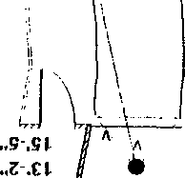\
.

CONTINUATION □  SUPPLEMENT X |  | JCSO Inv. Jack McFadden |  | 99-7625
Connecting Case Report No |  | Victim Nam Ori,inal Report  Columbine High School, et al |  | Date This Report  10-22-99
X First Degree Murder

RE:

Interview with Bijen Monte.

DETAILS,

On October 21, l 999 at approximately 1750 hours. Bijen Monte responded to the Jefferson County Sheriffs Office at my request to be reinterviewed concerning information she had supplied to the sheriff's office concerning her observations at Columbine High School on 04-20-99. Monte was accompanied by her mother and father who were present during the following interview. Monte stated that when previously interviewed she had given inaccurate information concerning Sean Graves. Monte said she observed Sean Graves crawling to the door by the teacher's lounge and she wanted to clarify that point.
I advised Monte the main reason she was being reinterviewed was due to the fact that she had stated ------- was standing over two gunshot victims on the southwest corner of the school. Monte stated she was 100% sure she saw ------- person known to her, standing over, who she now knows to be Dan Rohrbough and Lance Kirklin on the
J
southwest corner of the school near the steps. I advised Monte that according to other witness statements. ------------- was at home between 8:00 a.m. and 12:00 p.m. on 04-20-99. Monte explained due to the witnesses being a family member and neighbor, those individuals could have lied for ------ and she still believed
was the individual standing over the two injured males holding a gun. Monte stated she never saw ------- fire the gun he was holding and reiterated her description of ------ from her previous interview.

Monte stated after observing this individual, known to her as ---------------- standing over the injured students, she ran into the cafeteria. staying in the cafeteria for a couple minutes. Monte stated she had first told investigators that bombs were going off inside the cafeteria, but she could have been mistaken. Monte stated it was possible the bombs were going off outside the cafeteria. Monte stated while in the cafeteria looking out towards the senior parking lot (south), she observed two male individuals dressed in dark clothing looking in the window. Monte stated she only got a quick glance, approximately one to two seconds, at those individuals, but did not believe it was the same individual that had been standing over the injured students by the southwest comer.

Monte stated after staying in the cafeteria for approximately a couple minutes, she ran out of the cafeteria towards the auditorium. at which time she entered the auditorium and saw two suspicious males dressed in dark clothing. Monte stated the auditorium was dark and she was unable to see any faces or identify the individuals but she felt these individuals were suspicious and ran the other way. Monte stated after hiding in the auditorium for a very short period of time she exited the auditorium and ran to the main hallway in an easterly direction. exiting the school via the east doors by the business office. Monte stated while she was running down the east hallway, she was being fired upon from an unknown location. Monte stated the easterly door windows were shot out as she ran out the door.

JC-001-001025

CONTINUATION □  SUPPLEMENT X | Reporting Agency  JCSO |  | Reporting Officer  Inv. Jack McFadden | Case Report No  99-7625
Connecting Case Report No |  | Victim Name Original Report  Columbine High School, et al |  | Date This Report  10-22-99
X First Degree Murder |  |  |  | Recommend Case· Review X  Closure □

I asked Monte if the individuals in the auditorium had weapons, to which she replied no.

I showed Monte cafeteria video photo #44 and asked her if she could identify anyone in the picture. Monte replied she could not.

I then showed Monte video photo #51. to which Monte replied, the black shirt, shoes, gun, and hat possibly looked like ones worn by the gunmen seen on the southwest comer of the school.

I then showed Monte video photo #52 and #53. to which Monte replied she could not identify anybody in those photos.

Prior to the conclusion of this interview, I advised Monte that there were several witnesses out on the southwest comer of the school at the same time she was and had different recollections of what took place and who was there. I asked Monte if she could explain the differences in the stories of the several other witnesses. Monte stated she had no explanation for the other witness observations and reiterated she knew --------- prior to the incident and that's
who she saw standing over the two injured students.

At approximately 1945 hours, the interview was terminated.

ADDITIONAL INFORMATION:

Monte's father stated Monte is currently having bad dreams/nightmares about the incident at Columbine High School. Monte also does not feel safe at Columbine High School.

DISPOSITION:

Lead #5055 closed, case open.

JC-001-001026

MOORE, C.

JC-001-001027

Transcription of handwritten statement of Chris Moore
JC-001-001028

Phone Interview with Christopher Moore
7821 W. Ottowa Place
973- 7133

Moore states he was in student parking lot and kids started running out of the school just as he was leaving.

He saw and heard nothing.

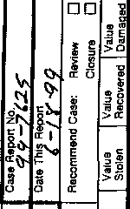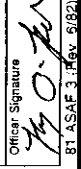

·
· ·
,,
:
'
JC-001-001028

DD

DD

J
•
I
i
1 z
0'

I.
- . o
'
f
•Z

MULLAN, TIMOTHY

JC-001-001029

Transcript of handwritten statement for Timothy Mullan

JC- 001- 001030

Interview with Timothy Mullan
6895 S. Yukon Way
973- 5280

Timothy Mullan states that he left school at approx. 11:15 and when leaving the lot he observed Klebold’s BMW drive into the lot but was unable to say who was driving or how many people were in the vehicle.

NELSON, TESSA

JC-001-001031

ARAPAHOE COUNTY SHERIFF'S OFFICE
CR#

This statement is voluntary and is made by me without threat of punishment, and without unlawful coercion, influence or inducement.

VEHICLE INFORMATION: ( ) Suspect
) Victim

Year Make Model Style _ Color
License State Vin # Damage $
NARRATIVE:
Transcript of handwritten statement by Tessa Nelson

JC- 001- 001032

Tall (white) male in long black trench coat, with a black ball cap (possible some red on it) wearing black boots, and black jeans. He had black hair that came a little above his shoulders, skinny. He had a gun that looked like a small machine gun? (I don’t know guns very well).
Possibly ------------- ?

JC-001 001032

Arapahoe County Sheriff's Office 5686 South Court Place Littleton, Colorado 80120

ARAPAHOE COUNTY SHERIFF'S OFFICE
CR#
STATEMENT (continued)

We were eating lunch outside, in view of the stairs, when we heard loud noises. At first we thought someone had lit a firecracker. A few people fell to the ground. Then I saw the person shooting coming down the stairs towards us. A girl near us sat up and she had blood on her shirt. Tiffany and I got up and ran into the school as fast as we could. When we ran in we were screaming “someone’s shooting” then we headed to the bathroom. We hid in the biggest stall with two other girls. We all sat on the toilet so you wouldn’t be able to see our feet. There were lots of gun shots and we could hear everyone screaming. We could tell he was shooting in the bathroom or outside of the bathroom. It sounded like he was shooting the stalls. We were sure he would shoot us. After about 10 minutes there was less shooting downstairs and the shots were getting faint. We decided if we didn’t get out of there right away we would have no chance of getting out. We ran out of the bathroom and out of the fire exit in the business hall. There was tens of smoke in the commons. Once we got out we ran towards Pierce where a man directed us to a house near by.

Page of
JC- 001-001033

C0NTINUATION □  SUPPLEMENT X | Reporting Agency  JCSO |  | Reporting Officer  BROOKS | Case Report No  99-7625-R
 |  | Victim Name Original report  COLUMBINE |  | Date This Report  05-10-99
X FIRST DEGREE MURDER |  |  |  | Recommend Case: Review □  Closure D

WITNESSES:

Tessa Corinne Nelson/ DOB 112683 6676 West Rowland Avenue Littleton, Colorado 80128
303-978-1959
Columbine High School / 9th grade

INVESTIGATION;

In 05-06-99, at about 8:00 a.m., I interviewed CHS student Tessa Nelson as follow up on DN20l5. The interview was conducted at Tessa's home, in the presence of her mother, Denise Nelson.

Tessa told me that on 04-20-99, at about 11:10 a.m., she had just finished her fourth period American Government class. After leaving class, Tessa said that she walked to the science hall where she met her friend, student Tiffany Lien (9th). Together, Tessa and Tiffany then walked downstairs (interior stairs} to the cafeteria for lunch. Upon entering the cafeteria at about 11 15 a.m., Tessa said that she and Tiffany stood in line and received their school lunches. After they received their lunch trays. Tessa said that she and Tiffany then walked to the south side of the cafeteria and exited one of the doors. Tessa said that she could not remember which door it was. Once outside, which Tessa estimated would have been about 11:20 a.m., she and Tiffany walked to the southwest corner of the cafeteria's exterior and sat down at a bench located next (east} to one of the "planters."
Tessa described the "planters" as raised grassy areas, some with trees, surrounded by cement. Tessa indicated on a map where
she and Tiffany sat down. Tessa said that when she and Tiffany sat down, another student named Melissa Miller (9th}, who Tessa remembers seeing inside the cafeteria, sat her backpack down next to them and then walked toward the student parking lot.

JC-001-001034

CONTINUATION □  SUPPLEMENT X | Reporting Agency  JCSO |  | Reporting Officer  BROOKS | Case Report o  99-7625-R
Connecting Case Report No. |  | Victim Name Original Report  COLUMBINE |  | Dare This Report  05-10-99
X FIRST DEGREE MURDER |  |  |  | Recommend Case:: Review □  Closure □

Tessa said that after she took a couple of bites of her pizza, she heard several "pops" coming from the area near the top of the exterior stairway, just north of her. Tessa said that she and Tiffany thought these pops were firecrackers, the result of a senior prank. Tessa said that she then looked northward, toward the stairs, but didn't see anything. Tessa said that almost immediately thereafter, she saw "people rolling down the hill," referring to the hill on which the stairway lies. Tessa said that she thought that students were perhaps filming a "Friday feature" for RNN, the campus television station. At that point, Tessa said that she saw a white male, who she described as tall, wearing a black trench coat, with a black ball cap (possibly some red on it) that was on backwards, black jeans, black boots, with black hair that came slightly above the shoulders and curled outward. Tessa said that this individual was coming down the stairs (about a fourth of the way down), and appeared to be holding what looked
like a small machine gun (Tessa said that after seeing the weapons used by Eric Harris and Dylan Klebold on television, she is convinced that the weapon she saw was the Tec- 9). Tessa said that at this point. she still '"didn't think it was real."

Tessa said she then saw a female, who she identified as Anne Marie Hochhalter, sitting on the curb to the southwest of the largest planter. Tessa then indicated Anne Marie Hochhalter's location on the map. Tessa said that Hochhalter was facing east as she sat eating lunch with a couple of friends, whom she identified as Jayson Autenrieth (9th) and Jayson's girlfriend. Tessa said that Hochhalter suddenly twisted to the (her) left, "fell over" the curb, and then sat up and screamed. When Hochhalter sat up, Tessa said that she (Tessa) saw blood on Hochhalter's shirt. Upon seeing the blood on Hochhalter’s shirt, Tessa said that both she and Tiffany then realized what was happening, but remained motionless for a few seconds because "we were in shock." Tessa said that Jayson's girlfriend then got up and ran past she and Tiffany, toward the south side of the cafeteria. At about this same time, Tessa said that she and Tiffany got up (leaving their backpacks behind) and ran to the south side of the cafeteria, where they then "ran screaming" into one of the south doors. Once inside the cafeteria, Tessa said that she and Tiffany then ran eastward, into the girls' bathroom located near the southeast corner of the cafeteria. Upon entering the bathroom. Tessa said that she, Tiffany, and two other female students, one of whom Tessa could only identify as Brianna, ran into a stall, closed the stall door, and stood on the toilet so as to prevent their legs from being seen. Tessa said that she remembers most of the students inside the cafeteria were still sitting when she and Tiffany ran inside, en route to the bathroom.

Tessa said that about two or three minutes after entering the bathroom, she heard several loud gunshots, which she thought were

JC-001- 001035

CONTINUATION □  SUPPLEMENT X | Reporting Agency  JCSO |  | Reporting Officer  BROOKS | 99-7625-R
Case Report No |  | COLUMBINE |  | Date This Report  05-10-99
X FIRST DEGREE MURDER |  |  |  | Re<commend Case: Review □  Closure □  I I

coming from outside the bathroom door in the cafeteria area. Tessa said that for the next twenty minutes or so, it became quieter, but she could still hear periodic but more distant gunfire. At that point. Tessa said that she heard about four explosions, spaced approximately 10 to 15 seconds apart. Tessa said that these explosions would cause the stall to shake, and that ceiling dust would fall. Tessa said that she and the others remained inside the bathroom stall for about another half hour, during which time the gunshots became increasingly fainter. Tessa said that during the last ten minutes or so that they were inside the bathroom, she did not hear any gunshots or explosions. Tessa said that at that point (she estimated they had been inside the
bathroom for between forty-five minutes to one hour), they all decided to leave.

Tessa said that the four of them then exited the bathroom. Tessa said that they quickly passed by the cafeteria, where she noticed it was filled with smoke and debris. Tessa said that the four of them then immediately ran southward, down the Business hallway and out the south doors. From there, Tessa said that she and Tiffany ran across the junior parking lot to the
“seminary house" located on the northwest corner of South Pierce Street and West Polk Avenue.

Tessa said that an Arapahoe County sheriff's deputy took her statement at the seminary house.

Tessa told me that upon initially entering the cafeteria, she did not notice any duffle bag(s) or anything else suspicious or out of the ordinary. Tessa told me that although she was aware of the "Trench Coat Mafia," within the school, she did not personally know Eric Harris or Dylan Klebold. Tessa said that she had seen Harris in the school on one prior occasion, but never met him. Tessa said that she did not know any of their publicized associates, but said she “knew of” ------- from when he attended school at Columbine. Tessa told me that she thinks the individual she saw with the gun might have been -------- she knew what Perry looks like and said this individual looked very much like--------. I asked Tessa if she had been close enough to this individual to pick him out of a photo lineup. She said that she probably could.

I then presented Tessa with a Photographic Lineup Admonition, which she signed and dated. Tessa then read the Photo Lineup form, and told me she understood it. I then presented Tessa with an unmarked photo lineup, which showed --------- in photo number 3. Tessa looked at the lineup for about five seconds, and picked photo "3." Tessa then marked "possible"

JC-001- 001036

CONTINUATION □  SUPPLEMENT' X | JCSO |  | Officer  BROOKS | Case No  99-7625-R
 |  | Victim Name  COLUMBINE |  | 05-10-99
X FIRST DEGREE MURDER |  |  |  | Recommend Case: Review D  Closure D

identification and photo "3" on the Photo Lineup form, which she then signed and dated. This form was then signed and dated by myself and Tessa's mother, Denise Nelson. Tessa then initialed and dated the photo lineup under photo 3.

The interview was concluded at about 8:45 a.m.

The names of those students provided by Tessa were run through Rapid Start and Denver Detective Mark Woodward; no lead sheets were prepared because each had been previously interviewed, or scheduled to be interviewed.

See attached : Arapahoe County S. 0. statement form (copy) School map
Photo Admonition/ Lineup forms, photo lineup

DISPOSITION: Open.

JC-001-001037

JC-001-001038

"
...
-I

'

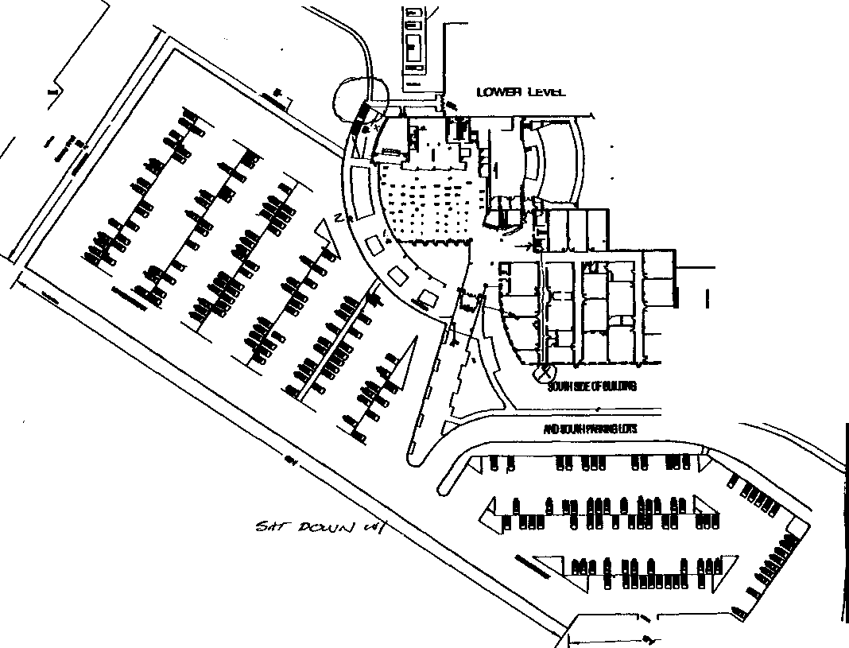

CONTINUATION □  SUPPLEMENT | Reporting Agency  JCSO |  | Reporting Officer  PETERSON | Case Report No  99-7625-CCCCCC
Connecting Case Report No. |  | Victim Name Original Report  COLUMBINE |  | Date This Report  10-20-99 '
X FIRST DEGREE MURDER |  |  |  | Recommend Case: Review □  Closure 0  I I

WITNESSES:

TESSA C. NELSON, DOB/11-26-83
6676 W. Rowland Ave.
Littleton, CO 80!28
(303) 979-1959
Student-Columbine High School

DENISE NELSON
Same as above.
Work: (303) 880-7400

INVESTIGATION:

On 10-20-99, at approximately 1540 hours, witness Tessa Nelson and her mother, Denise Nelson responded to the Jefferson County Sheriffs Office South Substation. The purpose for them responding to the South Substation was a pre-arranged re­ interview of Tessa Nelson in reference to the shooting at Columbine High School on 04-20-99.

Tessa Nelson said on 04-20-99, just prior to the shooting, she was sitting just outside of the cafeteria/commons area of Columbine High School with a friend of hers by the name of Tiffany Lien, eating pizza. Tessa said that she looked toward. the exterior stairway on the southwest side of Columbine High School and said she saw a male subject on this stairway, and described him as the following: a white male, approximately 6'4" tall, skinny build, wearing a black baseball cap on backwards. a black trench coat that hung down to approximately this subjects mid calf length, and Tessa said "It was not shiny" and did not believe that this trench coat was made out of leather. Tessa said this male subject was also wearing black jeans and black combat style boots. Tessa said as she was watching this male subject, he pulled back the right side of his trench coat and swung a firearm out of the coat that had been hidden underneath of it. Tessa said the subject held this weapon in his right hand after
pulling it out of his jacket with his right hand. Tessa said that when she saw this subject shoot this firearm, he shot it while

JC- 001-001039

CONTINUATION □  SUPPLEMENT X | Agency  JCSO |  | Officer  PETERSON | Case Report No  99-7625-CCCCCC
 |  | Victim Name Original Repon  COLUMBINE |  | Date This Report  10-20-99 '
X FIRST DEGREE MURDER |  |  |  | Recommend Case: Review D  Closure D

it was in his right hand. I asked Tessa Nelson what he was shooting the weapon at, and she told me "he was shooting at anybody” Tessa said at one point she saw a female victim lying on the ground outside of the cafeteria/commons area of Columbine High School and said that this female victim was bleeding in the area that Tessa described as the area of one of her sides. Tessa Nelson pointed to the area above the belt, and on the right side of her body. Tessa Nelson said she now believes that this victim's name was Anne Marie Hochhalter.

Tessa Nelson continued and told me that the male gunman she saw on 04-20-99 on the exterior stairway of the school was alone, and said he did not appear to be with anybody else. Tessa said the subject had "bad hygiene" and had facial scars and/or bad acne. Tessa said after the shooting at Columbine High School on 04-20-99, she looked through the Columbine High School yearbooks and said she located the picture of ------------ and that is who she now believes was this gunman that she
--------- in the hallways of Columbine High School.
saw on 04-20-99. Tessa said prior to the shooting, she had seen

However, she did not know what his name was at that time. I asked Tessa Nelson how certain she was that this gunman was in fact ------ and she told me "I'm pretty sure." She said she did not believe this person was Dylan Klebold due to the fact the gunman had either black or dark brown hair and she said she knows Dylan Klebold to have lighter colored hair. I briefly explained to Tessa Nelson about the physical evidence at the crime scene not indicating any other shooters were
involved with Dylan Klebold and Eric Harris, however, she did not say anything, but she did not change her beliefs either.

I showed Tessa Nelson the photographs printed from the Columbine High School cafeteria/commons area videotapes. The photos that I showed to her were all from Group A and were photographs #44, 51, 52, and 53. After looking at these photographs, Tessa Nelson said neither of the suspects in the photographs were the gunman that she had seen on 04-20-99. I asked her if she knew who was in these photographs, and she said she recognized them as being Dylan Klebold and Eric Harris.

I asked Tessa Nelson if she could provide any further information about the statement made in a prior interview, about a suspect other than Dylan Klebold or Eric Harris entering the ladies bathroom that she had hidden in with Tiffany Lien on 04-20-99, at Columbine High School, and shot the mirrors. Tessa said Tiffany Lien told her that when they both ran out of the bathroom on 04-20-99, Tiffany said she had seen that the mirrors had been shot out. Tessa Nelson said she had not personally witnessed

JC-001- 001040

CONTINUATION
SUPPLEMENT
Connecting Case Report No.
□

Reporting Agency
Officer
JCSO

PETERSON
Victim
COLUMBINE
Case Report No
99-7625-CCCCCC
Date This Report
'

X FIRST DEGREE MURDER

□

10-20-99
Recommend Case.
'
Review □
Closure
□

this occur, nor did she see the mirrors damaged on 04-20-99, as they ran out of the restroom. Tessa said since 04-20-99, she had been walked through Columbine High School with either Columbine High School Task Force Detectives and/or Columbine High School administrative personnel. Tessa said when she went through or into the bathroom, that she had hidden in on 04- 20-99, she saw that the mirrors were not damaged. She said she asked if the mirrors had been replaced and said she was told no. Tessa Nelson said she now believes the mirrors had not been shot out as Tiffany Lien had told her. For the sequence of events after this time period of Tessa hiding in the restroom, see the reports documenting other interviews that have been conducted with Tessa Nelson.

I asked Tessa Nelson and her mother Denise Nelson how their family has been doing since the shooting at Columbine High School on 04-20-99. Denise Nelson said that they were doing very well until October 19, 1999, when another student (who Denise Nelson said Columbine High School personnel had told them was Eric Veik) threatened to blow up Columbine High School. They asked me what I could tell them about that incident. I told them that a student of Columbine High School had been arrested for threats. Prior to my interview of Tessa Nelson and Denise Nelson on 10-20-99, I had asked J.C.S.0. Sgt. Randy West exactly what information I could provide to the students and their families about this incident because I had been contacted by another mother of a Columbine High School student about this incident. Sgt. West told me to advise the students and/or their families that the Jefferson County Sheriff's Office was made aware of a student making threats on 04-20-99 and a subsequent investigation into those threats resulted in the arrest of a student. (It should be noted that of the two students parents that contacted me and asked me about the incident, on 10-19-99, both parents already had the name of Eric Veik as the suspect. Denise Nelson advised me that Columbine High School administrative personnel had provided the name of Eric Veik. I did not provide any students, parents, etc. with the name of Eric Veik as being the student arrested or being involved in these
threats on 10-19-99.)

I gave Tessa Nelson and her mother Denise Nelson my business card and I also gave them a J.C.S.O. Colorado Safe School Hotline business card. I advised Tessa Nelson and her mother that should they hear anything about other threats from students at the high school or in reference to any school to contact me or contact this Colorado Safe School Hotline.

ADDITIONAL INFORMATION: I asked Tessa Nelson if she knew Isaiah Shoels and she said she did not know him,

JC-001-001041
□

Reporting Officer

CONTINUATION
SUPPLEMENT
Connecting Case Report No.
JCSO PETERSON
Victim Name Original Report
COLUMBINE
Case Report No
99-7625-CCCCCC
Date This Report

X FIRST DEGREE MURDER

□

10-20-99
Recommend Case:

however, she knew who he was from seeing him at Columbine High School. Tessa advised me that at no time did she ever observe anybody racially intimidate or harass Isaiah Shoels due to his race. Tessa said that it appeared to her that Isaiah Shoels was very well liked by the other students at the high school.

Tessa Nelson told me that for approximately the first two or three weeks after the students returned to Columbine High School in August of 1999, parent volunteers had checked name tags/identification cards while admitting the students into the school. She said at that time the students were required to wear their student ID/name tags, however, since then, she said the ID cards
are not checked, nor are the students required to wear them where they are visible. Tessa said that due to the fact the IDS are not checked on students entering the school, she is somewhat afraid, however, she said if this procedure had been in place prior to 04-20-99, she knows that Dylan Klebold and Eric Harris would have had identification cards and been admitted to the school
with them.

DISPOSITTQN: Case is open, pending further investigation.

JC-001-001042

NEVILLE, P

JC-001-001043

CONTINUATION
SUPPLEMENT

INTERVIEW WITH PATRICK NEVILLE, DOB/O5-12-83
6344 South Chase Street Littleton, Colorado (303) 347-9704

INVESTIGATION:

On Thursday, May 6, 1999, at about 0910 hours, I contacted Patrick Neville concerning what he witnessed at Columbine High School on April 20, 1999, at approximately 1120 hours. Neville stated that he arrived at Columbine High School on 4- 20-99 at 7:15 a.m. and went to his first period history class. Neville stated that his fourth period class, which started at 10:25 a.m. he was in the commons area of the cafeteria seated at table UU (see attached diagram). Neville stated that he was seated at table UU with Chris Wisher, Robbie Wisher, Jake Apodaca, and Trent Carney until 11:10 a.m. Neville stated that he left the school with Don Arnold, exiting the school by the entrance located on the upper level by the business office on the east side of the school. Neville stated that he and Arnold went to the parking lot on the north side of the school, got in Arnold's vehicle and drove south on Pierce Street, turning west on Polk Street, following Polk down to a greenbelt area, at which time they exited their vehicle and walked up to the Columbine High School soccer fields from the south side. Neville showed me on a map of the Columbine High School area where he and Arnold were. Neville stated at the soccer fields were Chris Wisher, Jake Apodaca. Don Arnold, and himself. Neville stated that from where he was at the soccer fields he could see the west side of the school. stating he was approximately hundred yards away from the west entrance/exit doors. Neville stated that while smoking a cigarette with other students, he heard what he believed to be firecracker noises at 11:20 to 11:25 a.m. Neville stated that the firecracker noises appear to be coming from the southwest corner of the school and that he looked in that direction and noticed two gunmen in the southwest area of the school. Neville described the first gunmen as tall with a black trench coat, dressed all in black. carrying a gun, described as a long gun. Neville stated that the second gunmen was a white male, with a white shirt. blue jeans. who he observed throwing something on the roof which exploded. Neville stated he knew it exploded because he could hear the noise and see the smoke coming from the roof. Neville stated that he also observed the long gun being fired. making motions of recoil from a weapon. Neville also stated that he saw kids falling and saw one person falling in the area approximately a hundred feet west of the west entrance and behind the air condition/heating equipment. Neville stated that once he realized that

JC-001- 001044

CONTINUATION SUPPLEMENT | JCSO |  | MCFADDEN | 99-7625-R
 |  | Victim Name Original Report |  | 05-01>-99
First Degree Murder |  |  |  | Recommend Case: Review D  Closure D

people were being shot that he and his friends left and drove to a residence on Polk Street, stopping, explaining what was going on and asked if they could use the phone to call their parents, to which they did.

ADDITIONAL INFORMATION:

Neville stated that he had additional information related to possible suspects related in this incident Neville stated that he thought it was strange that --------- always sat at table WW (diagram attached) for several months prior to 4-20-99 and that on 4-20- 99 he was not at that location during fourth period.

DISPOSITION: Case open, pending further investigation. (Copies of diagrams attached).

JC-001-001045

1

'

JC-001-001046 - ,
-
'

- -

: ·····- I --- - - ' IJ.) -t-
,
1--- I X

'

.. --1.

I'

-

,-- - \
,_

- -
' - (1 1[

J• --- ·-

-

V
-

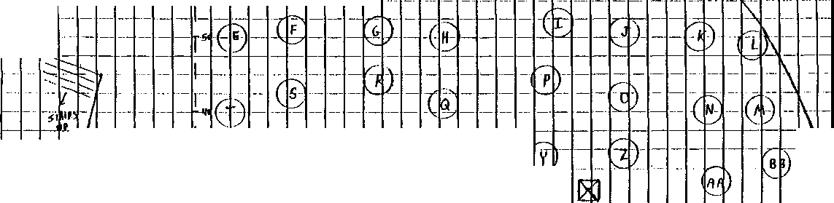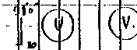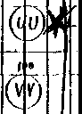
-, •

'
--

El
-

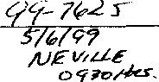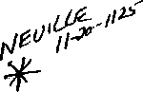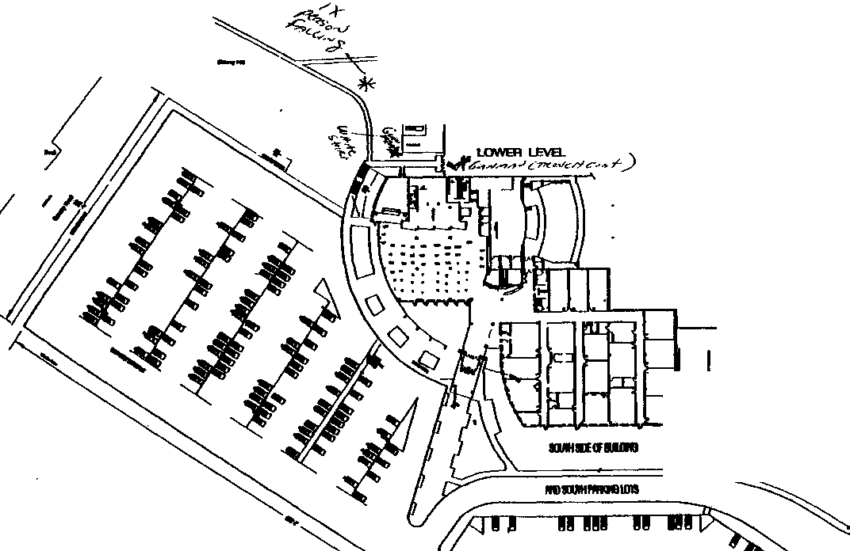

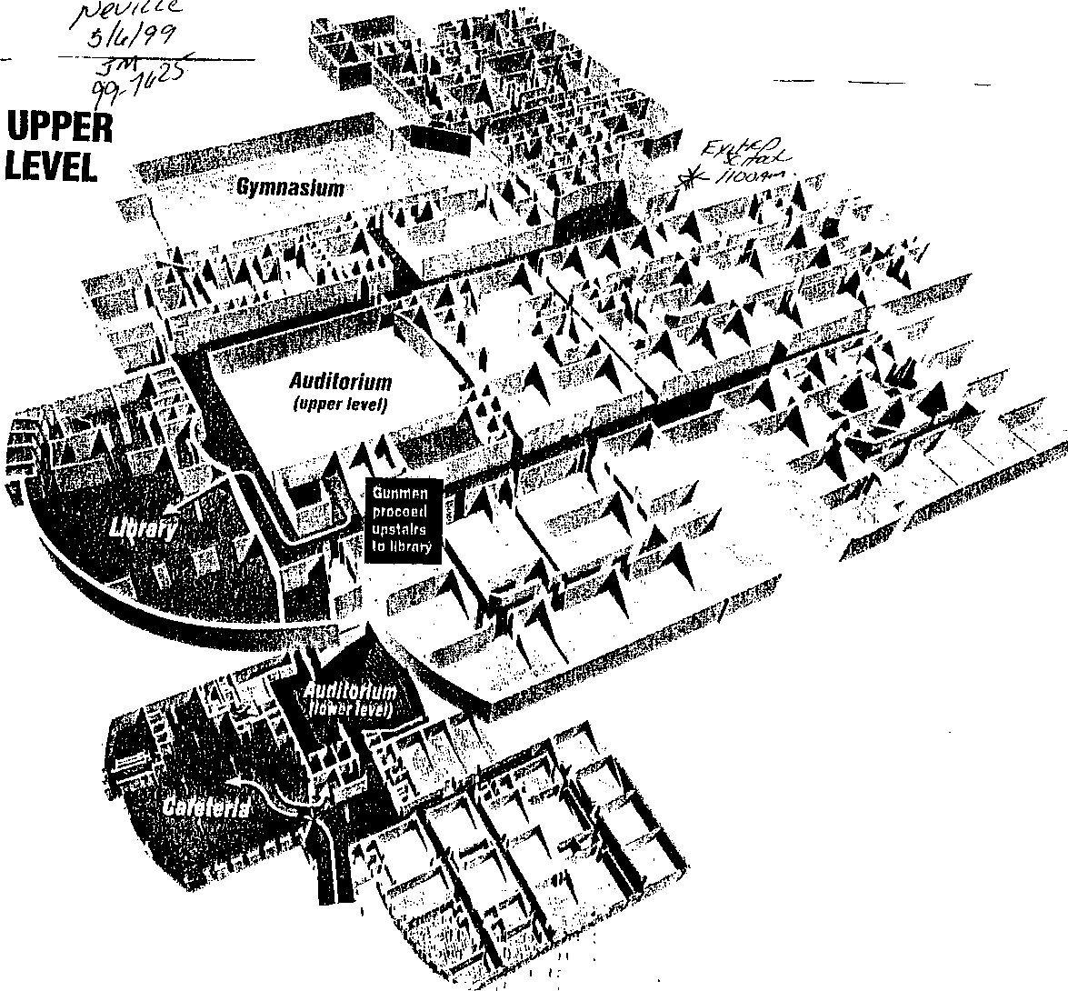JC-001-
001048

- Library
and cafeteria
- Auditorium
and clmir room
D Classrooms
- Corridors
Stairwell

LOWER LEVEL

'' ..

NICHOLS, C

JC-001-001049

JEFFERSON COUNTY DISTRICT ATTORNEY'S OFFICE

SUPPLEMENTAL REPORT

Defendant: Date:
Deputy D.A.:

4-22-99
Docket Number:
Case Number: 99A062
Investigator: J.Burkhalter

********************************************************************

Cindi Nichols, dob 9-21-83 6297 s. Benton Way Littleton, CO 80123
Ph. 303-797-7754

This investigator was led to Ms. Nichols by information provided by Melissa Miller. Ms. Nichols was interviewed at her home with her mother present. Ms. Nichols is a Freshman at Columbine H.S.

Cindi stated she was with her friends, Laura (Smalley) and Lisa

(Melissa Miller). lunch and talking
The three of them were outside going to have when she heard what she first thought were

firecrackers and then she saw smoke. Cindi stated she looked around

and saw two guys start shooting. down the stairs and then back throwing bombs.
They shot a girl and then went up the stairs shooting guns and

Cindi stated a guy (student) in a truck was driving into the student parking lot and they yelled for him to go away. The suspects then threw bombs at him. Cindi stated they hid behind a vehicle and then ran to a home after running through a field.

Cindi stated the incident started about two minutes after she and her friends arrived in the parking lot. She stated she gets out of class about 11:10 A.M. and saw the suspects about 11:25 A.M. to 11:30 A.M. She stated the two suspects went inside the school after being outside and she heard more bombs. She stated the doors they
l JC-001-001050

went into are right next to the library. She stated she heard the shots and explosions but didn't hear any conversation from the suspects.

Cindi was asked to escribe the suspects. Suspect# 1 A white male, 17 to 18 YOA,
She stated the following:
5 1 5n , skinny, redish/blond

hair shoulder length, greasy. Wearing Large Black coat, black pants. The weapon was long, two handle kind of gun. The suspect was holding it with both hands. Cindi didn't see this suspect throw anything. She has seen this suspect first semester at the school during passing in the hall between classes.

Suspect #2 A white male, with dark black hair that was short. He had on a gray shirt. Cindi stated jhe was throwing something. Cindi couldn't remember anything else about this suspect.

Cindi was asked to describe the student driving the truck into the parking area and she stated the driver was alone and had blond hair. The driver was male. Cindi described the truck as a gray/black with a red stripe. Possibly a Ford older model.

Cindi stated the initials - doesn't mean anything to her.

Cindi stated she talked to the press but not about any details of the incident. They wanted to know her reaction.

The.interview was concluded at this time.

2 JC-001-001051

NORMAN, G.

JC-001- 001052

Transcript of handwritten statement-
Garrett Norman

(JC-001-001053- 001054)

Interviewed by phone on 6-10/1245. Garrett said he was sick on 4-20 and did not attend periods 1-4. He said his dad drove him to school for his 5th period math class (in MA-9), and that he arrived at the front of the school (east side) at about 1105. Garrett said he entered main doors and walked north down first hallway to the right. He then exited the school through the doors located near the northeast corner of the gym. From there, he walked to smoker’s pit where he smoked a cigarette for about 5 minutes. Garrett said he then intended to stop by the library to scan some documents before heading to his Algebra class. Garrett said he began walking southwest from the smokers pit, past the west side of the gym. Garrett said that while walking south along the west side of the fenced maintenance area he heard an explosion and then saw smoke rising from the senior parking lot. Garrett said he stood there for about 30 seconds, thinking it was a senior prank. At that point, Garrett said that students began running out the west doors, north of the library. Garrett said one of the students yelled, “There’s a guy with a gun inside!” Garrett said most of the students then ran northward toward the south fence of Clement Park. Garrett said he turned around and ran with them to the smokers pit. Garrett said he never saw anyone get shot, nor did he see any shooters. Garrett said that upon arriving back at the smoker’s it, he heard the fire alarm go off (about 11:25). Garrett said he then jumped the fence and ran northward into Clement Park. Interview concluded at about 1200.
-see lead 4115/class report
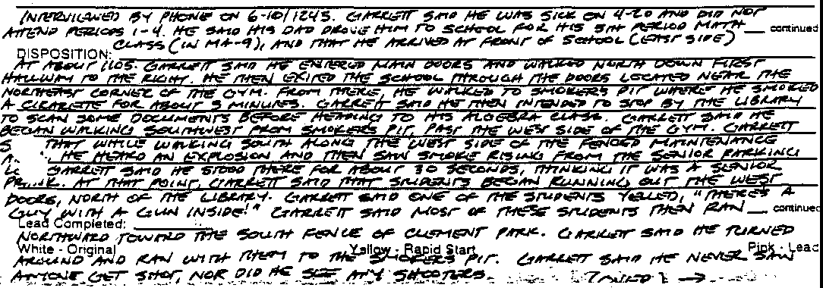
,--
l

JC-001-001053
!

OGLE, S

JC-001-001055

PIRNARR Arvada Police/Court System Arvada Police Department
NARRATIVE
Page l 04/29/1999

================================================================================

Ref# 99-12067

Type ASSTOA
Reported Date 04/20/1999 Time 12:39:32
Status RTF

Location 6201 S PIERCE DET23 04/28/1999 04279 /KK

JCSD 99-7625

On April 22, 1999 at approximately 2030 hours, Investigator Duane Eaton of the Arvada Police Department and Investigator Gary Clyman of the Colorado Attorney General's Office responded to 9835
W. 64th Place, Arvada, Colorado, 80004, to interview Steve Ogle (DOB 12/26/49), a witness to the homicides at Columbine High School in Jefferson County. The investigators had information that Ogle had been out in the park on a golf cart with Dick Strange, a maintenance man for the Clement Park adjoining the school
property. The investigators had information that Ogle was being given a tour and that he and Strange had observed at least one of the suspects involved in the homicide firing a weapon on the outside of the school. Investigator Eaton had made telephone contact with Ogle and Ogle agreed to an interview
Ogle advised the investigators that he had been on a golf cart tour of the Clement Park facility and that near the end of the tour he and Dick Strange were up on a football field and track looking around the park. He advised that they were at that
location because it was a little bit higher than other parts of the park and gave them a good view, He advised that this was near the south end of the park and football field area. Ogle advised that he was looking towards the school and believed himself to be approximately 100 to 150 yards away from the school He advised that it was a very nice day and he had observed approximately five to seven students on the soccer field area below them He states that at one point he began hearing a popping noise an thought it might be fireworks, maybe a senior prank, due to the fact that it was near the end of the school year He advised, however, that the popping sound continued which led him to believe that it may not be fireworks.
Ogle advisad that when he looked towards the school, he observed a white male near the corner or curved part of the building. It was later determined through school maps by the investigators that the person observed by Ogle was standing near a stairway between the library and cafeteria of the school, Ogle advised that it appeared that the white male was wearing a white dress shirt. When asked to explain the shirt in more detail, Ogle advised it appeared to be a shirt used by fireman or policemen. He advised that the subject was moving his right arm around and it appeared that he was holding his right arm with his left arm from below. Ogle advised that he looked long enough to observe that there was an object in the subject's right hand. He advised that the object appeared to be long like some type of firearm and longer than a pistol. He advised it appeared that it might be a sawed off shotgun. Ogle advised he observed the subject from the subject's

JC-001- 001056

PIRNARR Arvada Police/Court System Arvada Police Department
NARRATIVE
Page 2
04/29/1999

========================================$=======================================
Ref # 99-12067 Reported Date 04/20/1999 Time 12:39:32 Type J\.SSTOA Status RTF
Location 6201 S PIERCE ST

DET23 04/28/1999,042799/EATON/KK

right profile. He advised that it appeared that the subject was leaning against the building along the curved portion and pointing towards the parking lot or facing south.

The investigators asked Ogle if he recalled the time that he had observed the subject. Ogle advised that he believed that he had observed the subject at approximately 1130 hours. He advised that he believed that he and Strange were back at the maintenance shed for the park at approximately 1140 hours.

Ogle advised that he in fact believed that the subject was firing a firearm towards the parking lot. He advised that at one point he observed numerous juveniles come running towards the area of the park where he and Strange were. He advised that the juveniles were yelling, “Call the police, call the police.” Ogle advised the investigators that he believed these were the juveniles/students who had eventually ended up at the maintenance shop for the Clement Park. Ogle advised the investigators that he had an unobstructed view of the portion of the school building where he had observed the subject firing the firearm. Ogle advised that he had a "straight shot" of the area of the school he was watching. He advised that originally the juveniles that came running toward them were not within his view. He advised that he believed that they had run through a lower area below the school and then came up a rise towards his location

Ogle was asked if he had observed any injuries on any of the juveniles/students. Ogle advised that he did not observe any injuries but that one of the juveniles had advised that one of their friends had been shot in the leg.

Ogle was asked if he believed that he and Strange were being shot at at any point. Ogle advised that he did not believe the subject with the firearm was shooting towards the soccer fields because the juveniles on the soccer field just stood around. He also believed that he did not believe the subject was shooting at the Ogle advised that he believed the shooter was shooting into the parking lot area of the school.

Ogle advised that he and Strange became concerned about what was occurring and began to fear for their safety. He advised that they began driving back towards the maintenance shed for Clement Park. Ogle advised that as he and Strange drove back to the maintenance shed, they were following the sidewalk that went along the north and northeast edge of the school.He advised that as they passed that area of the school, they observed numerous juveniles/students sitting on the bleachers who did not appear to be scared or upset by what was taking place. Ogle advised that he told these juveniles about the shooting, at. which point the back doors of the school opened and approximately 30 to 40 juveniles came running out. He advised that they had to climb the fence to get away from the school and into the park. He advised that he did

JC-001- 001057

PIRNARR Arvada Police/Court System Arvada Police Department
NARRATIVE
Page 3
04/29/1999

================================================================================

Ref # 99-12067
Type ASSTOA
Reported Date 04/20/1999 Time 12:39:32
Status RTF

Location 6201 S PIERCE ST

DET23 04/28/1999 042799/EA ON/KK

not observe any students at that point who were injured.

Ogle advised that as they continued to follow the sidewalk back to the maintenance shed, they observed no police vehicles in the parking lot areas. He advised this only to let the officers know that he had observed a police vehicle in the parking lot between the school and maintenance shed earlier this date. He advised that it had been a green vehicle with fully marked police insignia on it though he could not recall which police agency.

Ogle advised that as he and Strange were arriving at the maintenance shop, they observed a police officer on a motorcycle arrive in the area of the school. He advised that it appeared the motorcycle was coming from the west. Ogle advised that when he and Strange got back to the maintenance shops, he advised he heard what he believed to be gunfire for approximately 20 minutes. He advised that he also heard some loud explosions and believes he heard the first explosion while he was on the football fields looking at the school. He advised he had not heard the first explosion until after the gunfire had started, however.

Ogle advised the investigators that he believes he and Strange were on the football field area looking towards the school for approximately five minutes. He advised that he had heard popping sounds before the first "boom" sound. Ogle also advised that while en route back to the maintenance shed, he believes he heard three to four explosions coming from the area of the school. He advised that he believes he heard maybe a total of five explosions total.
Ogle advised that he also observed smoke in the general area of the subject he had observed firing into the parking lot of the school. He advised that the smoke was white, very light colored and not dark.
The investigators asked Ogle if he had any recollection of seeing any other persons with the person he had observed shooting the gun. More specifically, the investigators asked if he had observed anybody who appeared to be with the gunman and not running away from the gunman. Ogle advised that he did not remember any persons in the area of the shooter who appeared to be associated with the shooter He advised once again that he had a straight shot look at the profile of the subject against the light colored building. Ogle advised that he focused on that subject only and focused on the subject's arm moving around while firing what appeared to be a firearm. Ogle advised he did not see anyone else around the subject. It should be noted that Ogle was wearing glasses during this interview and was asked if he had to wear glasses. Ogle advised that they were only reading glasses and that he wore contacts under normal circumstances. Ogle advised he was wearing contacts when he observed the subject near the school and that he has good vision with his contacts.
Ogle advised that when he and Strange got back to the

JC-001-001058

PIRNARR Arvada Police/Court System Arvada Police Department
NARRATIVE
Page 4
04/29/1999

==============---===============================================================

Ref# 99-12067
Type ASSTOA
Reported Date 04/20/1999 Time 12:39:32
Status RTF

Location 6201 S PIERCE ST

DET23 04/28/1999 -042799/EATON/KK

maintenance shop, he noticed other employees of the park trying to get all the park employees out of the park and into the shop area for fear of their safety He advised that at one point a teacher from the school arrived at the maintenance shed. He advised that he believed this person to be a coach though he could not recall why. Ogle advised that this teacher was talking to the juveniles.

Ogle was asked if any of the students there made any telephone calls while at the maintenance shed. Ogle advised that all of the juveniles called their parents. He advised also that Dick Strange's supervisor also advised that he had called the police to advise them that the juveniles were there and safe at the maintenance shop and that some of them had observed shooting and wished to speak with the police. Ogle was asked how long he stayed at the maintenance shop before leaving the area. Ogle advised that he believes he left the shop at noon or just shortly after noon. He advised that while at the shop he watched some of the incident unfold on the television news. He advised that his car had been parked near the maintenance shed and that he left a little after noon. He advised that when he drove out of the area he drove straight across the baseball fields and out onto Bowles Avenue.
Ogle advised that he was driving a 1984 gray Subaru station wagon owned by himself and his wife.

Ogle was asked if he observed anybody else driving out of the area that drew his attention. Ogle advised that he did not see anybody else leaving the area but himself. He advised that at one point he did stop and talk to a police officer. He advised that the police officer asked him if he had observed anything and Ogle had told them that he observed some of the incident take place but that there were juveniles at the maintenance shops who had seen more. He advised that the police officer then let him exit out onto Bowles Avenue. He advised that as he was leaving he observed six to ten police vehicles driving into the area.

The investigators asked Ogle if he had spoken about this incident with anyone else but the police. Ogle advised that he had not spoken with anybody else about the incident except for his wife.
,

The investigators asked Ogle to once again describe the subject he had observed near the school shooting the firearm. Ogle once again explained what he believed was a uniform type white shirt being worn by the subject. He also advised that the subject was wearing dark pants but it is unknown if they were long or short pants. He also advised that it appeared that the subject had dark hair. Ogle advised that the shirt stuck in his mind and that he believed it had a higher collar than a regular t-shirt. He once again advised that it looked like a uniform type shirt. He states that he believed he even mentioned that to Dick Strange. Ogle advised that he was sure of what he saw due to the fact that he had really focused on the subject. He also reiterated that he had

JC-001-001059

PIRNARR Arvada Police/Court System Arvada Police Department
NARRATIVE
Page 5
04/29/1999

===============================================================================

Ref #: 99-12067
Type ASSTOA
Reported Date 04/20/1999 Time 12:39:32
Status RTF

Location 6201 S PIERCE ST

DET23 04/28/1999 042799/EATON/KK

observed something long in the subject's arm going up and down. He advised that the object was dark in color. Ogle was asked if he had observed any flashing coming from the object and Ogle advised that he had not observed anything exit the object but only heard the popping noise.
Ogle was asked if he ever lost sight of the shooter, Ogle advised that as soon as he and Strange started to leave the area, they lost sight. Ogle advised that he believed there was something like bleachers or a wall near the ball field blocking the view of the school once they moved. He advised that even when his view was obstructed of the school, however, he could hear the popping noises. Ogle was asked if he remembered anything specific about the juveniles/students that he had had contact with or observed.
Ogle advised that the only thing he had heard the juveniles say was, "The Trench Coat Mafia did it," and other juveniles spoke of a friend being shot. Ogle also advised that the person whom he believed to be a teacher said he had observed a child who had
gotten shot outside of the school. Ogle advised that there was one female and four to five males from the school in the maintenance area. He advised that the teacher was there off and on and had no idea where the teacher went when he was not there. Ogle advised that the juveniles were asked how many kids were involved in the assault and Ogle said that the juveniles told them that there was 50 who did it and claimed the were "satanists." He also advised that the juveniles who had talked about their friend being shot may have named the friend as Mike. He advised that the students claimed that Mike was shot in the leg and face. Ogle also advised that the person who he believed to be a teacher said that the subject was small and had blonde hair.

Ogle advised the investigators that the juveniles were still at the maintenance shop when he left the area He once again advised that when he left the area, he drove away eastbound on Bowles and stopped to make a call to his wife from Platte Canyon and Bowles. Ogle advised the investigators that he believed he and Strange began the tour of the park at approximately 1110 hours and while touring the park, never observed anything else out of the ordinary until he had observed the subject near the school
shooting
Ogle advised the investigators that he had no other information to add to his statement. The interview with Ogle was ended at approximately 2120 hours.

JC-001-001060

OPFER, M

JC-001- 001061

Page
of
_ Pages

Denver Police Department
STATEMENT

Case No.

Summary of Statement:

Transcription of handwritten statement by Mark Opfer-

Was going outside to write a report at 1130 am (lunch). Saw a male, Cau (editor: abbrev for caucasian), black trench coat, 5’7” black levis, unknown shoes. Was wearing mask!
Supect #2- Cau, male, black trench coat, black hat, red bitl (editor-?) with a large “B” on the front. Wearing black pants, 2nd party 6’3”- 6’4”.
Mark saw the shorter of the two shooting. Mark saw the shooter of shot the one victim who went. Heard explosions. Like shotguns, maybe grenades. Heard 8- 10 explosions.
Victim of the shooting is Dan Rohrbough.

JC-001-001062

JC-001- 001062

FD·302 [Rev. 10.6-95)

- 1 -

FEDERAL BUREAU OF INVESTIGATION

Date 4 / 2 8 / 1999
On April 27, 1999, Mark William Opfer, date of birth
August 26, 1984, of 6620 South Jay Drive, Littleton, Colorado, telephone number (303)798-7090, was interviewed at 6572 West Calhoun Place, Littleton, Colorado, in the presence of Howard E. Wisher, date of birth April 12, 1949, with the permission of his father, Glenn Opfer. After advisement of the identity of the interviewing agent and the nature of the interview, he provided the following information:
Opfer is a freshman at Columbine High School. He went to lunch in the cafeteria at 11:15 a.m. on April 20, 1999, and after eating went outside the cafeteria by himself. At around 11:30 a.m., he began walking up toward the library on the outside staircase located on the northwest side of the cafeteria. He was walking next to Daniel Rohrbough, and saw two white males at the top of the stairs, one of whom was holding what he thought was a water/squirt gun. Opfer did not recognize either of these individuals.
Both were wearing all black, with black trenchcoats. One was about 6'4" tall and was wearing a backwards black hat with a "B" emblem on it. He had no weapon visible. The other person was about 5'8" tall and had a large pistol in his hands. [Opfer identified it as the TEK 9 assault pistol he has since seen a picture of in newspaper reporting].
The shorter person began firing the pistol down the stairs. Opfer turned to speak to Rohrbough, who then looked at him strangely and fell down screaming. Opfer realized Rohrbough had been shot, so he ran down the stairs and into the southwest entrance to the cafeteria. Inside, he told a janitor and other students to get out because someone was shooting at other students. He then ran east through the hallway on the south side of the auditorium and then south down the Foreign Language area hallway, warning other students and faculty about the shooter.
Opfer and several teachers and students hid in a classroom for about three hours, and left the school about an hour after they heard the last gunshots and explosions.

Invesc1gat1on an O4/27/1999 at Littleton, Colorado
F1le# l74A-DN-57419 Date dictated 04/28/1999
by MAttthew S. Harris JC-001-001063

FD·302a (Rev. 10-6--95)

l 74A-DN-57419

Continuation of FD-302 of Mark William Opfer On 04/27/1999 Page 2

Opfer has heard about the Trenchcoat Mafia, but only knows two members of the group, Joe Stair [a Columbine student who graduated last year} and Chris Morris. At the time, Opfer believed the taller person in the black trenchcoat who was with the shooter was ----- since ------- is about the same height and build and always wears a black trenchcoat and a black beret.

JC-001- 001064

DEPARTMENT OF THE TREASURY  BUREAU OF ALCOHOL. TOBACCO, ANO FIREARMS  REPORT OF INVESTIGATION |  | Page l of  1 Pa es
ADDRESSED TO:  Special Agent in Charge Phoenix Field Division | MONITORED INVESTIGATION INFORMATION:
TITLE OF INVESTIGATION:

Columbine High School shooting/Bombing
Casa Number

785030 99 0009
TYPE OF REPORT: (Check Applicable Bo:,;es)

Report#

43

X | REPORT OF INVESTIGATION |  |  | COLLATERAL REPLY
 | REPORT OF INTELL!GENCE
Matthew C. Traver |  | SUBMITTED BY (Tit/a end Office)  SA/Denver II |  |  | SUBMITTED BY (Dete)  10/15/99
REVIEWED BY (Name)  Robin King |  | REVIEWED BY (Tifle and Office}  AAC/Denver II |  |  | REVIEWED BY (Date)
APPROVED BY (Name}  Christopher P Sadowski |  | APPROVED BY {Title and Office)  SAC/Denver II |  |  | APPROVED BY (Date)

DESCRIPTION OF ACTIVITY:
Interview with Mark Opfer

SYNOPSIS:
On 10/14/1999, SA Traver some community service.

contacted Mark Opfer at Columbine High School, where he was At this time Opfer provided a positive identification of an

doing

individual he saw with a firearm at Columbine High School on 4/20/99.

NARRATIVE:
- On 10/14/99, SA Traver contacted Linda Opfer at her residence located at 6620 s Jay Dr Dr. Littleton, Colorado. At this time Linda Opfer stated that her son Mark was at Columbine High School doing community service work. She also gave SA Traver permission to speak with Mark, without her being present.
2 On 10/14/99, SA Traver approached a Columbine High School faculty member who was
supervising a student that fit the description of Mark Opfer, that Linda Opfer had given SA Traver. At this time SA Traver identified himself to faculty member Tim Harp, and requested to speak to Mark Opfer. Harp telephoned Mrs. Opfer and did receive confirmation that SA Traver had just spoken to her and that she had given permission for SA Traver to speak to her son. At this time Harp escorted SA Traver and Mark Opfer into a room in the main office of the school.
- At this time, SA Traver explained to Mark Opfer the reason he was being contacted. He
then read a portion of an interview that Opfer had given to a FBI agent on 4/27/99 In this portion Opfer had described the individual that he saw with a firearm outside of the school. After reading the description to Opfer, SA Traver showed Opfer photo number
52 from packet A. Almost instantly Opfer became very upset and said "That's exactly what I saw!". He positively identified a the image of Dylan Klebold in the picture as being the individual he previously described on 4/27/99, as being the person he saw

JC-001- 001065

DEPARTMENT OF THE TREASURY
BUREAU OF ALCOHOL, TOBACCO. AND FIREARMS
REPORT OF INVESTIGATION - Continuation Sheet
Page 2 of
2 Pages
OF INVESTIGATION:

CASE NUMBER: REPORT NUMBER:

with a firearm on 4/20/99.
- Opfer said he did not really get a good look nor could he identify the other individual that he saw Klebold with that day outside of the school.
- After making the identification, Opfer requested that SA Traver accompany him to the
area of the school he was that day so that he could show SA Traver where he was, when he saw what he saw. Tim Harp accompanied SA Traver and Opfer.
- Opfer stated that he was in the cafeteria when he went outside. He stated he was at the base of the outside stairs talking to Dan Rohrbough when he looked up to the top of the stairs and saw Klebold and another person. One of them began firing a weapon, he heard Dan Rohrbough scream and saw him fall. At this point Opfer ran back into the school and down towards the foreign language rooms.

ATTACHMENTS
None.

JC-001-001066

PARKISON, K.

JC-001-001067

CONTINUATION □  SUPPLEMENT V | Reporting Agency  JCSO |  | PETERSON | Case Report No  99-7625-PPP
Connecting Case Report No. |  | Victim Name Original Report  COLUMBINE |  | Date 06-18-99
X FIRST DEGREE MURDER |  |  |  | Recommend Case: Review □  Closure□  I

WITNESSES:

KEITH ALAN PARKISON, DOB/06-28-83
7147 West Frost Avenue Littleton, CO 80123
303-972-6548
Student-Columbine High School

JERRY PARKISON
Same as above.
Work: Arapahoe County Road & Bridge 303-792-5016

SHERIE PARKISON
3151 West Girard Ave. #615
Englewood, CO 80110
303-806-9407

INVESTIGATION:

On 06-18-99, at about tOOO hours, I responded to 7147 West Frost Avenue to contact and interview Keith Alan Parkison, who is a student at Columbine High School. This interview was in reference to the shooting that occurred of04-20-99

Keith Parkison told me on 04-20-99, he was in attendance at Columbine High School and said at about 0700 hours, he entered the cafeteria. Keith Parkison told me that he selected a table to sit at, which was in the Commons area between the stairway and the "Rebel Corner." Keith Parkison showed me on the diagram of the Columbine High School cafeteria where the table was that he had selected to sit at on 04-20-99. The table he selected was located between the bottom of the stairway and the "Rebel

JC-001-001068
CONTINUATION □  SUPPLEMENT X | JCSO |  | PETERSON | 99-7625-PPP
Connecting Case |  | Victim Name Original  COLUMBINE |  | Date  06-18-99
X FIRST DEGREE MURDER |  |  |  | Recommend Case: Review □  Closure □  Value I Value I Voluo

Corner" store. Keith Parkison said there were other students near this table, but he could not remember who they were. I showed Keith Parkison photographs of the duffle bag and a propane tank that were later recovered in the Columbine High School cafeteria. Keith Parkison said he did not see either item prior to the incident on 04-20-99. Keith Parkison also said he did not see any of the Trench Coat Mafia students in the cafeteria or the Commons area on 04-20-99. Keith Parkison said at approximately 0725 hours on 04-20-99, he left the cafeteria and walked to his class, down the hall and east of the cafeteria on the lower level of Columbine High School. Keith Parkison said his teacher for this class was Mr. Ortiz. Keith Parkison said on 04-20-99, at about 1115 hours, he exited the school by walking out of the school doors south of the "Rebel Corner," and said he went and sat on a hill that is located southeast of this door. Keith Parkison said he was with Aaron Bonewell. and one other student but he could not remember who this third student was. Keith Parkison said he was sitting on the hill for approximately three minutes, when he heard "about two bombs" detonate and he said to him it sounded like the detonations came from the west side of the school in the area of the exterior of the cafeteria. Keith Parkison said he then saw several students running from the school to get away from it. Keith Parkison said a student ran past him and as he did, Keith Parkison said he asked this student what was going on. Keith Parkison said the student told him a student had a gun inside of Columbine High School and said
someone had been shot inside. Keith Parkison said he got up and ran across South Pierce Street and into to Leawood Park. Keith Parkison said while he was running, he heard approximately ten gunshots. but said he could not tell where they came from. Keith Parkison said at no time during the incident on 04-20-99, did he see who was shooting or detonating bombs. Keith Parkison said while he was in Leawood Park. someone believed that the students in the park were being shot at, so they left Leawood Park. Keith Parkison said while he was in Leawood Park, however, he did not hear any shots.

Keith Parkison said although he was not an associate of the Trench Coat Mafia students, he used to talk to some of them at the school. Keith Parkison said that he did not get along with Dylan·Klebold and in fact, said they did not like each other. Keith Parkison said they had nearly gotten into physical fights between each other in the past. Keith Parkison said this disliking between them started in a team sports class that he had with Dylan Klebold at Columbine High School. Keith Parkison said that Dylan Klebold picked on him, and finally this harassment nearly caused the fight. Keith Parkison said he never saw anybody pick on Dylan Klebold, however, he did see Dylan Klebold pick on other people.

Keith Parkison said he used to talk to Eric Harris, however, had not talked to him since approximately January of 1999 Keith

JC-001- 001069

CONTINUATION 0  SUPPLEMENT | Reporting Agency  JCSO |  | Reporting Officer  PETERSON | Case Report No  99-7625-PPP
Connecting Case Report No.  - |  | COLUMBINE |  | Date This Report  06-18-99
X FIRST DEGREE MURDER |  |  |  | Recommend Case, Review □  Closure □  V>luo I a a"e

Parkison said he quit talking to Eric Harris and the other Trench Coat Mafia students in January of 1999, because Eric Harris and the other Trench Coat Mafia students began picking on people and harassing them. Keith Parkison said that when this started, he stayed away from them.

Keith Parkison said that Dylan Klebold and Eric Harris were always together. He said he did not remember seeing either Dylan Klebold or Eric Harris at Columbine High School on 04-20-99. Keith Parkison said that Dylan Klebold and Eric Harris always wore a trench coat and said Eric Harris wore a Swastika on his trench coat. He also said Dylan Klebod may possibly have had a Swastika on his trench coat, but he was not sure. He did say that Eric Harris had a Swastika on his backpack. Keith Parkison said he never heard Dylan Klebold or Eric Harris talk about guns, bombs, blowing up the school, or shooting people. He said he never saw Dylan Klebold, Eric Harris or any Trench Coat Mafia students with firearms or bombs. Keith Parkison said that ------- was Dylan Klebold' s best friend, and Keith Parkison said that he could not understand how ------ could have not known about the shooting that was going to occur at Columbine High School prior to the incident on 04-20-99.

Keith Parkison said Joe Stair claims that he organized the Trench Coat Mafia, and although Joe Stair lives in the same neighborhood as Keith Parkison, they don't get along with each other and don't talk to each other. Keith Parkison said that in the past he was friends with Nicole Markham and Brian Sargent, as well as some of the others described. Keith Parkison said Robert Perry was good friends of Dylan Klebold and Eric Harris and said Robert Perry always wore a trench coat. Keith Parkison described Robert Perry as "quiet." Keith Parkison estimated the Trench Coat Mafia has approximately five actual active members and at least ten associates. Keith Parkison said they would listen to German music. Keith Parkison said that he no further information about the Trench Coat Mafia, or the Trench Coat Mafia students.

Upon my asking, Keith Parkison said that he has been doing well since the incident occurred on 04-20 99, at Columbine High School. I gave him one of my business cards and asked him to contact me in the future if he wished to talk with a J C.S.O. Victim Advocate. I told him I would make the necessary arrangements for him at that time. I also asked Keith Parkison to call me should he think of any further information in the future that may be pertinent to this case.

DISPOSITION: Case remains open, pending further investigation. JC-001-001070

JC-001-00
1071
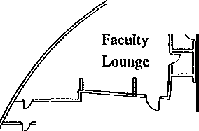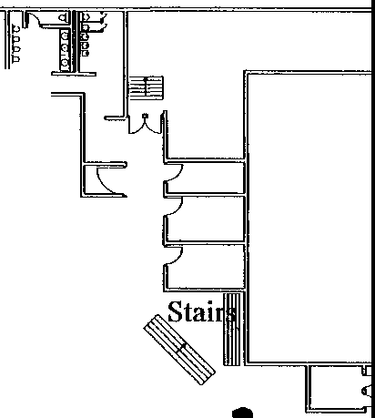
Kitchen
J
Serving Line
I
"
I
o 00

0

□.
Pillar o O
000
0
Q Q
Q
--

0
Q □Pillar Q Q Q Q

Q

Pillar

□ _0

CAFETERIA
oodCart

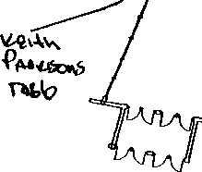

PAUKUNE, AMANDA

JC-001-001072

Colorado State Patrol
Investigative Services Section

Case Number | Connectin2 Case # | Report Type
99-311014/l | J.C.S.D. I 99-7625 | Assist - Jefferson County Sheriff's Department
Date | Time | Location
04-20-99 | 1120 | Columbine Hh!h School

SYNOPSIS: Assist to the Jefferson County Sheriffs Department with the investigation of the Columbine High School homicide.

INVQLVEMENTS:
Witnesses:
COLORADO STATE PATROL - 2207N. HWY 402 LOVELA... . CO. 80537 (970)663-0219
-Investigator Greg McComas

CIVILIAN WlTNESSES
(W)Paukune, Amanda 04-12-84 Res· 8784 W Progress PL

(Student - Columbine High School)
Littleton, CO. 80123 H-(303)933-0868

SUMMARY:
05-14-99/Friday

Per information control sheet #3288, I contacted (W)Paukune at her residence, regarding information she might have of possible suspe1.,'t accomplices.

(W)Paukune stated that she was at Columbine High School on 04-20-99. According to (W)Paukune, prior to the shootings she had been in the cafeteria, talking with friends. At approximately 11:10 am , she exited out the south doors, by the school store and walked through the junior parking lot. She then cut through an opening in the wooden fence, off school grounds, to meet with friends and smoke a cigarette. She stated, during her time in the cafeteria and while walking through the parking lot she did not notice anything unusual or see the suspects or their vehicles

At approx. 11 20am, she heard an explosion near the building and observed some students running. At that point she felt it was a senior prank, or a drug bust and continued smoking her cigarette, sitting on the sidewalk next to Pierce St. Shortly thereafter a friend by the name of Anthony, unknown last name, came running by and told her of the shooting. She and several other students ran to a nearby house for safety.

JC-001-001073

(W)Paukune stated, from her location she was unable to see the cafeteria or library areas and did not see any of individuals involved. She also stated she had not noticed anything unusual about the day prior to the incident. She did not notice any unusual behavior or see any strange individuals or items, such as duffel bags.

(W)Paukune stated, she was acquainted with both Eric Harris and Dylan Klebold. She met them last year, through a mutual friend, Kelly Schwab, who moved away to California a year ago She explained that Kelly Schwab used to hang around with the Trench Coat Mafia and suggested they join. (W)Paukune stated she did not want to join, due to the belief that the members were all bi-sexual, including Harris and Klebold (W)Paukune stated, once her friend moved she had very little to do with the individuals in the TCM. She did talk with Harris on occasion, just casual conversation, and described him as being very nice. She stated, Klebold did not seem to like her and was mean and sarcastic, therefore she tried to avoid as much as possible.

(W)Paukune stated she had never overheard any conversations about a plan for the shootings or of any other suspects

- Paukune identified her approximate location at the time of the shootings on the map attached to this report.

I | Date of Report | Investillator/IBM# | T | Supervisor/IBM# | Page
 | Mav 17, 1999 | G.S. McComas/ 5560 | I |  | 2 of 2

JC-001-001074

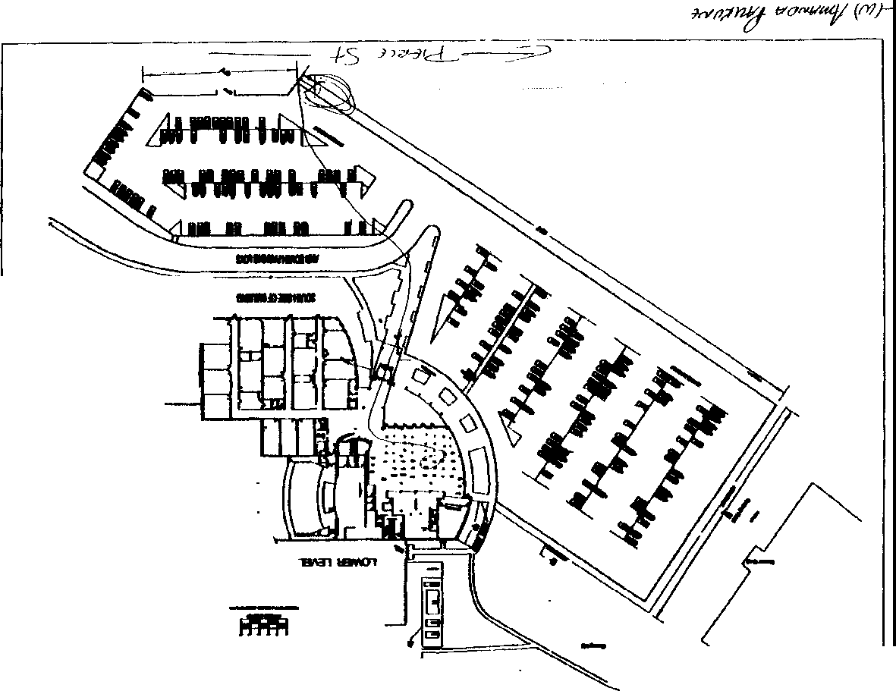JC-001-001075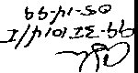

'
I

.,
-·-

PISTOLESE, M

JC-001- 001076

CONTINUATION
SUPPLEMENT

X
TCSO

Classification
homicide

-
:
REKER

5-10-99

-
_

I Serial No.
I

99-7625
Narrative:

Interview with Megan Pistolese

On 5-6-99,lnv. Reker did conduct an interview with Megan at her residence with her mother present.

Pistolese states that at approx. 11:15 she left her backpack by the bench in the common area of the lunchroom and went out the main cafeteria door and across the senior lot to the west end of the lot and along with Amanda Paukune, Garrett Horsfall and Lindsey Buffy, jumped a wooden fence so they could smoke a cigarette.

At this point they heard loud noises at an unknown location and then looked between the fence slats and saw kids running from the school and they then ran to a house on Pierce St. along with other groups of kids.

Megan did not see anything suspicious nor did see she any shooters.
Megan states that she was in the cafeteria at approx. 0700 am but did not see anything suspicious at that time.
Megan had no further information and the interview was concluded.

JC-001- 001077

TEAM FOUR INTERVIEW GUIDELINE

MINIMAL QUESTIQNS TO BE ASKED

  - Did you ever see the two large duffel bags in the cafeteria ?
No
2 Did you see anyone carrying or in the possession of those duffel bags, at a previous time ?
NO

  - Did you see Eric Harris or Dylan Klebold either on Monday or Tuesday? What were they doing? What did they say? Were they with anyone else? NO

  - Did you leave anything behind in the cafeteria or anywhere else in the school? Backpack- bench/black, mesh net. Gold sun keychain

5 Who were you with in the cafeteria ? Where were you sitting ?

6. Did you see or talk to any of the Trench Coat Mafia members on Monday? Tuesday? How about the
prior week or weekend ?

- Have you heard anything from anybody else about other suspects, bomb making, gun buying, etc.?
NONE
- What were you wearing ? Did you have a back pack ? What did it look like and/ or have in it ?
Bell bottoms, Lt blue t-shirt- striped

- How did you leave the cafeteria or the building ? What were the events that made you leave ?

1O What time did you enter the cafeteria ? Where did you come from (prior to the c.ifeteria) ?

11 Have them mark where they were sitting, their route out of the building and who they were with (if known)?

12. Can you provide any further information on the members of the Trench Coat Mafia?

13 Ask the parents if the kids have told them anything else ? Different ?

JC-001-001078

,

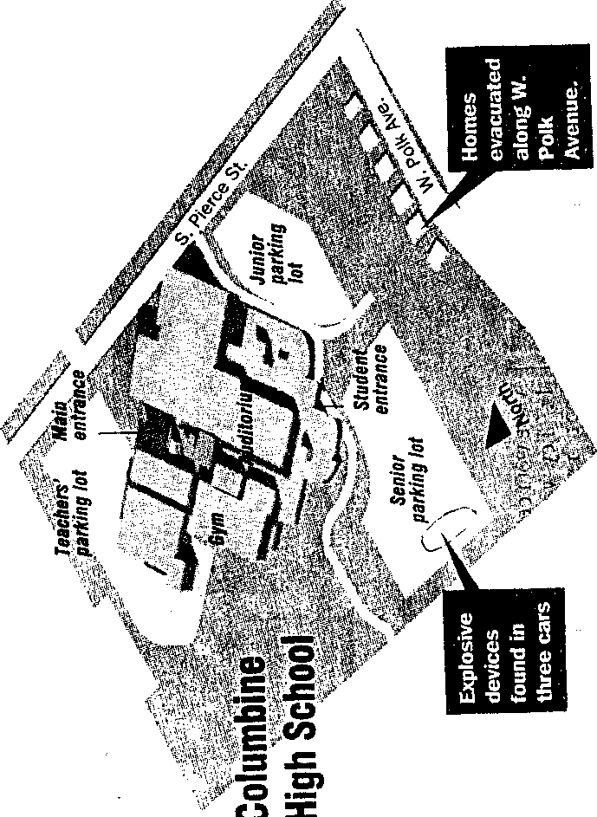
0

JC-001-001079

PITONIAK, J.

JC-001- 001080

CONTIlNUATION  SUPPLEMENT X | Reporting Agency  JCSO |  | Reporting Officer  BROOKS | Case Report No  99-7625-S
Connecting Case Report No. |  | COLUMBINE |  | 05-10-99
X FIRST DEGREE MURDER |  | Offense Status: Open X Exceptionally Cleared □  Cleared by Arrest( □ Unfounded □ |  | Recommend Case: Review □  Closure □

WITNESSES;

Joseph Charles Pitoniak I DOB 052984 5497 South Independence Street Littleton, Colorado 80123
303-904-03 [9
Columbine High School/ 9th grade

lNVESTIGATION:

0n 05-06-99, at about 9:30 a.m., I interviewed CHS student Joseph Pitoniak as follow up on DNl 751. The interview was conducted at Joseph's residence in the presence of his father, Joe Pitoniak, Sr.

Joseph told me that on 04-20-99, he spent fourth period (10:20 a.m. to 11 :00 a.m.} inside the cafeteria at table Y with his friends. Matthew Zago (9th), Shakespeare Log (9th), and Adam Ahlstrom (9th). Joseph explained that his fourth period is a “free period," and that he usually spends it in the cafeteria, talking with friends. Joseph said that at about 11:00 a.m. {ten minutes before fourth period ends}, he walked up the interior cafeteria stairway to his locker and retrieved his sack lunch, then returned down these stairs to the cafeteria. Joseph said that he returned to the cafeteria at about 11:10 a.m., and again sat at table Y. where he then ate his lunch with these friends. Joseph said that during this entire time, he did not see or notice any duff1e bag(s), nor anything else that he considered unusual/ out of the ordinary.

Joseph said that upon finishing his lunch, which he estimated was at about 11:15 a.m., he got up from table Y and walked outside via a south cafeteria door where he then sat down at a "bench" with friends Nathan Epling (9th), John Bright (9th), Jason Ramsouer (9th), and Nicholas Lumley (9th). Joseph described this bench as the "first" or southernmost bench on the south side of the cafeteria. After approximately "two minutes," Joseph said that he heard several "pops" which appeared to be coming

C-001-001081

CONTINUATION □  SUPPLEMENT X | JCSO |  | BROOKS | Case Report No  99-7625-S
Connec,ting Case Report No. |  | Victim Name Original Report  COLUMBINE |  | Date This Report  05-10-99
X FIRST DEGREE MURDER |  | □ |  | Recommend Case: Review □  Closure □  I I

from the west side of the cafeteria's exterior. Joseph said that he assumed these pops were the result of a senior prank and. curious, he got up from his bench and began to walk in a northwest direction, around to the west side of the cafeteria, toward the direction of the sounds. Joseph said that as he rounded the southeast corner of the cafeteria, he saw a male "down" on the grass toward the top of the hill, to the west of the stairway. Joseph said he then saw "a girl in front of me get shot in the lower abdomen." Joseph said that this girl (Anne Hochhalter) had been sitting with a couple of friends near the curb, facing east, near a grassy area on the west side of the cafeteria. Joseph said that when she was shot, she "just kinda hopped up, and grabbed her side and started screaming 'I've been shot,' and then kinda kneeled down and her friends covered her." Joseph said that he could see blood on her clothing. Joseph said that at that point, he realized this was no joke. Joseph said he turned around and ran back to the south side of the cafeteria, where he then entered the cafeteria through the "student entrance by rebel corner.'' Joseph said that he remembers Jason Ramsouer entering the school with him at that time.

Joseph said that upon entering this area, he saw janitors who were telling everyone to 'get down' and teacher Dave Sanders "going up the stairs." Joseph said that students inside the cafeteria began to get down, and that he and Jason then hid behind a soda machine by the bathrooms near the southeast corner of the cafeteria. Joseph said that he and Jason remained behind the soda machine for about "ten seconds," during which time he heard a single "explosion" that he thought came from upstairs. Joseph said that this explosion "shook the building." Joseph said that he and Jason then ran eastward down the Business hallway, then southward down the Foreign Language hallway. Joseph said that he and Jason then entered the "far east classroom," which is marked as FL3 on the school map. Joseph said that an adult female, who he thinks was a teacher, directed he and other students into said classroom. Joseph said that upon entering this classroom, he and Jason hid in the northwest corner so as to not be seen from the door. Joseph said that he didn't remain in the classroom for very long. Joseph said that someone mentioned barricading the classroom door, but that because the door opened outward into the hallway, this made no sense to him. Joseph said that after a couple of minutes, he, Jason, and another student named Spencer Wright (9th) exited the classroom and ran out of the school's south door.

Upon exiting the school. Joseph said that he and the others ran southward across the junior parking lot to the "seminary house" located on the northwest corner of Pierce Street and Polk Avenue. Joseph said that he remained at the seminary house for

JC-001-001082
CONTINUATION □  SUPPLEMENT X | JCSO |  | BROOKS | Case Report No  99-7625-S
. |  | COLUMBINE |  | Date This Report  05-10-99
X FIRST DEGREE MURDER |  |  |  | Recommend Case: Review D  Closure D

approximately forty-five minutes, during which time Spencer Wright telephoned his mother, who responded to the seminary home and picked up Spencer, student Adam Hinchey (9th) and himself and drove them to Spencer's home. Joseph said that student Aaron Wright (11th, Spencer's brother) was already inside his mother's car when they were picked up at the seminary home.

Joseph said that he never saw any shooter(s) or anyone wearing a trench coat while he was inside the cafeteria or outside on the west side of the cafeteria. Joseph said that he does not personally know Eric Harris or Dylan Klebold, nor any of their associates as presented by the media. Joseph said that his backpack is inside his locker, where he placed it after his third period class. The interview concluded at about 10:07 a.m.

The names of those students / teachers provided by Joseph were run through Rapid Start and Denver Detective Mark Woodward; lead sheets for students Shakespeare Log, Adam Ahlstrom, Nicholas Lumley and Adam Hinchey were prepared and submitted by me. All other students were either previously interviewed, or scheduled to be interviewed.

See attached cafeteria / school maps.

DISPOSITION; Open.

JC-001-001083

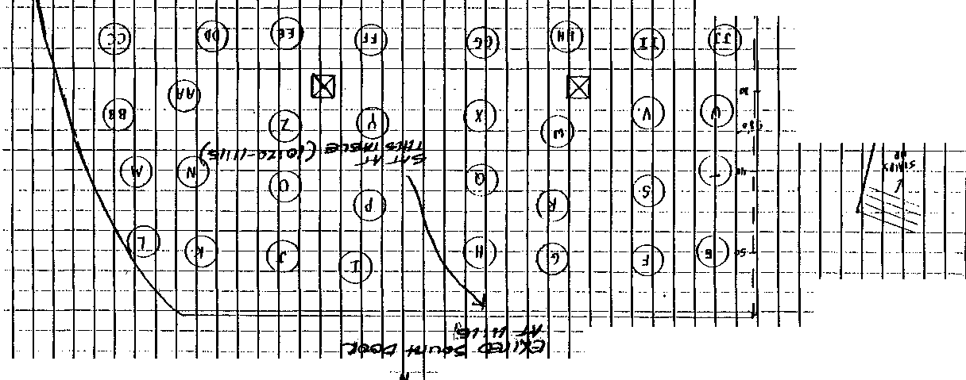- - . ·- ...

-- - - -- -I--- ---

' ..

'
··- .. ,. -·- ·-- --- - -I- -- ·- -- -
-- ·
JC-001-001084

-

-

.

l
- - '-'· .
'

- ·- - -- - --

.. 1., '

'

-- -- --I-- - --
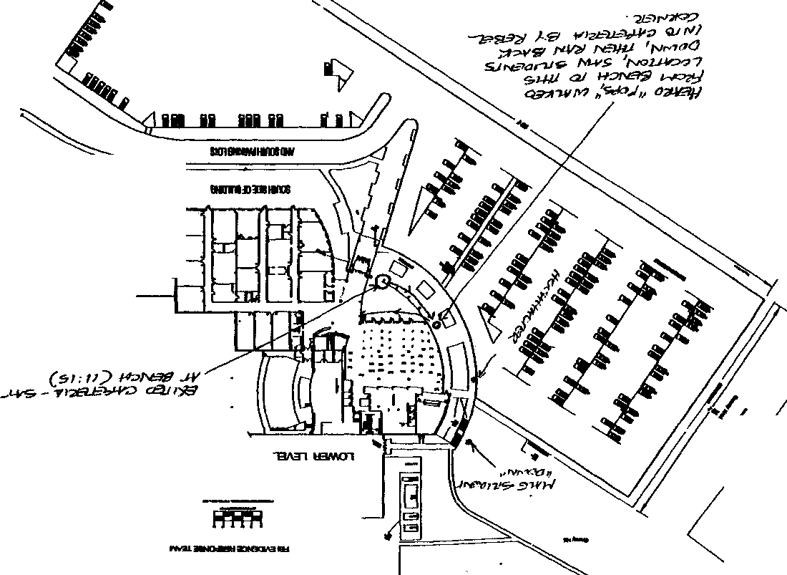
...
--
,,

JC-001-001085

0
0

9

•

100H09 JC-001-001085

JC-001-001086

Map of inside of school

PLACE, C

=

JC-001-001087

I
CONTINUATION □  SUPPLEMENT V | Agency  JCSO |  | Reporting Officer  Gary Muse | Case Report No  99-7625-C
Connecting Case No |  | Victim Name Original Report  Bernall, Cassie, et al |  | Dilt<:This Report  4-24-1999
X Homicide |  |  |  | Recommend Case: Review □  CJosure □

WITNESSES:

PLACE, CRAIG D., DOB/6-16-1947
6533 S. Vance Street, Littleton, CO 80123
Home: (303)979-2893
Employer: RI Schools/Columbine Senior High School (PE Teacher)
6201 S. Pierce Street, Littleton, CO 80123

INVESTIGATION:

On April 20, 1999, while assisting with interviews on the scene of a multiple homicide at Columbine High School, I interviewed Craig D. Place, a PE Teacher who had been evacuated from the school by SWAT personnel. Place told me that he heard shots being fired in the school, and began to assist in evacuating students from the school. Place told me that he saw a number of students who had bunched up in a corner and he moved them out of one of the exterior doors of the school. Place said that he did not think that he saw anyone with a gun, but said that he saw a number of students running, and the person or persons with the gun(s) could have been in the group of running students.

DISPOSITION: Open.

JC--001- 001088

  - I •

FEDERAL BUREAU OF INVESTIGATION

Date of transcription 06/10/99 Craig Place, date of birth June 16, 1947, 8451 South
Upham Way, Littleton, Colorado 80120, telephone number (303) 979-
2893, was interviewed at his residence. After being advised of the identity of the interviewing agent and the nature of the interview, Place furnished the following information:
Place is a Physical Education Instructor at Columbine High School. Place has a weight-lifting class that he instructs during second period. During third and fourth period he teaches a Team Sports class in the gymnasium. At 11:10 a.m. he is scheduled for A" lunch. On Mondays he has hall duty in the cafeteria during first period, which runs from 7:30 a.m. to 8:15 a.m.
On April 20, 1999, Place went to his car in the teacher's lot to get a bagel at approximately 11:15 a.m. He then was going to walk outside of the building all the way around to the cafeteria. He normally never goes to the cafeteria but had to go pay his social fees in the faculty lounge. As he was walking from his car toward the cafeteria, he heard what he first thought were the sounds of firecrackers. This was at approximately 11:20 to 11:25 a.m. and he was walking just outside of the gymnasium. As he continued to walk in the direction of the sounds he began to realize that the sounds were gunshots. He stopped and waited by the custodial entrance to the school. He continued to hear gunshots and moved back toward the entrance slightly. From his vantage point he was unable to see any gunmen. He could hear a student crying near the entryway to the west entrance of the school and the back exit of the library. He later found out the student was Mark Taylor.
Within a couple of minutes maximum, a police car arrived and parked on the side of the hill. Approximately ten minutes later students came out and ran behind the police car. Place believes these students came out the back door exit of the library. Place wanted to try to help the students and must have made some type of movement or gesture towards them. A police officer told them to “Get the fuck out of here." With him at that time at the custodial entrance door was Joe Marshall and Catherine Baumgartner.

JC-001-001089
Investigation on 05/27/1999 at Littleton, Colorado
File# l 74A-DN-57419
by SA John H. Elvig Control Number #DN-357__

174A-DN-57419
Continuation of FD-302 of Craig Rlace on 05/27/199
Place explained that he is Vietnam veteran and is familiar with the sounds of gunshots. He further explained that he is slightly hard of hearing and did not remember hearing any explosions.
Place, Marshall and Baumgartner moved to the north side of the gymnasium. They met up with Principal Frank DeAngelis.
The four of them then went to the gymnasium and assisted fifteen girls in a class exit the school. The students and the teacher, Kris Macauley, were hiding in a storage room located off of the gymnasium. They headed north out of the school and headed for Clement Park. They told the students to keep moving and not to stop. Place then went to an area known as "the pit" to get those students to continue moving back within the park. He helped students jump the fence into Clement Park and then continued pushing them back toward the corner of the park at Bowles and Pierce.
Place was familiar with Eric Harris from one of his classes and also when he served as Dean of Students. Harris was in Place's first-semester Team Sports class. Harris was a fair athlete and did well in all the activities in the class. Place did have a problem with him picking on freshmen, as a lot of the seniors did. For a two-year period, from approximately 1996 to 1997, Place served as Dean of Students. During that time he did have one opportunity to deal with Harris. Place could not recall the specifics of a snowball incident involving Harris and Brooks Brown. The incidence was resolved through "conflict resolution , and Place does not recall the specifics of any action.
During his time as Dean of Students he did have a group of students with whom he had several problems. This group included Chris Morris, Eric Dutro, Julie Grenke, Brian Sargent, Joe Stair, Robert Perry, Jamie Schuster (edit: perhaps Shofner?), and Cory Friesen. The problem with this group of students was not with other students but was within their own group. On one occasion Morris pulled a knife on Dutro after a school theater event. This incident went before a "manifestation _hearing", and no action was taken because Morris may have been classified as Special Education. Place remembered one problem with Stair greeting his male friends in the cafeteria with a kiss on the lips. This bothered other

JC-001- 001090

FD-302a (Rev. 10-6-95)

174A-DN-57419
Continuation of FD-302 of Craig Place ,on 05/27/1999 ,Page 3
students. School officials had to ask Stair and the others to cease the action.
At the time Place was Dean of Students he did not see Eric Harris or Dylan Klebold as being part of this group. He does not remember Brooks Brown being a member or this group either. He didn't know of the name “Trenchcoat Mafia" until it came out as a result of the incident at the high school. He does remember Morris dressing in a black trenchcoat and wearing a green beret. Place has seen Morris since the incident and says he has changed his appearance. Place knew who Klebold “was" but did not have Klebold in any class. He does not remember hearing of any problems with Klebold.
Attachment A is a diagram of Columbine High School. On the diagram Place indicated his path of movement outside of the school. He further indicated the location of the storage room within the gymnasium.

JC-001-001091

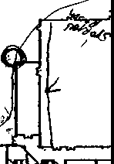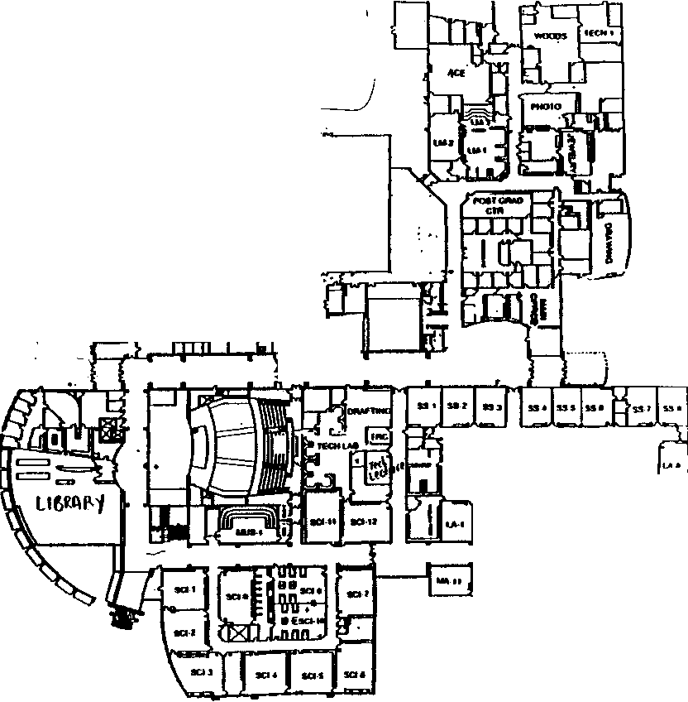COLUMBINE HIGH SCHOOL
982-4400 • MAIN OFACE
982-4410 - ATTENDANCE OFFICE

JC-001-001092

N

w E
( --

0

s
'

If
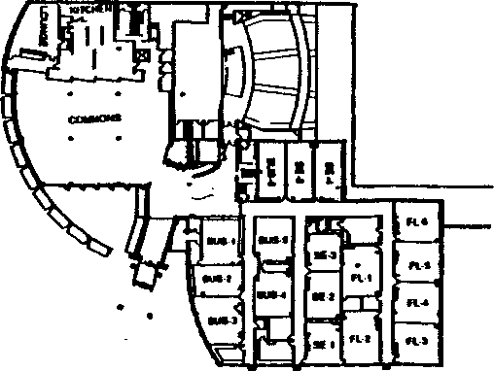

• •
--·

El
,., u> u, u,

-
--··
--··
--·
_, .... -·

-·

POLLOCK, MINDY

JC-001-001093

)

- I .
FEDERAL BUREAU OF INVESTIGATION

4/26/99

Mindy Pollock, 6298 W. Elmhurst Avenue, Littleton, Colorado, 80128, home telephone number (303) 972-8067, date of birth August 26, 1983, was contacted concerning the shooting that took place at Columbine High School (Columbine) on April 20, 1999. After being advised of the identity of the Agent and the purpose of the interview, Pollock provided the following information:
Pollock was a sophomore at Columbine and was ditching her fifth period class at approximately 11:00 a.m. on April 20, 1999. Pollock was in the commons area of the school with her friend, Evan Vitale, looking for a ride to Vitale's car. Pollock found Trent Karnes to give them a ride to Vitale's car.
Pollock, Vitale and Karnes left the school through the south double doors leading to the senior parking lot. Pollock was about to get into Karnes's vehicle when she heard a noise that sounded like firecrackers. Pollock saw a man running up and down the stairs on the south side of the school. Pollock also saw a man standing at the top of the stairs shooting people.
Pollock stated that she believed she was watching a skit and did not think what she was witnessing was real.
Pollock turned around as the vehicle left the parking lot and she saw people running. Pollock advised that she became suspicious when they passed a police car and it turned its lights on. When a second police car passed with its lights on, Pollock realized that the scene at Columbine may have been real.
Pollock described the individual that ran up and down the south stairs two or three times as follows: man wearing black pants, black shirt, black hat backwards, black trench coat and carrying a silver handgun. Pollock advised that she did not see the man on the stairs fire his handgun.
Pollock described the individual at the top of the stairs shooting people that were outside eating lunch, as follows: man wearing black pants, white shirt, black suspenders, hat and carrying a huge black gun.

lnvestig-iltion on 4/24/99 Littleton, Colorado (telephonically)

File# l 74A-DN-57419
by SA Carol M. Snieqowskie

4/26/99

JC-001- 001094

Control Number
WITNESS:

INTERVIEWERS:

DATE/TIME OF INTERVIEW:

PLACE OF INTERVIEW:

ASSIGNMENT SYNOPSIS:
MELINDA (MINDY) POLLOCK, Columbine High School student, DOB 8/26/83, 5'-0", I05lbs, black hair, brown eyes, 6987
W. Elmhurst Ave. Littleton, Colorado, 80123, (303) 972-8067.

Agent JERRY W. MEANS and Agent LARRY BROWN, Colorado Bureau of Investigation, 690 Kipling Street, Denver, Colorado, 80215, (303) 239-4211.

May 4, 1999, at approximately 09:45 a.m.

6987 W. Elmhurst Ave., Littleton, Colorado, 80123.

An interview was conducted with Mindy POLLOCK, DOB 8/26/83, of 6987 W. Elmhurst Ave., Littleton, Colorado on May 4, 1999. POLLOCK'S parents were present during the interview and scene re-creation at the school.

POLLOCK stated she was outside the school when the shooting started. Pollock stated she was walking across the parking lot with Trent KARNES, John COOK, Michael JOHASEN (editor-?), and T.J. (Tyler) LEAVITT.
POLLOCK stated she heard the shooting, turned around, and saw to people with guns on the west hill area of the school. She stated she and the friends she was with watched the shooters for approximately 2 minutes. She stated they thought the shooting was a senior prank. POLLOCK stated she saw one gunman near the bottom of the concrete stairs near the west access door to the cafeteria. In this report this gunman will be referred to as #1. She stated the second gunman was standing near the top of the concrete steps. In this report this gunman will be referred to as #2. POLLOCK stated she recognized the lower, #1 gunman as--------She stated on a scale of 1-10, (1) being uncertain and (10) being positive she was (8-9) it was ------. She stated she knows -------last year and does not remember seeing him since.

DESCRIPTION OF GUNMAN#!

The following is a physical description of the man she saw with a
gun, (#1):

- He had on a black trench coat that extended to between his knees and his ankles made of a cloth

JC-001-001095

type material. The coat was open and had no
patches.

-He had on a black baseball hat in the backward position.

-His face was long and his nose was pointed.

-He looked like a giant rat

-He had a light complexion and a mustache.

-He had a black shirt. She noticed no writing on the shirt.

-He had a silver colored handgun in his left hand. She stated the gun was sort of flat on top.

-She noticed nothing around his neck.

-He had black pants, (not jeans), and she noticed no pockets because the pants were covered with the coat The leg of the pants were over the top of the black boots.

DESCRIPTION
OFGUNMAN#2

SCENE
WALK-THROUGH

The following is a physical description of the man she saw with a
gun, (#2):

-Looser fitting black pants and black boots.

-White dress-type shirt with front buttons.

-Red hat on backwards.

-Holding a long black gun.

On May 4, 1999, at approximately 10:00 a.m., Agent Brown and the Reporting Agent took Mindy POLLOCK and her parents to the exterior southwest corner of Columbine High School. POLLOCK stated she was standing along the south side of the parking lot when she heard shooting and saw two gunmen. The Reporting

JC-001- 001096

Agent paced the distance from POLLOCK’S location to the area where she saw the #1 gunman. near the bottom of the concrete steps, and it was approximately 100 yards. POLLOCK stated she and her previously listed friends watched the lower shooter run up and down the stairs a few times and they just thought it was a game. She stated they got in their car and left. She stated they did not realize the shooting was real until they were a couple of blocks from the school and saw several police cars with their lights on headed for the school. POLLOCK stated they turned around and responded back to the school. but the police had the area blocked. She stated she did not see any other people running from the school.

Jerry W. Means
Agent
Colorado Bureau of Investigation

JC-001-001097

CASE# 99-7625
REPORTING AGENCY: JCSO
REPORTING OFFICER: DEPUTY STEVE LUCIANO
DATE OF THIS REPORT: 10-21-99 CONTROL# 5064

WJTNESS:
Melinda (Mindy) Pollock, DOB/8-26-83 6987 W. Elmhurst Avenue
Littleton, Co. 80123
303-972-8067

INVESTIGATION:
On 10-8-99 Columbine High School Student Mindy Pollock was re-interviewed at the Jefferson County Sheriff's Office South Sub-Station. Her mother, Linda Pollock, was present during the interview.

The purpose for the re-interview was to clarify Pollock's observations during the April 20th shootings at Columbine High School, specifically to statements made by Pollock during an interview on 5-4-99 with task force investigators. In that interview, Pollock stated that she was walking across the high school parking lot when the shooting started. Pollock reported seeing two gunmen. Pollock stated that she saw one gunman near the bottom of the concrete stairs by the west door to the cafeteria. The second gunman was standing near the top of the same concrete stairs. Pollock told investigators that she recognized the gunman near the bottom of the stairs as -------

I asked Pollock to describe the gunman she thought to be ------------ Pollock stated that he was "really tall and skinny" wearing a long, black trench coat, black pants and a baseball cap on backwards. He had a black gun in his hand "like a little handgun." Pollock stated that when the shooting started she was walking across the senior parking lot. She was near a light pole in the middle of the lot when she first heard gunshots.

I asked Pollock if she still believed that the gunman she saw near the bottom of the concrete stairs was -----------. Pollock told me that she still believed that the gunman she saw -------------
Pollock told me that she had seen ----------- several times at Columbine High School during her freshman year (Pollock is currently a junior). Pollock has not seen ----------- since her freshman year. Pollock stated that she has never seen Dylan Klebold before with the exception of media photos after the shootings. Pollock stated that a couple of days after the shootings, after learning through the media that Dylan Klebold was involved, she looked at his school photo in her school yearbook. Pollock noted that in the photo Klebold had short hair; the gunman she saw had long hair. Based on Klebold's yearbook photo, Pollock concluded that -------- was the shooter she saw.

JC-001- 001098

I then showed Pollock a series of three photographs (#51, 52, 53) taken from the video camera in the cafeteria. After looking at the photographs, Pollock immediately pointed to a photo of Dylan Klebold, and identified him as the shooter she saw at the bottom of the stairs. Pollock also immediately recognized the gun in Klebold's hand as being the same one she saw the shooter with. While looking at the photographs, I also explained to Pollock that the gunman she saw at the top of the stairs was, in fact, Eric Harris. Pollock did not dispute that.

The interview was concluded with Pollock understanding that the person she identified as ---------- was, in fact, Dylan Klebold. There were no additional concerns in reference to a third gunman.

JC-001- 001099

RAGOLE, JOSEPH

JC-001-001100

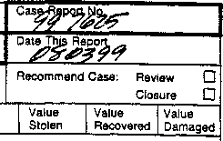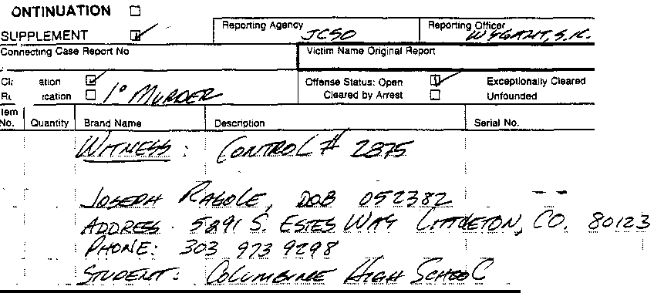JC-
□□
001-
001
100

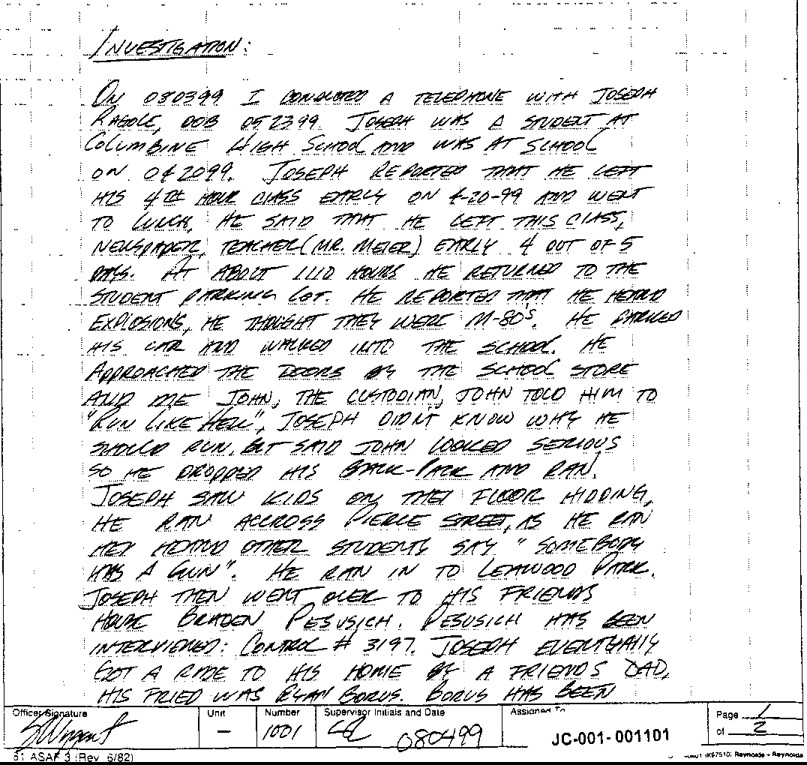

CONTINUATION 0
SUPPLEMENT
Continuation supplement

Transcription of handwritten statement of Joseph Ragole, JC- 001-001101through JC-001-001102

On 80399 I conducted a telephone with Joseph Ragole DOB 052399. Joseph was a student at Columbine High School and
Was at school on 042099. Joseph reported that he left his 4th hour class early on 4-20-99 and went to lunch. He said he left
This class, Newspaper, teacher Mr. Meier) early 4 out of 5 days. At about 1110 hours he returned to the student parking lot. He reported that he heard explosions, he thought were M-80’s. He parked his car and walked into the school. He approached
The doors by the school store and met John, the custodian. John told him to “Run like hell.” Joseph didn’t know why he should run but said John looked serious so he dropped his back pack and ran. Joseph saw kids on the floor hiding. He ran
Across Pierce Street, as he ran he heard other students say, “Somebody has a gun.” He ran in to Leawood Park. Joseph
Then went over to his friends house, Braden Pesusich. Pesusich has been interviewed: control #3197. Joseph eventually
Got a ride to his home by a friends dad. His friend was Ryan Borus. Borus has been interviewed: control # 3660.
Joseph reported that he knew both Harris and Klebold. He had been in classes with both. He did not associate with them
Outside of school functions.
Joseph had seen jocks pick on Harris and Klebold before, in the school halls. Joseph said that he would hang out with Klebold and Harris at school once in a while, usually in the morning and mostly during 1st semester. When I asked him
What he meant by hang out, he said, “I’d sit with them and talk.”
Joseph reported that the Trench Coat Mafia was a joke and said that the name came from the jocks. They were making
Fun of them.
Joseph reported that he had no prior knowledge of the shooting and never talked to either Harris or Klebold about this.
Joseph reported that “Jeffco” was wasting their time by investigating a third shooter/ gunmen. He said, “Knowing these
two guys, they were the only ones who knew, they were pushed over the edge.”

Disposition: Case Open

JC-001-001102

-

. RAMSOUER, JASON

JC-001-001103

CONTINUATION  SUPPLEMEN | JCSO |  | PETERSON | Case  99-7625-MM
 |  | Victim Name Original COLUMBINE |  | Date This Report  06-03-99
First Degree Murder |  |  |  | Recommend Case: Review. 0  Closure 0  I I
1 I Quantity I Brand Name / Description Serial No

WITNESSES:

RAMSOUER, JASON, DOB/02-27-84
7520 West Oregon Drive Lakewood, Colorado 80232
303-988-0534
Currently residing with his father, Jeff Ramsouer at 16188 W Maricopa Street
Goodyear, AZ 85338
602-932-3277
Student-Columbine High School

RAMSOUER, JEFF, DOB/12-09-59
16188 W. Maricopa Street Goodyear, AZ 85338
602-932-3277

RAMSOUER. ROBYN, DO8/05- I 9-61
7520 West Oregon Drive Lakewood. Colorado 80232
303- 988-0534

INVESTIGATION:

On 06-03-99, I contacted Jason Ramsouer by telephone, who is currently residing with his father, Jeff Ramsouer, for the summer in Goodyear, Arizona. Jason Ramsouer is a student at Columbine High School. This interview was in reference to the shooting that occurred on 04-20-99 at Columbine High School.

JC-001-001104
CONTINUATION □  SUPPLEMENT -- | JCSO |  | Reporting Officer  PETERSON | Case Report No  99-7625-MM
Connect1ng Case Report No  ' |  | Victim Name Origmal Report  COLUMBINE |  | Da1e This Report  06-03-99
First Degree Murder |  |  |  | Recommend Case: Review □  Closure □  !

Jason Ramsouer told me that on 04-20-99, at about 1115 hours, he walked through the cafeteria of Columbine High School and then went outside of the cafeteria, where he sat on a concrete bench. Jason Ramsouer said the following friends with were him at this time, Joey Pitoniak, Nathan Epling, and John Bright.

Jason Ramsouer said while they were sitting on the concrete benches outside of the cafeteria, he heard what he described as seven to eight gunshots that sounded like a shotgun being discharged. Jason Ramsouer said he believes these shots were from outside of the cafeteria. Jason Ramsouer said when these shots were heard, his friend, Joey Pitoniak, got up from the bench and walked in a northwesterly direction in order to try to and see where the shots came from. Jason Ramsouer said that after Joey Pitoniak went to look, he came running back and said that he saw a female laying on the ground bleeding. Jason Ramsouer said this female would have been on the west side of the cafeteria, laying on the ground. Jason Ramsouer said Joey Pitoniak did not know either who this female victim was, or he did not say who she was if he knew who she was.

Jason Ramsouer said that Joey Pintoniak and he ran into the cafeteria door (which he described as being on the south side of the Columbine High School cafeteria). Jason Ramsouer said he does not know where Nathan Epling or John Bright went from the concrete benches. Jason Ramsouer told me that once he entered the school, he went into the area of the "Rebel Corner" and said that Joey and he hid behind some vending machines at that location. Jason Ramsouer said they stayed there for less than one minute. He said they then ran down the foreign language department hallway, on the lower level of Columbine High School, and hid in a Spanish classroom. Jason Ramsouer said when he ran down the hallway and into the Spanish classroom, there were approximately 20 to 30 other people following him into the classroom to hide. Jason Ramsouer said while he was hiding in the Spanish classroom, he heard approximately four explosions that sounded like to him they were detonated inside of the school and possibly from the area of the cafeteria. Jason Ramsouer said the people hiding in the Spanish classroom remained in there
for approximately five minutes, then exited the room, then exited the school by running out of the one of the exterior doors. Jason Ramsouer said he ran to a seminary, which he said is at a house on the corner of South Pierce Street and West Polk.

Jason Ramsouer said he did not see any of the discharges from the firearms nor did he see any explosive devices being detonated. He said that he did not see any possible suspect with explosive devices and/or firearms at any time during the incident on 04-20-
- Jason Ramsouer told me that prior to the shooting, he had never heard of the Trench Coat Mafia. Jason Ramsouer said prior

JC-001-001105
CONTINUATION SUPPLEMENT | JCSO |  | PETERSON | Case Report No  99-7625-MM
 |  | Victim Name Original Report  COLUMBINE |  | Date This Report  06-03-99
First Degree Murder |  |  |  | Recommend Case: Review □  Closure □

to the incident, he had not heard of Dylan Klebold or Eric Harris. He said that he could recall seeing two to three different male students in the hallways at Columbine High School wearing trench coats, but did not know who they were. He said when he saw them, they were alone and he could not recall how long before the shooting he had seen them in the hallway.

Jason Ramsouer said on 04-20-99, when he walked through the cafeteria to go outside to the concrete benches, he did not observe any duffle bags and/or propane tank, that was later recovered in the Columbine High School cafeteria. Jason Ramsouer did say when he later ran from outside of the cafeteria to hide behind the vending machines, he left his backpack laying outside the cafeteria by the concrete benches. Jason Ramsouer described his backpack as being green in color and said it had school papers and books inside of it. Jason Ramsouer said his mother Robyn Ramsouer has since picked up the backpack for him from Columbine High School.

Jason Ramsouer did not remember what clothing that he wore to the high school on 04-20-99. Jason Ramsouer said he did not Know anybody who has a double pierced eyebrow. Jason Ramsouer also said he did not know what the "Thought of the Day" was over the Rebel New Network (RNN) on 04-20-99.

I asked Jason Ramsouer how he has been coping with the incident since it occurred on 04-20-99, and Jason Ramsouer advised me he has had no problems coping with it. I gave Jason Ramsouer my phone number and told him that if he needed to talk to a J.C.S.O. Victim Advocate in the future, to contact me and I would make the necessary arrangements for him.

DISPOSITION: Case is open, pending further investigation.

JC-001-001106

ROBERTS, J.

JC-001- 001107

PIRNARR Arvada Police/Court System Arvada Police Department
NARRATIVE

Page 1
05/12/1999

===============================================================================

Ref # 99-12067
Type ASSTOA
Reported Date 04/20/1999 Time 12:39:32
Status RTF

Location 6201 S PIERCE ST
DET57 05/11/1999 051099/ NM

JCSD 97-7625
CONTROL #2965

on Wednesday, May 5, 1999 Investigator Duane Eaton was assigned investigative lead #2965. The source of the information listed on the information control sheet was Neil Gardner, Gardner is the Jefferson County Sheriff's Office school resource officer assigned to Columbine High School. The narrative portion of the information control sheet advised that Gardner had been contacted by Roberts on Tuesday, May 4, 1999. Roberts had advised Gardner that she had passed and interacted with Eric Harris and Dylan Klebold as she exited the upper level west doors on Tuesday, April 20, 1999 Just prior to when the shootings and bombings began.
Investigator Eaton was assigned the task of contacting and interviewing Roberts in reference what she observed.

On Thursday, May 6, 1999 at approximately 1006 hours, Investigator Eaton met with Janine Nicole Roberts (DOB 07/02/80) and her mother at their residence, 8644 W. Progress Place, Littleton, Colorado, 80123. It should be noted that Roberts' telephone number is 933- 4675. Roberts agreed to speak with Investigator Eaton about what she had observed and her mother agreed to allow Janine Roberts to speak with the police about the incident.

Investigator Eaton asked Janine Roberts to first describe her day at school leading up to the incident. Roberts advised Investigator Eaton that her first period class begins at approximately 0730 hours and is Humanities class. She advised that there are no Trench Coat Mafia members or associates in that class to her knowledge. She did advise, however, that last semester during first period she had history class. She advised that Robert Perry was in that class. She advised that she sat near Perry and that she often observed him playing with cards from the game Magic. She advised that Perry once spoke to her and said that Buddha does not like you. Roberts also advised that Perry told her that if she ever spoke ill of him, Buddha would get her.

Roberts advised Investigator Eaton that her second period class is Government/Econ, her third period class is Physics, her fourth hour class is Weights and that her fifth hour class is Foods Class. She advised that she is in this class with Patrice Doyle.

Roberts advised Investigator Eaton that at approximately 1120 to 1125, she and Doyle exited the foods class and went to the parking lot area of the school She advised that they were going to the seniors parking lot of the school in order to get prom pictures from Roberts' vehicle. Roberts advised Investigator Eaton that she and Doyle exited the school via the upper level west
doors She advised that there is two sets of doors with an airlock in between. Roberts advised Investigator Eaton that as she exited

JC-001-001108

PIRNARR Arvada Police/Court System Arvada Police Department
NARRATIVE
Page 2
05/12/1999

===========================================--=============================

Ref# 99-12067
Type ASSTOA
Reported Date 04/20/1999 Time 12:39:32
Status RTF

Location 6201 S PIERCE ST DET57 05/11/1999 051099/EATON/KK

the door, she observed Rachel Scott and Richard Castaldo. She advised that she knew both Scott and Castaldo by name only and not personally. She advised that it appeared that they were having lunch together. Roberts also advised Investigator Eaton that as she exited, she observed Eric Harris and Dylan Klebold standing next to the fence and grass at the top if the stairway which leads down from the upper level to the cafeteria and seniors parking lot. She advised that she was only acquainted with the two males and did not know them personally, though she did know them by name.

Investigator Eaton asked Roberts to describe both Harris and Klebold at the time she observed them. Roberts advised that the only clothing she could recall Harris wearing was his black trench coat. She also advised that the only clothing she could recall Klebold wearing was what she believed to be black jeans. She advised that one of them, though she could not recall which, was wearing a white t-shirt underneath a coat.

Roberts advised Investigator Eaton that both she and Doyle walked by Harris and Klebold and said hi and smiled. She advised that both males nodded back to her and Doyle. Roberts advised Investigator Eaton that she observed both males moving their hands around at belt level but did not pay attention to what they were doing and did not observe anything more specific than that.

Roberts advised Investigator Eaton that as she and Doyle got to the bottom of the stairs, they heard a series of popping noises. Roberts advised Investigator Eaton that she turned around to look and observed one and possibly both Harris and Klebold shooting what appeared to be guns back towards the school towards the upper level west doors. She advised that at first she believed they were shooting paint balls as she recalls even making a statement to that effect to Doyle. She advised that at this point she did not think much of what was taking place and continued to walk towards her car.

Roberts advised Investigator Eaton that at some point she turned to look again and saw Harris and Klebold shooting at people sitting on the hill outside the west doors. She advised that there were people running away from Harris and Klebold and she observed one male whom she believed had been shot in the leg crawling away. She advised that she thought she observed other people try to get to that person and help that person but then run away because the shooting continued.

Roberts advised Investigator Eaton that she and Doyle hid behind a car in the seniors parking lot though she does not recall a description of that vehicle. She advised that she continued to hear what she what she believed to be gunshots and even bullets being fired in their direction She advised that near by she heard another loud popping noise and observed smoke emit from what she
believed to be a little bomb. Roberts advised Investigator Eaton

JC-001-001109

PIRNARR Arvada Police/Court System Arvada Police Department
NARRATIVE
Page 3
05/12/1999

=============================================================================
Ref # 99-12067 Reported Date 04/20/1999 Time 12:39,32 Type ASSTOA Status RTF
Location 6201 S PIERCE ST

DET57 05/11/1999 051099/EATON/KK

that she and Doyle then ran to Roberts' car in the parking lot. It should be noted that Roberts placed an X on an 8 1/2 x 11 sheet of paper with a diagram of the west and south side of Columbine High School where she believed she was standing when the shooting began. The X that Roberts placed on the diagram is at the bottom of the previously mentioned stairs. She placed the initials JR next to the X denoting where she was. Roberts also placed an X in the parking lot portion of the diagram where she believed her vehicle had been parked. Said map will be included with this report.

Roberts advised Investigator Eaton that because she was scared, she got in the closest door of her vehicle which was the passenger door. She advised that she reached over and unlocked the driver's door allowing Doyle entry into the vehicle through the driver's door. She advised that she placed the keys in the ignition and allowed Doyle to drive the vehicle. Roberts advised that since there was no car parked directly in front of her vehicle, Doyle drove the vehicle right through the spaces and stopped once to look back at the school. Roberts advised that they stopped and attempted to look back towards the school to see if what was taking place was "fake." Roberts advised Investigator Eaton that at this time she observed what she believed to be blood on the students on the grass hill near the upper level of the school. She advised that at this point Doyle drove the vehicle away from the school.

Roberts advised Investigator Eaton that she called her ex­ boyfriend's residence on her cell phone. She advised that she spoke with her ex-boyfriend's mother in order to tell the mother not to allow her ex-boyfriend to return to school as it was not safe. Roberts identified the ex- boyfriend as Nate Wills. She advised that she and Doyle then responded to the Wills' residence and learned that Nate Wills had returned to the school in order to look for his brother.

Roberts' mother then advised Investigator Eaton that she had something she wished to say. Mrs. Roberts advised Investigator Eaton that her daughter told her that immediately following the incident, she received a telephone call on her cell phone from a friend of the family. Mrs. Roberts did not identify this friend but did add that the friend worked for Channel 4 News. She advised that this family friend was aware of Janine Roberts' cell phone number and called Janine in order to ask her what was taking place. She advised that this friend then advised Janine Roberts that there were people that needed to talk to her and though Janine Roberts did not know who she was talking to, she apparently talked to Channel 4 News personnel. Janine Roberts then advised Investigator Eaton that it was at this point during the cell phone conversation that she told a person that she was speaking with that the suspects were Eric Harris and Dylan Klebold. It is believed that this is how the names of the suspects became available to the news as quickly as it did.
JC-001-001110

PIRNARR Arvada Police/Court System Arvada Police Department
NARRATIVE
Page 4
05/12/1999

==============================================================================

Ref # 99-12067
Type ASSTOA
Reported Date 04/20/1999 Time 12:39:32
Status RTF

Location 6201 S PIERCE ST

DET57 05/11/1999 051099/EATON/KK

Janine Roberts advised Investigator Eaton that she could not recall anything else that she had observed or that had taken place and the interview was concluded at approximately 1038 hours.

JC-001- 001111

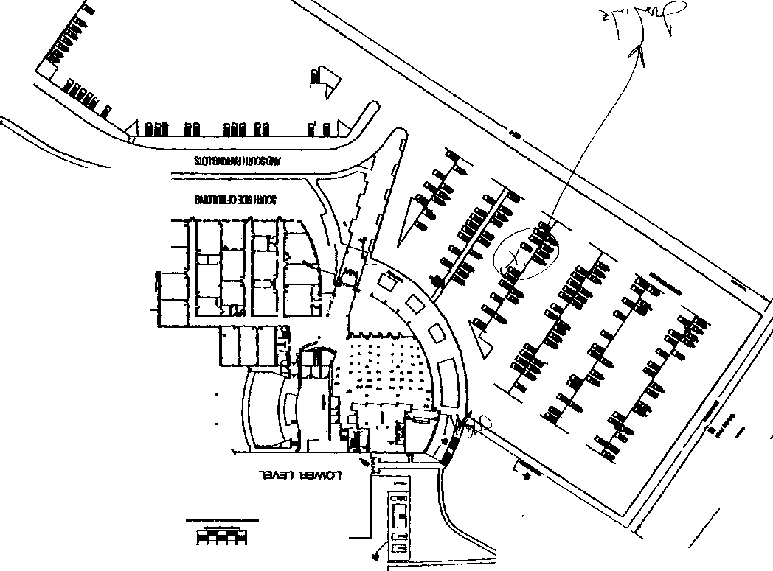
I·
JC-001-001112

....

\

l ROWE, D

JC-001-001113

Case No,
Denver Police Department
STATEMENT

\

Summary of Statement:

Transcript of handwritten statement for Denny Rowe JC-001-01114- 01115

Q: Are you a student at Columbine?
A: Yes

Q: Were you at school today?
A: Yes

Q: Where were you when you heard the shooting?
A: Hill outside cafeteria.

Q: What did you see?
A: Heard firecrackers, one guy took off his trench coat and had ammunition and grenades. He started shooting a Heckler type rifle. He shoot two girls in front of me. Then started shooting at us. My friend “Mark” got shot in chest, and my friend Michael Johnson got shot in leg. We took off and I felt the bullets go past my head and the ground around my legs. We ran for cover of a tree and hid behind shed. We continued to run and they shot at us again.

Q: What did the second suspect have for a weapon?
A: He had a small arm automatic. We continued to run looking for a phone and found a grounds worker and pretty (editor-?) quick policeman came on a motorcycle. They rescued Mike.

Q: Do you know the names of the shooters?
A: No

Q: Have you seen them before?
A: Yes in school, they are seniors. One carved his arm with a razor.

Q: Are you feeling OK?
A: Yes

JEFFERSON COUNTY DISTRICT ATTORNEY'S OFFICE

SUPPLEMENTAL REPORT

Defendant: Date: Deputy DA.:
(Columbine shooting) Docket Number: 99AO60 (N)
Case Number: 99-7625
Investigator: Mike Heylin

********************************************************************

WITNESS:

Denny Rowe DOB: 081883 8179 W. Fremont Ave Littleton, CO 80128
303-932-1175
c/o mother; Dustie Roth

-CHS student, outside ne Mike Johnson, Mark Taylor suspects, Taylor and Johnson

-saw Chris Morris outside
Pierce St. at 10:18 a.m. INVESTIGATION:

s, John Cook,
shot at by

walking toward

On April 29, 1999 at 1700 hours I contacted Denny Rowe at his home

for an interview.
following:
His mother was present. Denny then told me the

* He is a sophomore at Columbine High.

- When asked about knowing Eric Harris, he said that he has seen him around school but does not know him by name. He said the same went for Dylan Klebold.

1 JC-001-001116

  - When asked, he said that he has heard of the name,
but does not know him or what he looks like.

* He does know
-
friend of one of his
He said that -------is a good friends named Chris Stanford (303-973-0846).

The only thing he has
fighter. He said that
wearing a trench coat sometimes and a beret.
was that he is a good in a "militant" style

- When asked if he has heard of the name, Trench Coat Mafia," he said, "yeah.” He said he does not know any of the other students who are with that group.

- When asked if he saw any of the students mentioned above during school the day of the shooting, he said he did see -----------------. He said that he left the school at 10:18 a.m. after his 3rd hour class. He walked out the main doors on the east side to walk to a house at Polk and Pierce for seminary. He is a member of the Latter Day Saints. As he was walking out to go to that home, he saw ---- walking
_,,-;;;:s
east toward Pierce from the main doors. ----- was out and away from the main doors
when he saw him. He thought that ----- was dressed more militant than usual.
He said ----- was wearing his dark green beret, olive green or black surplus field

jacket, olive green or black pants
He was sure this student was ------. He said ---- was walking by himself. He does not know if ----- has a car.
that were tucked into combat boots.

- He did not see any other student mentioned above at school that day.

- He spent much of the 4th hour at seminary and then walked back to school at 11:00 a.m. to get lunch before the crowd. He entered the school via the south door by Rebel Corner. He walked along the south doors to the cafeteria and then up to the second lunch line from the west. He then walked to table N and had lunch by himself. He said about 75 students were in the cafeteria at that time. The A lunch hour had not started.
2 JC-001-001117

He finished lunch and then joined his other friends at table CC. Those were; Mark Taylor, Adam Thomas, John Cook, and Mike Johnson. They did not want to wait in the long lunch line so he suggested they go outside to wait. He thought the time then was about 11:20 a

- While in the school and cafeteria, he did not notice any unusual objects. He did not see any duffle bags.

- They all exited the cafeteria via the west door and walked up the outside stairs to the top of the hill. They then sat behind two tall pine trees to the west of the west set of school doors.

- He then noticed that two males with trench coats on were standing near the top of the outside stairs they just went up. He did not see where they came from, they just appeared there. He then saw and heard numerous firecrackers going off just outside the set of west doors. He thought they sounded like ''black cats.” He thought 10 to 1'5 firecrackers went off.

- He then saw one of the males with the trench coats on draw out a rifle. He described the rifle as looking like ones he has seen made by “H & K” He then saw this male shoot two females that were

sitting
against the wall
outside of the west doors by the west exit

door to·
the library.
The girls immediately
slumped over . He

thought the two suspects were were shot.
only about 10 feet
away when the girls

- He thought that this was all some sort of video situation and the firecrackers were sound effects. When asked, he did not see any duffle bags or backpacks with the two suspects.

- He and his group were about 25 feet away from the suspects observing this.

- He then said that the suspect who was standing next to the one who shot the girls then took off his trench coat. He saw that this

3 JC-001-001118

suspect was wearing a light gray t-shirt. He said that he was wearing an A1ice pack without the pack. He described this as a strap harnesses system and that there were two large camo sacks on each side of his hip. He said the packs looked full.

- He then described both suspects;

-the first suspect who took out the rifle and shot the two girls was a white male, taller than the other suspect, unknown if wearing a hat, wearing sunglasses, black trench coat, olive green pants tucked into combat boots.

-the second suspect who took off the trench coat was a white male, shorter than the other suspect, light gray t-shirt, olive pants tucked into combat boots.

- The second suspect then held up a weapon with the barrel up and moved his head as is he was covering the first suspect. He thought this suspect was holding the "Tec 9." He is familiar with guns and the media reports.

- He said that the first suspect then aimed his rifle down the

stairs and shot a boy at the bottom of the stairs. thought this was the boy who died on scene.)
(He later

- He felt that the suspects knew they were there by the trees. He said the first suspect then aimed at he and his group and began firing. He said he still thought that this was all possibly a paint ball incident.

- He said John Cock took off running to the west behind the shed that is there. He then noticed that Mark Taylor was lying on the ground unconscious on his right side. (He explained from knowledge learned later that Mark sustained a leg wound and a through and through wound from the left side torso that exited and struck his right upper arm.) He then saw Mike Johnson's leg bleeding. He said

4 JC-001- 001119

that wound was "gushing" and that Mike's jeans were soaked with blood within seconds.

- He and Adam Thomas then took off running west. They ran behind the shed and then around to the baseball field. He heard bullets whizzing by as he was running but did not know which suspect was shooting.

- They stopped at the southwest side of the baseball field and looked back. Mike was running but was about 100 yards behind. Mike eventually fell behind the shed. (He explained from knowledge learned later that Mike was shot in the back of the neck while running away. That round exited out his jaw. He said Mike's jaw is now wired shut.)

- He and Adam kept running, hopping over the north side football field fence. They ran into a Clement Park grounds keeper and used

his phone. He called 911 and was told by an operator
that they already knew about the shooting. He then hung up. He then saw a

motorcycle cop going down the hill. He and Adam eventually hid in a maintenance shed in Clement Park.

- He said he was initially interviewed by a cop he thought was on SWAT at Clement Park. He was interviewed by a detective at Leawood
Elementary School, but he did not know his name.

- He provided address and phone information for Adam Thomas and John Cook. I completed lead sheets for those two students for interviews.

When asked, he said he would return to the scene with investigators if necessary to point out exact locations he made his observations at.

This concluded my interview with Denny Rowe. JC-001-001120

SANDER, CARA

JC-001-001121

CONTINUATION SUPPLEMENT

WITNESSES:

Cara Sander, dob/04-03-83 Student at Columbine
9700 West Chatfield Avenue, #E Littleton, Colorado 80127
(303)979-5876

Jennifer Tindall
7849 West Caley Drive Littleton, Colorado 80123
(303)933-4851
Student at Columbine H.S.

Suzanne Rico Work: Extra
1840 Vic!Ory Boulevard
Glendale, California 91201
(8!8)972-0625
Media correspondent

INVESTIGATION:
On 04-2 l-99, I responded to the Command Post at Columbine High School. Sergeant Chris Tomford gave me several names of individuals to contact for interviews. Myself and Investigator Dave Brooks contacted Cara Sander at her residence at about 1000 hours. Sander had just been interviewed by Suzanne Rico, a correspondent with the television program, Extra. After Rico and her photographer left the Sander residence, Investigator Brooks and I interviewed Cara Sander.

Sander stated on the morning of 04-20-99, she and her friend, Jennifer Tindall, exited Columbine High School on the south and walked towards the Senior parking lot. Sander said her car was parked in parking space number 220.

Sander stated that as she and Tindall were walking to her vehicle, she heard about 15 shots within a couple of seconds. She asked Tindall. “Jen. was that gunshots?" She then looked up and saw gunman at the top of the outside stairs. which leads from the Senior parking lot up to the second level of the school. Sander stated the gunman was standing near the path that runs along the top of the hill. He was to the west of the stairway. She described the gunman as a white male with a very full face, “pudgy,

JC-001-001122

CONTINUATION □  SUPPLEMENT X | JCSO |  | OBBEMA | 99-7625-B
Date This Report
04-24-99
X FIRST DEGREE MURDER |  |  |  | Recommend Case: Review □  Closure □  I I

overweight" The gunman had dark hair, possibly 1 ½" long. He had dark eyes and dark thick bushy eyebrows. He was wearing a long black trench coat that appeared to be closed. He was holding a gun, which she described as "fat and large, long and wide." The gunman was holding the handle section of the gun in his right hand. The gun was positioned across his chest. She noticed that the gunman had a blank look on his face, was silent, and had no expression. She said she did not take notice of any jewelry, hat, or mask on the gunman. The gun was one color. She believed it was greyish.

Sander stated there was a white male standing a few feet from the gunman. She stated the white male had no facial hair, was wearing a white t-shirt. short sleeved. possibly with some red and black writing on the front. She stated this male did not appear startled or scared in any way by what the gunman was doing. Sander said the white male was standing to the gunman's left. The white male was standing between the gunman and the top of the stairs.

Sander said she heard a shot coming from the gunman which hit an unidentified white female who was near the curb on the north side of Senior parking lot. The female was described as a white female, possibly 5'00", with blonde hair. Sander stated the injured female fell forward onto her knees. Initially, Sander thought the girl had tripped, but then realized the girl had been shot. Two unidentified females, not far from the injured girl, began to run towards her to help her. The first of these two girls was described as a white female wearing a white shirt and a denim jumper skirt, possibly with light brown hair. The second female, Sander could not recall a description of Sander stated before the two girls were able to get to the victim. a male student went to the victim and attempted to lift the victim up. She described this male student as being a white male wearing a dark shirt. When this male tried to pick up the injured girl by placing his arms underneath her arms more shots were fired. Sander stated that she and her friend, Tindall, ran to her car and got inside. She then put the car into reverse and pulled out of the parking space. She exited the parking lot and drove south on S. Pierce St. Sander did not see the gunman again after she got inside the car. She stated she did not hear anymore shots after getting in the car. Sander and Tindall drove to Tindall's house where Sander phoned her mother to tell her she was all right.

Mrs Sander was present during my interview with Cara Sander Mrs. Sander stated at about 1125 hours she received a phone call from her daughter. She stated Cara Sander told her there had been a shooting at the school, and "This little girl was not

JC-001-001123

CONTINUATION SUPPLEMENT X | JCSO |  | OBBEMA | 99-7625-8
Date This Report
04-24-99
X FIRST DEGREE MURDER |  |  |  | Recommend Case: Review  Closure

getting up." Mrs. Sander stated her daughter described the suspect as being big with bushy black eyebrows, and very ugly.

I asked Cara Sander whether she noticed anything unusual prior to leaving the school building and walking to the Senior parking lot. Sander stated she had been in the cafeteria having lunch, and nothing appeared strange or odd to her. Sander stated she did not see anyone else in a trench coat, and that she heard no one screaming prior to leaving the building.

Sander stated on the evening of04-20-99, she saw the pictures of the two deceased suspects, Dylan Klebold and Eric Harris, on the TV. She stated neither of these two suspects were the gunman she observed at the top of the stairway holding the gun that she saw after she exited the cafeteria. Sander stated the suspect she saw had a fuller face with darker eyes, and thick dark eyebrows. We asked Sander to look through the Columbine High School 1998 yearbook to see if she could identify anyone matching the description of the gunman she had observed. Sander looked over numerous photos, and she then pointed to a picture and said, "That looks like him." She stated that what stood out to her was that this person had the same expressionless face that she had observed on the gunman. I looked to the index of names associated with the photos on that page. The person
■

in the photo that Sander pointed at was ----------- photograph was on page------------has been made and is attached to this report.
in the yearbook. A copy of that

We asked Sander to turn to the back of the yearbook to see if -------- was in the group of individuals shown in the photo of Trench Coat Mafia. That photograph is on page 268 of the yearbook. Sander turned to page 268, and then began looking at the names of the individuals listed above the photograph. The list only gave first names. Sander quickly put her finger on the list of names and began to read them out loud. She read several names and then read the name -------- Sander went back
■
to the beginning of the list and counted the number of names. When she came to -------- she said the number She then went
down to the photograph and began to count from left to right. -- persons. On the number-- she stopped on the person in the picture, who was ------ When Sander's finger landed on the photograph of ------- she put her hand over heart, said, '"Oh. my God," and then began to cry. Sander expressed concern that ------ might harm her.

------ photo shows him to be a more heavy set individual with a round face, short dark hair, and eyebrows that are dark.

JC-001-001124
CONTINUATION  SUPPLEMENT X | Reporting Agency  JCSO |  | Reporting Officer  OBBEMA | Case Report No  99-7625-B
Cnnnecting Case Report No |  | Victim Name |  | Date This Repo<t  04-24-99
X FIRST DEGREE MURDER |  |  |  | Recommend Case: Review □  Closure □  I I

and could possibly be considered· bushy.

Sander added that the gunman she observed al school appeared to have a very weighted down trench coat. She described the coat as looking huge and heavy. Sander drew a diagram of the things she had observed and discussed with me in the interview. A Xerox copy of that diagram is included with this report.

Investigator Brooks and myself contacted Jennifer Tindall at her residence. We conducted an interview with her in the presence of her parents. (See Investigator Brooks' supplement report for details.)

DISPOSITION: _{Open.}

JC-001- 01125 ASAF3 198 JCSD/167

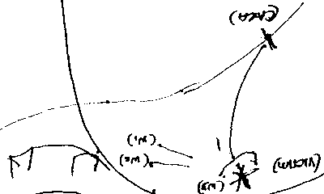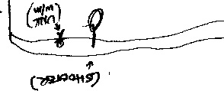(
...

JC-001-001126

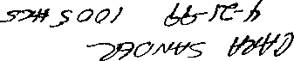

f
CONTIN- UATION SUPPLEMENT | JCSO |  | Reporting Officer  MOORE | 99-7625-1
 |  | Victim Name Original Report |  | Date This Report  04-29-99
Classification X First Degree Murder |  |  |  | Recommend Case: Review D  Closure 0  I I

DENISE MORGAN, DO8/08-31-58
20728 South East 3rd Way Redmond, Washington 98053
(425) 868-9095

INTERVIEW WITH WITNESSES

I

CARA SANDER, DO8/04-03-83
Student Columbine High School 9700 West Chatfield Avenue Unit E
Littleton, Colorado 80127
(303) 979-5876

INVESTIGATION:

On 04-21-99, at approximately 0830 hours, I was contacted by Lt. John Kiekbusch, who advised me to call Denise Morgan at the above phone number, (425) 868-9095, in reference to possible information she may have on the shooting at Columbine High School.

At this time I contacted Denise Morgan by phone and she stated to me that she has a friend who lives in the area and that her daughter attends Columbine High School and that she witnessed some of the events on 4-20-99 and that she wished to be interviewed by law enforcement. I obtained information on the student. who is listed as Cara Sander, from Denise Morgan.

Upon hanging up with Denise Morgan, I contacted Cara Sander at approximately 0840 hours on 4-21-99 Kara Sander advised that she is a student at Columbine High School and that on 4-20-99 she was in the parking lot on the south side of Columbine High School walking toward a car when she heard about 15 gunfire shots and upon turning around and looking toward the school,

JC-001-001127
CONTINUATION □  SUPPLEMENT | Reporting Agency  JCSO |  | Reporting Officer  MOORE | Case Report No  99-7625-1
 |  | Victim Name Original Report |  | Date This Report  04-29-99
First Degree Murder |  |  |  | Recommend Case Review  Closure  I I

Sander said she saw the suspects and that only one of them was shooting at this time. Sander said she saw a blond hair girl shot in the chest and that she saw one of the suspects on top of the stairs by the parking lot with a rifle that was black in color. Sander said that she saw the pictures of the suspects on t.v. and she advised me she did not feel that the pictures that were being shown were the suspects she saw. I then asked Sander to described the suspects, and she stated she could describe one of them and she advised that he had a full face, pale complexion, dark short hair, brown eyes, wearing a black trench coat. During Sander’s description of her location and the suspects location, she indicated she was about 100 feet from the suspects when she saw them but she stated she feels she could ID them if she saw some photographs.

Due to this I contacted Lt. John Kiekbusch and Sgt. Chris Tomford and advised them of what Sander had told me, at which time they advised they would immediately send out another investigation, who I later learned was Investigator Diane Obbema, to Sanders’ house to do a more in depth interview and possibly to show her some photographs.

DISPOSITION: Open.

JC-001- 001128
SUPPLEMENTAL REPORT/COLUMBINE HIGH SCHOOL
JCSO 99-7625 /FBI 174A-DN-57419 / CONTROL NUMBER: 3031
INV. DAN PFANNENSTIEL / WEST METRO FIRE 303-989-4307 BXT. 530

On May 10, 1999 I contacted Kim Sander, the mother of Cara Sander. Kim stated that her daughter had been interviewed by three detectives reference the Columbine High School Incident on April 20, 1999. Kim stated that Diana Obemma and another JCSO Investigator spoke with her originally and than more recently, she was shown several photo line-ups with Detective Joe Montoya.

Rapid Start Information Data Base indicates that Obemma's control number is 2502 and Joe Montoya's control number is 3057. I have attached Montoya's report (3057) to this lead sheet
Briefly, Ms. Sander told me that her daughter, Cara Sander, was not in the cafeteria at the time of the incident, but rather, was outside on her way to the parking lot. She stated that she was in the cafeteria originally and then left to go to her car for some make-up, thus leaving her back pack in the cafeteria.

See reports for control number 2502 and 3057 for further details.

JC-001-001129

DENVER POLICE DEPARTMENT
Case# Jeffco 99-7625

Control # 3057 and 2502

REPORTED BY: Detective Joe A. Montoya #91011 DATE OF REPORT: May 10, 1999
TYPE OF REPORT: Investigative Interview

SUBJECT: Cara Sander
Synopsis: Cara Sander said that she saw ----------------- shooting at students outside of the school on April 20, 1999. She said he was wearing a black trench coat and had a long gun. Sander was able to pick-------- out of a photo line up.

Details:
- Cara Sander is a first year student at Columbine High School. At the time of the shooting she was outside of the school on the west side. She heard about 15 shots, at first she thought that they were firecrackers then she saw the two gunmen standing on the ledge over the outside eating area. She was approximately 30 yards from the gunmen at the time.

- Sander said one male was wearing a white T-shirt, and the other was wearing a black trench coat. She made eye contact with the male in the black trench coat, and said that he was
- Sander described the male in the black trench coat -------, as a heavy set male,
which was kind of tall and had thick black eyebrows. She said that he was wearing a black trench and was shooting a long gun. I asked her if he was wearing a hat or gloves on and she said no.

- Cara Sander said that she did not know who ------ was prior to the shooting. She first learned his name when she picked his picture out of the Columbine high school yearbook for Detective Obbema of the Jefferson County Sheriffs Department. Sander picked ------ out of a photo line up for this detective on May 7,1999. She stated that the picture in the line up was different from the one in the yearbook.

Subject information: Cara Sander, DOB: 04/03/83
9700 W. Chatfield Ave.# E
(303) 979-5876

Detective Joe A. Montoya #91011
Denver Police Department JC-001-001130

CONTINUATION □  SUPPLEMENT X | JCSO |  | PETERSON | 99-7625-BBBBBB
 |  | Victim Name Original Report  COLUMBINE |  | 10-06-99
X FIRST DEGREE MURDER

WITNESS:
CARA SANDER. DOB/04-03-83
9700 West Chatfield Avenue, Unit E Littleton, CO 80127
(303) 979-5876
Student at Columbine High School

INVESTIGATION:
On 10-06-99, I met with Cara Sander at the Jefferson County Sheriffs Office South Substation in reference to reinterviewing her about the shootings at Columbine High School on 04-20-99. This interview was conducted after Cara met me at the South Substation at approximately 1540 hours on 10-06-99.

Cara Sander told me on 04-20-99, just prior to when the shooting incident started, she was with a friend of hers by the name of Jenny Tindall, who also is a Columbine High School student. Cara Sander said they exited Columbine High School together through the doors located on the south side of the cafeteria. She said they began walking toward the student parking lot, south of the school. Cara said as they approached the vehicle (which was parked in parking space #220) she heard approximately what sounded to her like gunshots. Cara said she heard approximately twenty of these shots. She said these shots were fired in rapid succession, and said she turned toward the high school. because that is where the shots sounded like they were coming from to her. Cara said when she looked toward Columbine High School, she saw two male subjects standing approximately 100 yards away and to the west, from the outside stairway near the cafeteria/commons area of Columbine High School. on a grassy hill. She described these males as the following: Subject #1 was described as a white male, wearing a black trench coat, black pants. and she said she did not see this subject wearing a hat. Cara said Subject #1 was carrying a weapon that she described as approximately two feet long, large in size, "boxy", and said Subject # 1 held this weapon across the front of his body, and said he had it pointed downward. She said she heard Subject #1 shooting this weapon in an unknown direction at an unknown target. Cara said Subject #l is the suspect she later identified as being------. Cara Sander said Subject #1 appeared to be calm with a "blank expression on his face." Cara Sander said Subject #2 was standing approximately arm’s length away from Subject #1 and to his left. She described Subject #2 as being a white male, approximately 5'10" to 5'11"

JC-001-001131

CONTINUATION SUPPLEMENT

tall and weighing approximately 205 to 210 pounds. She said he was wearing a white t shirt. and said also that Subject #2 had dark hair that she said was either dark brown or black, and said his hairstyle was a ''type of bowl cut” as far as she could remember. She said Subject #2 had pale colored skin, a chubby face, and said he possibly had bangs that hung approximately half way down on his forehead. Cara said that Subject #2 did not have a firearm or any other items in his hands that she saw. She said laying on the ground, berween SubJect #1 and #2, there was a black duffle bag. Cara said that she was not positive that Subject #1 and Subject #2 were with each other, due to the fact that she did not see them communicate between them, however, she said when the gunshots went off, Subject #2 was not afraid. She said he did not try to leave the area at that time. and described him as being "calm. with a blank expression on his face", as well. Cara said this is why she believes that Subject #1 and Subject #2 were together.

Cara Sander said after she heard the initial gunshots. Jenny Tindall and her got into Cara's vehicle and rolled the windows down so that they could see and hear better what was going on due to the fact her vehicle has tinted windows. Cara Sander said after rolling the windows down, she heard more gunshots and said she saw a blonde female fall to her knees outside of the cafeteria/commons area to the west. Cara said she and Jenny Tindall exited the parking lot of Columbine High School in Cara’s vehicle and drove south bound on South Pierce Street toward the Subway at Coal Mine and Pierce. Cara said they did not go to the Subway. but instead turned around to go back to Columbine High School. She said neither of them still could believe what they had just seen occur at Columbine High School.

Cara Sander told me that prior to 04 20-99, she did not know who ------ was, nor did she know the name of ------- . Cara said in fact. up until J.C.S.O. Investigators Obbema and Brooks interviewed her and asked her to look through
the Columbine High School yearbook. (the date of this interview according to Brooks and Obbema’s report was 04-21-99)
to try and identify who subject #1 was, she had not seen --------- nor had she seen a photograph of him. Cara said when photograph from the 1999 Columbine High School yearbook, this was the first time she had seen
a picture of him and learned his name. (See Investigator Obbema and Investigator Brooks reports for further information.)

I asked Cara Sander how certain she was that the person she described as being Subject #1 was in fact Cara
said without any doubt. she is 100 percent certain that the person that she saw and described as Subject #1 was -----

JC-001-001132

, (')RIGr,<l,
. 11,,•S- TIG<TO VICTl\tSERVICES I OTHER

CONTINUATION SUPPLEMENT

Cara said she would not care if ------- had alibi witnesses, or if physical evidence and witness statements indicated
was not present and was not involved in the shooting on 04-20-99 at Columbine High School. Cara said she would continue to believe Subject #1 was --------- and none of that would change her mind.

Cara Sander told me that she has been receiving professional counseling since the shooting on 04-20-99. Cara said she does not know, however, if this counseling is helping her or not, and told me she could continues to have problems with nightmares. She said that the first first weeks after returning to Columbine High School in August 1999. were especially difficult for her and other students. She told me that the students going in and out of Columbine High School no longer need to show their identification and said anybody can walk in and/or out of the school without being asked any questions, or without being asked for any identification. Cara said this makes her both angry and afraid at the same time. It should be noted that while interviewing Cara Sander during this reinterview, she had a very difficult time talking to me about the incident, especially in the beginning of the interview. Cara would break down and begin to cry. After I talked to her for a while, she became more at ease with this interview. Cara did tell me that she very rarely talks about the shooting incident with anybody including her friends, and said she has, however, talked to her father about it. I gave Cara Sander my business card and told her if she wanted to speak with a J.C.S.O. Victim Advocate in the future, to call me and I would make the necessary arrangements for her at that time. Cara also said her friend, Jenny Tindall, may want to speak to me about the incident. She said she would give Jenny Tindall my name and phone number and advise her to call me if she wishes to. I gave Cara Sander a J.C.S.O. School Hotline business card also.

Cara Sander said if she remembered any further information that may be pertinent to this case, she has my business card and will contact me with this information.

/

ADDITIONAL INFORMATION:
Cara Sander told me who she described as Subject #1, and who she described as being the gunman outside of the cafeteria/commons area of Columbine High School on 04-20-99 "looked huge." Cara said she believes Subject#1 took on this appearance because he was wearing a trench coat and Cara said the trench coat appeared to be full of something he was carrying
inside of it.

JC-001-001133

JC
CONTINUATION □  SUPPLEMENT | JCSO |  | PETERSON | Case Report No.  99-7625-BBBBBB
 |  | COLUMBINE |  | Date  10-06-99
X FIRST DEGREE MURDER |  |  |  | Recommend Case: Review  Closure

DISPOSITION: Case remains open, pending further investigation.

JC-001-001134

Schott, K.

JC-001- 001135

CONTINUATION SUPPLEMENT

WITNESS
Schott, Karen A. 10-13-80
7282 S. Allison WY. Littleton, Co. 303 979-4255

Narrative:

On 4·30-99 I called and spoke with Schott and asked if she knew either Eric or Dylan. She said she knew Dylan only to recognize him in the hallway. She did know Eric because she has had him in her classes before. She has never had any problems with either and Eric has always been very nice to her.
He has never asked her for a date or anything along those lines.

She is not an athlete and dates a student from Colorado School of Mines. Schott could provide no further information.

JC-001• 001136

COLUMBINE HIGH SCHOOL TASK FORCE

CONTROL NUMBER: JCSD CASE NUMBER: FBI CASE NUMBER:
GOLDEN POLICE NUMBER: REPORT DATE: DETECTIVES:
2816
99-7625
I74A-DN-574l9 99-Il62
OS/I 1/99
Jon Watson Jeff Kreutzer

Background:
From phone list in HARRIS' wallet. Name of "KAREN" 979-4255.

Lead:
Check phone number 979-4255. Interview name listed.

Disposition:

SUBJECT: Karen Ann SCHOTT
DOB: 10-13-80
7282 S. Allison Wy.
Littleton, CO 80128
(303) 979-4255

SCHOTT was interviewed by telephone in the interest of time.

SCHOTT told me that she and HARRIS were in the same World History class during her junior year (last year). She said that they talked about class projects and that sort of thing, and that he was extremely nice to her. She said that shortly after school let out they spoke a couple times, but that was the extent of their contact. She said they never dated or went out socially.

No further information relevant to the investigation.

JC-001-001137

SCHUSTER, MONICA

JC-001-001138

- I -
FEDERAL BUREAU OF INVESTIGATION

4/27/9'9

Monica Schuster, home address 4700 W. Hamilton Place, Denver, Colorado, telephone number (303)935-4308, date of birth December 7, 1981, contacted the Federal Bureau of Investigation (FBI) through Young Life leader, Kerry- Parker, telephone number
(303) 948-0174. After being advised of the identity of the interviewing Agent, Schuster provided the following information:
Schuster advised that she was a friend of Robyn Anderson's and was in Anderson's car in the parking lot of Columbine High School (CHS) on April 20, 1999, during the shooting incident. Schuster stated that Anderson may know something about the what took place in the school because, "she bought them the guns."

Schuster advised that Eric Harris and Dylan Klebold were friends of Anderson's. Schuster had known Harris and Klebold since the first of this vear. Schuster and Anderson would visit Harris and Klebold during lunch at Blackjack pizza. Schuster advised that Klebold was with their group during prom.
Schuster stated that at 11:10 a.m. on April 20, 1999, she left Columbine with Anderson and Tammy Golden to get lunch at Dairy- Queen. When they returned to Columbine at approximately 11:25 a.m., Schuster noticed students standing across the street from the school. Schuster believed that the students were outside because of a fire drill.
Anderson pulled her vehicle into the senior parking lot. Schuster advised that by now they could hear gunfire and Golden was crying. Schuster stated that she saw a male holding a rifle through the library window. Schuster did not get a good look at the man but described him as being in a white tee shirt and having an arm with a large build. Schuster stated that the arm of the gunman was too large to belong to Harris or Klebold.
Schuster, Anderson and Golden remained in Anderson's vehicle until 3:00 p.m. when they were told by officers that they could exit the vehicle. Schuster described Anderson's behavior before and during the incident as "weird". Schuster advised that Anderson was acting "strict" when that was not at all in her

lrlvesi:igi1icn OR 4/26/99 at Lakewood, Colorado
File# 174A-DN-57419
by SA Carol M. Snieqowski

Dau <li1:1alCII
(telephonically}
4/27/99

JC-001- 001139

174A-DN-57419
Monica Schuster ,on 4/26/99 Page 2
character. Schuster stated that Anderson acted as if it was urgent that they get out of the school and then asked Schuster if she wanted to stay and eat at Dairy Queen. Schuster stated that she told Anderson that she did not want to eat at Dairy Queen because she did not want to be late for class.
Schuster advised that Anderson was very close" to Harris and Klebold. Schuster stated that Anderson wanted to be Klebold's girlfriend. When Schuster learned that Harris and Klebold had committed the shooting at Columbine she was very surprised Klebold was involved. Schuster stated that she thought Chris Morris would be with Harris, not Klebold. Schuster stated that she could see Harris doing something like this because he was much more angry.
Schuster stated that Anderson told her that she was with Harris and Klebold when they bought the guns. Schuster wonders if Anderson may have known the shooting at Columbine was going to happen. Schuster did not see Harris or Klebold on April 20, 1999.

JC-001- 001140

GOLDEN POLICE DEPARTMENT
CONSHEET - REPORT NARRATIVE

REPORT DATE: 04-28-99
REPORT ID#: 9908504.AJX
CLASSIFICATION: Agency Assist J.C.S.O.
CR#: 99-1362
IN#: 9908504
Detectives: 1150/2260

COLUMBINE HIGH SCHOOL TASK FORCE
Jeffco Case #99-7625
F.B.I. Case #174A-DN-57419 Control Number 2062, Assigned 04-30-99, Kreutzer/Watson
On 4-30-99 we were assigned lead #2062 to interview Monica Schuster which was developed from a previous contact and interview. Monica Schuster was with Robyn Anderson for lunch at the time of the incident.

On 05-03-99 at 1845 hrs., we interviewed Monica Schuster at her residence at 4700 Hamilton Pl., with her parents present. She was asked to relate the day of the incident as information had been obtained which lead
to the fact she and Tammy Golden were with Robyn Anderson all went to lunch together just prior to the shooting at Columbine High School. To which she
desired to back up to the trip to Washington D.C. with Robyn Anderson. Monica explained she spent alot of time with Robyn during the trip and they became friends and talking frequently. The trip to Washington ended on the 17th of April, which was the day before Prom.
Monica did go to the Prom and was with the group including Klebold and his girlfriend. Then once at the after prom she met up with Harris and they spent sometime together just goofing around going to the various sites and playing the various games. Monica did not notice Harris acting strange nor having any strange comment or conversation. She felt he was acting normal.
Monica then talked about the Monday prior to the shooting stating it was a good day. Then on Tuesday the day of the shooting she described it as a good day. She picked up from the fourth hour class for her is German. She saw Robyn then tried to talk her into going to the German class together as Robyn is in the independent study class for German. She is only required to go to an actual class once a week. Monica related how she doesn't know many in the class and just wanted a friend she knew with her.

Robyn did go to the 4th hour German class and Monica added it was pretty easy to talk her into going with her. After class Monica suggested to Robyn they go to lunch. At this point Robyn told Monica they needed to
get going and she was in a hurry to go. Monica has a friend Tammy Golden

JC-001-001141

who is a lower classmate and usually is with her at lunch and spends time together. Robyn knows this and was telling them to hurry up and not take to long at the lockers before leaving for lunch. Robyn then left them and she got her car and meet them in the teachers lot to pick them up. Monica felt Robyn was in a hurry and once they were in the car they took off
quickly then Robyn in Monica felt Robyn had slowed down some and was not in a hurry as she was at the school.
They all went to lunch at the Dairy Queen which is South of the school on Pierce St. Monica didn't have much money however Robyn did loan her the money needed for lunch. Once they all had their lunch they returned to the school into the parking lot. As they entered the South side of the school into the junior lot Monica noticed police cars entering behind them and as they continued into the lot they saw people exiting the school. They heard shots and bangs. Robyn parked her car towards the rear of the senior lot area. the car was parked facing towards the fence and they watched the entire events unfold by watching out the rear hatch back window of Robyn's car.
When they first arrived into the parking lot Monica assumed at first it was a fire drill or something like it. Over the years she has seen many fire alarms being pulled like 17 times for senior pranks and end of school problems. Monica had positioned herself in the front passenger seat to look backwards to the school. Tammy Golden was in the back seat with Robyn in the drivers seat. They ate their lunches as the events continued police were in and around the car, they were told to remain in the vehicle and to stay down. While in the vehicle Robyn was eating her lunch very calmly and once finished she was looking for a "Blizzard" which was purchased. She was quickly looking for the items and not really concerned about what was happening in the school. She could see persons on the ground on the hill near the cafeteria. She described one of the persons was trying to pull
herself up and then fall over. This person she knew had been injured.
One other farther up the hill was not moving at all just lying there.
Once people started to exit the school Monica and Tammy were trying to identify them to account for the ones they knew. Tammy was very upset and was crying off and on.
It took several hours before they were told to exit the car, and then directed to the soccer fields with their hands on the their heads. Monica described one event which she felt was strange. When Robyn left the car, she was the last to leave, she took the time to take her purse and lock the car up. She was not moving as fast as others and was very calm. Once they arrived at the Chancing Plaza there was lots of media in the area.
Monica saw the campus security person Sid Keating near the park area. She was glad to see Monica, they exchanged some hellos. Monica was told at that time it was Trench Coat Mafia members who were causing the problem at the school.
Monica was able to call her mother and she arrived and took the three home. As they were going home Monica's mother commented the news had identified Eric Marris (she was not sure of the last name). Robyn when she overheard this corrected the name to Eric Harris. Robyn at this time showed some emotion reference the events.
As they continued to travel home, Monica's father made a comment to

JC-001-001142

Robyn "How does it feel to go to Prom with a killer. Robyn didn't react much to the statement. After the incident Monica had not talked to Robyn for about 3 to 4 days. She was advised by a person at the church she attends that she should avoid any conversation with Robyn with regard to the incident at Columbine High School.
Prior to the time she was not going to talk to Robyn she did chat on the phone with Robyn. Robyn made a comment how she was with Harris and Klebold at the time they bought some guns. Monica asked how and why questions about the guns. Robyn only replied she has an attorney and she should not talk about it. The only other comment about the guns was they needed someone who was 18 to get them. Robyn never touched the money, nor did she show any I.D. to purchase them. When the guns were purchased according to Monica would have been prior to the trip to Washington. She believes it was sometime between November to late March. She is aware of Harris being 18 yrs. old on April 9th, 1999 he would have been 18 years old.
During this conversation Robyn was upset about the film that was developed from prom and how it got out to the media. She felt Monica had given them to the media. Once this was explained she was ok with the statement from Monica she was not involved.
In summary Monica explained the high points of the interview. It was Monica's idea to go to lunch, Robyn agreed readily. Robyn was in agreement to help pay for the lunch. This was surprising to Monica as she is very conservative and only one other time offered to assist with money. Robyn was quite forceful with wanting to hurry up and to get Tammy going faster. Robyn seemed to Monica she was more rushed than normal. Then once they were on their way she calmed down after getting away from the school.

Monica is not sure about if Robyn had knowledge of the incident prior to it happening. Monica explained the reaction from Robyn eating might have been possible shock to the incident, her comments and reactions.
Robyn is one that does not look at the consequences to her actions and does not catch things as quick as most.

JC- 001-001143
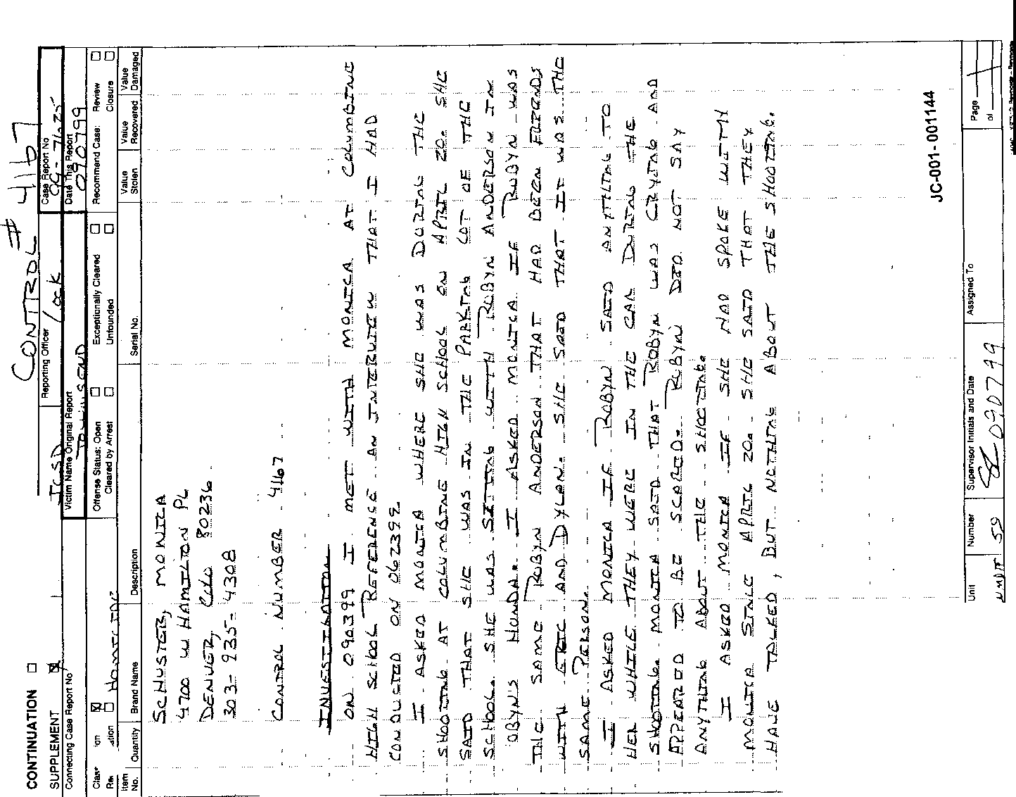

'

J
•
l

Typed transcript of handwritten statement
Monica Schuster

JC-001-001144 through JC-001-001145

Schuster, Monica
4700 W Hamilton Pl
Denver, CO 80236
303-935-4308

Control Number 4167

Investigation:
On 090399 I met with Monica at Columbine High School reference an interview that I had conducted on 062399.
I asked Monica where she was during the shooting at Columbine High School on April 20. She said that she was in the parking lot of the school. She was sitting with Robyn Anderson in Robyn’s Honda. I asked Monica if Robyn was the same Robyn Anderson that had been friends with Eric and Dylan. She said the it was the same person.
I asked Monica if Robyn said anything to her while they were in the car during the shooting. Monica said that Robyn was crying and appeared to be scared. Robyn did not say anything about the shooting.
I asked Monica if she had spoke with Monica (editor’s note- officer should have written Robyn) since April 20. She said that they have talked, but nothing about the shooting.
JC- 001- 001144

Investigation:
I spoke with Monica reference the shooting on April 20. Monica said that she was sitting in Robyn Anderson’s car in the senior parking lot eating lunch. She said it was about 1125 hrs. She said that she heard gun shots coming from the area of the cafeteria. She looked at the cafeteria and saw Dylan shooting a gun out of a library window. She knew it was Dylan because she knew Dylan. She said that she noticed someone else walking by the library windows and possibly had a gun. Monica said the other person could have been Eric. I asked her what Dylan was wearing. She said that he had on a white t-shirt, but could not see anything else. She did not see him shoot anyone. She was not in the cafeteria anytime that day.
Monica told me that the police would not let them leave the parking lot for about 2 ½ hours.
JC-001-001145

SECHLER, A

JC-001-001146

FD-301. (Rev. 10-6-95)

- I •
FEDERAL BUREAU OF INVESTIGATION

4/27/99

Alyssa Sechler, 7900 West Portland Avenue, Littleton, Colorado 80128 telephone number (303) 972-3509, pager number
(303) 760-4720, date of birth 8/11/81 telephonically contacted the writer and furnished the following information:
Sechler is a student at Columbine High School (CHS) and is currently employed at the Ken Caryl Animal Hospital. A client, Sherry Davis, came into the hospital this morning and told her that Dylan Klebold used to frequently come over and visit her neighbor, a 15 year old boy who dropped out of school. Davis' telephone number is (303) 972-6427.
Sechler also added that Sarah Leary, telephone number
(303) 979-6085, is a student at CHS. Leary told Sechler that she had walked into CHS with Eric Harris on Tuesday morning, 4/20/99, at approximately 7:30 am. Leary's boyfriend, Josh Last Name Unknown (LNU), works at Black Jack Pizza with Eric Harris and Dylan Klebold.

JC-001-001147

4/24/99 at Denver, Colorado
File# 4-DN-57405
by SA Paulette N. Brundage
(telephonically)

Denver Police Department Metro Gang Task Force

Date: 05-13-99
To: The Jefferson Cowity District Attorneys Office
From: Detective Terry Demmel 78007- Assigned with The Columbine Law Enforcement Task Force

Supplementary Report

Ref: Interview with Columbine Senior student Alyssa Sechler DOB 08-11-8 t; Alyssa had already been interviewed by FBI S/A Paulette Brundage

On 05-12-99 at 9:00 A.M. Detective Terry Demmel, assigned with the Columbine Law Enforcement Task Force, contacted Columbine Senior student Alyssa Sechler at her home. Alyssa's parents Linda and Wendell were both present for the interview. Alyssa reported that on Tues. the 20 ^{th} that she had 5th hour off and gotten out of her 4th period class at 11:10 AM. She walked out the west entrance door and walked to her car in the parking lot. As she was driving out of the lot at approximately 11:15 A.M. Alyssa reports that she passed Eric Harris at the north end of the Junior parking lot as he was arriving driving in his gray Honda. Alyssa stated that she knew Eric well and waved at him with Eric waving back. Alyssa could not recall what Eric was wearing but marked the map at the location where she passed him. Alyssa also marked the map where Eric always parked daily. Alyssa then left the school and met with her boyfriend Derek Malin at his job at" Big O Tires'· for lunch. Derek couldn't leave and join her for lunch and at some time after that she became aware of what had happened at the school.

During the interview Alyssa reported that she had been to Eric’s house twice and had German class with Eric from 9-11th grade. She considered Eric a friend and added that she didn't know Dylan very well. During the conversation Alyssa added the information that her friend Shara Leary thinks that she walked into the school that morning with Eric Harris. Shara's boyfriend is" Josh", unknown last name, who worked with Eric and Dylan at Black Jack's.

Alyssa reported that her good friends Kristi Epling and her boyfriend Nate Dykeman paged her that whole afternoon of the 20th. Alyssa reported that she knew that Nate knew both Eric and Dylan very well and Nate did not want to believe it was them that
had committed the acts. He kept saying to just wait and see for sure who the parties

JC-001-001148

were. That night Alyssa went to church with both Nate and his girlfriend Kristi where they met and were with Timothy Kastle who Alyssa stated was a very good friend of Nates.

Alyssa stated that she thought it was a couple of days later after the incident while she was driving her car that she Nate and Kristi had a conversation. They were on they're way over to pick up Alyssa'a boyfriend Derek for lunch when

{Sentence redacted by police}
Alyssa stated that Kristi Epling had gone to Florida with Nate; stayed for a week; and come back last Friday. She reportedly had gone to Sea World; saw Klondike and Snow and had a good time. The added information was that Kristi is planning on moving down to Florida as soon as school is out to be with Nate.

At the end of the interview Alyssa showed Det. Demmel her last years school annual and the signing that Eric Harris had written. Alyssa's father made a copy of the page along with a copy of a photograph that Alyssa had taken of Eric Harris while at the after prom party at about 2:00 A.M. The family offered to give Det. Demmel the copies as long as they were not released to the news media. Det. Demmel assured the family that they were strictly for investigative purposes and would not be released to the news media with his guarantee.

JC-001- 001149

0
JC-001-001150

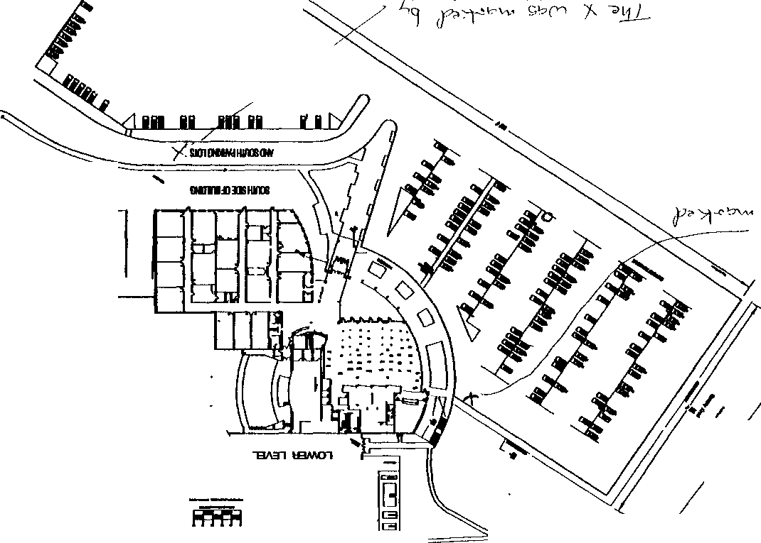

'

Control Number

WITNESS:

INTERVIEWERS:

DATE/TIME OF INTERVIEW:

PLACE OF INTERVIEW:

ASSIGNMENT SYNOPSIS:
ALYSSA SECHLER, DOB 8/11/81, 5'-03", 115 lbs, brown hair,
7900 W. Portland Ave., Littleton, Colorado, SS #559-85-2399 (303) 972-3509,

Agent JERRY W. MEANS and Agent SCOTT MUNDINE,
Colorado Bureau of Investigation, 690 Kipling Street, Denver, Colorado, 80215, (303) 239-4211.

May 19, 1999, at approximately 09:00 a.m. 7900 Portland Ave., Littleton, Colorado.
Alyssa SECHLER was contacted by phone, on May 14, 1999. Ms. SECHLER advised the Reporting Agent that she had already been interviewed two times. The Reporting Agent spoke to Alyssa's father. Wendell SECHLER. who agreed to a third interview.
Wendell SECHLER stated he and his wife would be present at the interview.

On May 19, 1999 at approximately 09:00 a.m. Agent MUNDINE and the Reporting Agent met with Alyssa SECHLER and her parents. Alyssa SECHLER'S boyfriend, Derrick MALIN was also present. Alyssa SECHLER stated she is friends with Kristy EPLING who dates Nate DYKEMAN. She stated the first time she met DYKEMAN was last year, however, she did not get to know him real well until approximately 3 months ago, when he started dating EPLIN'G. SECHLER stated she typically saw DYKEMAN once a day since he started dating EPLING.

SECHLER stated she knew Eric HARRIS better last year than this year. She stated she saw him at the after prom, and a few months ago he went with her and her mother, Linda to get her windows tinted. She stated that HARRIS was in her German class and he is very smart. She stated that she has no notes from HARRIS besides the entry in her yearbook. SECHLER stated HARRIS did not like jocks, but she just thought it was hot air. She stated a copy of the yearbook entry was given to Officer Terry DEMMEL when he interviewed her. She stated she has never heard HARRIS talk about weapons or bombs, however, he did draw a picture in her yearbook with his note of a guy holding a gun. She stated HARRIS also signed EPLINGS yearbook, but EPLING has not

JC-001- 001151

told anyone about that. SECHLER stated Eric HARRIS was always nice to her, and if she had seen him in the school during the shooting he probably would not have shot her. She stated he did not like the German teacher, because the teacher picked on her, HARRIS, and EPLING. She stated HARRIS also hated Shawn LEE and Shawn KELLY. SECHLER stated she did not know KLEBOLD personally but she had seen him in the school, and recognized him as a student at Columbine. She stated she was in band with Dustin GORTON. SECHLER stated GORTON had several problems with the Police. She stated GORTON hung out with KLEBOLD and HARRIS. She knew who Robyn ANDERSON was because they were in 6th hour together.
SECHLER stated she does not know any of the other TCM members.

SECHLER stated she was at the school on the day of the shooting. She stated she did not see HARRIS or KLEBOLD at the school until she was leaving. SECHLER stated Sara LEARY told her that LEARY saw HARRIS in the school the morning before the shooting. LEARY told her that HARRIS did not have on a backpack or any guns, and she gave him a friendly hug.
SECHLER stated she left the school at approximately 11:10 a.m., just after her 4th hour class. She stated as she was driving her vehicle out of the parking lot she saw HARRIS driving into the junior's parking lot. She stated he was the only one she saw in the car and they waved at each other. It appeared to SECHLER that he was blocking certain traffic. She stated she went to her home where she heard about the shooting. SECHLER stated she paged Kristy EPLING and asked her if she thought it was HARRIS and KLEBOLD that did the shooting. EPLING told SECHLER that she did not believe it. A few hours later on the day of the shooting DYKEMAN dropped EPLING off at SECHLER'S house.
SECHLER asked DYKEMAN if the shooters were HARRIS and KLEBOLD and he told her "that has not been confirmed". The evening of the shooting SECHLER, DYKEMAN, and EPLING went to church where they met with Tim KASTLE. She stated she overheard KASTLE tell DYKEMAN that KLEBOLD held a gun to his head. She heard DYKEMAN tell KASTLE "Dylan is not like that", "If only I could have done something, I could have stopped this".

SECHLER was asked about EPLING and she stated EPLING and her had an up and down relationship, however, since the shooting they had been talking a lot. SECHLER stated she has never dated DYKEMAN, and he was EPLINGS girlfriend. She stated
EPLING is going to Florida after she graduates to be with Nate and

JC-001-001152

attend school. SECHLER stated EPLING has not told her about any weapons or bombs. and has asked her to hold nothing.

SECHLER was asked if she thought Nate DYKEMAN could be
,involved in the shooting or may have known it was going to occur. She stated DYKEMAN may have known if he and HARRIS were close like they use to be, however, since DYKEMAN started dating EPLING she did not believe he knew anything. She stated DYKEMAN was jealous of HARRIS so they got in a huge argument, and almost had a fist fight. She stated they have gotten to be friends again, but not like they were.

Jerry W. Means Agent
Colorado Bureau of Investigation

JC-001-001153

PIRNARR Arvada Police/Court System Arvada Police Department
NARRATIVE
Page l 06/08/1999

=======================================================================

Ref # 99-12057

Type ASSTOA
Reported Date 04/20/1999 Time 12:39:32
Status RTF

Location 6201 S PIERCE ST

DETlOl 06/07/1999 060499/VONDEROHE/KK

The following supplement will be in reference to Arvada Police Department Cr 99-12067 and will correspond with the Jefferson County Sheriff's Department CR 99-7625 regarding the Columbine High School shootings/murders that occurred there on 04/20/99. IO Detective Jim Vonderohe is a member of the task force that was formed to investigate the murders at Columbine High School and in conjunction with this duty, IO is assigned investigative leads to follow up on. Regarding this supplemental report. IO was assigned a lead with control #2785 that involved----------------
Attached to this lead informational control sheet was a note indicating that Alyssa might be ---------------- who resides at 7900 W. Portland Avenue, Littleton, Colorado, 80128, with telephone number ------------. On 05/25/99 IO telephoned the above mentioned residence and spoke with the mother of Alyssa May Sechler, DOB 08/11/81. She advised IO that her daughter has previously been interviewed three different times regarding the Columbine High School shooting investigation. IO explained to her that IO just wanted to ------------------------------------. Mrs. Sechler confirmed that telephone number ------------------ is ------------- pager number.
With no further information to be gained from interviewing Mrs. Sechler, the conversation was concluded at this point.

JC-001-001154

SHAKOWSKI, C

JC-001-001155

Page

Denver Police Department
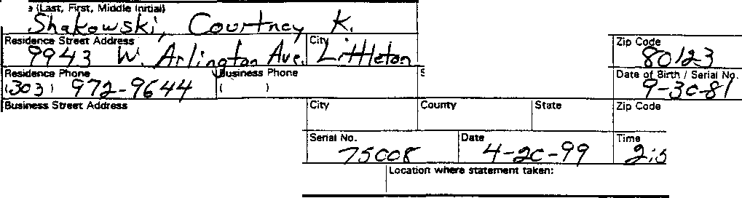STATEMENT

O Person advised
Social Security No.

::
·o
_Hours
Case No..

Summary of Statement:

I was walking outside and saw at least 2 people walk in with black trench coats. I didn’t see any guns. One guy was really tall. It was between 11:10 and 11:20. The second person was significantly shorter than the other. I then left for lunch. CS

I have read the foregoing statement and the facts contained therein are true to the best of my knowledge and belief. I do not maintain that it contains all of the facts or details of the incident, but only those facts about which I have been asked.

JC-001- 001156

JEFFERSON COUNTY DISTRICT ATTORNEY'S OFFICE

SUPPLEMENTAL REPORT

Defendant: Date: Deputy D.A.:

4-27-99
Docket Number:
Case Number: 99AO62
Investigator: J.Burkhalter

********************************************************************

Courtney Shakowski, dab 9-30-81 9943 W. Arlington Ave.
Littleton, CO. 80123
Ph. 303-972-9644

This investigator met with Courtney and her mother, Nancy, at their home. Nancy Shakowski stated another one of her daughters, Jill, was also a witness and has not been contacted by or called any investigators.

Courtney stated she was walking across the junior parking lot when she was the two suspects walking into the double doors leading into the hallway and cafeteria area.

Courtney described the first suspect as a white male, in his teens

about 6'2", skinny with longer brown hair. trench coat, black, about to his knees.
He was wearing a long

The second suspect was described as white male, in his teens about 5'4", skinny but a bigger size with short blondish ash blond hair and he was wearing a black trench coat.

Courtney stated one of the suspects, she doesn't remember which, was carrying a big black duffel bag in his right hand. She stated both looked like they had a huge belt on their waist.

JC-001- 001157
1

Courtney stated she gets out of class at 11:10 A.M., after 4th. hour

and was leaving the school for lunch. Lindsey, and Cora Last Names Unknown. Nissan Sentra, 1991, black and parked in She arrived at school about 7:25 A.M., filling up.
She stated she was with Courtney was driving her her assigned spot of 364. and the lot was already

Courtney stated she knows John Savage and he hangs out with the TCM
but doesn't wear a trench coat.

Courtney stated she is on the Year Book staff and they all know that Robyn Anderson wrote a dedication to the TCM for the yearbook but that dedication was taken out. She stated the police have it.

Courtney stated she now remembers a guy with long blond hair, ear length wearing a white T-shirt who was walking behind the two

suspects in the and going in the
same direction. He was about 3' or 4' behind them same direction as the suspects.

Courtney went on to say that she attended the after-prom party and saw six or eight TCM people, but they weren't wearing their trench coats.

The interview was concluded at this time so that she could attend a
funeral.

JC-001-001158
2

CONTINUATION □  SUPPLEMENT X | JCSO |  | FELSOCI | 99-7625-E
 |  | Victim Name Original Report |  | Date This Report  05--04-99
X FIRST DEGREE MURDER |  |  |  | Recommend Case: Review 0  Closure 0

WITNESSES:
Courtney Shakowski
9943 West Arlington Avenue Littleton, Colorado 80123
(303)972-9644

Student at Columbine High School

INVESTIGATION:
At 2005 hours. I contacted Courtney Shakowski at her residence in reference to a First Degree Murder that occurred at Columbine High School, 6201 South Pierce Street. on 04-20-99

During our conversation, Shakowski informed me she was interviewed prior to me contacting her and I told her that I re-contact her reference more specific questions concerning the incident. I began by asking her if she ever saw the two subjects dressed the black trench coats before. She stated she has seen them around school, but could not give a description of their face. She stated that one was taller, about 6102" in height. and that they were together at first walking northwest toward the Senior parking lot from the Junior parking lot.

Shakowski informed me she was with two of her friends. Lindsey Ludwig and Cora Lininger. She told me that she and her friends were walking toward Ludwig's car so they could go eat lunch. She stated this was about 11 l 5 hours. She stated this was the time she noticed the two subjects in black trench coats. She described the taller one as having long brown hair and didn't appear to be carrying anything. She stated the second subject was also wearing a black trench coat and was shorter, and that this subject had blond short hair and was carrying a big black duffle bag in his right hand. I asked her if it appeared heavy. and she stated it looked full. She said he was kind of leaning over while he was carrying it but was not leaning over a lot. She stated at one point. they both looked at her and her friends, but kept walking. I asked her if they were carrying anything else. and she stated no. She stated their trench coats were somewhat closed, and that it looked like they were hiding something underneath their coats, because they looked very bulky.

Shakowski informed me she observed the shorter subject, who had the duffle bag, cross the entrance way to the parking lot from the Junior parking lot. She stated as he did this, her friend. Autumn Hettinger. was driving her car out of the parking lot, d had to stop and let him cross the driveway that leads to Pierce Street.

JC- 001-001159

CONTlNUATION □  SUPPLEMENT X | JCSO |  | FELSOCI | Case Report No  99-7625-E
Date
05-04-99
X FIRST DEGREE MURDER  □ |  |  |  | Recommend Case· Review □  Closure □

Shakowski also stated there were three other people walking behind these two subjects while they were in the parking lot. She stated behind them, about three feet, was a white male with long blond hair wearing a white T-shirt. She stated she never saw this person before, and two feet behind him, she saw two other white males, but could not give a description of them, because by this time she was further away from them. She stated all these subjects, including the two in the trench coats. were white males.

I asked Shakowski how far away she was when she first saw the two subjects in the trench coats. She said they were about 20 yards away from her, and stated the location was in the Junior parking lot, the third parking row from the building. She stated that Ludwig's car was in the second row. and that the two subjects were first seen crossing the third parking row. She stated this was about 50 feet away from the south end of the building.

DISPOSITION: Open

JC-001- 001160

SHOELS, ANTHONY

JC-001-001161

Denver Police Department
Case No.

Typed transcript of handwritten statement of Anthony Shoels

Summary of Statement

I was out at lunch, outside by the parking lot with Matt Parsons. Then all of a sudden there were gunshots but I did not know they were bullets at the time. When the girl got up from the curb she was bleeding that’s when I knew they were gunshots and bullets. But before the girl got shot my friend was up looking at the hill at the guy. Then after the girl who got shot me and my friend ran inside to the cafeteria and got on the ground. Then everybody started running up stairs and to outside to the park. After a few minutes after that people started running to houses and places, that’s all I saw.

Q: Do you know who the girl was that got shot?
A: No

I have read the foregoing statement and the facts contained therein are true to the best of my knowledge and belief. I do not maintain that it contains all of the facts or details of the incident, bur only those facts about which I have been asked

JC-001-001162

SIMONS, BRENDA

JC-001-001163

Typed Transcript of Handwritten Statement for Brenda Simons

JC-001-001164 through JC-001- 001165

Brenda Simons DOB 090782
Address: PO Box 891 Indian Hills, CO 80454
Phone: 303-697-2899
Student: Columbine High School

Investigation:
On 081099 I interviewed Brenda Simons via telephone. Brenda reported that she had not been interviewed by police prior to this date regarding the Columbine High School shooting.
Brenda was at school on 042099, she left the school prior to 2nd period and returned at the end of 4th hour. She reported that she had a Marketing graduation ceremony at the Wellshire Inn, during 2nd through 4th period. When she left the Wellshire Inn @ about 1045 hours she drove back and parked her vehicle near Leawood Park. As she was walking towards the school she reported hearing bombs and saw students running out of the school screaming. She said the kids were running towards her in the park. She began to run, too. She looked for friends but could not find them. She waited in the park, then went into houses for protection. She did not remember whose house she went in.
Brenda said she knew Harris because he was in a gym class with her. She’d only had contact with him because of the class. She denied having any prior knowledge of this incident. As she left the school (2nd) period she reported seeing nothing unusual as she walked out of the school.

Disposition: Case Open

Additional Information:
Teacher for Marketing class, Mrs. Frommer

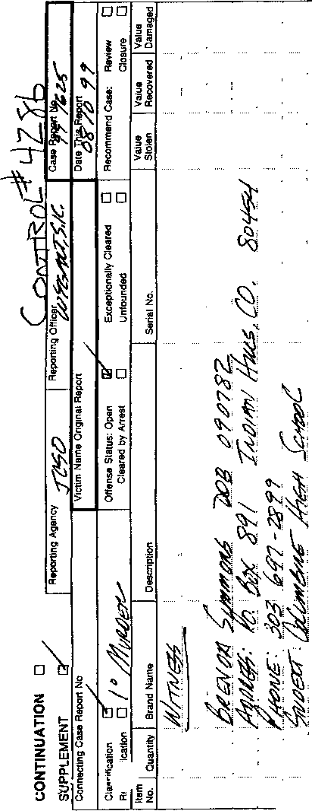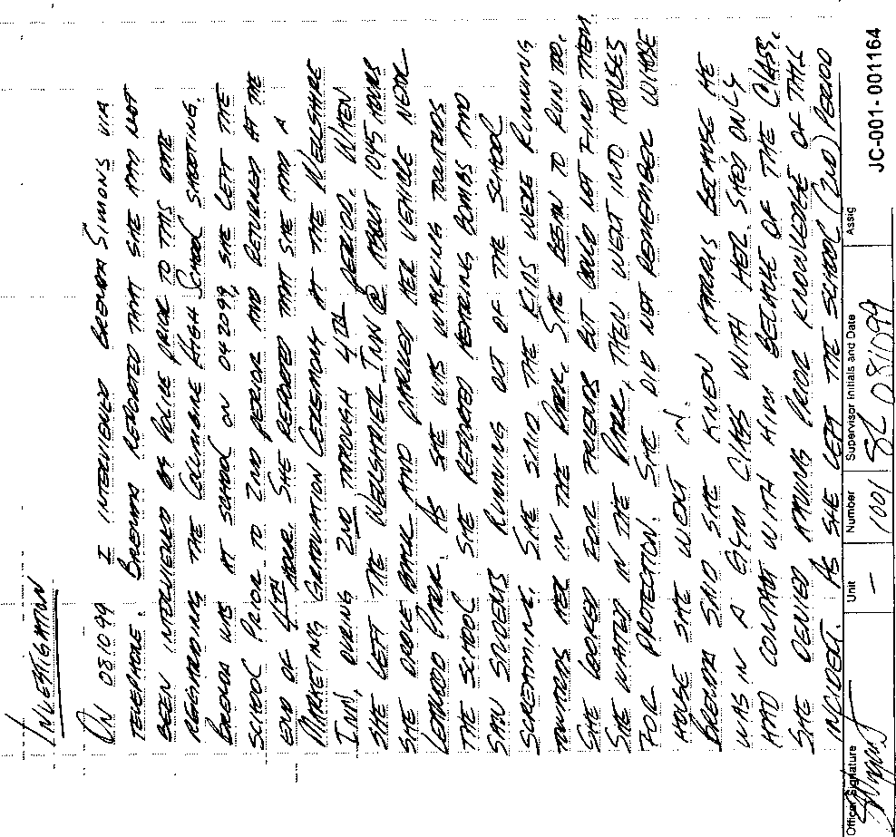

    - :. 0

, ' , I , . I
... ! : . !
i 1 ,

,C".8 '-
;

.... I ..

' ....
i
l
1\1 j
•
0

'$ " "

i'"

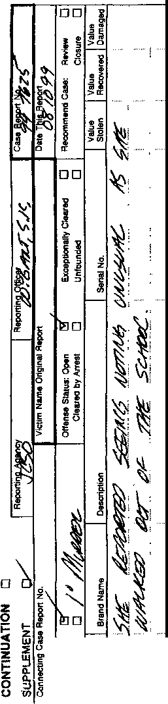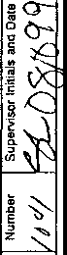i 0 0': I,='z,
- --

.SLIZESKI, C

JC.001-001166

Colorado State Patrol
Investigative Services Section

Case Number | Connecting: Case #
99-311014/P | J.C.S.D. / 99-7625 | Assist• Jefferson County Sheriff's Department
Date | 11111e | Location
04-20-.99 | 1120 | Columbine High School

SYNOPSIS: Assist to the Jefferson County Sheriff's Department with the investigation of the Columbine
High School homicide.

INVOLVEMENTS;
Witnesses;
COLORADO STATE PATROL -2207 N HWY· 402

LOVELAND CO 80537 (970)663•0219
Investigator Greg McComas

CIVILIAN WITNESSES
(W)Slizeski. Caryn 11-18-82
Res: 7925 W Walker Dr.
(Student - Columbine High School)
Littleton, CO. 80123 H-(303)933-3103

SUMMARY;
05-21-99/Friday

Per information control sheet #1205, I contacted (W)Slizeski at her residence, regarding information she might have of possible suspect accomplices.

(W)Slizeski stated, she had been in school, at Columbine all morning on 04-20-99 and had not noticed anything or anybody unusual. She arrived at school at about 7·30am and went straight to her first period biology class. Her day continued, uneventful, through fourth period geometry class, which ended at approx. l l:10am. Upon the completion of geometry she went to her locker, which is located on the second floor near the gymnasium. She then went to the library to study. Shortly after arriving at the library a friend, Matt Hardy, talked her into going to lunch with him.

(W)Slizeski stated, Hardy's car was parked in the senior lot and they exited the school through the main west doors then turned and walked down the steps leading to the cafeteria area. Upon exiting, (S)Slizeski stated, she noticed two individuals, wearing black trench coats, out in the field in the area between the equipment building and the soccer fields. She stated, she did not pay much attention to them and only saw the

Date of Report | Investigator/IBM# | Supervisor/IBM# | Page
Mav 23, 1999 | G.S McComas/ 5560 |  | 1 of2

JC-001-001167

individuals for a short time. The two males were at a distance, but thought they were walking toward Clement Park. She stated, she recognized one of the individuals as Eric Harris, whom she had a class with last year. She described the other individual as looking big and fat, with dark hair. She stated, she did not know Dylan Klebold. She did not recall if either individual was carrying anything.

Once outside, she and Hardy walked to his vehicle., which was parked near the grass on the north side of the senior lot. They drove through the lot and exited onto Pierce St. While at the stop sign, from the lot to Pierce St., she heard what she thought was an explosion. She did not look back, and had no idea what was taking place at the school. (W)Slizeski was not sure of the time she left school grounds but thought it was approx.
11:30am.

(W)Slizeski stated, she did not see any unusual activity in the school or parking lots as she was leaving. She had not heard anyone talking about the shooting plan prior to that day.

(W)Slizeski diagramed her route and the observation of the two individuals on the map attached to this
report.

I | Date | Investigator/IBM | Supervisor/IBM# | Page
 | May 22, 1999 | G.S. McComas/ 5560 |  | 2 of2

JC-001-001168

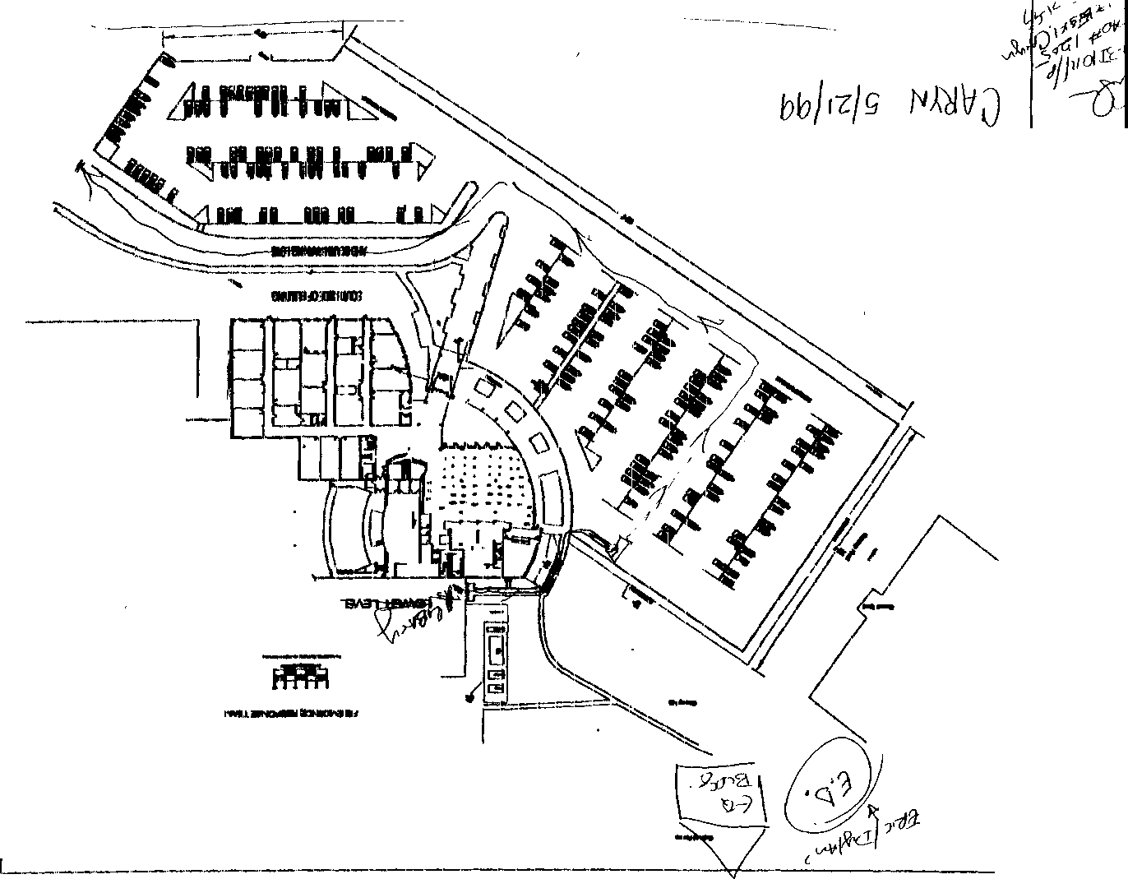------- ------·.. ·------- -

"

'

-
,
JC-001-001169

Pages
Denver Police Department
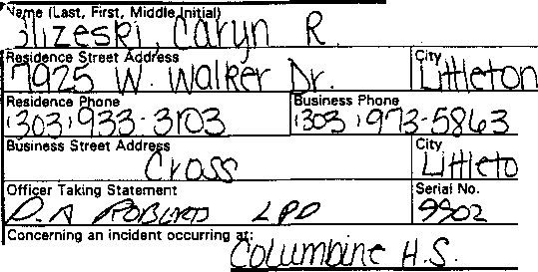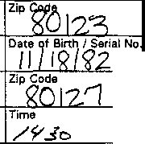STATEMENT
·Making Statement:
□ Officer
.
Witness

-- ---
.

Date

Hours
Location

Case No.

Summary of Statement

I was in library when a friend, Matt Hardy, came in and asked if I wanted to go to lunch. I said yeah sure. Walked out the door by the library, walked down the stairs went out to Matt’s truck. I looked up and saw two guys in black trench coats walking towards Clement Park. One guy was skinny, Eric Harris, had black pants lots of pockets, with his hands in his pocket, then walking next to him was a big fat guy wearing the same thing. He had, what I could see, chin length black hair. With his hands in his pocket as well. I was out of the parking lot about 1130.

•

I have read the foregoing statement and the facts contained therein are true to the best of my knowledge and belief. I do not maintain that it contains all of the facts or details of the incident, but only those facts about which I have been asked.

JC-001-001170

SMALLEY, L

JC-001- 001171

JEFFERSON COUNTY DISTRICT ATTORNEY'S OFFICE

SUPPLEMENTAL REPORT

Defendant: Date:
Deputy D.A.:

ORIGINAL

4-22-99
Docket Number:
Case Number: 99A062
Investigator: J.Burkhalter

********************************************************************
Laura Smalley, dob 9-11-83 5315 s. Jellison St.
Littleton, co. 80123
Ph. 303-933-3291

This investigator met with Laura Smalley and her mother at their

home after receiving information from Mellisa Miller. Freshman at Columbine H.S.
Laura is a

Laura stated she had just finished Science class at 11:10 A.M., and went to the student parking lot about 11:15 A.M., to meet her two friends, Cindi Nichols and Melissa Miller. They were all talking to each other on the West side parking lot.

Laura stated she was two students on the upper stairs with guns and bombs. She described the two students as follows:
Suspect #1 Dylan, Shoulder length wavy blond hair, 18 YOA, in
army boots that were black. She stated he had a rifle loading it three or four times. He appeared to be 5'8" in a long black trench coat.
Suspect #2 Eric, brown short hair, 5'6" wearing a black trench coat. She didn't describe anything else about this suspect.

Laura went on to say one suspect brought four bombs from inside his coat and threw them with his right hand. When he threw them the gun had a strap and hung at his side.

1
JC-001- 001172

Laura stated the suspects were at the top of the stairs when she heard two shots and looked up to see the suspects shoot at the school. She stated about 15 students were in the immediate area. The suspects were shooting the glass doors at one time.

Laura stated a gray pickup truck with an upperclassman driving, possibly a senior, came into the area and then left when bombs were thrown at him.

Laura stated the campus cop was driving into the area as well and

had Andy (dean supervisor) with him in the car. wearing a yellow uniform shirt.
The campus cop was

Laura stated this is all she can remember happening at this time as she was hiding behind a vehicle before running to a fence and going into someone's house. She stated she was contacted by Channel 7 at this woman’s house but she didn't tell them much.

Laura stated a girl, real tall, a junior or senior is a TCM. When asked how she knows this she stated she saw it on the news and recognized the girl.

Laura doesn't know what -------- is.

She doesn't know white Bronco.
and she doesn't know anyone driving a

Laura stated she has seen Eric Harris in the school hall in the mornings usually between 8:30 and 8:35 A.M., between classes. She did not see him Tuesday, 4-20-99.

Laura stated two kids in her science class have referred to 420 by

saying it's Thomas and Freshman.
"4-20".
Julie
Both kids are Mormon and their names Anderson according to Laura. They
are are
Adam both

JC-001-001173
2

Laura stated she has only heard the names of John and Brian Savage but doesn't know them.

Laura stated she left her backpack outside and described it as a purple one with her ID inside it. She thinks it was left on a bench on the lower stairs. It has government and language arts books inside. She also stated a key chain and calculator and spell

checker are inside. brand name tag.
She thinks the name “Carolina Brian”1 is the

The interview was concluded at this time.

4/24/99
Date

JC-001-001174
3

SPAHLINGER, JOHN

JC-001-001175

- I -
FEDERAL BUREAU OF INVESTIGATION

Date of transcription 04/22/99
JOHN SPAHLINGER, Sports and Athletic Supervisor, FOOTHILLS PARK AND RECREATION DISTRICT, Clement Park, 7306 West
Bowles Avenue, Littleton, Colorado, telephone 303-933-0585, was advised of the identity of the interviewing agents and the purpose of the interview. SPAHLINGER provided the following information:
SPAHLINGER was at the Clement Park maintenance facility during the late morning hours of 04/20/99. The facility was located adjacent to Columbine High School (CHS), on the Northwest side.
SPAHLINGER recalled first hearing gun fire that morning and observing approximately ten to 12 CHS students running toward his maintenance building. SPAHLINGER began assisting those students climb over the chain link fence which separated Clement Park from CHS. While assisting the students, SPAHLINGER believed he heard more gun fire and rounds going over their heads, to include his own.
SPAHLINGER placed the students inside his maintenance facility for safekeeping. A majority of the students SPAHLINGER helped informed him there had been a TRENCH COAT MAFIA (TCM) gang shooting over at the high school and that there were four shooters involved. One of the shooters was described as a tall white male, with a white shirt. The students, who were initially at the soccer and football fields, advised SPAHLINGER that when one of the TCM gang members had dropped his coat, they observed him carrying a gun and that was when they began running towards Clement Park.
Approximately 20 to 2S minutes later, 20 more CHS students arrived at SPAHLINGER's maintenance facility, this time, accompanied by a female parent, possibly with a last name of HANEY.
SPAHLINGER took his golf cart and located a police officer, agency unrecalled, and brought the officer over to speak with the kids at his maintenance facility.

Investigation on 04/22/99 Littleton, Colorado

74A-DN-57419

Date dictated 04/22/99

JC-001- 001176

174A-DN-57419
JOHN SPAHLINGER On 04/22/99 Page 2
SPAHLINGER eventually linked the students up with DAVE SHEPHARD {PHONETIC), Security Office, Jefferson Public Schools. SPAHLINGER believed SHEPHARD may know some of the kids.
SPAHLINGER had each of the students who came to his maintenance facility write their names down so he could document who was there. SPAHLINGER believed this list was eventually provided to a JEFFERSON COUNTY SHERIFF'S deputy, possibly ERIC MILLER.
SPAHLINGER's maintenance man, DICK STRANGE, was out on the CHS football field with one of their vendors at the time of the shooting. STRANGE claimed to have witnessed the entire event unfold.

JC-001-001177

CONTINUATION □
 | JCSO |  | MCFADDEN | Case Report No  99-7625-W
 |  | Victim Name Original Report |  | Date This Report  05-19-99
First Degree Murder |  |  |  | Recommend Case: Review □  Closure □
1 |  |  |  | ge<j

SUPPLEMENT "

TELEPHONE INTERVIEW with JOHN SPAHLINGER (303) 979-2005, work: (303) 517-2919

INVESTIGATION:

On 05-19-99, l telephoned John Spahlinger concerning follow-up on the Columbine High School shooting reference control #2803. Spahlinger stated that on 4-20-99, after the shooting had begun at Columbine High School, he observed students running north from the school, climbing the 12 foot fence which leads into his maintenance shed area. He allowed those students to enter his building for safety. Spahlinger stated that he overheard the kids discussing how many gunmen they had seen or heard. Spahlinger stated that he heard stories from two gunmen to five gunmen, but really wasn't paying attention. that he was just checking their safety. Spahlinger also stated that he had heard from Dick Strange (previously interviewed) that there had been gunmen at Columbine High School.

Spahlinger stated he had no other information to report and that he did not know where someone got that he had witnessed five individuals exit a black vehicle while working in the park.

DISPOSITION: Case open, pending further investigation. Lead #2803 closed.

JC-001-001178

Stepp, B

JC-001-001179

CONTINUATION □  SUPPLEMENT | JCSO |  | FELSOCI | Case Report No  99-7625-M
Connecting Case Report No. |  |  |  | Date This Report  04-30-99
First Degree Murder |  |  |  | Recommend Case: Review □  Closure: □

WITNESS:

BRIAN STEPP
6297 South Gray Court Littleton, Colorado 80123
(303) 347-9593
Student: Columbine High School

INVESTIGATION,

At 1200 hours, I contacted Brian Stepp at his residence in reference to a First Degree Murder, which occurred at the Columbine High School on 04-20-99.

During our conversation, Stepp stated that he has first lunch, which is "A" lunch. He stated that during his lunch time he was playing soccer with some of his friends named Justin Woods, Arthur Curtis, and Billy Arapkiles. He also stated there was another boy, but he only knew his first name as Jason. He stated that the soccer field is just west of the school parking lot and that they were playing about I 120 hours on 4-20-99. He stated at that time he turned around because he heard something that sounded like fireworks coming from the school. When he looked, he saw two subjects near the double doors just north of the library He described one as wearing all black, had black cargo pants on, and a black trench coat. He stated the other subject had on a black trench coat, but was wearing a white shirt. He believed that their heads were covered with a hat and that he could not identify these two subjects. I asked him if they were carrying any bags and he stated that they were not. He told me that he noticed the subject in all black bend down and appeared to be lighting fireworks that were laying near the wall of the school. He then stated he believed they were pipe bombs. He stated after that this subject stood up and began shooting what looked like a gun with a banana clip. l asked if he was shooting at anybody, and he stated that at that time it appeared that the subject was not. He stated that one person, unidentified, walked out the double doors of the school and the subject in all black with the gun that had the banana clip, shot toward the double doors and the person, what appeared to fall down.

JC-001- 001180

=-
CONTINUATION □  SUPPLEMENT y | JCSO |  | FELSOCI | Case Report No  99-7625-M
Connecting Case Report No. |  |  |  | 04-30-99
X First Degree Murder |  |  |  | Recommend Case: Review □  Closure □  I

Stepp stated that the subject in all black began shooting at a group of students on the hillside just north of the Senior parking lot and that they all began to run, but one boy was left behind. He then stated that the subject wearing all black then pointed his gun toward him and the people playing soccer and began shooting. He stated that he could hear bullets go by his head. so they laid down. When they looked up it appeared that the subject was reloading the gun. They then ran behind a hill and when they looked again, they saw the two subjects walking out of the double doors and that the subject with the trench coat and banana clip began shooting at them. He stated that the two individuals fell to the ground.

Stepp explains that while he was looking over the hill he also observed the subject wearing all black with the banana clip gun start to shoot out the windows of the double doors. He explained that these are the same double doors that he told me about that are just north of the library. He then observed the two subjects walk down the exterior stairs toward the cafeteria and al that time the same subject shot out a window of the cafeteria. He told me that this window was near the soda machines that were located inside.

Stepp stated that nobody in his group was shot and that they then ran into the neighborhood west of the school until they reached somebody that could help them.

Stepp stated that while they were also hiding behind the hill, he heard two explosions and then saw smoke rising from the roof of the school. I asked him where his book bag was. He stated that he left it near the soccer field next to a trash can.

I asked Stepp if he was in the cafeteria at ail, and he stated that before the lunch period, he was inside the cafeteria at a table on the south side of the interior of the cafeteria. He stated he was there at 4th period and this was prior to 1110 hours. He explained to me that he was sitting with a friend named Brent Session. I asked him if he noticed any duffle bags, any backpacks, or anything, laying around, and he stated that he did not notice anything unusual.

He stated that he usually sees Joe Stair a few times a week when be walks to the cafeteria during 4th period. He stated that he did not see him on 4-20-99.

 | Unit | Number |  | [

JC-001-001181

CONTINUATION □  SUPPLEMENT | JCSO | FELSOCI |  |  | Case Report No
Connecting Case Report No. |  |  |  |  | Date This Report  04-30-99
X First Degree Murder |  |  |  |  | Recommend Case: Review □  Closure □

I asked him if he knew anything about the ''Trench Coat Mafia and he stated they were always together and they looked depressed all the time. He stated that he did not really know any of them.

DISPOSITION: Open.

JC-001-001182

STEWART, J

JC-001-001183

Transcript of handwritten statement from James Stewart

JC- 001-001184 through JC- 001-001185

Summary of Statement
I was sitting outside of the cafeteria on the west side. I began reading when I thought I heard firecrackers going off and dirt flying up in the air. One person 5 ft away was shot in the left leg at the knee. I then saw a tall, white male in a trench coat come down the hill. He had a black trench coat, long blondish hair, backwards black hat. He looked down at his hands and it looked like he had a gun maybe 1 ½ feet long. I then went inside the cafeteria while the kid that was shot was screaming “I’ve been shot.” A cafeteria lady came out and warned the students to get down, she then tried to pull the wounded student in the building. Another cafeteria lady was waving some students into the kitchen and back in an office. Then more students came in, about 20 total. We shut the door and one kid called the police. For maybe 20 mins, we heard loud booms, one cafeteria lady described it as a shot gun.
I heard maybe 10 shots from the shotgun over that 20 min. span. We then barricaded the door and stayed down. We were in there for maybe 2 hrs.

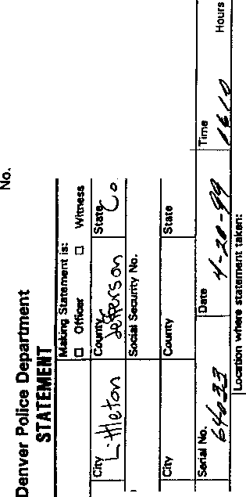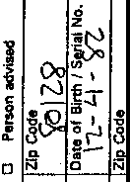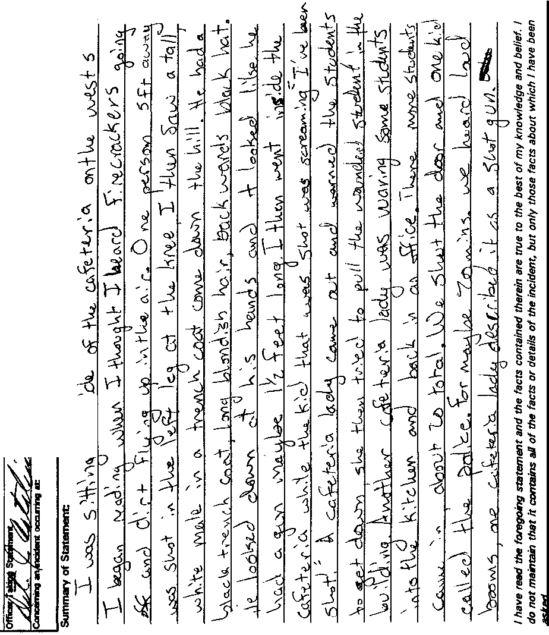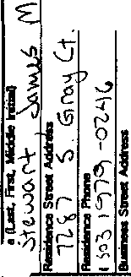
.
•
0
'i'
.
t.)
.,
·-6

u!!

J_ "'
!

JC-001-001184
Transcript of handwritten statement for James Stewart

JC-001-001186 through JC-001- 001187

During 1st period lunch 11:20- 11:30 James was outside on the westside of the school. With him was Kyle Bramlett and Mark Christner, and Will Beck. We were up against the school wall. James 1st heard shots (maybe firecrackers). Shots appeared to be coming from the north area away from the school and dirt coming up about 15’ away. Poss bullets. James looked up and saw a person wearing a black trench coat appeared to be looking at the gun. The gun the victim things is about 12- 18” long appeared to be attempting to move a lever on the side of the gun. James saw an unknown male. Heard this male yelling that he had been shot. They all ran back inside, we went to the cafeteria. Kyle was with James, unknown where the other 2 went to. A lady inside the hall brought or attempted to drag an injured party from the scene inside the cafeteria.
James was hiding inside the room. He heard 7- 10 shots loud- James stayed in the room for about 2 hrs.

Can ID suspect-
Seen him before and thinks he is a senior in 4th period math last semester

JC-001-001187

ORIGINAL

JEFFERSON COUNTY DISTRICT ATTORNEY'S OFFICE

SUPPLEMENTAL REPORT

Defendant:
Date:
Deputy D.A.:
(Columbine shooting)
042599
Docket Number: 99A062 (B) Case Number: 99-7625 Investigator: Mike Heylin

********************************************************************

WITNESS:

James Stewart DOB: 120482 7287 S. Gray Ct.
Littleton, co 80128
303-979-0246
c/o mother; Diane Stewart (no work) and father: DonStewart (w}
303-741-7633
-CHS student, sitting outside the commons when shooting began, saw one male student get shot there, saw Dylan with gun coming down hill next to stairs, went to storage room by kitchen until rescued by SWAT

INVESTIGATION:

On April 21, 1999 at 1440 hours I contacted James Stewart at his home for an interview. Jeff Co S.O. Sergeant Chris Tomford had previously given me a yellow Denver P.D. statement form with a brief written statement from James Stewart. I was directed to contact James for an additional interview. James Stewart's parents were at home as well as his sister, Laura, a senior at CHS. Laura was off campus during the shooting and came back as the incident was in progress. James then told me the following:

- When asked if he knew Eric Harris he said no. He only has seen
him in the hallway a couple of times.

1 JC-001- 001188

  - When asked if he knew Dylan Klebold he said he saw Dylan in the

halls more than Eric. Dylan stood out tall and always black trench coat on.
had the long

  - When asked if he knew a he said no.
  - When asked if he knew a he said no.

  - When asked if he knew a questioning witnesses) he said no.
(a name provided for

  - When asked if he knew any of the trench coat students he said no. He has seen them in school saying they congregate under the stairs by the cafeteria. He does not know how many there are.

  - When asked, he said he does not know anything about a white Bronco.

- He also said he has not talked with the press about this incident.

- Regarding what he saw, he said that he was sitting outside the door to the cafeteria with a Kyle Bramlett and a student named Mark. He only knew that Mark's last name might start with a "C."

- While he was sitting outside the cafeteria door, he heard popping like firecrackers and saw dirt flying by the stairs that lead up from the cafeteria to the hill area and the library .

- He looked up the hill by the stairs and saw Dylan
{identification from news accounts matching the student he used to see in the halls) walking down the hill by the stairs but not on the stairs. He said he did not know where Dylan came from.

- He described Dylan as wearing a black baseball cap backwards, having long curly sandy blond hair over the ears, nothing on his face, wearing a black trench coat, blue jeans, unknown shirt or

2 JC-001- 001189

shoes. He first noticed Dylan as he was half-way down the hill next to the stairs. He said Dylan was walking in the area between the stairs and the building.

- He said Dylan was holding an unknown type of gun out in front
of him. Prior to seeing Dylan, he heard from 5 to 8 shots.

- He then heard some student yell, "I'm shot, it burns, I can't feel my leg” He saw the male student holding his left leg. He did not see any blood and thought it was a firecracker.

- This was all occurring just outside the cafeteria door by the bottom of the steps. He tried to help the wounded student in the door. Kyle Bramlett and Mark were with him.

- He said a lunch lady said to get down that there was a 11 “shooter”. He said a custodian also was trying to help. He said that a second lunch lady said there was a “back room” by the kitchen that was like an office and food storage room.

* He walked fast to the room off the kitchen and heard all the students in the cafeteria running toward the stairs area.

* He said that he made it to the room with about 18 other people. They tried to barricade the door with oxygen tanks and boxes of food, and stayed in the room about 2 1/2 hours.

- For the first 20 minutes, he heard about 10 loud, “booms”11

- He said that a Matt was in the room with them and had a phone. He said that Matt was relating information. He said at one point, they knew that SWAT officers might be firing cover shoots and he did hear 3 to 5 shots then. He heard SWAT officers busting doors and

their's opened slightly about 6 inches. them out in groups, with "ladies first.” He was in the last group to get out.

3
SWAT officers then took

JC-001-001190

* The SWAT officers took them through the teacher's lounge and then out a window and up the hill along the wall to the cafeteria and up the library. They were running up to a fire truck. He said a couple of kids were getting cut from broken glass.

- As he was making his way up to the truck, he saw male body lying at the bottom landing of the stairs by the cafeteria. He saw another body, that of a girl, at the top of the hill.

- He never saw Dylan again after he did on the hill, and he never did see Eric Harris.

- He was able to make contact with his parents around 4:30 p.m. that afternoon.

- He added that while locked knocked on the door to get in.
in the store room, a Jeremy Mullin Jeremy was with a Mike Kich. They

told them they were unable to open the door for them. hour after the shooting.
This was an

Eric drew a rough sketch of the outside stairs area by the cafeteria and library.

This concluded my interview with James Stewart.

JC-001-001191
4

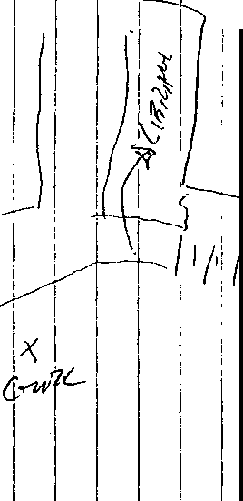'
' I
I
•
'
'
!
I

I •

I
-
.:

' ' • • ' I I ' I

, ! ,.. I , ! , . I ,
i

! 1 ' I!

1I I! 'I

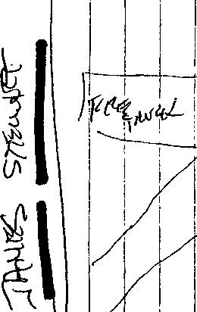I _{I} _{I}
''
I'
I
t---
I
i
i
' I
I
! ' I
I
I

I
I
I 1
I
i

'
'
I
I

1

STRANGE, DICK

JC-001-001193

FEDERAL BUREAU OF INVESTIGATION

04/22/99
DICK STRANGE, born 05/24/50, mechanic, FOOTHILLS PARK
AND RECREATION DISTRICT, Clement Park, 7306 West Bowles Avenue, Littleton, Colorado, home telephone 303-234-9693, work telephone 303-933-0837, extension 14, was advised of the identity of the interviewing agents and the purpose of the interview. STRANGE provided the following information:
STRANGE was providing a tour of Clement park for one of his bolt vendors, STEVE OGLE, during the late morning hours of 04/20/99. As they proceeded around the park in STRANGE's golf cart, they ended up on the large hill overlooking Columbine High School (CHS), Northwest of the football field. It was there at approximately 11:45 am that STRANGE first observed four to five individuals, all dressed in black trench coats, standing alongside CHS in the vicinity of the gymnasium. The individuals got STRANGE's attention because it was hot that day and they were all wearing black trench coats, standing next to a light-colored wall. STRANGE then observed these individuals walk Southwest along the high school, heading from the gym towards the cafeteria side of the school.
As STRANGE and OGLE drove off the hill on a bike path heading towards the school, STRANGE lost sight of the individuals wearing the trench coats. As the two men reached the small structure located near the outfield fence of the Southernmost CHS baseball field, STRANGE began hearing what he thought was possibly firecrackers going of-f _ He then observed one individual, dressed in a trench coat, standing in front of the Southwest entrance of CHS, the one with the big glass doors.
STRANGE saw this person drop his coat, pull out two guns and begin firing at students socializing in and around the soccer and football field areas. STRANGE also heard explosions going off at this time.
STRANGE was positive the weapon this individual fired was fully-automatic. This individual initially fired at the kids on the soccer field, then began firing at other fleeing students in the area. Some of the students climbed over the fence at Clement Park and ran to the maintenance facility, where STRANGE believed they were eventually interviewed by a Jefferson County
Sheriff's deputy.

04/22/99 at Littleton, Colorado
174A-ON-57419

JC-001-001194

l74A-DN-574l9
DICK STRANGE an 04/22/99 Page 2
At the time of the shooting, STRANGE observed only one individual wearing a trench coat because the small structure they were sitting behind had partially blocked his view of the school. STRANGE assumed this person was one of the four or five he had initially observed. STRANGE distinctly recalled hearing two different caliber weapons being fired in the area. One of the weapons, possibly a larger caliber, sounded much louder and fired at a slower rate of speed than the other weapon.
STRANGE did not recognize any of the individuals he saw wearing trench coats. STRANGE possibly recognized one of the individuals being shot at on the soccer field as a CHS student, PAT NEVILLE (PHONETIC).
STRANGE then informed OGLE they should immediately leave the area and the two drove off to find a police officer. They later spoke with an officer, department unrecalled, who drove a blue, unmarked patrol car. They also reported their observations to STRANGE's supervisor, JOHN SPAHLINGER.
STRANGE drove to work at about 8:00 am that morning.
STRANGE recalled driving past a black four-door, 500-series BMW, with white interior, which was headed North away from CHS. The vehicle drove through the underclass student parking lot, located in Clement Park, North of CHS. STRANGE specifically remembered this vehicle because it was full of high school kids and was a lot nicer than the car he owned. STRANGE knew the vehicle to be a 500-series because he used to work at a BMW dealership.

JC-001-001195

Strobel, B

JC- 001- 001196

FD-302 (Rev. 10-6-95)

- 1 -

FEDERAL BUREAU OF INVESTIGATION

Date of transcription 4/29/99
On 4/29/99, Bobby Strobel, DOB 2/13/81, 7791 South Carr Street, Littleton, Colorado 80128, was advised of the identity of the interviewing Agents, and the nature and purpose of the interview. He provided the following information.

On the morning of 4/20/99, Bobby Strobel was on his way to a banquet breakfast for his marketing class, but turned around and went home because he felt ill. Later that morning, at approximately 11:15 a.m., he drove back to the school, and parked in the south student parking lot when he noticed two students standing halfway between the student lot and the west cafeteria windows. He doesn't recall what they were wearing at this distance, nor was he able to recognize them. He left his car in the parking lot, and walked up towards the school front office.
Another student was running toward him, and told him that someone was in the school with machine guns and bombs. He went back to his car, and drove it onto Pierce, and continued to Bowles, and then to a Gart Brothers store so that he could call his Mother.
He then drove around- near the school area neighborhoods, hoping to find his brother. He also stopped at the public library where he noted many Columbine students gathering. When he didn't locate his brother, he drove to his Grandmother's house where he found his Brother.
Bobby never saw Klebold or Harris on Tuesday or Monday.
The last time that he saw them was at the prom. He noted that Klebold had a date, but that he did not know who the girl was. Klebold and Harris during their Junior year were quiet, and hung around together. Although he knew who the Trench Coat Mafia (TCM) were, he didn't think that Klebold and Harris were members during their Junior year. During this past Senior year, he noticed that Klebold and Harris would sometime wear trench coats, and hang around with others that he believed were in the TCM. He didn't see any other TCM members or associates the weekend before
4/20/99,
Bobby provided the names of students that he believed were either in the TCM or were associates of the TCM, as follows:
- Joe Stair (graduated 1998)
- Chris Morris
- Robyn Anderson

Investigation on 4 / 2 9 / 9 9 at Littleton,
File# 174A-ON-57419/ 99-7625/ CN 2616
SA Russell J. Atanasio

by SA Ricky Wright
JC-001-001197

FD-302a (Rev. 10--6--95)

174A-DN-57419/ 99-7625/ CN 2616

Bobby Strobel
- Brian Sargent
- Brooks Brown
- Dustin Gordon
On 4/29/99 Page 2

When Bobby was at the library earlier that day, he saw Joe Stair at the library. He remembers that plain clothes Police Officers detained Stair in the library. He stated that Stair seemed to be displaying a bad/"flippant” attitude, and that when he saw Stair, Stair smiled at him and gave him a thumbs up.
Finally, Bobby stated that shortly after the shootings occurred,
- was the first person that he suspected to be involved.

JC-001-001198

TAYLOR, D

JC-001-001199

Case No.
Denver Police Department

Transcript of written statement of Denee Taylor

JC- 001- 001200 through JC- 001- 001201

I walked outside to smoke and a few minutes later I hear shots, then more shots & about 5 minutes later I saw some 1 hundred or so coming running out. Then I asked what happen & none said to much but they were crying so I walked in the fill to the student parking lot & then saw a figure in dark clothing in the library window through the blinds. Then I saw all the glass shatter at the doors by the downstairs commons parking lot. I didn’t see any faces but I heard loud explosions that occasionally rumbled the fence I was leaning on. I was going to go back in but the teachers wouldn’t let me.

“Frankinstine” long black hair, white, goofy face, pointed nails, weird-
Chris- in Econ w/ me doing a project on weapons & guns always wears a beret.
Don’t know his name but hes big & real quiet. He doesn’t live here in Littleton, he lives in Denver.

THERRIEN, C.

JC-001-001202

JEFFERSON COUNTY DISTRICT ATTORNEY'S OFFICE

SUPPLEMENTAL REPORT

COLUMBINE HIGH SCHOOL
Date: 5/12/99
CONTROL NUMBER: 3109
Docket Number: FBI#: 174A-DN-57419
Investigator: Vondenkamp

********************************************************************

on 5/12/99 I interviewed 16 year old CHS student Christopher Therrien at his home in Littleton, Co. Chris's step-mother was present during this interview.

Chris stated he was outside the cafeteria near the south west corner of the building around 11:25am. He has 5th hour free, but usually meets friends in the cafeteria to have lunch. On 4/20/99 he left Mr Bundy's math class at 11:15am and walked to the cafeteria, where he met friends Brian Frye and Bijen Monte. Chris did not recall seeing any unusually large duffle bags in the cafeteria, or anyone carrying a large duffle bag that day, or the previous day.

They walked outside through the south doors of the cafeteria, talking about going up to the soccer fields to eat. Towards the corner of the building, Bijen sat down on the grass and wanted to eat her lunch there. Chris placed a marked where he and his friends were standing on the drawing I provided for him, which depicted the cafeteria and tables inside. He recalled facing east, talking to Bijen who had sat down on the grass.

Chris heard popping noises, coming from the north. He immediately thought they were firecrackers, and it was a senior prank. He turned to look, and saw Lance Kirklin fall down about 5-6 yards from where he stood. Then he saw a second kid fall down a few yards west of Lance. Chris then saw a female fall down directly west of where he stood, about 5 yards. He saw blood on the female. At this same time, Chris saw a tall (6'1") white male, black cap, large nose, shoulder length
1 JC-001-001203

hair, black trenchcoat carrying a black 1 1/2 foot long gun, with a “bullet clip" on the underside of the gun. Chris believed he was about 15 yards from this person, as the person was walking alone down the outside steps on the north side of the cafeteria.

Chris stated they ran into the cafeteria through a south door. When he got inside, people were standing looking out the windows. Someone yelled "get down", but Chris remained standing and running for the inside cafeteria steps. He stated he and Brian were up the stairs "very quickly". As they ran past a science room, a teacher who was unaware what was going on, told Chris to stop running. They continued running through the south hallway planning to inform the administration. The hallways were empty at this time. They turned to the north, near the math dept, heading for the administration. When they reached the north hallway, across from the administration, Chris stopped because he heard more gunfire down the hall to the

west. The shots the lockers in
were being the hall.
fired in his direction, ricocheting off He described the sound as a loud

ricocheting noise, much more rapid than the gunfire he heard outside.
He and Brian ran across the hall into the administration. He did not see the person who was firing the weapon upstairs, and could not say how far away they were. As he and Brian entered the administration area, the Principle was coming out and heading towards the west, where the gunfire was coming from. Chris, Brian, several students in the administration area and many faculty members exited the school north of the principle's office. Chris did not see any gunman, or suspicions people outside the school when he exited.

He ran to Clement Park and was later picked up by a female student he did not know. They drove to Brian's house and called family.

Chris had no further information on the shootings, and had little knowledge of the TCM. He had heard of them, and seen them around school, but did not know any of them.

2 JC-001-001204

Christopher Therrien 7740 S. Sheridan Ct Littleton, Co. 80123
933-4806

JC-001-001205

3

-- -

-

L -- ---

--

·
JC-001-001206 000000120001206

-
' ₋
--

-- -

-
.
- -
(

' -

•

·c;.

·- '- - -
..:._
_
-_
_':: \
\

j e- -
( ·- -- -- - - ,-- - -- ,-- .
- 1-;----1 - -

- - ₋

-

-

" fl--. ( -
--
j
T

---1. .
;t,-
1 r:.IJ -- -§
,-----1,-
- -
_(b,

\ ) .

..

_L_ --·

, -
-

.._ --
_

1- -- ,,_ - -- -- - - -

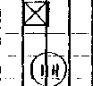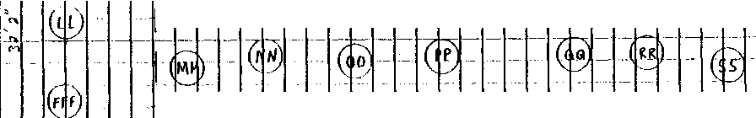-

JEFFERSON COUNTY DISTRICT ATTORNEY'S OFFICE
SUPPLEMENTAL REPORT ORIGINAL

COLUMBINE HIGH SCHOOL
Date: 5/24/99 REFERENCE CONTROL NUMBER: 3109
Docket Number:
FBI#: 174A-DN-57419
Investigator: Vondenkamp

********************************************************************

On 5/20/99 I received a phone call from CHS student Christopher Therrien. I had interviewed Chris on 5/12/99 at his home in Littleton, Co, (reference control# 3109). Chris advised me that he had seen a picture of the person he described to me as the shooter at CHS on the outside steps, north of the cafeteria on 4/20/99. He stated that the picture he saw was of and he was "pretty sure" he was the shooter he saw that morning at CHS. I scheduled an interview with Chris at his home on 5/24/99, and advised him I wanted him to look at a photo line up. He agreed to this.

On 5/24/99 I interviewed Chris Therrien at his home in Littleton, Co. His step mother, Carol Therrien was present for this interview.

I asked Chris what events lead up to him looking at a picture of and calling me on 5/20/99. He stated that on 5/18/99 he was talking with his friend Bijen Monte, who he was with during the CHS shooting. They were talking about the incident, and Chris advised Bijen that he gave the following description to the Investigator that interviewed him. He described the shooter as a WM,
6', large nose, acne, shoulder length hair wearing a black cap, possible a backwards baseball cap and dark trenchcoat. He then told Bijen he thinks it was Dylan Klebold, but was not sure. Bijen said it was not Dylan Klebold she saw that morning outside the cafeteria.

She then showed Chris a picture of Chris stated that the picture
the yearbook. "appeared" to

be the person carrying a black 1 1/2 foot long gun at CHS on 4/20/99.

1 JC-001- 001207

Chris stated he also spoke with Brian Frye, who he was with on 4/20/99, and Brian identified -------------- as a shooter on the outside of the CHS cafeteria. Chris stated that he has not spoken with anybody about this identification, except Brian, Bijen and his family. On 5/19/99 he was watching the news, and they reported that the investigation had ruled out a third shooter. He decided to
contact me based on this.

I gave Chris a photo line up explanation form, and had him read it outloud to me. He read it and stated he understood this form. I then showed Chris a photo line up with 6 similar featured males. He looked at the 6 photos, then pointed to photo #5. He stated that the person in photo #5 was "possibly" the person he witnessed carrying a gun, wearing a trenchcoat on the outside steps north of the CHS cafeteria on 4/20/99. He stated that "I still have Dylan Klebold's picture in my mind, because I've seen his picture so many times since it happened". Chris checked "possible" and wrote #5, then signed and dated the photo line up form. Chris stated he recognized photo #5 as
, a CHS student who he had seen in the school this past

year, occasionally wearing a in photo #5 in this line up.
trenchcoat. was positioned Chris had no more information to add.

Chris' a step mother advised me they were moving in June. They will be at 5402 N. Nevada Ave #106, Co Springs, Co. 80918.
(719)-528-8147, from 6/8/99 7/31/99. They will then move to a home they are building on 8/1/99. This address is 4306 Witches Hollow Ln, Security, Co. 80911. phone unknown at this time.

2 JC-001-001208

THOMAS, A

JC-001-001209

Page_/_ of
_ Pages

Denver Police Department
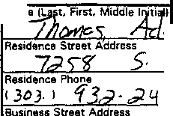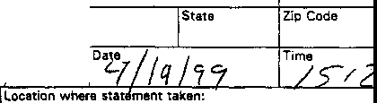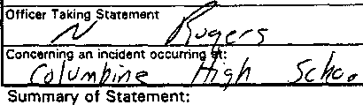STATEMENT
"""
j, /,/1
□ Officer
Making Statement ls:
,tness
fl,J C ,/--

lc -fo>,,.,
,uent',y4<
s,,-1_
[StaCtec;
□ Person advised
Zip C-ode
~
(_ :.---
Business Phone
( ), l...J
Social Security No.
0ate of Sinh / Serial No.
'8'
City County

Serial No.
t5'&)
Hours
Case No.

At 11:30 am me and my friends were setting outside about to get up to buy lunch when I heard firecrackers go off by the door but I didn’t care I just paid no attention because it was a senior prank but they shot at us missed shot some girl. She fell to the ground someone yelled she’s bleeding then they shot at us again. I looked over saw my friend running + my other one was gone and Mike was bleeding from the knee. I felt the mud from the ground when the bullets hit my face so I ran felt the bullets fly past my face + body and I heard the ricochet off the shed me + my friend hid behind. Then asking if we were ok we ran again jumped over a fence found a gardener call 911. Flagged down a cop told him he said to go in a shed. We went in I told 1 of the 3 men who were there I called my mom wrote my name of a white board. Then met my mom at the library.

I have read the foregoing statement and the facts contained therein are true to the best of my knowledge and belief. f do not maintain that it contains all of the facts or details of the incident, but only those facts about which I have been
asked.

JC-001-001210

CONTlNUATION □  SUPPLEMENT | JCSO |  | ERZEN | 99-7625-LLL
ON# 4631 |  |  |  | Date This Report  7-15-99
FIRST DEGREE MURDER |  |  |  | Recommend Case. Review  Closure  I I

ADDITIONAL WITNESS
ADAM JOHN THOMAS, DOB/ 11-4-82 7258 SOUTH IRIS COURT LITTLETON, CO 80128
303-932-2483
STUDENT COLUMBINE H S.

PARE:'l'TAL INFORMATION ALEECA THOMAS
SAME ADDRESS/ PHONE AS ABOVE
WORK: 303-973-3313 EXT 32-+

ALLEN THOMAS
SAME ADDRESS, PHONE AS ABOVE WORK. 303-296-9033

INVESTIGATION
On 7-8-99. between the hours of 1433 and 1517 l had an opportunity to speak with Adam Thomas in reference to the Columbine incident that occurred on 4-20-99. Information obtained during the course of our investigation I identified Adam as being a potential witness

Upon contacting Adam he relayed the following information to me:

Adam stated on -l- 0-99, he arrived at school at about 0720 hours, and he rode to school with his brother, Allen Thomas Adam told me that Allen parked his vehicle in Clement Park and the two of them then walked into the school and used the main entrance to enter school that morning. Adam stated he did not observe anything out of the ordinary when he arrived at school that
particular day.
JC-001-001211

CONTINUATION □  SUPPLEMENT V | JCSO | ERZEN |  |  |  | 99-7625-LLL
-DN# 631 |  |  |  |  |  | Date This Report  7-15-99
FIRST DEGREE MURDER |  |  |  |  |  | Recommend Case: Review  Closure

I asked Adam what his classes were that day He stated first hour he has choir which 1s taught by Mr Andres Sr Second period he has Spanish which is taught by Ms. Hickman. Third hour he has American Government. taught by Mr Savino Fourth hour he has Science, taught by Ms Wyan. After Adam ""as released from his fourth hour science class he said he met with a group of friends at the far west end of the math/science hallway, in the circle commons area just south of the main staircase which allows you to go downstairs to the cafeteria. Adam was asked who his friends were that met with him that day. He told me Dorian Salazar. Todd Lovell, John Cook. Denny Rowe. Tyler (T J) Leavitt, Michael Johnson, and Mark Taylor. Adam told me
that they met just after fourth hour and he believes it was between 1100 and 1110 hours I asked Adam if the group then
proceeded down into the cafeteria area for lunch. He told me Dorian went to his science class. T.J. went to gym, and Todd went to Seminary (Seminary is a home located at Polk Ave. and Pierce Street. and is affiliated with the Mormon religion).

Adam stated the rest of the group that didn't have classes fifth hour then went into the cafeteria area and walked over to a table near the teachers lounge. Adam told me that the cafeteria was very busy that day and instead of remaining in the cafeteria and waiting in the long food lines, they exited from the cafeteria using the north,west cafeteria doors, walked north on the sidewalk up the staircase, to the trees, just west of the sidewalk where they sat and began to talk. At this point I verified with Adam that John Cook. Denny Rowe. Michael Johnson. and Mark Taylor were the other parties that accompanied him outside the cafeteria
that day

Adam stated that the five of them began to talk and around 11.20 hours. he recalled that he heard "popping noises" coming from behind them. Adam stated he turned and looked to his left where he observed Eric Harris and Dylan Klebold standing m the top of the stairs, and the two of them had just lit some "black cat fireworks" and he saw them move away from the fireworks I asked Adam how far Eric and Dylan were away from him. He stated they were anywhere from 7-8 yards, just east of their location I asked Adam how he knew these two individuals were Eric Harris and Dylan Klebold. He said he knew they were both students at the school and it wasn't until he saw news media reports that he put names with the faces. Adam described Eric Harris as wearing a black trench coat, some type of black hat, sunglasses, army camo pants, black military boots and his pants were tucked inside the boots. The shirt he was wearing was a white T-shirt. Adam then described Dylan Klebold's clothing as a black trench coat. black T-shirt. some type of black cargo pants and black military boots. I asked Adam how he came up with the time of 1120 hours when he first saw Eric and Dylan. He said his friend. Denny Rowe. had looked at his watch just after they heard the

\
JC-001- 001212

CONTINUATION □  SCP?LEMENT y | Report10 '\ enc:  JCSO |  | R pon,ng Otlicer  ERZE | Case Report 'Jo  99-7625-LLL
Conneciing Case Report '\Jo  DN# 631 |  | Victim '<ame Or,ginal Report |  | Da,e This Report  7-15-99
I-  C ,cion X lfMURDER  Kecla,s,licauon □ |  | Offen>< ';t><uoc Onen X E<ecptoonoll; Clenre<l 0  Cleare<1 i,, me>t 0 L'nfounde4 □ |  | Recommend Case: Re,·ie" □  Closure □  I e I V l e  co,,, ma
'"'io" I 1)uanmy I Bruid '<,me I DesctiR1oon I Serial o |  |  |  | ¥, eVaiu .,d Oa a uoo

firecrackers going off, and at that point they were getting ready to go back into the cafeteria to get lunch. Adam said as they were getting ready to go back into the cafeteria he recalls looking again to the left which allowed him to see Eric and Dylan. and he saw both individuals take their black trench coats off and dropped them on the ground. Adam described the two of them looking like "Rambo." stating they were ''laced'' with bullets and he saw three grenades on Eric at that time. I asked him what he meant by being ''laced" with bullets. He said they had some type of ammo belts around their upper torso.

Adam told me at this point Eric Hanis turned towards them and he had an automatic weapon. stating he thought it was AK-47. He said Eric started to raise the weapon which was on the right side of his body. and once the weapon reached Eric’s hip area, Eric started firing the weapon, moving it back and forth. from side to side I asked Adam if he made eye contact with Eric. Adam said Eric was smiling and appeared to be laughing, and he was walking or standing kind of hunched Over. Adam told me at this point Dylan was standing off behind Eric and he didn’t see exactly what Dylan was doing. Adam described a female who he initially thought was Rachael Scott sitting on the grass area. just south of the outside stair case. He told me this female stood
up and jokingly commented to Eric and Dylan, “Do you guys want to fight. do you want a piece of me?”" At this point Adam sees Dylan raise some type of a rifle, points it at the female who’s standing south of them and fire one round. He told me the ternaie 1s shot. he believes in the stomach area and she falls to the sidewalk just south of the stair case Adam told me an unidentified female, who he believes was with the shooting victim. runs over to her and rolls her over and then stands up and yells at Eric and Dylan. ''You hurt her. she's bleeding." Adam tells me that Eric and Dylan are still facing in a southerly direction, and later Eric and Dylan tum towards Adam and his group of friends and start to fire their automatic weapons at them Adam made the comment to me that his friends Denny and John told the group at this point, "This isn't a joke, we need to get out here. run" Adam explains as he starts to move he remembers seeing Mark Taylor attempt to jump up at which time Mark is shot. either in his right arm or the right side of his body. He told me that Mark fell to the ground. He then remembers seeing Michael Johnson trying to move and sees Mike being shot in the right leg. just above his knee. I asked Adam what occurred next. He said he and Denny Rowe start to run northwest towards the maintenance field, near the football field of the high school. He said John Cook ran north towards the baseball fields in Clement Park. I asked if he remembers either Mike or Mark following them. He told me that later Denny told him that Mike did make it to the maintenance shed, near the football field, but he didn't go any further than that. He couldn't tell me if Mark got up and ran or if he stayed where he was shot.

JC-001-001213

CONTINUATION □
 | JCSO |  | ERZEN | 99-7625-LLL
Date This Report
7-15-99
X FIRST DEGREE MURDER |  |  |  | Recommend Case: Review"  Closure

SUPPLEMENT "

"
Adam explained that once he and Denny reached the maintenance shed they stayed there just briefly, to make sure the two of them were okay, and Denny looked at his watch and one minute and 57 seconds had expired once Eric initially shot at them They then continued west along the football fields chain link fence. He said as they were running west he could still hear gunshots and was hearing ricocheting bullets coming from the maintenance shed and from the chain link fence they were running along. Adam said they ran west and once they got around the football fields they ran to a maintenance facility building, located near the baseball fields at Clement Park. Once they reached the maintenance building he remembers contacting a maintenance person from the park, at which time he asked the individual if he could use his cell phone to call 9- 1- l Adam remembers the person was riding in some type of golf cart, but Adam could not supply any information as to the identity of the maintenance worker.

At the completion of this initial interview, Adam made a comment to me stating that Eric Harris was the first person to start shooting the day of 4--20-99, and Dylan was the first person to kill I asked him to clarify, that for me He told me that he meant
that Eric was the first person to shoot in reference to when he shot at Adam and his group of friends. and Dylan was the first to
kill when he shot the female. who he believed to be Rachel Scott. who was just south of the exterior stairs.

On 7-14-99. between the hours of 1057 and 1130, I contacted Adam and his mother at their residence in reference to the statement he made to me on 7-8-99 . I showed Adam a map of the cafeteria at the high school and asked if he could tell me
where he and his friends were seated once they got down into the cafeteria Adam identified them as sitting at table WW stating they were only there a few minutes due to the lunch line being so long At that point I had Adam depict where they were sitting and had him sign the diagram of the cafeteria. Adam was shown a map of the exterior area of the high school and l asked him to depict where he and his friends were seated. At this time he diagramed their location near the trees to the west of the top of the exterior stairs I then had him depict where he initially saw Eric and Dylan on4-20-99, and also had him show me where the female victim was who he originally identified as Rachel Scott. Once he completed that task. I then asked him again in question to his identification of Eric Harris and Dylan Klebold. Again, Adam told me he knew the two were students and
through news media reports he actually put names to the faces He also told me that Eric Harris had been given the nickname of "Du Hast". I asked him what Du Hast meant He told me that it is German for “You Hate." I asked him to spell “Du Hast"' for me and he said D-u-e-h-a-u-s-t. I asked where Eric Harris got that nickname. He told me there is a group by the name of
,J, cjl'\, ature |  |  | L'n,i  ii.. | \um er  "'5) | Super. ,so, lni11ol.s and Da,o | I -',,signed fo | J | Page j  " '
' | (  -<
j ' "· |  | "-.\SS •,,1 ''" | ,;c"""'", _{c,} I ·•,ca |  |  | JC,001-001214 ->.S"-FJ -l 9 IOIJ 16--1

'

I
CONTINUATION □  Sl.PPLD1ENT _x_ | Repor1;ng Agene,  JCSO |  | Reporting Ot cer  ERZEN | (JS<: Report""  99-7625-LLL
C,,nn<.'<'tin Case Report 'so  D'i# 4631 |  | Vi.:Hm 'lame On •nal Repon |  | Dale This Report  7-15-99
c·. ,on X 1/MLRDER  R.c<las«fica<roo a |  | Olf•n•e Stone,. ')pen X Excepi,ona;1, Cl<ared -  Cbr,d C' '""' L·"to"n<k<l C |  | Recommend Cose: Re, ie" C  Closure C  Value I \ol<1e I \'olee
'"o" I l)uantitv I Brand '<am< I Description I )er,al 'io |  |  |  | S,olen Recoserod Dom• "j

“Rammstein" and apparently Eric Harris was a fan of this group. Other students at the school knew this and they gave Eric Harris that nickname

I asked Adam to clarify his description of the weapons that Eric and Dylan had on 4-20-99. I asked him how he came up with the identity of the weapon Eric was carrying as a AK—47. He told me that he’s not real familiar with weapons and that's what he had heard the weapon was. Adam told me both individuals seemed to have some type of automatic weapons and the gun Enc had appeared to be smaller in length than the weapon Dylan was carrying, and he recalls there was some type of magazine that extended from the bottom of the weapon After initial questoning m reference to the weapons Adam apologized and said hes not familiar with weapons. so it's hard for him to describe them or give me an type of a specific manufacture name

I proceeded to ask Adam how he was identifying the female shooting victim as being Rachel Scott. He told me that he wasn’t sure what the victim’s name was but he had heard from a friend of his sister's. Amber Michelle Huntington. that the only female shooting victim outside was Rachel Scott and he had come to the conclusion she was Rachel, Through the course of our
investigation we have identified the female who was shot to the south of the exterior stairs as being. Anne Marie Hochhalter Again, I asked Adam if he could assist me in identifying the female that went to assist the female shooting victim. Again. he told me he could not tell me who the party was and could not provide a description of the person . At this point .Adam interrupted and said he did recall after Dylan Klebold shot the female who was standing at the bottom of stairs he remembers Dylan put his rif1e down and picked up a second weapon. Adam again told me he couldn't describe the weapon. but believed it was some type of long gun. It was just after Dylan picked up that second weapon that Dylan and Eric turned back towards Adam and his group and started firing, that's when Adams’ friends. Mark Taylor and Michael Johnson ultimately got shot. Adam was then shown photo line-up. Page #3, at which time I asked if he could identify the person who initially started to shoot at him and his friends 4-20-99 Adam immediately pointed to photo #2, identifying Eric Harris as the party who shot at his group. Adam was shown a second photo line-up page #9 and was asked to identify the person who he saw shoot the female student near the staircase. Adam immediate pointed to photo #3, and identified Dylan Klebold as the one he saw shoot the female student.

Adam was asked if he could recall any additional information in reference to this incident Adam told me he forgot to tell from our initial interview that after Denny Rowe and he reached the maintenance facility over near Clement Park he remembers that

JC-001-001215

CONTlNUATlON  SUPPLEMENT | JCSO |  | ERZEN | 99-7625-LLL
-DN# 631 |  |  |  | 7-15-99
FIRST DEGREE MURDER |  |  |  | Recommend Case : Review  Closure

a motorcycle officer from the Jefferson County Sheriffs Office drove past them, at which time he contacted that individual and told him what was occurring at the high school.

On this date between the hours of 1150 and 1213, I had Adam and his mother meet me at Columbine High School. at which time I had Adam again go over the sequence of events that he initially gave me during the interview, I also asked him to tell me again where he was seated with his friends. where Eric Harris and Dylan Klebold were located and where the female victim was shot near the stairs Adam confirmed where everybody was located and their locations are depicted on the exterior diagram I provided to Adam earlier on this date. The only discrepancy at the scene was that the exterior stairs have been removed for remodeling. and the trees where Adam and his friends were located ha\e also been removed. As we were standing on the sidewalk and looking towards the west doors of the school, Adam told me that he recalls something else. He said he remembers seeing females and one male, who were seated over near the north exterior wall of the library about 10- 20 feet from the west doors, but he couldn’t provide any information as to their identity. The only thing that he could tell me was that he recognized the parties as being students at the high school and they were involved in the drama club and have participated in the school plays. I asked him if he was sure there were three individuals, he told me he believed there were three but there could have been just two. Through the course of our investigation we identified Rachel Scott and Richard Castaldo as being in that general area. Adam also recalled that once he and Denny Rowe had gotten up and started to run towards the maintenance shed. near the football fields, that he heard three loud explosions coming from the high school and he believed those were the three grenades that he described earlier in the interview that Eric Harris had attached to his ammo belts. Adam also told me once he started running northwest. towards the maintenance shed that he never looked back towards the high school and couldn't provide any additional information as to Eric or Dylan’s movements once they left the area

ADDITIO AL INFOR:\IATION
I obtained a clothing description from Adam pertaining to what he was wearing on the incident date He said he was wearing a pair of blue jeans, a navy blue short sleeve shirt, and black tennis shoes. Adam could provide no information as to rumors or any prior knowledge that this incident was going to occur. I also verified with Adam that the only two individuals he observed on 4-20-99, shooting any weapons at the school were Eric Harris and Dylan Klebold. The original maps that I showed to Adam the map of the interior (which depict his movement through the building) and exterior are attached to this report The photo line-

JC- 001-001216
CONTINUATION  SUPPLEMENT | JCSO |  | ERZEN | 99-7625-LLL
DN# 4631 |  |  |  | 7-15-99  -
X FIRST DEGREE MURDER |  |  |  | Recommend Case: Review  Closure

ups that I showed Adam where he identified Eric Harris and Dylan Klebold as the suspects in this incident are also attached to this report.

FBI Case 4-DN-57419 ON# 4631

DISPOSITION Open. pending further investigation.

JC-001-001217

COLUMBINE HIGH 8CHOOL

LITTLETON, CO 80123
APRIL20, 1999
JC- 001-001218

0

- -- LOWER LEVEL.

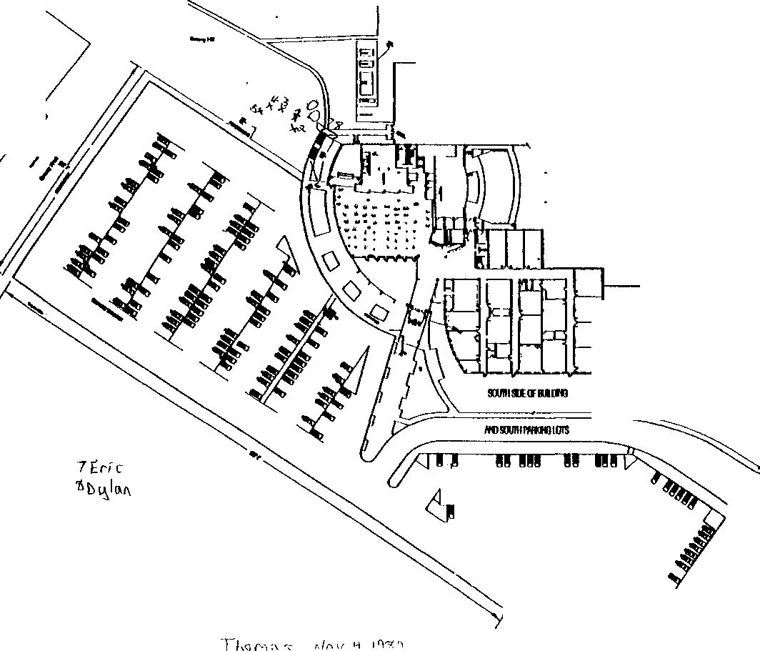

\

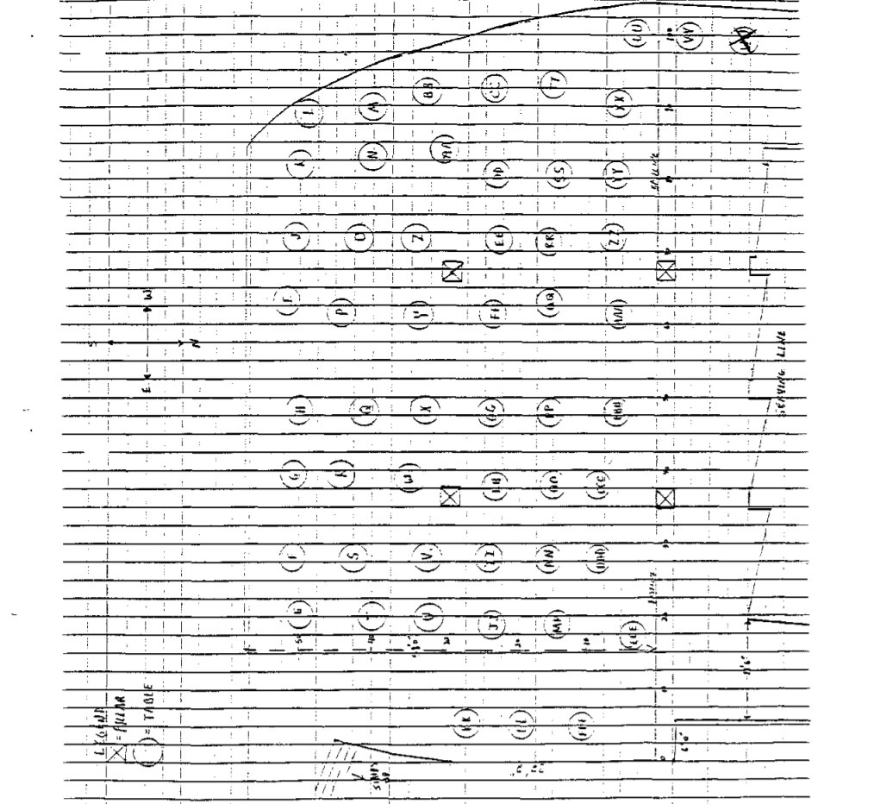JC-001-001219

.

.

-

THOMPSON, K

JC-001-001220

FBI CASE#!74A-DN-574l9 JEFFCO CASE#99•7625 CONTROL #3090

KATHRYN THOMPSON
5235 W. Portland Dr.
Littleton, CO.
303.979 7370

On 05110/99 at 1115 hrs. Kathryn Thompson was interviewed in her home by Detective
S.C. Shott #72049 (DPD). Ms. Thompson's mother Bianca was present.

Ms. Thompson reported that she attended class on the day of incident and she entered the cafeteria between the hours of 1l:15AM· 11:20Am. She was with two of her friends who she identified as Dawn Muirhead and Loni Brown. The three of them went over to the Rebel Comer and ordered something to eat. Ms. Thompson said that she purchased two egg rolls then the three of them left the cafeteria area and went outside and sat at a nearby picnic table to eat. Several minutes later, she heard what sounded like gunshots coming from the area of the soccer field. She first thought that it was the drill team making the noise unit she saw one of her friends (Anne Marie) being dragged by two of her friends. Ms. Thompson said that she could see that .Anne Marie was wearing a gray shirt and there was an area on the shirt that was covered with blood. At this point, things started to sink in as to what was happening. She and her two friends ran into one of the side doors of the cafeteria and they attempted to find a faculty member to help. They found a janitor and informed him that someone had just been shot. Several teachers were in the cafeteria and they were ordering everyone to get on the floor and stay down.

Ms. Thompson said that she and Loni ran out of the cafeteria through the main doors and out into the parking lot. She said that Dawn was wearing a knee brace and could not move as fast and she ran out another door. Ms. Thompson said that she dropped her backpack some where near the main entrance of the cafeteria near the picnic table area. As far as she knows, her backpack is still there.

Ms. Thompson said that she did not see either Eric or Dylan on the Monday or on Tuesday, the day of the incident. She said that she saw both of them on the previous week and believes that it was on Wednesday. At that time, she noticed that both of them were carrying black backpacks covered with some kind of white writing scribbled over the surface and both packs had patches that said "serial killer".

Ms. Thompson said that she knew both Eric and Dylan from school and she once had a date with Eric. She said that she went out with Eric on a Saturday night in February (1999). Her mother put a stop to the dating because Eric was a senior and he was too old for her. They discontinued their relationship and remained friends. Eric told her that he understood her mother's feelings and he agreed not to take her out again.

JC-001-001221

Ms. Thompson said that on the day of the shooting she was wearing khaki pants and a white T-shirt. She was not in the cafeteria when the shooting started and ran into the cafeteria to get help. The only property she left behind was her backpack that should be in the area of the main doors near the cafeteria by the picnic tables.

JC-001- 001222

JEFFERSON COUNTY DISTRICT ATTORNEY'S OFE1CE
SUPPLEMENT REPORT

DATE 05/18/99

CONECTING CR# JCSO 99-7625 CONTROL# 3495
CASE REPORT# 99A062

INVESTIGATOR: G.B. MUMMA

SUBJECT:

Kathryn Anne Thompson AKA: Katie
DOB 122183

5235 W Portland Dr Littleton, Co. 80123 Columbine High School | 303-979-7370
Mother: Bianca Thompson | 303-979-7370
Father: Gene Thompson | 303-645-8557

OBSERVATION/INVESTIGATION:

I responded to
-and found that
That address and contacted Gene and Bianca who, told me that they had been contacted by a member of the Denver Police
Department who had interviewed Katie. I told them that I was there in regards to ------------------------
Bianca stated that was because Eric had made numerous phone calls to Katie trying to get a date. Bianca went on to say that Eric had met Katie at the Chili's restaurant one night, but that was the last time she had direct contact with him. Bianca stated that Eric was calling all the time for a while, and she had interrupted a call once. Bianca thought it strange that a senior in high school was attempting to get a date with their daughter, a freshman, so they had told her she couldn't go out with him, but she had not put up any fight about it. Bianca learned later from a friend of Katie's (Erin Lucero) that Katie was afraid of Eric also

Bianca then stated that Eric had asked Katie if she was on the Internet, and if she had an E-mail address, but Katie is not allowed on the net unless she is supervised, and she doesn't have an E-mail address.

No further action taken by this Investigator.

JC-001-001223

TINDALL, JENNIFER

JC-001-001224

Control Number

ASSIGNED TO:
Agent Larry A. Brown, Colorado Bureau of Investigation, 690 Kipling St., Suite 4000, Denver, CO, 802125, phone (303) 239-4211.

DATE/TIME of INTERVIEW. Initial interview, April 20, 1999, between 12:30 pm. and 2 p.m. Follow up interview, April 27. 1999

PLACE of INTERVIEW Initial interview, near Columbine High School on Caley CT, Littleton, Co Follow up interview, telephonic to her residence

DISPOSITION: INTERVIEW THE FOLLOWING
Jennifer J. TINDALL, DOB: 10-25-82, 7849 W Caley ST, Littleton, CO, 80123, phone (303) 933-4851

TINDALL stated she and Cara SANDERS left the school cafeteria and headed for the student parking lot, located on the southwest side of the school, when she heard what she believed to be firecrackers.
TINDALL turned towards the school and saw a male, wearing a black trench coat, walking up the stairs next to the building. TINDALL said she noticed another person standing on the hill. This person was shooting at people in the parking lot with a very long, black gun. TINDALL recalled wondering why the shooter was not shooting at the person in the black trench coat The shooter was approximately six feet tall, thin build, brown hair. and wore a white T-shirt. TINDALL approximated the distance between her and the shooter as being about the length of the school's gymnasium floor. TINDALL said she saw the shooter fire and hit a girl in the leg. The girl fell to the ground and an unidentified male student tried to assist her up. The unidentified male then ran back into the school. TINDALL assumed he was going for help. According to TINDALL. the male in the black trench coat looked in the direction of Clement Park while the other male continued shooting. TINDALL stated she and Cara SANDERS ran to SANDERS' car and drove away They drove up Pierce Street to King Soopers. They later went to TINDALL'S residence on Caley Street. TINDALL said she walked to Caley Court where paramedics and ambulance crews were tending to the injured. TINDALL said she saw no other suspicious activity TINDALL stated she later learned that the girl she saw shot in the leg was Rachel SCOTT

Agent
Colorado Bureau of Investigation

JC-001-001225

DENVER POLICE DEPARTMENT
Case# Jeffco 99-7625

Control # 3320

REPORTED BY: Detective Joe A. Montoya #91011

DATE OF REPORT: May 12, 1999

TYPE OF REPORT: Investigative Interview SUBJECT: Jennifer Tindall

Synopsis: Jennifer Tindall was in the senior parking lot when the shooting started. She did get a look at both of the shooters, but could not make a positive identification on either one.

Details:
- Jennifer Tindall was with Cara Sander in the senior parking lot when the shooting started on April 20, 1999. She was approximately 30- 40 yards to the south of the shooters, at that time. Tindall said at first she thought the shooting was a prank. but then she saw a blonde female get shot and fall down in the commons area. At that time she and Sander made it to their car and left the parking lot area.

- Tindall said that she first observed the suspect standing at the top of the steps that overlook the commons area. She described him as a thin white male with brown hair, wearing a white short sleeved T-shirt, and tan pants. She then saw the second suspect run up the steps and stand next to the suspect in the white T-shirt. She described the him as a heavy set male, with black hair that was possibly pulled back into a tail, wearing a long black trench coat that was buttoned up.

- Tindall saw the male in the white T-shirt, shooting a long gun toward the parking lot and commons area, but she never saw the other suspect shoot. She did not get a look at the suspect's faces, but insisted that neither suspect she saw was Eric Harris or Dylan Klebold.

- I showed Jennifer Tindall a photo line up containing a photograph of ---------- Tindall picked out --------- photograph as possibly being the male in the black trench coat. I asked Tindall how she was able to pick out ----- photograph if she did not see the suspect's faces. She said that his build looked similar to the male in the black trench coat. Realizing that you can not see a persons build in a photo line up, I concluded that Tindall could not positively identify ---------- as one of the shooters.

Subject information: Jennifer Tindall, DOB: 10/25/82
7849 West Caley Drive
(303) 933-485 I

Detective Joe A. Montoya #91011 Denver Police Department

JC-001-001226

.
CONTINUATION □  SUPPLEMENT | JCSO |  | BROOKS | 99-7625-A
 |  | COLUMBINE H.S. |  | 4-26-99
X FIRST DEGREE MURDER |  |  |  | Recommend Case: Review  Closure  I I

J

INVESTIGATION
On 4-21-99. at about 11 27 a.m., Jefferson County Sheriffs Investigator Diane Obbema and I interviewed Columbine High School student Jennifer Juanita Tindall. dob/10-25-82. 7849 West Caley Drive, Littleton, CO, 80123. home phone. (3031933- 4851. This interview was conducted as a follow-up to our earlier interview with Columbine High School student Cara Ann Sander. dob14-3-83, 9700 West Chatfield Avenue, #E, home phone (303)979-5876. The interview with Jennifer was conducted at her residence in the presence of both parents.

Jennifer told us that she is a 10th grader at Columbine High School, and was at the school on 4-20-99. at about 1115 am. At that time, Jennifer said she and her friend. Cara Sander. had exited the cafeteria at the school and were walking outside heading toward Sander's vehicle which was parked in the student parking lot At that time, Jennifer said she heard what she thought was the sound of firecrackers going off. Jennifer said that she gave little immediate thought to the sound and assumed it was simply firecrackers being set off as a senior prank. Jennifer said she then heard something "ricochet" near to where she and Cara were walking. Jennifer said she and Cara then entered Cara’s car and began to drive out of the student parking. Jennifer said she looked back toward the school and noticed a white male wearing a black trench coat standing at the top of the hill, to the right of the stairs, near the cafeteria. Jennifer described this subject as tall with wide broad shoulders, black hair in a pony tail, black pants, and no mask. Jennifer said the subject did not appear to be holding anything at that time and was facing away from the student parking lot. Jennifer said that she saw another white male standing to the right of the first subject (the subject’s right), closer to the building This second subject, according to Jennifer, was wearing a white T-shirt. black pants. and appeared to be holding a black gun Jennifer said this person had brown hair, and appeared to be firing the gun in the direction of people eating outside on the stairs and on the grassy area nearby. Jennifer said she wasn't certain of the identity of the second subject. but now thinks that it was Eric Harris after being told by fellow classmates that Harris was wearing a white T-shirt. Jennifer said that she is “absolutely certain" that the subject wearing the white T-shirt was holding a gun and appeared to be firing it

Jennifer said that in subsequent conversations she has had with fellow schoolmates, she was told that students Craig Scott and Heidi Johnson had both been inside the library at the school during the shooting Jennifer said she was told that Craig Scott had blood on his hands, and that Heidi Johnson witnessed a female student get shot in "cupboard area" of the library The

JC-001- 001227

CONTINUATION
SUPPLEMENT |  | JCSO BROOKS |  | 99-7625-A
Connecting Case Report No |  | Victim Name Original Report |  | Date This Report
 |  | COLUMBINE H.S.
X FIRST DEGREE MURDER |  |  |  |  | Recommend Case; | Review | □
 |  |  |  |  |  | Closure | □
1

'

interview concluded at about 12:00 p.m.

Lead sheets for students Craig Scott and Heidi Johnson were subsequently prepared and submitted by Investigator Dave Brooks A hand-drawn map of the school, indicating the locations of the above subjects, was prepared during the interview by Jennifer Tindall. It was collected by Investigator Brooks and attached to this report.

DISPOSITION OPEN

JC-001-001228

JC-001-001228

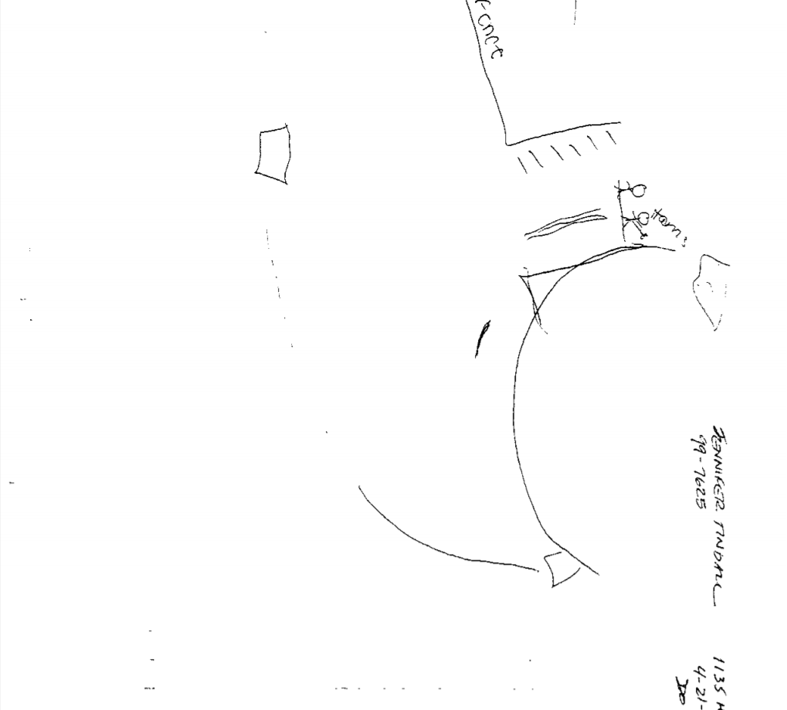

CONTINUATION □  SUPPLEMENT V | Reporting Agency Reporting Officer  JCSO PETERSON |  | Case Report No  99-7625-DDD
COLUMBINE  First Degree Murder |  |  | Date This Report  06--14-99 -  Recommend Case: Review  Closure
WITNESSES:

JENNIFER TINDALL, DOB/10-25-82
7849 West Caley Drive Littleton. CO 80123
303-933-4851
Student-Columbine High School

CHRISTINA TINDALL
Same as above.
Work: 303-978-1525

ROBERT TINDALL
Same as above.
Work: 1-800-377-!765

INVESTIGATION:

On 06-14-99, at about 1100 hours, I responded to 7849 W. Caley Drive to contact and interview Jennifer Tindall, who is a student at Columbine High School. This interview was in reference to the shooting that occurred on 04-20-99 at Columbine High School

On 06-14-99, at about 1100 hours, I interviewed Jennifer Tindall in the presence of her mother, Christina Tindall. Jennifer Tindall said on 04-20-99, at about I 100 hours, she entered the Columbine High School cafeteria after coming from the Junior student parking lot. Jennifer Tindall said she entered the cafeteria through the door that is located along the south side of the cafeteria and the door she entered was the far east door. Jennifer Tindall said she then sat down at a table in the cafeteria and put her backpack down (described as a green Jansport). Jennifer Tindall said she sat at the table, and was facing the stairs. She was, therefore, facing in an easterly direction. Jennifer Tindall said she was eventually sitting with the following people

JC-001-001230
CONTINUATION  SUPPLEMENT | JCSO |  | PETERSON | 99-7625-DDD
 |  | Victim Name Original  COLUMBINE |  | Date This Report  06-14-99
First Degree Murder |  |  |  | Recommend Case: -  Review  Closure

at this table, Kristin Schoenhoff, Christy Medina, Elisha Encinias and her boyfriend (name unknown), Cara Sanders, Nate Montgomery and Ryan Pool. I showed Jennifer Tindall the diagram of the Columbine High School cafeteria and she pointed to table "T" as the table she had selected to sit at when she entered.

Jennifer Tindall said about ten minutes after she sat down in the cafeteria, her described friends came downstairs to the table she had selected. Jennifer Tindall said Cara Sanders asked her to go outdoors with her, so they got up from Table "T' and proceeded to exit the cafeteria through the same door on the south side of the cafeteria, that she had earlier entered. Jennifer Tindall showed me on the diagram of the Columbine High School cafeteria. which door she had entered and later exited. (See this diagram for the locations marked.) Jennifer Tindall was previously interviewed by detectives in reference to the sequence of events that occurred after she exited the cafeteria. I did not reinterview her about these events.

I showed Jennifer Tindall the photographs of the duffle bag and the propane tank that were later recovered in the cafeteria at Columbine High School. Jennifer Tindall said she did not see either item prior to or during the incident. Jennifer Tindall also said she did not see anyone carrying items of the same description, either prior to or during the shooting.

f asked Jennifer Tindall what information she may have about the Trench Coat Mafia or the Trench Coat Mafia students. Jennifer Tindall said she did not have much information. but she did tell me that she was afraid of the Trench Coat Mafia students Jennifer Tindall said none of the Trench Coat Mafia students had ever bothered her or harassed her, but she was still afraid of them. Jennifer Tindall said she would usually see the Trench Coat Mafia students in the hallways of Columbine High School. but she did not talk to them. She said the Trench Coat Mafia students were distinguishable by their style of dress. She said that other than seeing them in the hallways, she would see them at times gather underneath the stairway or near the bottom of the stairs in the cafeteria. Jennifer Tindall said they would congregate at that location. Jennifer Tindall said she had seen Brian Sargent with the Trench Coat Mafia students in this area. She said Brian Sargent wore black clothing, but she did not remember if he
wore a trench coat or not. Jennifer Tindall said she did not see any of the Trench Coat Mafia students being harassed by other students. Sh' e said she did not observe the Trench Coat Mafia students harass other students either. Jennifer Tindall told me that
she did not recall seeing any Trench Coat Mafia students in the cafeteria area or the area described on 04-20-99

JC- 001- 001231

CONTINUATION  SUPPLEMENT | Reporting Agency  JCSO |  | Reporting Officer  PETERSON | Case Report No  99-7625-DDD
 |  | Victim Name Original  COLUMBINE |  | 06-14-99
First Degree Murder |  |  |  | -  Recommend Case: Review  Closure □

Jennifer Tindall said she knew of no one who may be manufacturing explosive devices and/or possessing firearms. I asked Jennifer Tindall if she knew of anyone who had a double pierced eyebrow, and she replied, "Yeah, Nathan Dykeman."' Jennifer Tindall told me that her information on this came from her friend Christina, who had told her this.

Jennifer Tindall said that on 04-20-99, she saw the "Thought of the Day" on the Rebel News Network (RNN). She said it said something to the effect of "You shouldn't be inside here today. It is nice outside." Jennifer Tindall said that Dylan Klebold and Eric Harris were on the RNN staff to the best of her knowledge. Jennifer Tindall said that she believed on 04-20-99 an audition was held that day for staff members for the Rebel News Network. Jennifer Tindall said her friend Lauren Beechman told her that she had auditioned along with Rachel Scott for the position on the RNN at Columbine High School on 04--20-99. Jennifer Tindall said Dylan Klebold was present during these auditions according to Lauren Beachem..

I asked Jennifer Tindall how she was doing since the incident occurred and she said she was doing well.. Her mother, Christina Beechman said that Jennifer Tindall has seen a counselor/therapist in the past and since 04-20-99. I gave Jennifer Tindall. one of my business cards and asked her to contact me if she wanted to talk to J.C.S.O. Victim Advocate in the future, and I told her I would make the necessary arrangements for her at that time.

DISPOSITION: Case is open, pending further investigation.

JC-001- 001232

JC-001-001233

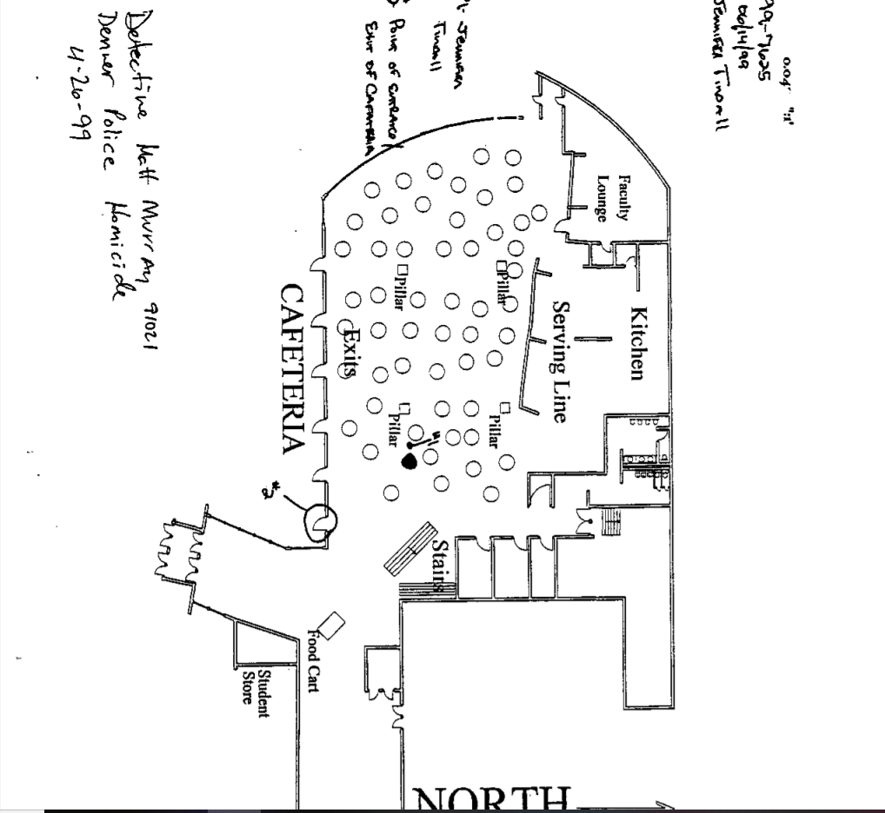

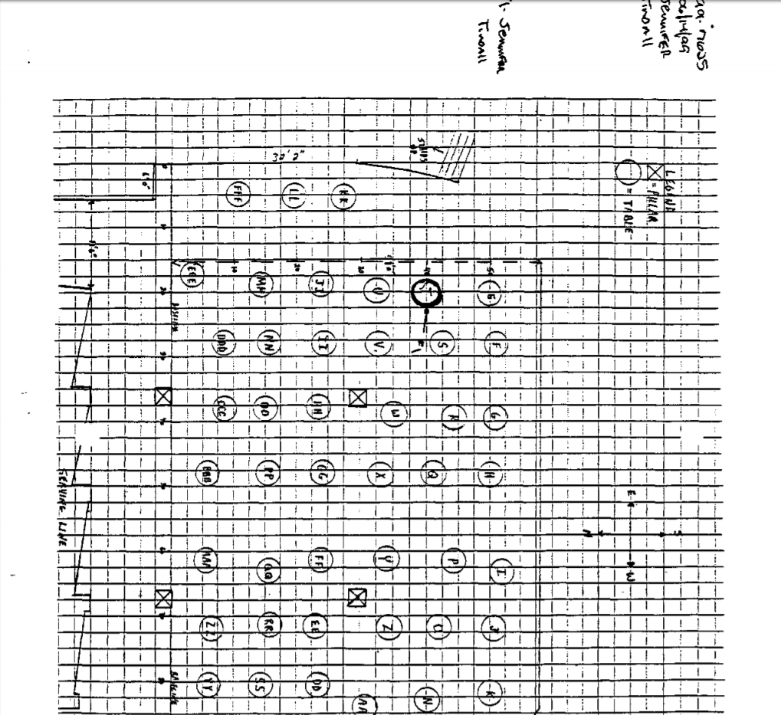JC-001-001234

ORIGlNAL
 | Department of the Treasury  Bureau of Alcohol, Tobacco, and Firearms  REPORT OF INVESTIGATION |  | .
Special Agent in Charge Phoenix Field Division |  | MONITORED INVESTIGATION INFORMATION:
TITLE OF INVESTIGATION:

Columbine High School Shooting/Bombing
Case Number

785030 99 0009
TYPE OF REPORT: (Check Applicable Boxes)

Report#

46

X | REPORT OF INVESTIGATION |  |  | COLLATERAL REPLY
 | REPORT OF INTELLIGENCE
SUBMITTED SY (Name)  Matthew C. Traver |  | SUBMITTED BY (Title and Office)  SA/Denver II |  |  | SUBMITTED BY (Date)  12/14/99
REVIEWED BY (Name)  Robin King |  | REVIEWED BY (Title and Office)  AAC/Denver II |  |  | REVIEWED BY (Date)
APPROVED BY (Name)  Christopher P. Sadowski |  | APPROVED BY (Title and Office)  SAC/Denver II |  |  | APPROVED BY (Date)

DESCRIPTION OF ACTIVITY:
Interview with Jennifer Tindall. SYNOPSIS:
On 12/9/99, SA Traver contacted Jennifer Tindall at her residence, with her Mom present
for the entire interview and her father present for the later part of the interview. At this time Tindall stated that the picture she was shown of Dylan Klebold and Eric Harris did look like the individuals she saw outside of the cafeteria at Columbine High School on 4/20/99

NARRATIVE,
  - on 12/9/99, SA Traver contacted Jennifer Tindall at her residence located at 7849 W. Caley Drive, Littleton, Colorado. Tindall's mother was present during the entire interview, her father came in for the latter portion of the interview. Tindall stated that she had originally thought that the individual she had seen outside of the cafeteria at the bottom of the stairs was ------------ . However after discussing the matter with friends and her family, and seeing pictures of Harris and Klebold, she believes that the two subjects she saw on 4/20/99, outside the cafeteria were Eric Harris and Dylan Klebold. She stated that when she saw the subject at the bottom of the stairs, she thought he was fat and because of the trench coat, she thought of
She stated that this subject had a pony-tail, but ------- did not have a pony- tail. Also, after talking about the matter with her mother, she realized that if the subject had guns and other items concealed under a trench coat it would give him a heavier or fat appearance.
Tindall stated that although she did not no Harris or Klebold prior to the incident on
4/20/99, she was fairly sure that was who she saw, after talking to friends and looking through the yearbook, and seeing photos of Klebold and Harris in the media.
- At this time SA Traver submitted two photos from packet A for Tindall's review. Tindall

JC-001- 001235

DEPARTMENT OF THE TREASURY
BUREAU OF ALCOHOL, TOBACCO, AND FIREARMS
REPORT OF INVESTIGATION - Continuation Sheet
Page 2 of
2 Pages
OF INVESTIGATION:
l

CASE NUMBER: REPORT NUMBER,

stated that the image of Eric Harris in photo 52, looked like the individual she had seen standing just to the east at the top of the westside stairs. Also, that the image of Dylan Klebold looked like the individual wearing a trench coat, who went from the bottom of the westside stairs and walked to the top to talk to Harris. Prior to viewing the photos Tindall drew a map of where she was when she saw both subjects. At this time Tindall marked on the map by writing Dylan, where she had originally seen Dylan Klebold and placed an x, where she had seen Eric Harris. After reviewing photo 52 form packet A, she stated that she was certain that the two subjects she had seen on 4/20/99, were Eric Harris and Dylan Klebold. Tindall stated that she remembers Harris from his white shirt and that he had a big gun. She did not see Klebold holding a firearm. Tindall again stated that she had seen Harris near the top of the stairs just off to the east in the grass. Tindall had seen Klebold at the base of the westside stairs, and then walk up the stairs to Harris and stare out into Clement park.
- Tindall stated that although she had seen Harris with a gun, she could not recall seeing the gun being fired. Tindall stated that she did hear gun fire and did see one girl get shot, It was at about this time that she and Cara Sanders drove from the parking lot and left the school grounds.
- Tindall concluded by stating the she was certain of her identifications, after seeing the photo 52 from Packet A.

ATTACHMENTS
Copy of diagram drawn by Jennifer Tindall

JC-001-001236

JC-001-001237
.
"

I '

'
\

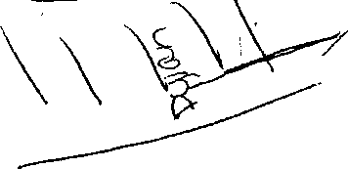

TORREZ, J

JC-001-001238

PIRNARR Arvada Police/Court System Arvada Police Department
NARRATIVE
Page 1
05/20/1999

===========================================================================

Ref# 99-12067 Reported Type ASSTOA
Location 6201 S Pierce
DET8l 05/20/1999 052099/
Date 04/20/1999 Time 12:39:32
Status RTF

99-7625 Jefferson County Sheriff's Department Control #3349
On May 14, 1999, Investigator Duane Eaton of the Arvada Police
Department was assigned investigative lead #3349. The investigative lead information control sheet listed the source of information as Linda Shultz, a parent of a Columbine High School student, with a phone number of 730-8090. The narrative portion of the form advised that Mike Heylin of the Jefferson County District Attorney's Office had interviewed Aleana Shultz in the presence of Linda Shultz at the Shultz residence. Heylin advised in the narrative portion of the form that another daughter, Jennifer Torrez, a Columbine High School student, had been in the parking lot of Columbine High School and observed Harris and Klebold in the parking lot by a black BMW just prior to the incident. Jennifer Torrez was supposedly with a friend, Erin Adams. Jennifer Torrez was not at the Shultz residence at the time of Aleana Shultz's interview. Investigator Eaton was assigned the task of contacting and interviewing Jennifer Torrez about seeing the suspects in the parking lot.
Investigator Eaton met with Jennifer Amber Torrez (DOB: 09/05/82) on Thursday, May 20, 1999 at approximately 1000 hours. Investigator Eaton met with Torrez and her mother Linda Shultz at their residence. Torrez and her mother both agreed to an interview with Investigator Eaton.

Torrez advised Investigator Eaton that on April 20, 1999 she attended her regular classes until leaving for her 5th period for lunch. Torrez advised Investigator Eaton that her 1st period class starts at approximately 0730 hours and is Sociology taught by Mr.
Bath. Torrez advised her second period class is Photography taught by Ms. Harikawa. Torrez advised her 3rd period class is Choir taught by Mr. Andres Jr. Torrez advised Investigator Eaton that neither Eric Harris nor Dylan Klebold are in any of her classes.
Some female students associated with the Trench Coat Mafia are in her Choir class. She advised that in her Choir class are Kristen Theibault, Pauline Colby, and Nicole Markham. Torrez advised Investigator Eaton that Theibault and Colby were not in Choir class on April 20, 1999. She advised she could not recall if Markham was in class that date. Torrez did advise however that it was relatively normal for students to be absent from Choir class this time of the year. She advised that if a student is going to cut a class Choir is one they will get in the least amount of trouble for skipping. Torrez advised her 4th period class is her Foods class taught by Ms. Inman.
Torrez advised Investigator Eaton that she normally gets out of Foods class at approximately 1110 hours. She advised that her 5th period of school is lunch period. Torrez advised on this date her and Erin Adams exited the school via the cafeteria and walked

JC-001-001239

PIRNARR Arvada Police/Court System Arvada Police Department
NARRATIVE
Page 2
05/20/1999

==========================================================================

Ref# 99-12067
Type ASSTOA
Reported Date 04/20/1999 Time 12:39:32
Status RTF

Location 6201 S PIERCE ST DET8l 05/20/1999 652099/EATON/MO

into the junior's student parking lot in order to access Adams' vehicle. Torrez advised that as she and Adams were leaving the school and on the sidewalk area just outside of the cafeteria and facing the junior and senior parking lots, she observed Dylan Klebold's black BMW parked in the senior's parking lot in its normal location. She advised she was able to observe Dylan Klebold sitting inside his vehicle. She advised that Dylan Klebold appeared to be the vehicle alone. Torrez advised Investigator Eaton it was normal for her to see Klebold sitting in his car during 5th period lunch. She advised he often sat alone though occasionally she observed Eric Harris with him in the vehicle in the parking lot. Torrez advised Investigator Eaton she could not observe what clothing Dylan Klebold was wearing or what activity he was involved in inside of the vehicle.
Torrez advised Investigator Eaton she is aware of who Dylan Klebold is, She advised she is aware of his name and knows him on sight. Torrez advised Investigator Eaton that she does not ever recall socializing with Dylan Klebold outside of school. She advised the only time she had a conversation with Klebold was during last years school year when they had bumped into each other in the cafeteria and they had spoken.
Torrez advised Investigator Eaton she is aware of who Eric Harris is also. She advised she knows Eric Harris by name and by sight though she has never socialized with him or ever spoken with him that she recalls.
Torrez advised Investigator Eaton that she never really considered Eric Harris and Dylan Klebold members of part of the Trench Coat Mafia. She advised it was her opinion that only the persons in the school yearbook picture listed as Trench Coat Mafia were the true members. She advised she had always believed that Eric Harris and Dylan Klebold were just friends of some of the Trench Coat Mafia members.
Torrez advised Investigator Eaton that in the past she has dated a friend of some of the members of the Trench Coat Mafia. She advised this person was not a member of the Trench Coat Mafia however. Torrez advised this past boyfriend as Keith Parkison. She advised however that she and Parkison broke up during October or November of 1998. She advised that Parkison was friends with some of the females associated with the Trench Coat Mafia and more specifically Kristen Theibault and Nicole Markham. She advised that though she has never had problems with any of the members of
the Trench Coat Mafia or Eric Harris or Dylan Klebold, when she did break up with Parkison she was aware that Theibault and Markham were upset with her about that.
Torrez advised Investigator Eaton that she and Adams left the junior's student parking lot at approximately 1120 hours. She described Adams' vehicle as a 1986 blue colored Honda Accord with

JC-001- 001240

PIRNARR Arvada Police/Court System Arvada Police Department
NARRATIVE
Page 3
05/20/1999

=================================================================================

Ref# 99-1.2067
Type ASSTOA
Reported Date 04/20/1999 Time 12,39,32
Status RTF

Location 6201 S PIERCE ST DET8l 05/20/1999 052099/EATON/MO

dark tinted windows. She advised that when they left the school they drove southbound on Pierce Street to get lunch at the Burger King at the intersection of Coal Mine and Pierce Street. She advised that while she and Adams were in the drive-thru at said Burger King they heard and observed police and fire vehicles driving by at high rates of speed towards the school. She advised at this time she had no idea what was taking place at Columbine High School. Torrez advised that when they headed back to the school the streets were blocked at Weaver Street and Pierce Street and she was unable to get back to school. She advised at this point she was paged by her mother so she went home and called her mother at work. Torrez advised she learned from her mother at this time what was taking place at Columbine High School.

Torrez advised Investigator Eaton that a short time later she went up into the area of Leawood Park directly across the street from Columbine High School in an attempt to see what was taking place. Torrez advised Investigator Eaton she did not observe any of the activity involving the suspects, Torrez advised Investigator Eaton she did not hear any explosions or hear any gunfire associated with the suspects in this incident. She advised the only thing she really observed was the SWAT teams moving up towards the school from behind a fire truck.

Torrez advised Investigator Eaton that she had no other information related to this incident. Investigator Eaton concluded the interview at approximately 1025 hours.

JC-001-001241

JC-001-001242

'

-
[3
"'

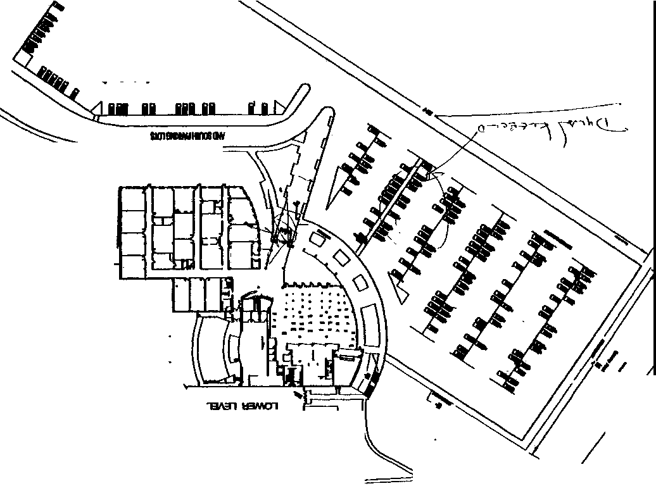

VITALE, JAMES EVAN

JC-001-001243

I
CONTINUATION  SUPPLEMENT | Reporting Agency  JCSO |  | Reporting Officer  GERLACH | Case Report No  99-7625-A
Connecting Case Repor1 No. |  | Victim Name Original Rcport |  | Date This Report  4-20-99
X HOMICIDE |  |  |  | Recommend Case: Review D  Closure D  e o• a a
1 I Quantity I B111nd Namt I 0-ription I Serial No |  |  |  | t:\ R c• eml j D Vma 1god

WITNESS
EVAN VITALE, DOB/10-31-81 5952 WEST CHESTNUT AVE. LITTLETON, CO 80128
(303)973-9085
STUDENT AT COLUMBINE H.S.

INVESTIGATION
On 4-20-99, at approximately 1245 hours, I interviewed witness Evan Vitale in reference to this incident. Evan told me the following.

Between 1110 and 1120 hours, he was "ditching school," he was in the south parking lot of the school and getting ready to leave in a car with other friends of his. He told me that he heard a "pop-pop-pop." He said he looked to the north and saw, "A kid on
the hill with a gun." He described this individual as having dark hair, dark skin, a white shirt and a trench coat with dark pants. He told me that it looked like he "had a rifle." I asked him how many "pops" he heard. He said, "Maybe thirty." I asked him if he saw anyone else. He told me that on the west side of the school he saw a second individual. "Running up and down the
stairs." He described that individual as wearing a dark trench coat, black ball cap backwards, and he had long blond hair. He told me he recognized that individual from the school but did not know his name, only that he had seen him around the school. Evan told me that he and his friends then left the school and drove south on Pierce Street and saw Sheriff's Office cars responding. He told me that he Went home, got his car and came back to the school. He said by the time he arrived a command post had been set up and he was sent to Leawood Elementary. This was all the information Evan was able to provide to me. concluded my interview with him.

JC-001-001244

FBI 174A-DN-57419
JCSO 99-7625
Investigator: Glenn Moore - Golden Police Department / (303) 384-8080

RE: CONTROL # 1756
After failing to locate any male students registered at Columbine High School by the last name of "Evans" I re-contacted Trent KARNES. KARNES said he thought the other passenger in his car was "Pete Evans," but that the other person in his car at the time, Mindy POLLOCK, would know his name. I then contacted POLLOCK who provided the only other passenger in the car to be Evan VITALE.
TELEPHONE INTERVIEW:
VITALE, Evan (DOB:103181)
5952 W. Chestnut Avenue
Littleton, CO 80123
(303) 973-9085
05-11-99 11 :20pm

VITALE began by saying a law enforcement officer in plain clothes had interviewed him at the scene on April 20th 1999. No record of this interview was found in Rapid Start tracking.

VITALE began by describing what his class schedule was at the time of the incident. He said he had first hour off, second hour was his drawing class, third was History, with fourth hour in Language Arts, and fifth hour scheduled in Guitar class. He added that he had "ditched" fifth hour on April 20, 1999.

At about 11:20am VITALE said he had caught a ride with Trent KARNES, and another passenger, Mindy POLLOCK. He described KARNES' car as being a small red two-door and that it was older, but could not provide a make or model. He further described KARNES' car was parked in what he thought was his assigned space on the south side of the senior lot, nose in toward the wooden privacy fence facing the backyards of the homes. As he got into the backseat he heard what sounded like fireworks coming from the area of the school.

As VITALE turned around and looked back towards the school he saw a white male standing at the top of the stairs, just north of the cafeteria/library area. He said this male was facing somewhat toward the cafeteria, and could not see his face. This male was standing on the opposite side of the short chain link fence. He explained that this male was resting a long "big gun" on the fence and was shooting it "fast, maybe automatic" toward the grassy squares in front of the cafeteria. He said this person was wearing a white shirt, black pants with dark hair or a dark hat.

At the same time VITALE saw another white male running up and down the same stairs. He described this second male as wearing black pants, black shirt, and a black trench coat, with as black ball style cap on backwards. He said he did not see anything in this person's hands, but added that the other passenger, Mindy POLLOCK, had told him she saw him carrying a handgun. VITALE said this second person was Dylan KLEBOLD.

JC--001-001245

FBI 174A-DN-57419 JCSO 99-7625
Investigat Glenn Moore - Golden Police Department / (3Q3) 384-8080

RE: CONTROL# 1756
He explained that he had seen KLEBOLD around school, and knew him on sight, but had not known his name prior to the shooting.

During this same time period he saw a male student running up the grassy hill to the northwest in an apparent attempt to flee as he had red on his pant leg, possibly blood soaked.

After about two minutes Trent KARNES to drive from the lot. After KARNES backed out of the space VITALE said he looked back at the school and saw what he described as a "third shooter." VITALE described this person similar to that which he had of the first person. This he described was a white male wearing a white shirt and black pants, but could not describe him further, other than he was sure it wasn't KLEBOID. He explained that this person was holding what he thought was a shotgun as it had a "slide pump thing." He described this person was standing alongside the wall next to the single door on the west side of the cafeteria. just below the stairs.

VITALE said he could not eliminate the possibility that this third person may have been the same person he saw shooting at the top of the stairs. He could not confirm his having seen all three of the suspects at the same time. He explained thinking it would have been impossible for the person at the top of the stairs to 'jump the fence" and run down to this location in the brief amount of time from when he initially saw him. He also felt sure that the person at the top of the stairs was holding a much larger long gun than the shotgun type weapon held by the person by the door.

VITALE said prior to the incident he knew HARRIS by name, and again knew KLEBOLD only on sight as a student at Columbine High School. He described that HARRIS had an ongoing conflict with a friend of his, Cale KENNEDY. He further described this saying the two occasionally exchanged fighting type words as they crossed in the hallways. He added that he could not sufficiently see the suspect at the top of the stairs due to this person being partially turned toward the school, away from him, and thus did not know if it was HARRIS. He also could not identify the person standing beside the doors of the cafeteria due to his vantagepoint. ·

As they drove from the parking lot he said he had seen a student-aged boy laying on the pavement in the parking lot, next to the handicapped parking spaces. He said this person was not moving, and was facing away from them so he could not provide any further description.

On May 11, 1999 at about 4:30pm I escorted VITALE to the Senior Parking Lot to the area where he thought they had been parked at the time. This was due to his inability to discern the exact locations on the small diagram of the school. VITALE pointed out the areas described above.
•• NO new leads generated. JC-001-001246

CONTINUATION □  SUPPLEMENT X | JCSO |  | PETERSON | Case Report  99-7625-EEEEEE
Connecting Case Report No. |  | Victim Name Original Report  COLUMBINE H.S. |  | Date This Report  11-9-99
X 1/MURDER |  |  |  | Recommend Case: Review 0  Closure 0
WITNESS,
Evan Vitale, DOB/10-31-81 5952 West Chestnut Avenue Littleton, Co. 80123
303-973-9085, pager/303-203-2713
Student/Columbine High School

INVESTIGATION:
On 10-4-99 I was assigned FBI CN#5072, which was to re-interview Evan Vitale in reference to the shooting at Columbine High School Qn 4-20-99. The purpose for the re-interview was because Evan Vitale had reported previously to Columbine High School Task Force Detective Glen Moore, that he may have possibly seen a third shooting suspect on 4-20-99.

I called Evan Vitale and arranged an appointment for the re-interview for 10-18-99 at 1530 hours at JCSO South Sub-Station.

On 10-18-99. I responded to JCSO South Sub-Station and waited for Evan Vitale to show up, however, he did not show up

On 10-19-99 I contacted Evan Vitale and another appointment date was set up for 10-25-99 at 1530 hours at the South Sub­ Station. Again. I waited on that date for Evan Vitale, however, he did not show up.

On !0-26-99, I contacted Evan Vitale about missing this appointment. and he said he had forgotten about the appointment At that time. we arranged to meet on 11-3-99 at 1530 hours at the South Sub-Station.

On 1 l-3-99 I responded to the South Sub-Station and waited for Evan Vitale, however, he did not show up. I was able to contact Evan by his pager and when he called me back he said he was at a car dealership and that was why he didn’t make our
appointment.
JC-001-001247

On 11-4-99 I contacted Evan Vitale and an interview appointment was set up for 1 l-9-99 at 1500 hours at the JCSO South Sub-

CONTINUATION □  SUPPLEMENT X | JCSO |  | PETERSON | Case Report No  99-7625-EEEEEE
. |  | Victim Name Original Report  COLUMBINE H.S. |  | Date  11-9-99 '
X 1/MURDER |  |  |  | Recommend Case: Review 0  Closure □  I I

Station. At approximately 1330 hours on 11-9-99, I called Evan Vitale's pager to remind him of our appointment for that day. however, he did not answer his pager, nor did he call me back. I responded to JCSO South Sub-Station on 11-9-99 and waited for Evan Vitale until approximately 1645 hours, but he did not show up for the appointment.

I contacted JCSO Investigator Kate Battan and advised her that Evan Vitale had not shown up again for an appointment. and had not answered his pager when I called that number. Investigator Battan told me to return CN #5072 to her to handle the problem.

It should be noted that each time I spoke to Evan Vitale about making these appointments. I stressed to him about how important the information he had about this case was to JCSO and to the Columbine High School Task Force. I also advised him we took his information very seriously and that is why I needed to re-interview him. He said he understood what I was telling him each time I told him this.

DISPOSITION: Open pending further investigation.

JC-001-001248

.
CONTINUATION  SUPPLEMENT X |  | I | JCSO | LUCIANO |  | 99-7625-B
 |  |  |  | COLUMBINE HIGH SCHOOL |  | 11 16-99

CONTROL# 5072

WITNESS:
Vitale, James Evan, DOB/10-31-81 5952 W. Chestnut Avenue Littleton, Co. 80123
303-973-9085

INVESTIGATION:
On 11-16-99 Columbine High School student James Evan Vitale was re-interviewed at Columbine High School, 6201 South Pierce Street. James' mother was not present for the interview; however, she was contacted on the telephone and advised prior to the start of the interview. Columbine High School Assistant Principal Kevin Land was also advised of the interview.

The purpose for the interview was to clarify Vitale's observations during the 4-20-99 shooting at Columbine High School, specifically to statements made by Vitale during an interview on 5-I1-99 with task force investigators. In that interview, Vitale reported seeing what he thought to be a third shooter standing by a single door on the west side of the cafeteria.

Vitale told me that on 4-20-99 he. Mindy Pollock and Trent Karnes walked to Trent Karnes' car. Karnes' car was parked in the senior parking lot, space #276. Vitale stated that he sat in the back seat, Pollock was sitting in the front passenger seat and Karnes was in the driver's seat. Vitale stated that immediately after they were seated in the car he heard several "pops”. Vitale turned around and looked out the back window of the car. Vitale stated that he saw Dylan Klebold running up and down the cement stairs on the west side of the cafeteria. Vitale stated that Klebold was wearing a black trench coat, black shirt, black pants and a black hat. Vitale stated that he doesn't remember if Klebold had a gun or not. Vitale stated that he knew right away that the person he saw was Dylan Klebold because he recognized him from seeing him at school before. Vitale stated that he saw another person standing at the top of the cement stairs. Vitale stated that this person was wearing a white t-shirt and possibly black pants. This person was not wearing a trench coat. Vitale stated that this person "had a long gun" and was shooting. Vitale stated that he looked at Dylan Klebold and the person he saw shooting for a minute or less. Vitale stated that at the time he didn't know who the shooter was. Vitale now knows that person to be Eric Harris from seeing Harris' picture through the media. Vitale stated that after about a minute or two from the time they first
heard the shots, Karnes started to back his vehicle out of the parkings As Karnes was driving out of the parking lot

JC-001-001249

CONTINUATION
SUPPLEMENT

I
I
X
JCSO
Reporting Officer
LUCIANO

COLUMBINE IDGB SCHOOL

Case Report No
99-7625--B
Dato This Report
11-16-99
Recommend Case R.,., Review

,

I

Closure

Vitale looked out the car window again. It was at this time Vitale saw what he described in his interview on 5- l l-99 as a third shooter. Vitale told me that he saw a person standing by the single door that is by the teacher's lounge on the west side of the cafeteria. Vitale stated that this person was not wearing a trench coat. Vitale stated that this person was wearing a white shirt, possibly black pants and was holding what looked like a shotgun. Vitale stated that after seeing media photos this person could have also been Eric Harris. Vitale stated that he still isn't sure, because he doesn't think that Harris could have moved from the top of the stairs to the bottom by the single door from the time he saw him when he looked out the back of the window and when he looked out the window again as they were leaving the parking lot.

I explained to Vitale that based on his own consistent statements, there is at least one minute between the time he saw the shooter at the top of the stairs and when he looked out the window again and saw the person standing by the single door at the bottom of the stairs. I further explained that this was more than enough time for that person to move from the top of the stairs to the bottom. I also explained that the clothing description Vitale provided of the person at the top of the stairs and the person at the bottom of the stairs was the same.

I then showed Vitale a series of four photographs (#44, 47, 52, 53) taken from the video camera in the cafeteria on 4-20-99. Eric Harris is pictured in each of the four photos. After looking at the photographs, Vitale stated, "That definitely looks like the person I saw." After further questioning, it was clarified that Vitale was referring to the person he saw at the bottom of the stairs by the single door. Vitale stated. "This whole time I've questioned if that I could have seen him twice."' Vitale was referring to Eric Harris.

The interview was concluded with Vitale no longer having any concerns in reference to there being a third shooter.

DISPOSITION: Open

JC-001-001250

'

VOL, GALINA

JC-001-001251

CONTINUATION □  SUPPLEMENT X | JCSD |  | Inv. Larry Erzen | .  99-7625
.  DN 4975  · · □ |  | Victim Name |  | Date This Report  08--10-99
First Degree Murder

ADDITIONAL WITNESS:

Vol, Galina, DO8/12-21-80 7083 South Webster Street Littleton, CO 80123
H: 303-973-8746

Business Address: Student - Columbine High School (Parental Information)
Vol, Yelena
7083 South Webster Street Littleton, CO 80123
H: 303-973-8746
B: _lfl3-973-5486

Vol, Semyon
7083 South Webster Street Littleton, CO 80123
H: 303-973-8746
B: 303-333-3333

INVESTIGATION:

On August 10, 1999 between the hours of l 020 and l 030, I had an opportunity to speak with Galina Vol in reference to the Columbine incident that occurred on April 20, 1999. Upon contacting Galina. she did verify she was at school on the incident date and proceeded to tell me that she is a student assistant and helps Ms. Macauley with her fifth hour Body Shaping class. Galina told me that just prior-to arriving at Ms. Macauley's class, she had stepped outside to get some fresh air and was in the area of the west stairs that come from the junior/senior parking lot and believes it was between 1110 and 1115 hours. Galina described hearing popping noises coming from the student parking lot, telling me that she initially thought this was some type of a senior prank, that somebody was lighting off some fireworks.
Galina was outside for only a short period of time and she reentered the school through the west entrance, located near the library.

JC-001-001252

,_
CONTINUATION □  SUPPLEMENT X | Reporting Agency  JCSD |  | Reporting Officer  Inv. Larry Erzen | Case Report No  99-7625
. |  | Victim Name |  | Date This Report  O5-10-99 .,.,,_
□ First Degree Murder |  |  |  | □ Recommend Case: Review □  Closure □

Galina proceeded to the wrestling room, which is located in the gymnasium., for Ms. Macauley's Body Shaping class. Galina explained that shortly after she arrived in class, some unidentified students came running into the wrestling room and told the staff and class there were some individuals shooting at students. At this point, students in the class started running from the classroom. Galina told me that she remained in the wrestling room for only a short period of time, at which time she was recontacted by Ms. Macauley, who told the remaining students to exit the school. Galina explained that she exited from the school from the north exit in the gymnasium.

Galina was asked if she saw any gunmen while at Columbine. Galina stated she did not see any gunmen, she only heard those popping noises which she described as being fireworks and later learned it was actual gunfire.

Galina was unable to provide any additional information reference this incident.

ADDITIONAL INFORMATION: FBI Case #4-DN-57419, ON #4975.
Disposition:

Case open pending further investigation.

JC-001-001253

WAGNER, S

JC-001-001254

JEFFERSON COUNTY DISTRICT ATTORNEY'S OFFICE SUPPLEMENT REPORT

DATE 05124199

CONECTING CR # JCSO 99-7625

CONTROL # 3593

SUBJECT:
Stephanie Wagner
6585 W Leawood Dr. Littleton, Co. 80128
Columbine High School

Mother: Debra Rodgers
Step Father: Todd Rodgers
CASE REPORT# 99A062 INVESTIGATOR: G.B. MUMMA

DOB 051083
303-795-3369

303-778-4434
Work

OBSERVATION/INVESTIGATION:
On 052499 I contacted Stephanie at home by phone. and told her I needed to talk to her about the shooting and her whereabouts during 5th hour. Stephanie stated that she was out at the "smoking pit" at 11:15-11:20 AM and that she had started to walk to the cafeteria when she heard an explosion, but didn't think anything of it because she thought it was a senior prank. Stephanie then stated that she saw Eric Harris at the top of the stairs talking to Brooks Brown. I asked Stephanie what Eric was wearing and she stated that be was in his black trench coat and black pants. I asked Stephanie what happened next and she replied Brooks went down the stairs and Eric pulled out a "BIG" gun and started shooting into the main hall doors. I asked Stephanie if she was sure that she had seen Brooks Brown and not someone else and she stated that she was
sure. I asked Stephanie what happened next and she stated that she was very scared and started running toward Clement Park, then once she got there she went home. Stephanie was unable to provide any further
information.

No further action taken by this Investigator.

JC-001- 001255

WATTS, E.

JC-001-001256

CONTINUATION SUPPLEMENT
Transcription of handwritten statement of Eric Watts
JC- 001-001257

Watts, Eric
7962 W. Chestnut Way
LTn, COLO 80128
303-93303146

Control Number 4093

Investigation:
I spoke with Eric reference the shooting on April 20. He said that he was eating his lunch in the outside commons area by the senior parking lot. He heard gun shots but did not see where they were coming from. Eric said that he did not see anything that happened. He said that he did not see anything in the cafeteria when he bought his lunch.

Disposition: Open

WINGER, K.

JC-001- 001258

CONTINUATION SUPPLEMENT

D Clo.au"' D

Transcript of typewritten statement of Winger, Kimberly

JC- 001-001259

Winger, Kimberly
8071 W Grand Ave
LTN, COLO 80123
303-973-2790

Control Number 4264

Investigation:
I spoke with Kimberly reference the shooting on April 20. She said that she was eating lunch in her car. She was parked in the far east section of the senior lot. She heard gun shots, but did not see who was shooting. She said the shots were coming from the area of the cafeteria. She was not in the cafeteria anytime that day.

Disposition:
Open

JC-001-001259

WISHER, C

JC-001- 001260

CONTINUATION SUPPLEMENT | JCSO |  | MOORE ORIGINAL | 99-7625-L
 |  | Victim Name Original |  | Date This Report  04-29-99
L  First Degree Murder |  |  |  | Recommend Case; Review  Closure

INTERVIEW WITH CHRIS WISHER. DOB/03-19-83, W/M
Student/Columbine High School 6572 West Calhoun Place Littleton, Colorado 80123
(303) 730-2530

INVESTIGATION:

On 4-20-99, at about 1610 hours, I was contacted by Chris Wisher in the parking lot of Clement Park. Wisher stated that he had already been interviewed previously on 4-20-99, but that he wished to contact me and provide me with further information. Wisher stated that he was behind the school by the cafeteria when he heard what he thought was fireworks going off Wisher said
he saw two kids in trench coats and he described one of the kids as wearing a white T-shirt and throwing bombs onto the school Wisher said he was not positive, but he believed one of the suspects was -------. Wisher said that the other kid in the trench coat fired a shotgun at him and that at this time he knew what was going on was real Wisher stated that the other suspect in the trench coat had an automatic rifle. Wisher stated after the incident started he ran from the scene. through a field. and waved down a car and went to someone's house and called 9-1-l Wisher stated that his first interview was in more detail as to what occurred at this time. Wisher stated the reason he wished to contact me was the fact that a reporter had contacted him while he was standing outside the crime scene tape, and the reporter knew that Wisher had been interviewed by law enforcement officers He stated the reporter asked him if the kid that was sitting in the red van being interviewed by law enforcement officers was one of the suspects. Note: The person in the red van being interviewed was ------------------- Wisher stated that the reporter asked him to go up to the van and look and see if that was one of the suspects and to let him know. Wisher stated he looked at ---------- and then told the reporter that it looked like one of the suspects. but he could not tell him for sure if it was. I then asked Wisher if the person in the van was one of the suspects he saw. He told me also that -------------- looked like one of them. but he could not tell me it was one of them. He stated he was unsure if this was the same person he had seen in the parking lot.

DISPOSITION: Open.

JC-001-001261

COLORADO STATE PATROL
WITNESS STATEMENT

Trooper: UCR/Case #:

Defendant Date of Incident:

location: County:

I make the following statement of my own free will with no force or threats used against me and no promises made or implied to induce me to make this statement:

Name: Chris Wisher
Home Address: 6572 W. Calhoun Pl
Phone: Home:730- 253
Business: _

Me and my friends were about 100 yards away from the people. There were 3 of them. 2 wearing trench coats & one wearing white shirt. We heard what we thought was a gun & started running. Then we figured that they were fireworks and went back. We saw one of them aim a gun at us and started shooting at us. We heard the gun shots going by our head so we fell to the ground. We got up & saw the kid in the white throw what looked like grenades on the roof. That is when we both got back up and started running. There was also another guy in Weaver Park in the bushes ducking w/ a gun in his hand. We don’t know if it was the same gunman from the school or a different one.

JC-001- 001262

- l -
FEDERAL BUREAU OF INVESTIGATION

Date of transcription 04/28/1999
On April 27, 1999, Christopher Howard Wisher, date of birth March 19, 1983, of 6572 West Calhoun Place, Littleton, Colorado, telephone number (303)730-2530, was interviewed at his residence in the presence of his father, Howard E. Wisher, date of birth April 12, 1949. After advisement of the identity of the interviewing agent and the nature of the interview, he provided the following information:

Wisher is a sophomore at Columbine High School. He normally eats lunch during fourth period, which he has free, and at the end of the period at 11:10, he and his friends normally go outside. On April 20, 1999, just prior to the 11:15 bell, he and his friends, Jake Apodaca, Josh Chavez and John [Last Name Unknown] were sitting at a table inside the cafeteria near the south window, which faces a parking lot.

Wisher saw Dylan Klebold walk into the southwest entrance to the cafeteria from the parking lot. He was dressed all in black, with black trousers, black shirt, black boots, a black trenchcoat and a black Colorado Avalanche hat worn backwards, which had a Boston Red Sox emblem sewn on it. Wisher does not recall Klebold carrying anything, and saw him walk over to the vending machines in the cafeteria.
According to Wisher, during lunch, Klebold and Eric Harris would normally sit in Klebold's BMW in the parking lot on the south side of the cafeteria and watch people. Wisher only knows Klebold and Harris by sight.
After the 11:15 bell, Wisher and his friends walked out of the southwest exit of the cafeteria, towards the soccer field. He heard a sound which sounded like fireworks, similar to a string of Blackcat firecrackers going off. [Wisher indicated that prior to April 20, 1999, he had never heard gunfire]. About 50 yards away, outside on the west side of the cafeteria, he saw a tall white male, dressed all in black, with a black trenchcoat, and what he thinks was a black hat and dark sunglasses. At the
time, he did not recognize this person, but thought it might be
S
------ a member of the Trenchcoat Mafia who is about the same height and build.

Investigation on 0 4/27/1999

at Littleton, Colorado
JC-001-001263

.File# l74A-DN-57419
by SA Matthew S. Harris
Dated Dictated 04/28/1999

174A-DN-57419

Continuation of F0-302 of Christopher Howard Wisher on 04/27/1999 . Page 2
Wisher saw this person shoot at three students near the southwest corner of the cafeteria with what he thinks was a shotgun, based upon the loud noise and the slower rate of fire.
This shooter then pointed the shotgun at Wisher and his friends and fired four or five shots at them. Wisher and his friends fell to the ground and covered their heads. When Wisher locked up, he saw the gunman walking towards the southwest cafeteria entrance.
Wisher also saw a white male dressed in a white short­ sleeved tee shirt and blue jeans, kneeling with his back to him near the northwest corner of the cafeteria. He did not recognize this person, and since his back was to him, could only tell he had either light brown or blond hair. This person had no weapon nor other gear visible.
Wisher saw this person throw an object one-handed on top of the cafeteria/library roof. It appeared metallic with sunlight glinting off of it, and one to two seconds after landing it exploded with a loud bang, a flash of fire and a pall of smoke.
While he observed the person in the black trenchcoat shooting outside and the person in the white tee shirt throwing the explosive device, he also heard very rapid gunfire coming from somewhere within the school. Wisher was unable to see who was doing this shooting or tell exactly from where in the school it was coming from.
After this person threw the bomb, Wisher and his friends got up and ran to a nearby house on Teller Court, where Wisher called his father to let him know he was safe. Howard Wisher indicated he noted the time of the call as 11:20 a.m.
Wisher knows two members of the Trenchcoat mafia, Joe Stair, a former Columbine student who graduated last year, and Chris Morris.
He spoke with Morris once about the sport of paint ball, which they both play. Wisher indicated Morris normally sits by himself at a table on the south side of the cafeteria near the window, but cannot recall if he saw him in the cafeteria on April 20, 1999.

JC-001-001264

l 74A-DN-57419

Continuation of FD-302 of Christopher Howard Wisher On 04/27/1999 Attached in a lA envelope is a diagram of the school indicating where Wisher was located and where he saw the shooter in the black trenchcoat and the person in the white tee shirt who threw the explosive device.

JC-001- 001265

CONTINUATION □  SUPPLEMENT X | JCSO |  | Inv. Jack McFadden | 99-7625
 |  | Columbine High School, et al |  | Date This Report  10-13-99
X First Degree 1nurder |  |  |  | Recommend Case· Review X  Closure □

RE:

Follow-up interview with Christopher Wisher. DOB/03-19-83.

DETA.ILS:

On October 12, 1999 at approximately 1500 hours. I met Christopher Wisher and his father, Howard Wisher. in the lobby of the Jefferson County Sheriff's Office. The Wishers responded to the sheriff's office at my request to be interviewed concerning his observations at Columbine High School on April 20. 1999.

I advised Christopher Wisher that I was reinterviewing him because he had stated in his first interview with Special Agent Matthew Harris that he had thought one of the gunmen was -------------- a member of the Trench Coat Mafia. who resembled -------- same height and build. I also advised Christopher Wisher that he had described a white male dressed in a white short sleeve T-shirt and blue jeans at Columbine High School on April 20. 1999. I showed Christopher Wisher a copy of Special Agent Harris' report. to which he agreed it was a correct reflection of his statement.

I then asked Wisher if he still thought the one individual dressed in the black trench coat was --------------. Wisher stated it was his first impression based on association that he identified -------- Wisher stated he only got a partial look at both gunmen and could not identify either person by name.

Wisher stated he was only able to give a clothing and physical description of the individuals. Wisher stated he was
almost positive it was not ---------- I then explained to Wisher that ------------ was not at the school at the
beginning of the incident at Columbine High School. Wisher replied, "Then I guess it is not him."

I then showed Wisher photograph #51. which is a picture of two individuals in the cafeteria taken from the video camera in the cafeteria. Wisher stated both of the individuals shown in photo #5 l were the individuals he saw standing outside. Wisher did state he did not notice the web type gear on the individual with the white T-shirt until he looked at the photo. Wisher stated the individual in the photo with the white T-shirt was the individual he observed throwing bombs on the roof of the school.

DISPOSITION:

No further action taken. Lead #5053 closed.

JC-001- 001266

WOODS,J

JC-001-001267

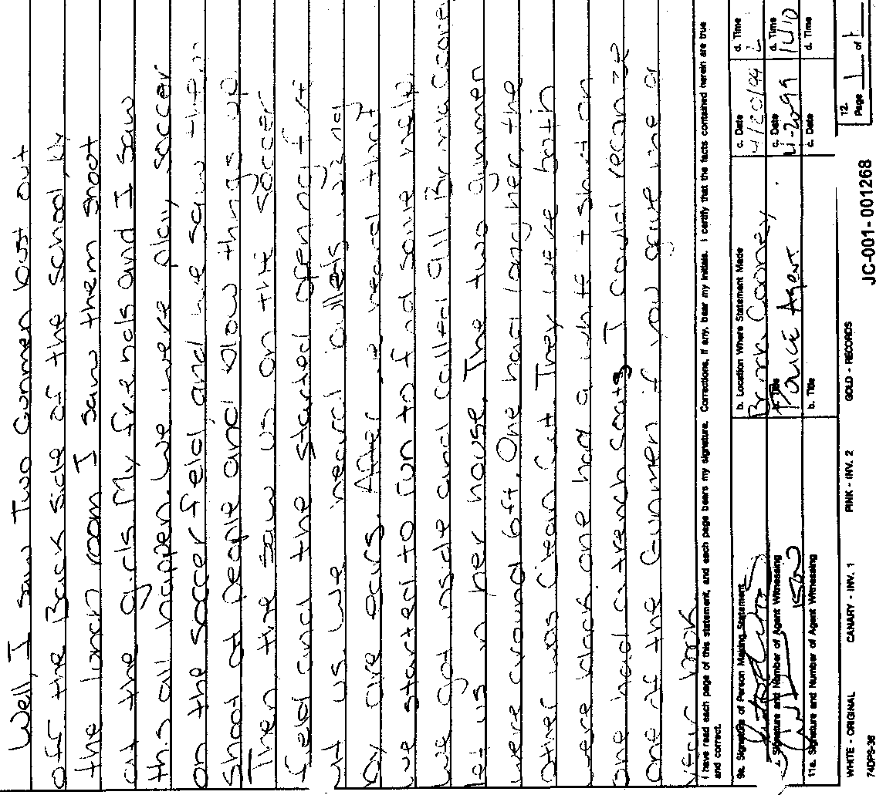,,

. ' ,,

.

•

''

Transcript of handwritten statement from Justin Woods

JC- 001- 001268

Well, I saw two gunmen bust out off the back side of the school by the lunch room. I saw them shoot at the girls. My friends and I saw this all happen. We were play soccer on the soccer field, and we saw them shoot at people and blow things up. Then, the saw us on the soccer field and the started opening fire on us. We heard bullets wising by our ears. After we heard that we started to run to find some help. We got inside and called 911. Brenda Cooney let us in her house. The two gunmen were around 6 ft. One had long hair, the other was clean cut. They were both wore black one had a white t-shirt on. One had a trench coat. I could recognize one of the gunmen if you gave me a year book.
CONTINUATION □  SUPPLEMENT | JCSO |  | RLSOCI | Case Report No  99-7625-L
Dale This Report
04-29-99
First Degree Murder |  |  |  | Recommend Case: R,-eview □  Closure □
WITNESS:

JUSTIN WOODS, DOB109-18-83
6231 South Garland Street Littleton, Colorado 80123
(303) 979-2198
Student: Columbine High School

INVESTIGATION:

At 1330 hours, I contacted Justin Woods by telephone in reference to a Murder in the First Degree. which occurred at Columbine High School, 6201 South Pierce Street, on 4-20-99.

During our conversation, Woods stated that he was playing a game of soccer with six other boys on the school's soccer field, which is located northwest of the school. I asked him who else was with him. He stated Brian Stepp, Art Curtis, and another student named Billy, and he didn't know his last name. He stated these were the three out of six students that he knew the
names of.

At approximately 1115 hours, Woods observed a male in a black trench coat and stated that this was Dylan Klebold. He informed me that he came out of the building and was kneeling down near the double doors, which are located on the west side of the building just north of the library. He stated that it looked like he was throwing firecrackers into the grass because he began hearing popping sounds. I asked him how far away he was from this person in the trench coat, and he stated about 50 feet. He stated that he then saw another person with a white short sleeve shirt, wearing black pants, and boots. He informed me that neither of these people had on hats nor masks. He stated the person with the white T-shirt was carrying a shotgun and that he was firing it, but he did not see anybody get hit.

Woods stated that, who he believed was Klebold in the trench coat had a handgun with a banana clip, and believed it was some

JC- 001- 001269

CONTINUATION □  SUPPLEMENT | Reporting Agency  JCSO |  | Reporting Officer  FELSOCI | 99-7625-L
Connecting Case Report No. |  | Victim Name Original Repon |  | Date This Re,,ort  04-29-99
X First Degree Murder |  |  |  | Recommend Case: Review □  Closure □

kind of machine gun.

Woods stated that he and Brian Stepp observed three girls get shot that were outside the cafeteria, near the parking lot. He stated that he believed one girl got shot more than eight times because they were trying to count the number of shots. He also saw the suspect in the white T-shirt lean up against the wall and fence with the shotgun and shoot toward a boy who fell down. He believed he was shot in the leg or his mid section. I asked him how he knew that and he stated, because he saw the area the person was bleeding from. I asked him how far away these victims were when they were shot, and he stated about 15 feet.

Woods stated that after he observed these suspects shooting at the students, he saw a lot of people running through the parking lot He told me that Klebold then started shooting at them and he heard bullets going by him. He stated at this time there were approximately 12 people in the soccer field because some were running northwest from the building toward them: H stated
that they ran up over the hill and hid and at that time he heard two explosions. He stated that he thought they were on the rooftop of the school because from where they were hiding they could see the high school roof and saw smoke rising from on. top of the library. They then began to run again toward a neighborhood and when be turned around to look. he observed both suspects walking down the exterior stairs, toward the cafeteria. He stated that he also saw more smoke in the parking lot, prior to going into the neighborhood west of the school to find some help.

Woods stated that Klebold was wearing a black hat and that the other suspect in the white T-shirt was clean cut and he also came out of the double doors when he had the shotgun.

DISPOSITION: Open.

JC-001- 001270

WRITZ, M

JC-001- 001271

,;..-

CONTINUATION SUPPLEMENT PETERSON
 | :
 |  | COLUMBINE | 06-14-99
x First Degree Murder |  |  | Recommend Case: | Review  Closure ·□

WITNESS

·

MICHAEL ROBERT WRITZ. DOB060482
8030 S. Yarrow Littleton. CO 80l-23 303-978,8946

PHYLLIS WRITZ
Same as above
work: 303-982-8855

.

Ed WRITZ
-

Investigation:

On 6-14-99, at 0930 hours, I contacted witness Michael Writz by telephone in reference to the shooting that occurred on 04-20-99 at Columbine High School. Michael Writz is a student at Columbine High School.
Michael Writz advised me on 04-20-00, at about 11:10 to 11:15 hours, he walked throught the cafeteria and then stopped at the bottom of the stairs to wait for his friends. Michael Writz said the friends that he was with were

.-

CONTINUATION JCSO PETERSON
 |  | Victim.Name Original Report  COLUMBINE | 06-I4-99'' • | L '-
,First Degree Murder

was walking with his arms and hands stiffly down toward his sides as if he was trying to conceal something. I asked Michael Writz if he thought this was odd at the time or if he thought about_ it later after the incident. and he said at the time he saw the· subject on 04-20-99, he thought it was suspicious then. Michael Writz said that the subject in the trench coat did not have anything in his hands at that time.

Michael Weitz advised me that he could provide no further information about the incident due to the fact that he was off campus
when it occurred. I gave Michael Writz my name and phone number and asked-me to contact me if he should recall any further information that may be pertinent to this case. Michael Writz said he would contact me in the future if he had any additional information.

'•

DISPOSITION
Case open pending further investigation

. .

·,

' •,./,
. ·'·
'

.-".;,:

,, '

·

JC-001-001273

·· _:

JC-001-001274

re..·.

- .'
Math Witnesses A-K
- K
' '
·,,

- ·1·

•••

':._,.

..,_.,,.,

.",.
-- -''
_; :.: ·-,,
·.,.<;
,_ 1'
- •, ' ·

, ..,, .'
.-.-,.::

':'·,

Abel, Victoria
_._.,
,

JC- 001-001275

,_•. ,.o-

UNCLASSIFIED
INFORMATION CONTROL

Case ID: Priority: Source: Afflliation:
Method of Contact
In Person O Telephone/Radio
Observation O Written

174A-DN-57419
PRIORITY Classification: UNCLASSIFIED
WEBB, R JCSO
Control Number: ON4320

Phone Number: (303) 271-5605 Information Received Date: 06/0711999 Time: 12:00 PM

Prepared by:
WEBB, RICHARD
/JEFCO SO
(Component/Agency)

Event Narrative: VICTORIA MARJE ABEL, 933-9312, STUDENT 5TH HOUR INT MATH I (TANK)

Event Date: Categories:
Event Time: References:
INTERVIEW STUDENT - CHS

Event Reviewed by: KE

Lead Required? YES

Lead:
INTERVlEW VICTORIA MARIE ABEL
Lead Control Number: ON4320

.. •,".",

Assigned To:
-----
ERZEN, LARRY
Date: 06/30/1999 Time: 11:07 AM

Disposition:
VICTORIA MARIE ABEL WAS IN MR. TANK'S 5TH HOUR CLASS. CLASS WAS ORDERED OUT OF SCHOOL BY MR. TANK THEY RAN TO LEAWOOD PARK. DIDN'T SEE ANY GUNMEN, HEARD GUNSHOTS OR EXPLOSIONS ONCE THEY GOT TO THE PARK. NO FURTHER INFO TO PASS ON. SEE #4319 FOR REPORT.

Lead Reviewed by: SL

Lead Completed? Date: 07/21/1999

Printed on 7/21/1999 at 9:03 AM UNCLASSIFIED Page I
JC-001-001276

AGUSTINI, VICTORIA

JC-001-001277

UNCLASSIFIED
INFORMATION CONTROL

Case ID:
Priority: Source: Affiliation:

174A•DN•57419
ROUTINE Classification: UNCLASSIFIED WEBB, RICHARD
JCSO

Control Number: ON4356

Phone Number: (303) 271-5605 Information Received Date: 06/07/1999 Time: 12.00 PM
Method of Contact
In Person O Telephone
Observation O Written

Prepared by:
WEBB RICHARD INVESTIGATIONS/JEFCO SO
{Last Name) (First Name) (Component/Agency}

Event Narrative: VICTORIA LEE AGUSTINI STUDENT IN 5TH HOUR GEOMETRY

Event Date: Categories:
Event Time: References:
INTERVIEW STAFF - CHS

Event Reviewed by: SL Lead Required? YES

Lead:
Lead Control Number: DN4356
DETERMINE OBSERVATIONS OF VICTORIA LEE AGUSTINI, 933-7645

Assigned To: LUCIANO, STEVE Date: 06/16/1999 Time: 9:03 AM
---------------------------------------

Disposition: PHONE INTERVIEW ON 6-18-99. VICTORIA AGUSTlNI WAS lN 5TH HR GEOMETRY, HEARD GUNSHOTS POSSIBLY IN HALLWAY. EXITED CLASSROOM/SCHOOL OUT TO LEAWOOD PARK. SPOKE TO HARRIS A COUPLE TIMES, ADVISED THAT HE HELPED HER FIND A CLASSROOM ON THE FIRST DAY OF SCHOOL

Lead Reviewed by: SL Lead Completed? Date: 07/07/1999

Printed on 717199 at 1:19 PM UNCLASSIFIED

JC-001- 001278
Page 1

AHLSTROM, A

JC-001-001279

FBI 174A-DN-57419
Jcso 99-7625
Dotective: Marie Allen-Denver Police Department / (303) 640-1183

RE: CONTROL# 3204
INTERVIEW:
Adam Alhstrom
7310 W. Fairview Dr.
Littleton, CO 80123
(303) 979-5525
Subject Columbine High School Shooting,

OnS/14/99 I interviewed Adam Alhstrom at his residence 7310 W. Fairview Dr. Adam reported that he entered the cafeteria at approx. 10:20AM and he left at approx. 11:12AM and he came from his math class. Adam said he sat at table Y with Matt Zago, Joe Pitoniak. Shakespeare Log and Nathan Epling. Adam said he didn't observe the duffel bags or anyone carrying the bags in or around the cafeteria area. Adam said he didn't observe any TCM or associates in the cafeteria and that didn't know any of the TCM.

Adam said he was in his math class when he heard loud noises and people screaming in the hallway. Adam said a girl was banging on the outside of the classroom window yelling something. Adam said he exited through a nearby door and then he went to Leawood Park. Adam said he didn't observe the shooters inside the school and he didn't see any TCM outside the school. Adam said that his friend, Nathan Epling saw Mr.
Sanders get shot.

NO new leads generated.

JC-001-001280

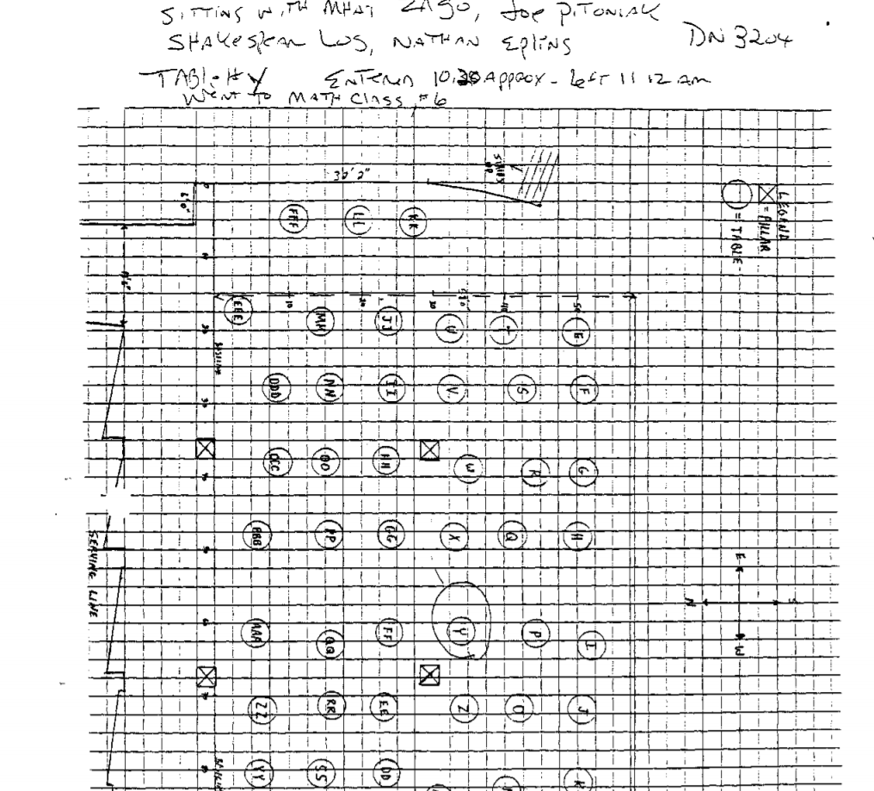

JC- 001- 001281

ARAPKILES, A

JC-001-001282

Offense MURDER
LAKEWOOD POLICE DEPARTMENT

R-1 SCHOOLS
1173 STEFFES, TIMOTHY

S U P P L E M E N T
Data, 05/05/99
Page, 1 of 2

-------------------------------------------------------------------

ASSOCIATED CASE REPORT NUMBERS:
JEFFERSON COUNTY SHERIFFS C.R.: 99-7625 FBI CONTROL NUMBER: 174A-DIV-57419
SUBJECT:
ARAPKILES, AMANDA
DOB, 09/30/81
7824 WEST ONTARIO PLACE LITTLETON, CO.
(303) 973-5026
PARENTS:
MOTHER: MARY SUE ARAPKILES FATHER: WILLIAM ARAPKILES
OBSERVATION/ INVESTIGATION:
ON MAY 4, 1999 I WAS ASSIGNED XO INTERVIEW AMANDA ARAPKILES A STUDENT AT COLUMBINE HIGH SCHOOL, AND WAS POSSIBLY IN THE CAFETERIA AT THE TIME OF THE SHOOTINGS.
ON MAY 5, 1999 AT 0800 I WENT TO 7824 W. ONTARIO PLACE AND CONTACTED AMANDA AND HER PARENTS. AMANDA CONFIRMED THAT SHE WAS A STUDENT AT COLUMBINE HIGH SCHOOL AND WAS IN THE ELEVENTH GRADE. SHE ADVISED THAT SHE WAS AT SCHOOL ON APRIL 20TH BUT WAS NOT IN THE CAFETERIA. AMANDA RELATED THAT SHE WAS IN HER MATH CLASS AT THE TIME OF THE SHOOTINGS. SHE CONTINUED TO SAY THAT SHE HAD BEEN IN THE CAFETERIA BETWEEN 0930 AND 1015 ON APRIL 20TH. SHE SAID THAT SHE HAD BEEN SITTING AT A TABLE LOCATED IN THE HALL WAY TO THE SOUTH-EAST EXIT FROM THE CAFETERIA. AT THIS TIME SHE DID NOT SEE ANYTHING LIKE A DUFFEL OR LARGE GYM TYPE BAG IN THE CAFETERIA. SHE STATED THAT THERE WERE A FEW OTHER STUDENTS IN THE CAFETERIA DOING HOME WORK AT THE TIME SHE WAS THERE. THEY WERE SEATED MOSTLY AT THE TABLES ALONG THE EAST END OF THE CAFETERIA.
ACCORDING TO AMANDA SHE HAD LEFT HER MATH CLASS IS LOCATED ON THE MAIN LEVEL OF THE HIGH SCHOOL AT THE FAR EAST END OF THE BUILDING NEAR THE MAIN ENTERANCE. SHE CONTINUED TO SAY THAT SHE LEFT THE CLASS TO USE THE REST ROOM, AND WHEN SHE CAME OUT SHE ENCOUNTERED A STEPHANIE LOHRENZ. AT THIS SAME TIME A JOEY MILLAZZO CAME RUNNING BY AND TOLD THEM TO GET OUT OF THE SCHOOL BECAUSE A GIRL HAD BEEN SHOT. AT THIS TIME AMANDA HEARD THREE GUN SHOTS COMING FROM THE WEST END OF THE SOUTH MAIN HALL. SHE THOUGHT FROM THE AREA OF THE STAIR WAY BETWEEN THE LIBRARY AND CAFETERIA. AMANDA SAID

JC-001-001283

LAKEWOOD CO PD Page 2 of 2
Supplement 05/05/99 1173 STEFFES, TIMOTHY
CR;# 98038856

THAT SHE DID NOT PAY MUCH ATTENTION TO WHAT JOEY SAID BECAUSE OF SENIOR PRANKS. AT THIS TIME SHE OBSERVED A LARGE NUMBER STUDENTS RUNNING UP THE STAIRS FROM THE CAFETERIA AND COMING DOWN THE HALL TOWARDS HER.
AMANDA ADVISED THAT SHE WENT BACK INTO THE CLASS AND TOLD THEM TO GET OUT OF THE BUILDING. SHE RELATED THAT AS THEY WERE GETTING READY TO LEAVE A TEACHER TOLD THEM TO RETURN TO THE CLASS ROOM. AMANDA SAID THE CLASS DID GO BACK INTO THE ROOM BUT SHE CONVINCED HER MATH TEACHER TO LEAVE THE BUILDING WHICH THEY DID BY WAY OF THE MAIN ENTRANCE. AMANDA REPORTED THAT SHE DID NOT SEEN ANYONE WITH A GUN NOR DID SHE SEE WHO WAS SHOOTING.
AMANDA ADVISED THAT SHE DID KNOW ERIC HARRIS FROM THEIR FRESHMAN YEAR BUT SHE HAD HAD NO REAL CONTACT WITH HIM. SHE CONTINUED TO SAY THAT A MUTUAL FRIEND, RYAN SCHUMER, DID KNOW ERIC AND THAT SHE HAD BRIEFLY TALKED WITH ERIC IF HE WOULD SIT DOWN WITH HER AND RYAN. SHE ALSO REPORTED THAT THERE HAD BEEN NO RUMORS ABOUT IMPENDING TROUBLE ON THE 20TH NOR HAD THERE BEEN ANY MENTION OF SOMETHING HAPPENING TO CELEBRATE HITLER1 S BIRTHDAY. SHE ADVISED THAT SHE DOES NOT KNOW ANYONE ASSOCIATED WITH THE TRENCH COAT MAFIA AND SHE DOES NOT HAVE ANY CONTACT WITH THEIR MEMBERS. SHE RELATED THAT SHE HAD ENCONCOUNTERED THEM IN THE HALL WAYS. THEY WOULD USUALLY BE WALKING SHOULDER TO SHOULDER DOWN THE HALL FORCING OTHER STUDENTS OUT OF THE WAY. AMANDA DID SAY THAT A FRIEND, BROOKS BROWN, DID KNOW SOME THE THE T.C.M. MEMBERS BUT SHE DID NOT KNOW IF HE WAS PERSONALLY INVOLVED WITH THE GROUP.
AMANDA REPORTED THAT SHE HAD LEFT HER PACK IN THE MATH ROOM. SHE DESCRIBED THE PACK AS A BLACK AND BROWN GYM TYPE BAG WITH HANDLES AND A SHOULDER STRAP. THE BAG CONTAINED HER NOTE BOOKS, A VOCABULARY BOOK, AN
ASSIGNMENT BOOK, AND PERSONAL SCHOOL PAPERS.
AMANDA ADVISED THAT SHE IS NOT FAMILIAR WITH ANY NAMES THAT HARRIS OR KLEBOLD MIGHT HAVE BEEN USING ON THE INTERNET.
AMANDA COULD PROVIDE NO ADDITIONAL INFORMATION AND THE INTERVIEW
CONCLUDED AT 0900.

---------------------------------------------------------------------------
Agent.: 1173 STEFFES, TIMOTHY rme<!: 05/07/99 17:12
sergeant., 1514 HINKLE, GEORGE 05/07 /99 13: 07
----------------------------------------------------------------------*EOR*

JC-001-001284
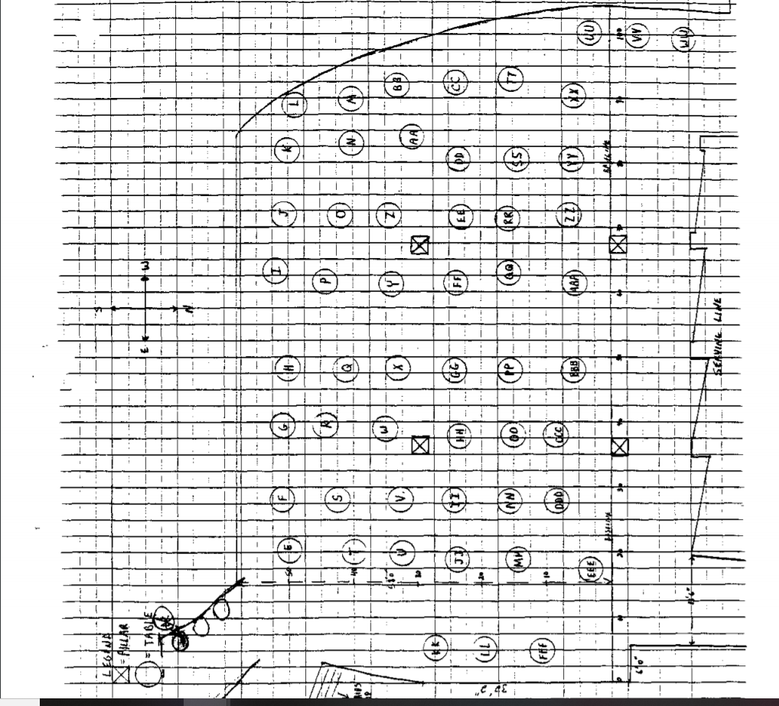

JC-001-001285

ASHTON, ADAM

JC-001-001286

INFORMATION CONTROL
CONTROL NUMBER

SOURCE Sgt Rich Webb
Affiliation: JCSO
Phone Number: 271- 5605

Prepared by- Sgt Webb

NARRATIVE

Student 5th hour Algebra I

Method of Contaci:-
In Person Telephone
_ Observation _ Written

Date 6-7-99 Time 1700

Narrative reviewed by: Lead Set'? (YIN): Yes

Assigned to: (Zimmerman) Date 060799
LEAD: Determine observations

Adam Kyle Ashton
797-2649

Disposition: I have attempted to contact Adam (Kyle) Ashton 11 times. Both of his parents, Kevin and Kathy Ashton have assured me he will call me but he has not. According to attendance, Ashton was present for Mr. Bundy’s class. No significant information has come from those in class. Lead should be closed or forwarded to another investigator.

JC-001-001287

JC-001-001287

Pink • Lead

BAER, JUSTIN

JC-001-001288

Denver Police Department
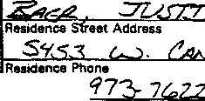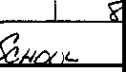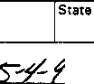STATEMENT

City
Making Statement is:
□ Officer
Cownv
Busmess Phone
Social Security No.
Date of Binh / Serial No.
lfu-slness Street Address
Cify
County
Zip Code
Serial No.
Date
Time
7-7
-
Hours
Concerning in1nadent·occurriOg at:
Location where statement taken:

Case No.

Summary of Statement:

Transcription of handwritten statement. Justin Baer

I was in the mat room and some girl ran in and said someone’s shooting, so we ran outside. We ran across the street to leawood Park. We waited out there for a while and I saw one of the trench coat guys come outside. We heard some shots and ran out into the neighborhood. I ran to Christina Bells house.
While we were in the park I heard about 3 shots and a bang. There was smoke on the roof.

I think the one who came out might have been Dylan, but I’m not sure.
I talked to Eric some during 1st semester, he was quiet. I would talk to him about the Family Values concert tour or say “What’s up”

I have read the foregoing statement and the facts contained therein are true to the best of my knowledge and belief. I do not maintain that it contains all of the facts or details of the incident, but only those facts about which I have been asked.

JC-001-001289
Page of Pages Case#

Summary of Statement (cont.)

In the hall because my friend ------- would talk to him. I saw her later and she said she was on his list.

During 1st semester I was in gym + Eric had a class then too. One day we were playing “Biff” (like Dodge ball, but every man for himself). Eric won the first game, but the second game some jocks ganged up on him _ were hitting him in the face w/ balls. Then after gym they were pushing him into lockers.
Last Friday (the 30th) Melissa Chavez told Abigail + Christine Bell at the Pretzel Maker (SW Plaza) where I work that she was friends with Eric + Dylan. She was with them and about 6 other people + they were talking about getting bombs + blowing a place up. They had a blue print. She said that she didn’t know what building it was. She said she had learned about it at the beginning of the year and a friend of hers had called the cops but they didn’t do anything about it. The next day she said she was tired of the other workers making fun of her, so she quit. She told Shannon that she didn’t know the other people, but she could identify them.

JC-001-001290

Page 3 of 3 Pages

Denver Police Department
STATEMENT

Summary of Statement:

On Saturday Melissa told the manager that she needed to go for a walk. She walked off fast and about 5- 10 minutes she walked back fast. She seemed nervous + wouldn’t look @ anyone. There were 3 guys with trenchcoats who were behind her. But I didn’t know if she was with them. She quit and then walked out. Shannon went out + talked to her and that was when she was told about the beginning of the year. Melissa went outside + then came back in w/ one of the guys. He was looking at me + Jason like he was on drugs or something. Melissa smiled at him and then they left.

I have read the foregoing statement and the facts contained therein are true to the best of my knowledge and belief. I do not maintain that it contains all of the facts or details of the incident, but only those facts about which I have been asked.

JC-001-001291

Signature of Person Making Statement

JC-001-001291

"

CONTINUATION SUPPLEMENT

Witness:
Baer, Justin DOB 5-2-82 973-7622 5453 W Canyon Tr Littleton CO 80128

Investigation:
About 0920 hrs I conducted a phone interview with (W) Baer. (W) Baer said he was in the math room on the 2nd story when a girl (unkn) came into class and said, “There are kids shooting people and blowing up the school.” (W) Baer said the kids in the room started leaving to exit the school via a nearby exit door. As he was enroute to the exit door she saw (S) Harris by the science room shooting a shotgun at nearby people (2 shots). (W) Baer did not see anyone appear to get shot. (W) Baer ran to the exit door and across Pierce to Leawood Park. While in the park he saw (S) Harris come outside the school and shot the shotgun several times. Then he threw a bomb onto the roof of the school. At that point (W) Baer ran from Leawood Park to a friends home (Mary Bell) nearby. From there he called his mom at home.
(W) Baer said he had talked to (S) Harris a few times in gym class during the year. (S) Harris never indicated he had any anger or was going to do anything like this.

Dispo: Open

JC-001-001292
(

BALLEGEER, M.

JC-001-001293

CONTINUATION  SUPPLEMENT X |  |  | LOCK | 99-7625
 |  | TOWNSEND |  | 5112/99
HOMICIDE |  |  |  | Recommend Case: Review  Closure

WITNESS:
BALLEGEER, MARK, DOB: 3120183
6272 West Cross Drive Littleton, CO 80123
Ph: 303-734-9682
CONTROL NUMBER: 3233 INVESTIGATION:
On 5/12/99, I met with Mark Ballegeer at his residence reference the Columbine shooting. I asked Mark if he had been in the cafeteria on the morning of the shooting and he said he was there during fourth hour. I brought out a sketch of the cafeteria and asked Mark if he could circle the table where he was sitting. Mark circled table "U" and placed an "x” where he was sitting. Mark said he was in the cafeteria between 10:30 and 11:05. I asked where he came from and he said he was coming from History and went directly to the cafeteria because he has fourth hour off. Mark said after fourth hour he went to his Math class. I asked him
to expIain to me what he heard or saw at that time. Mark said that he heard screams in the hallway and
heard bombs going off while he was in his Math class. Mark said it sounded like they were coming from the area of the Science room and then he heard the fire alarm go off, so he thought that a Science project might have gone bad and caused the explosion and the fire alarm to go off. Mark said that his teacher then told them to get out of the room and they ran south into the adjoining room and down the hallway and exited on the south side of the school into the Junior parking lot. He then went to Leewood Park. I asked if he heard any shots being fired while he was in the school and he said yes, he heard numerous shots while outside and he believes he heard some in the school also. I asked if he heard any explosions while in the school and he said he didn't remember, but he does know that when he was out of the school he heard some explosions coming from, what he believed to be, the cafeteria area. I asked Mark if he saw any other shooters or who was setting off the explosions, and he said no, he did not. l asked Mark if he had seen two large duffel bags while he was in the cafeteria and he said, no. I asked if he had seen anyone carry in or in possession of large duffel bags and he said, no, he had not. I asked if he knew who Eric and Dylan were and he said not until this happened. He said he had seen them in school, but never knew who they were. I asked if he remembers seeing them on Monday or Tuesday and he said "no". I asked if he left anything in the cafeteria and he said no, but that he left his East Pack backpack in the Math room. I asked if he had seen or talked to any of the Trench Coat Mafia members on Monday or Tuesday. He said, no, he had not because he doesn't hang around any of them. I asked if he had heard any rumors about any other suspects, bomb making or buying of guns and he said, no, he had not. I asked what he was wearing that day and he said "blue jeans, an American Eagle blue shirt, and tennis shoes". I asked Mark if he uses the Internet and he said, yes, he does. I asked if he has a screen name and he said it's "Mark-444444". I asked if he recalled anything on the Internet prior to the shooting and bombing. He said,"no”. I asked if he had seen anything since then and he says he remembers seeing something last week reference the bombing.

JC- 001-001294
CONTINUATION
SUPPLEMENT

I
X

JCSO

TOWNSEND
Classification
x Homicide

No

Brand Name
I Description
I Serial No
Value iI Value
Recovered Damaged
I
Val
Stolen
Recommend Case: Review
Closure

.
'
5112199
99-7625

LOCK

I asked what it was and he said it was an E mail stating that "the Trench Coat Mafia will strike again." I asked if he had copied this off of the computer and he said, no. I asked if there was any screen name on the message and he says he does not remember. I asked if the message was still on his computer and he said no, he deleted it. I asked Mark if he knows anyone with a double pierced eyebrow and he said, no. I asked if he saw or heard any unusual announcements prior to the shooting and he said he does remember seeing the announcement stating "Today will not be a good day". I asked if he saw the whole announcement or part of it and he said he remembers seeing the whole announcement from beginning to end and that's all it said. I asked if he could provide any further information on the Trench Coat Mafia and he said, no, he could not. I asked if he had any further information that would assist with this investigation and he said, no. I gave Mark a business card and asked that he call if he remembers anything else. At this time the interview with Mark was concluded.

The following students were sitting with Mark at the table during fourth hour: Mike Leary
Chad Roybal
Josh (a Freshman?)
Eric Trujillo
Travis Meason
Jason Jones

JC-001- 001295

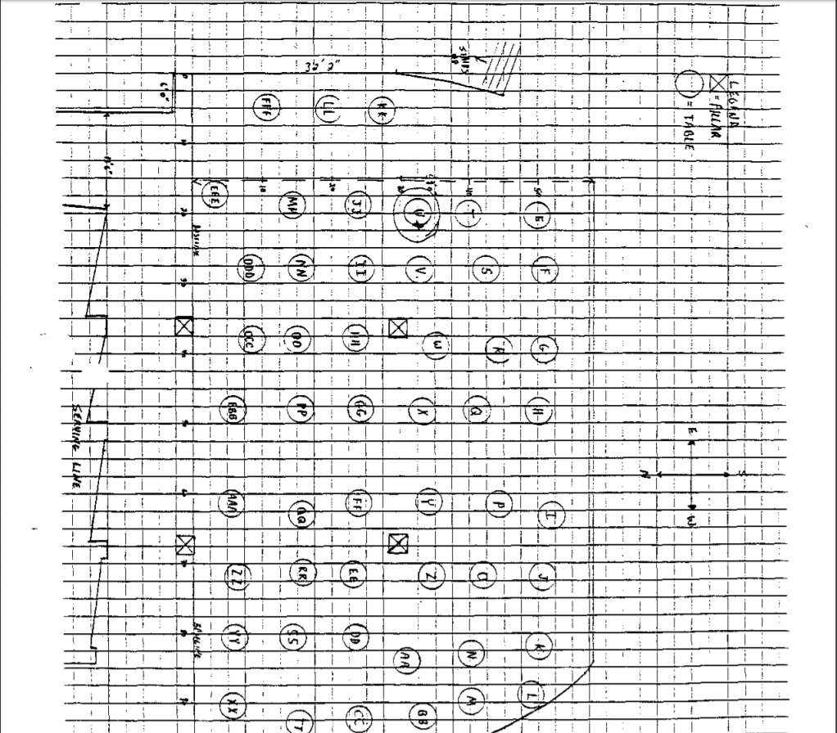

JC- 001-001296

BARNES, MARY

JC-001-001297

CONTINUATION □  SUPPLEMENT | JCSO |  | Reporting Officer  PETERSON | Case Report No  99-7625-PPPP
 |  | Victim Name Original Report  COLUMBINE H.S. |  | Date This Report  7-9-99
X 1/MURDER |  |  |  | Recommend Case, Review □  Closure: □

WITNESSES
MARY REBEKAH BARNES, DOB/1-8-84 8337 SOUTH UPHAM WAY #101
LITTLETON, CO 80128
303-979-9038

DEBBIE BARNES
SAME ADDRESS/PHONE AS MARY

MARK G. BARNES
SAME ADDRESS/PHONE AS MARY
WORK: 303-792-7525 CENTENNIAL AIRPORT

INVESTIGATION
On 7-9-99, at about 1400 hours I contacted witness Mary Rebekah Barnes who is a Columbine H.S. student. [ contacted her reference an interview in regards to the shooting that occurred at Columbine H.S. on 4-20-99.

Mary Barnes advised me that on 4-20-99 she arrived at Columbine H.S. at approximately 0745 hours. Mary said she recalls this time because she was late getting to that class by approximately fifteen minutes. Mary said she went to her classes and during fourth hour class time she said she was in the cafeteria at Columbine H.S. Mary said she was with approximately ten friends in the cafeteria/commons area, and she described the location they sat at as a stone bench at the bottom of the stairway. Mary said while she's going down the stairs toward the commons area, she turns to her left at the bottom of the stairs and there is a stone bench there. That's where she and her friends had gathered to talk. I asked Mary if she recalled seeing any duffle bags or propane tank in the cafeteria, such as the ones that were later recovered. Mary said she recalls seeing people with duffle bags, however she believed they were athletic bags being carried by the athletes that she saw. Mary said she did not see the propane tank prior to or during the incident.
JC-001-001298

CONTINUATION  SUPPLEMENT | JCSO |  | PETERSON | Case Report No  99-7625-PPPP
 |  | Victim Name Original Repon  COLUMBINE H.S. |  | Date This Repon  7-9-99
X I/MURDER |  |  |  | Recommend Case: Review □  Closure □

Mary Barnes said at approximately 1115 hours, on 4-20-99, she went into her geometry class which is on the upper level of Columbine H.S. She told me the teachers names in that class are Ms. Moore and Mr. Ortiz. Mary said once she got into the classroom. the students checked their homework at the beginning of the class. Mary said on 4-20-99, the students who had gone to this class were "goofing off." She said within approximately ten minutes of the beginning of the class, she heard a loud bang, and then said she heard another loud bang. Mary said Ms. Moore and Mr. Ortiz exited the classroom and went into the hallway to check on what was taking place. Mary said when they exited the door into the hallway, she could hear running in the hallway and screaming. Mary said Ms. Moore was the first to return. and said she returned to classroom by herself Mary said Ms. Moore was trying to lock the door to the classroom, but due to being scared she was unable to get the key in the lock. Mary said just as Ms. Moore was getting it locked Mr. Ortiz returned to the classroom. Mr. Ortiz told the students in the class. ·'They have a gun, they have a gun, get out of here as fast as you can." Mary said the students, including herself exited the classroom very quickly into the hallway, and as she did she said she heard numerous gunshots. Mary said these shots were possibly coming from the commons/cafeteria area of Columbine H.S. She said she could see smoke from the air coming up from the commons area.
Mary also described the door of the school she exited next. She said this is the door that's on the east side of Columbine HS. and south of the main entrance and administrative offices. Mary said after exiting the school through this door she ran across South Pierce Street, away from Columbine H.S. and into Leawood Park. Mary estimated she was in Leawood Park with other students and teachers for approximately thirty minutes. She said while she was in Leawood Park. she was watching other students run away from Columbine H.S. through the exits. Mary said after approximately thirty minutes of being in Leawood Park. she heard more gunshots and left Leawood Park. She said she went into the surrounding subdivision to a friend of hers house, by the name of Denise.

[ asked Mary if she looked toward Columbine H.S. when she heard the last shots. She said no, she tried not to look because she was scared Mary said at no time during the incident on 4-20-99, did she see any of the suspects, nor did she see anyone with any weapons or explosive devices.

I asked Mary Barnes what she knew about the Trench Coat Mafia. Mary told me that her brother, Josh Barnes, is a prior member of the Trench Coat Mafia students. She said she knew some of the other members. Due to the fact that Josh had brought them
home to their house in the past. Mary said Josh has not been involved in the Trench Coat Mafia for approximately the past two

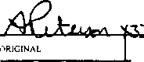 -Offic-er Sig-natu-rre
------
-
-

;

of
Page l
JC-001-001299
CONTINUATION □  SUPPLEMENT | JCSO |  | PETERSON | Case Report No  99-7625-PPPP
 |  | Victim Name Original  COLUMBINE H.S. |  | Date  7-9-99
X I/MURDER |  |  |  | Recommend Case: Review 0  Closure 0

years. I asked Mary to tell me more about the Trench Coat Mafia. She advised me that they are, "social outcasts." She said they have very poor attitudes toward life. and she said they did not care about anybody. Mary said after the shooting on 4-20-99, she talked to her brother, Josh Barnes, and Mary said when she said the Trench Coat Mafia students had been involved in shooting people, Josh acted like he did not care what so ever about what had happened. Mary said she knew Eric Harris to be a nice, but "a different type of a person." She said Eric Harris was a "very moody" type of a person. Mary said she did not recall seeing Eric Harris wear a trench coat, however, he did wear "dark depressing clothes." Mary said she is referring to his black clothing, and this is why she classified him as an outcast. Mary said she did not know anything further about Eric Harris and said prior to 4-20-99, she did not know Dylan Klebold, however. she did remember seeing him at times with Eric Harris at school. Mary said she has known ------------- since they went to kindergarten together. Mary said that ------- was very ''violent" when he gets mad. She also said he had, "a really bad attitude." Mary said in fact one time when she was approximately nine years old, --------- punched her in the stomach "out of the blue." Mary said she does not know what caused him to hit her in the
stomach. Mary said she tried to stay away from -------------- due to his "poor attitude" and the "way he treats people." Mary
said she knows of one other person by the name of ------------ but does not know his last name. She said ------------ is usually very nice and nice to her, however. he displays a very "hateful attitude" toward people. Mary also said he talked about "hurting people.'' I asked her if ---------- talked about killing people, she said no he did not get to that point in his conversations. Mary said -------- did play violent video games such as "Doom." Mary, at the time of the interview, said she could not provide any further information about these individuals or about the Trench Coat Mafia. due to the fact she has tried to distance herself from that type of people for approximately the last two years. Mary said when she talked to her brother, Josh after the shooting on 4-20-99, that was last time she talked to him, and she has not had any type of communication with him as of recently

Mary Barnes advised me she does not know of any other suspects that may have been involved in the shootings, either prior to, during, or after 4-20-99 Mary said she does not know of anybody, nor has she heard rumors of anybody who may be manufacturing explosive devices, and/or buying or selling firearms.

I asked Mary Barnes if she considered herself a Trench Coat Mafia student, or a Trench Coat Mafia student associate. She said definitely not, and again told me she has distanced herself from this type of people that are in this group. Mary said in fact she had several friends that were victims of the shooting on 4-20-99.

JC-001-001300

CONTINUATION □  SUPPLEMENT | Reporting Agency  JCSO |  | PETERSON | CaseReportNo  99-7625-PPPP
Connecting Case Report No. |  | Victim Name Original Report  COLUMBINE H.S. |  | Date This Report  7-9-99
X 1/MURDER |  |  |  | Recommend Case: Review □  Closure, 0  :

I asked Mary how she has been doing since the shooting on 4-20·99. She said she had some problems earlier, as did other members of her family, including younger children in her family. Mary said she has seen a counselor. I gave Mary my phone number and asked her to contact me if anyone wanted to talk with a JCSO Victim Advocate. I told her this Victim Advocate would be glad to talk with her or any of her other family members if they so desired in the future. I advised Mary to contact me if they did want to visit with one and I would make the necessary arrangements for them at that time. Mary also said she is going to think back and try to locate more information about the Trench Coat Mafia, and various Trench Coat Mafia students. She said if she gets that information she will contact me in the future and relay it to me.

DISPOSITION Open, pending further investigation

JC-001-001301

BEERY, CHANTEL

JC-001- 001302

COLUMBINE HIGH SCHOOL TASK FORCE

CONTROL NUMBER: JCSD CASE NUMBER: FBI CASE NUMBER:
GOLDEN POLICE NUMBER: REPORT DATE: DETECTIVES:
1147
99-7625
174A-DN-57419
99-1362
05/14199
Jon Watson Jeff Kreutzer

Background:
KEATING reported that Chantel BEERY (08-31-83 / 8417 S. Otis St.) was an associate of TCM and HARRIS.

Lead:
Interview BEERY

Disposition:

SUBJECT: Chantel BEERY
DOB: 08131183
8417 Otis St.
Littleton, CO 80128
(303) 933-9509

BEERY was interviewed at her residence on May 13, 1999, in the presence of her father, Doug BEERY.

BEERY is a sophomore at Columbine High School. In her freshman year she was friends of members of the trench coat mafia. She was acquainted with Brian SARGENT, Chris MORRIS, Joe STAIR, a girl named PAULINE - whose last name she did not know - and Kristen Theibault.
BEERY said THEIBAULT is in her second hour choir class.

BEERY recalled that the members and people who associated with them used to hang out in the area of the commons where the vending machines are located. BEERY said the members of the group used to play a card game during off periods, which was some type of "war" game, played with a special deck of cards. She recalled that the TCM was formed before she started at Columbine last year.

BEERY told detectives that she thought the trench coat "mafia thing was over before school let out last year".

BEERY was assigned to "B" lunch. At the time of the shooting, BEERY told detectives she was in Math class, and when the teacher told them to leave they all departed the building through an adjacent door and went across the street to the park. She said the teachers kept moving the students back, and at one point she said someone began shooting toward them from the area of the main office, so they all ran. She did not see who was doing the shooting.

JC-001- 001303

COLUMBINE HIGH SCHOOL TASK FORCE

CONTROL NUMBER: JCSD CASE NUMBER: FBI CASE NUMBER:
GOLDEN POLICE NUMBER: REPORT DATE: DETECTIVES:
1147
99-7625
l 74A-DN-57419 99-1362
05/14/99
Jon Watson
Jeff Kreutzer

BEERY was minimally cooperative. She provided answers to direct questions, but would not elaborate; nor would she volunteer information.

It should be noted that Doug BEERY advised detectives that his brother is a Jefferson County Sheriff's Department deputy.

No further action at this time.

JC-001-001304

BEHOUNEK, ANN

JC-001- 001305

UNCLASSIFIED
INFORMAT/ON CONTROL
Control Number: DN4341

Case ID: Priority: Source: Affiliation:
174A-DN-57419
PRIORITY, Classification: UNCLASSIFIED WEBB, RICH SGT
Method of Contact
In Person Telephone
Observation Written
JCSO

Phone Number: (303) 271-5605 Information Received Date: 06/08/1999 Time: 11 00 AM

Prepared by:
WEBB RICHARD INVESTIGATIONS/JEFCO SO
(Last Name) (First Name) (ComponentAgency)

Event Narrative: ANN KRISTINE BEHOUNEK !N 5TH HOUR ALGEBRA (HAVENS) SEE 4339 FOR
REPORT.

Event Date:
Categories:
Event Time: References:
INTERVIEW STUDENT - CHS

Event Reviewed by: SL Lead Required? YES

Lead:
Lead Control Number: ON4341
DETERMINE OBSERVATIONS. ANN KRISTINE BEHOUNEK 978-9211

Assigned To: TRAVER.MATT Date: 06/23/1999 Time: 10.31 AM Disposition: ANN BEHOUNEK TAKING TEST, DID NOT HEAR ANYTHING, SAW PEOPLE &
HEARD PEOPLE RUNNING OUT SCREAMING, FIRE ALARM WENT OFF, EXITED CLASS WENT TO PARK. HEARD THAT PEOPLE WERE SHOOTING, RAN INTO SAMARITAN'S HOUSE & STAYED FOR A WHILE.

Lead Reviewed by: SL Lead Completed? Date: 07/06/1999

JC-001- 001306

Printed OD 7/6/99 at 2:17 PM UNCLASSIFIED Page 1

BIEHL, BEN

JC-001- 001307

CONTINUATION □  SUPPLEMENT X | JCSO |  | OBBEMA | Case Report No  99-7625-F
 |  | Victim Name Original Report |  | Da1e This Report  04-24-99
X FIRST DEGREE MURDER |  |  |  | Recommend Case: Review  Closure

WITNESSES:
Ben Biehl, dob/06-26-82 5609 West Alder Way Littleton, Colorado 80128
(]03)933-1652

Student at Columbine H.S.

INVESTIGATION:
On 04-23-99, at about 1740 hours, I interviewed Ben Biehl over the phone. He stated he saw ---------- walking into the gym in the middle of the day a few weeks before the shooting. He stated he hadn't seen ------- in a long time, and was surprised to see him in the gym. He stated that ------------------ may be a student in the school, and if so, he had every right to be in the school gym at the time.

Biehl stated two students named Phil and Nathan Vanderau (phone 303-971-0536)could have some more information. He
stated Phil Vanderau was shot at by the suspects. He also stated that an Eric Moody (phone 303-932-9041) worked with the suspects at Blackjack Pizza.

DISPOSITION; Open.

JC- 001-001208

CONTINUATION □  SUPPLEMENT | JCSO |  | MOORE, C. | Case Report No  99-7625-HHHH
 |  | Victim Name Original Report  COLUMBINE |  | 06-22-99
X FIRST DEGREE MURDER |  |  |  | Recommend Case, Rev1!W □  Closure □

ADDITIONAL WITNESS:

BENJAMIN BIEHL, DOB/06-26-82
5609 West Alder Way
Littleton, CO 80128
303-933-1652

INVESTIGATION:

On 06-22-99, I was assigned Lead #4202 to interview Benjamin Biehl, a Columbine High School student on 04-20-99, who had fifth hour Algebra I class with Mr. Bundy.

On 06-22-99, at about 1104 hours, I contacted the listed phone number for Biehl, 303-933-1652. I told Biehl that I was contacting Columbine High School students who had been registered for Mr. Bundy's fifth hour Algebra I class. I asked Biehl if he was at Columbine High School on 04-20-99 and he stated that he was. I asked Biehl if be was in Mr. Bundy's class and he stated that he was. I told him that my understanding was that class actually started at 11:15. I asked him, following class starting, what his first indication was that something was wrong. Biehl stated the first thing he heard was the fire alarm. He stated this went off ten to fifteen minutes after class started. Biehl stated that Mr. Bundy was giving a pop quiz which was to last fifteen minutes and it hadn't yet been finished. Biehl stated that an unknown teacher ran by and told them to get out of the class. He stated this teacher ran by about fifteen seconds after the fire alarm went off. Biehl stated the teacher was unknown to him, but was a white male, 35-40 years of age, 6'2", medium build, with, possibly, brown hair. He stated the male teacher was yelling "get out of the building." Biehl stated that once he entered the hall, people seemed "unusually panicked for a fire alarm." He stated that most people were actually running. Biehl stated they left the math hall and went into the main hall where he saw smoke. He stated that he went outside to the normal area for a fire alarm and the teachers told them to keep going. Biehl stated this was actually the first time that be believed something was actually wrong. He stated that he had been sitting in the class with John Ungerland and Shaun Downey.
JC-001• 001309

CONTINUATION □  SUPPLEMENT | JCSO |  | MOORE,C | Case Report No  99 7625-8888
 |  | Victim Name Ongiaal Report  COLUMBINE |  | Om This Report  06-22-99
X FIRST DEGREE MURDER |  |  |  | Recommend Case: Review □  Closure, □

I asked Biehl if there was anything that be had either beard or seen, either prior to or since the incident which be thought may help us. He stated there was not. Biehl then stated, "You know about the red Geo." I asked him what he meant. He stated that later that afternoon, John Ungerland was driving around in order to find his girlfriend After picking up his girlfriend. they were driving through the neighborhoods and his girlfriend commented that a passing car had a camera in it. Ungerland looked at and saw that the red Geo had a male in it with a gun. Biehl stated that three days later. he was at Clement Park, trying to get close, when he saw that the police had a red Geo stopped.

I asked Biehl if he knew either Eric Harris or Dylan .Klebold. He stated that he did not. I asked him if he recognized either one of them and he stated he did not. I asked him if on 04-20-99, he had been in the cafeteria at all during the day. He stated that he had walked in through the Commons and up the stairs and had come back down to a computer class at about 0725. I asked him if he noticed anything unusual in the cafeteria area at that time. He stated he did not. I asked him if there were any people in there. He stated at that time of day there are not a whole lot, although sometimes some freshmen who have no other place to go hang out there. Biehl stated that he is not too awake that time of morning and truly doesn't notice things.

I asked Biehl if there was anything else that he thought would help. Biehl stated that he was sure we would know that there were more than two people involved. I asked him why he felt that way. He stated that some girl who lives down the street from him had been in the cafeteria during the incident. I asked who that was and he stated that it was Brittany Weeden (unknown spelling). Biehl Stated that Weeden is a freshman. Weeden told him that she had seen one of the shooters wearing all white. Biehl stated he had also heard that there was a shooter on the roof and that he had personally seen a patrolman put up his trunk as if he was receiving gun fire from a higher location. I asked Biehl if there way any other information he had to pass on and he stated there
was not.

I checked the Rapid Start system reference a red Geo and discovered the following leads already assigned: 1500, 2661, 2664. 2674, 2906, 3074. I checked the Rapid Start system reference Brittany Weeden and discovered the following leads already assigned: 1493, I 881, 2408, 3064, 3133, 3902. Regarding an individual on the roof, Investigator Glenn Moore identified a
technician working on the roof at the time of the incident, lead #2881.
JC-001-001310

CONTINUATION □  SUPPLEMENT | JCSO |  | MOORE, C  -- | Case Report No  99-7625-HHH H
- -· |  | Victim Name Original Report  COLUMBINE |  | DateThi Repon  06-22-99
X FIRST DEGREE MURDER |  |  |  | Recommend Case: Review □  Closure □

DISPOSITION: Open. pending further investigation.

JC-001-001311

BLATCHFORD, JUD

JC-001-001312

FBI CASE NUMBER - 4-DN-57419
CBI CASE NUMBER - 991-0185
JEFFERSON COUNTY SHERIFF'S DEPARTMENT CASE NUMBER 99-7625

REPORTING AGENT:
LINDA R. HOLLOWAY 690 KIPLING
DENVER. COLORADO 80215
(303) 239-4211

NAME CONTROL NUMBER

JUD BLATCHFORD - 4258 JOSE M JOHNSON • 4278
ERIC ANTHONY COLLOVA - 4269 ALAN ANDERSON - 4260 SHEENA ANNE CASTEEL· 4267
ERIKA DAWN MOKLESTAD • 4282 DANIEL ALAN HEFFINGTON· 4276 ANDREW ROBERT FISHER - 4274 LISA ANNE MATEN - 4281
JAYME PATRICIA ATKINSON· 4262 RYAN ROBERT MORRILL • 4284 NICHOLAS LANE TUNSTEAD • 4291 PHILLIP MICHAEL PANKAU· 4287 ALLISON JEAN BOBB - 4265 JEREMY C. THOMPSON - 4290 ASHLEY J. WRIGHT - 4292
PAUL VJNCENT BANKER - 4263 KIMBERLY MARIE CUMMINGS - 4270 ALEXANDER J. PARSONS - 4288 CASEY CYPHER - 4273

SUMMARY

On June 29. 1999 I contacted members of 5th hour Geometry class. The normal teacher for that class is Jud BLATCHFORD, however, a substitute teacher was presiding over the class on April 29, 1999. The name of the substitute was not determined. He was described as a white male, 50 to 60 years of age and looks like “Santa Claus" without a beard.

JC-001-001313

On July 1, 1999, I spoke with JUD BLATCHFORD, the regular teacher for the geometry class, He was not at school that day because of a pre-planned conference in Golden. There was a substitute teacher for his class whom he spoke with after the incident. He learned from the male substitute who was from Arvada, Colorado that approximately 5 to 10 minutes after the class began, he heard the fire alarms. Some other students entered his classroom and announced that there was shooting going on down the hall. Teacher ROBIN ORTIZ then came into his classroom and instructed all the students to vacate the building. All of his students left the building through a nearby emergency exit. The substitute was the last one to leave the building. All students left together. All students who were contacted related the identical story. Only one student contacted, Casey Cypher, was not in class at the time the incident happened. He had left the building prior to the shooting. The only two students who did not return messages were also listed as not in class on April 20, They were Junko KOJIMA (4279) and Ian PULJU (4289).

The first student who was contacted on June 29th was SHEENA ANNE CASTEEL, DOB 11/09/83. She lives at 6352 South Newland, Littleton, Colorado 80123, home phone (303) 797- 7667. She was telephonically interviewed on June 29th and related that she first became aware of the incident when a couple of students ran into the classroom panting and very excited and related
that there were people shooting guns. A teacher from another classroom came into the math class
and told the students to run out the emergency exit. She left the school with her classmates and ran across the street to Leeward Park.

She did not see the shooters nor does she know them. She was in the commons area (cafeteria) after 4th hour, however, she did not see any large duffel bags or see anyone carrying anything suspicious.

The next student contacted was ALAN ANDERSON, DOB 09/11/84. His address is 6407 South Saulsbury Street, Littleton, Colorado 80123, phone (303) 972-3924. He related that he was in Geometry class which had a substitute teacher that day. Mr. ORTIZ, a teacher, came into the classroom and told the students to leave. The entire class exited the school via a nearby emergency exit door and when to a nearby park. He did not see the shooters nor does he know them. He did go through the cafeteria between 4th and 5th hour class, however, he did not see
any duffel bags.

The next student contacted was DANIEL ALAN HEFFINGTON, DOB 03128/82, address 5575 West Leewood Drive, Littleton, Colorado 80123, phone (303) 347-1718. He stated that Mr.
ORTIZ came into the classroom and told the students that they needed to leave the school because there were student shooting. He also left thru the emergency exit with his classmates. No other significant information was obtained.

The next student contacted was LISA ANNE MATEN, DOB 05/01/84, address 7284 South Yukon Court, Littleton, Colorado 80128, phone (303) 972-3370. She also stated that there was a substitute teacher that day and that Mr. ORTIZ came into the classroom and told the kids to leave, which she did. She had Eric HARRIS in a gym class at one time, but otherwise knew nothing of the two shooters.

JC-001-001314

The next student who I attempted to contact was ANDREW ROBERT FISHER. DOB 01/22/84, Address 2118 South Yukon Street, Lakewood, Colorado 80227, phone (303) 987-1954. He was not at home, however, I did speak with his mother, Kathy FlSHER who related that her son had told her that he had heard a popping noise and that some kids came into the classroom very excited an announce that there were kids shooting in the cafeteria Mr. ORTIZ then came into the room and told the kids to get out of the school. He exited out a south side emergency exit.
He was not in the cafeteria that day nor did he know the shooters.

The next student interviewed was ERIKA DAWN MOKLESTAD, DOB 07/14/84, address 5535 South Lee Street, Littleton, Colorado 80127, phone (3030 978-0825. She related that she was in geometry class with a male substitute teach and classmates when students came into the classroom and announced that there were kids with gun shooting. The fire alarms went off and they were directed to exit the building thru a nearby emergency exit. She went to the park with classmates. She was in the cafeteria during her first period class with student KATIE SCHOTT(sp), however, she did not see anything suspicious.

The next student interviewed by telephone on June 29th was JAYME PATRICIA ATKINSON, DOB 06/22/84, address 6336 south Teller Court, Littleton, Colorado 80123. She related the same scenario as her other classmates: she was in class when 10 to 12 other students came into the classroom and stated that there were people shooting in the school. She heard the fire alarm go off and ran with other student out the emergency exit and across the street. She also does not know KLEBOLD or HARRIS and was not in the cafeteria that day.

The next student interviewed was RYAN ROBERT MORRILL, DOB 12/02/83, address 7529 West Portland Ave, Littleton., Colorado 80128. He stated that he was in math class with a male substitute teacher when some kids came into the classroom and announced that there were kids shooting. Mr. ORTIZ, the baseball coach, came into the room and told the student to leave out a nearby emergency exit. He was in the cafeteria during 4th hour with students JOSH CASEY, TYSON KNAPKE, DAN AND KIM MOHRBACHER. They were sitting by the staircase next to the trophy case. He didn't see anything strange like duffel bags.

The next student interviewed was NICHOLAS LANE TUNSTEAD, DOB 07/24/83, address 7128 West Frost Place, Littleton., Colorado 80128. He related the same story as the other students. He was in math class when some kids came an announced that there were kids with guns. Coach ORTIZ told the kids to leave and they did; exiting out a nearby emergency exit. He was not in the cafeteria that day.

Students JEREMY C. THOMPSON, DOB l 0/25/83, address 6954 West Hinsdale Drive, Littleton, Colorado 80218, PHILLIP MICHAEL PANKAU, DOB 122282, address 6078 south Marshall Drive, Littleton, Colorado 80123 and ALLISON JEAN BOBB, DOB 04/15/84, address 6879 West Quarto Place, Littleton., Colorado 80128 also related the same story: they were in math class when students came in an announced that there were shooters in the school. :Mr.
ORTIZ came into the room and told them to leave the building which they did. Their classroom
was the nearest room to an emergency exit. They all ran out the door and to a nearby park.

JC-001-001315

On July l, 1999 I spoke with Cindy FRONSOE, the mother of student ERIC ANTHONY COLLOVA, DOB 08117/83, address 5867 West Ken Caryl Place, Littleton, Colorado 80128, phone (303) 972-4829. (Control number 4269). She related that her son, ERIC COLLOVA was out of state for the summer. She related what her son had told her about what his actions were on April 20. Eric told her that he was in math class with classmates and a substitute teacher. Some other students came into the room and announced the problem. He exited the building through a nearby side door and ran across to a nearby park. He did not see the shooters. There is no need to talk to Eric in person since his story is the same as other students previously interviewed.

JOSE M JOHNSON (Control number 4278) DOB 04/25184. Address 6000 Canyon Drive, Littleton, Colorado 80128 phone (303) 979-3291 related the same story: he was in class when three people came in and said that two males were shooting guns. A teacher came in and instructed them to leave. The fire alarms were sounding as the class exited through a nearby emergency exit.

LEAD 4292
ASHLEY J. WRIGHT DOB 031984
7184 WEST WALDEN DRIVE
LITTLETON, CO 80128
303 948-9489
INTERVIEWED JULY 29, 1999. SHE WAS IN MATH CLASS. SUBSTITUTE WAS A MALE DESCRIBED AS IN HIS 50'S OR EARLY 60S. LOOKED LIKE SANTA CLAUS WITHOUT A BEARD. APPROXIMATELY 15 MINUTES INTO THE CLASS, ABOUT SEVEN STUDENTS RAN INTO THE CLASSROOM AND ANNOUNCED THERE WERE GUYS WITH GUNS. THEY RAN OUT THE NEAREST DOOR AND SHE RAN TO THE SEMINARY. DIDN'T SEE GUNMAN.
LEAD 4263
PAUL VINCENT BANKER 008 04-28-84
7982 SOUTH CHESTNUT WAY LITTLETON, COLO. 80128
303 979-5832
INTERVIEWED ON JULY 29, 1999. HE WAS IN GEOMETRY CLASS WHEN KIDS FROM THE CAFETERIA RAN INTO ROOM AND ANNOUNCED HERE WERE SHOOTERS WITH GUNS. COACH ORTIZ CAME INTO CLASSROOM AND TOLD KIDS TO RUN. HE AND OTHER CLASSMATES RAN TO A NEARBY PARK.

LEAD 4270
KIMBERLY MARIE CUMMINGS 008 03-28-84
6343 SOUTH DEPEW COURT LITTLETON, CO 80123

JC-001- 001316

303 797-3015
INTERVIEWED JULY 29, 1999. SHE WAS IN CLASS, SOMEONE CAME IN AND TOLD THE KIDS TO GET OUT. SHE RAN WITH THE OTHERS TO A NEARBY PARK.
LEAD 4288
ALEXANDER J. PARSONS
DOB D3-21-84
7825 S. MARSHALL COURT
LITTLETON, CO. 80128

INTERVIEWED JULY 29, 1999. HE WAS IN MATH CLASS WHEN KIDS CAME AND WARNED OF SHOTS FIRED IN THE SCHOOL. HE RAN WITH THE REST OF THE CLASS TO THE PARK.
LEAD 4273
CASEY CYPHER
DOB 04-02-82 4401 s. CODY WAY
LITTLETON, CO. 80123
303 933-4526
ON July 29, 1999 CASEY CYPHER WAS INTERVIEWED BY TELEPHONE. HE RELATED THAT HE LEFT COLUMBINE HIGH SCHOOL AFTER 4TH HOUR; BETWEEN 11:05 A.M. AND 11:10 A.M. HE WENT TO KURT RODIBAUGH HOUSE FOR AN EARLY LUNCH. HE DIDN'T RETURN TO THE SCHOOL.

JC-001-001317

BONDAR, NICHOLAS

JC-001- 001318

CONTINUATION □  SUPPLEMENT | JCSO |  | PETERSON | Case Report No  99-7625-WWWW
 |  | Victim Name Original Report  COLUMBINE |  | Date This Report  07-16-99
X FIRST DEGREE MURDER |  |  |  | Recommend Case: Review 0  Closure □

WITNESS:

NICHOLAS GENE BONDAR. DOB104-24-84
6380 S. Brentwood St.
Littleton, CO 80123
(303) 972-2115
Student at Columbine High School.

VANESSA BURGAGE
Same as above.
Work: 240 West County Line Road
Englewood, CO 801110
(303) 791-0410

GENE BONDAR
6638 West Weaver Ave.
Littleton, CO 80123
(303) 798-7988
Work: Columbine Medical (303) 210-1481

INVESTIGATION:

On 07-16-99, at approximately 1330 hours, I contacted Nicholas Gene Bondar by telephone. Nicholas is a student at Columbine High School. The reason for my contacting him was to interview him in reference to the shooting on 04-20-99 at Columbine High School.
JC-001-001319

I
CONTINUATION □  SUPPLEMENT | JCSO |  | Reporting Officer  PETERSON | 99-7625-WWWW
 |  | Victim Name Original Report  COLUMBINE |  | Date This Report  07-16-99
X FIRST DEGREE MURDER |  |  |  | Recommend Case: Review C  Closure □  I V er a a
!JS::' ! Quanliry I Brand Name I Descnpt1<m I SeNI No |  |  |  | Reca,ueed \ D m ged

Nicholas Bondar told me on 04-20-99, he rode his bicycle to Columbine High School for his scheduled classes and arrived at approximately 0740 hours. Nicholas said on 04-20-99, he did not have a first hour class, so he went into the cafeteria/commons area of Columbine High School on the lower level. Nicholas said he was with the following friends: Scott Beaver, Scott Gregory, Nathan Tribble, Katie Schott, Reed Richter, and Erika (unknown last name). Nicholas said they were at a table near the post in the center of the cafeteria. From the description, Nicholas gave me of the table's location, I marked the location on a diagram of the Columbine High School cafeteria of where he had sat on 04-20-99. Nicholas said that he could not remember which side of the table he was at, and also could not remember which direction he was facing toward from this selected table. I asked Nicholas if he remembered seeing a duffle bag or propane tank in the cafeteria/commons area such as the one later recovered. Nicholas said he did not see either of these items, and said he did not remember seeing anybody wearing a trench coat on 04-20-99 in the cafeteria/commons area. He also said he did not remember seeing anybody wearing a trench coat in the hallways of Columbine High School on 04-20-99.

Nicholas Bondar said after having the first hour class off. he went to the second hour class which was a journalism class from 0825 to approximately0915 hours, and was on the upper level of Columbine High School. Nicholas said after the journalism class was over, he went to his third hour class, which was an English class from approximately 0920 to !015 hours. and was also on the upper level of the school. Nicholas said when his journalism class was over. he went to his fourth hour class. which was a wood shop class from approximately 1020 to 1110 hours, and said this class was also on the upper level of the school. Nicholas told me when his wood shop class was over, he went to his fifth hour Geometry class that was scheduled to be from approximately 1115 to 1205 hours. Nicholas said a few minutes after arriving at his Geometry class, he was at the front of the class, by the chalkboard. when he heard "a big bang" that he described to me as sounding like someone popping a plastic bag. Nicholas said one of the Geometry class teachers, Mr. Ortiz. ran out of the classroom and into the hallway to see what had happened. Nicholas said he did not remember what the other teacher, Ms. Moore, did during the incident. Nicholas said Mr. Ortiz returned to the classroom approximately two minutes later, and told everyone in the classroom to get out of the school. Nicholas said the students ran out of the classroom, down the hallway, and exited Columbine High School through the doors on the east side of the school, and south of the main entrance and administrative offices of Columbine High School. Nicholas said he then ran east bound away from the school, across South Pierce Street, and into Leawood Park. Nicholas said while he was in Leawood Park, he was talking to other students, trying to find out what was occurring at the school. He said while in Leawood

JC-001-001320

!
CONTINUATION 0  SUPPLEMENT | JCSO |  | PETERSON | Case Report No  99-7625-WWWW
Connecting Case Report No.  . |  | Victim Name Original Report  COLUMBINE |  | Date This Report  07-16-99
X FIRST DEGREE MURDER |  |  |  | Recommend Case: Review □  I

Park, he heard two gunshots that sounded like to him were coming from the area on the west side of Columbine High School, in the vicinity of the school cafeteria.

I asked Nicholas Bondar what he knew about the Trench Coat Mafia, the Trench Coat Mafia students, and in particular Dylan Klebold and Eric Harris. Nicholas said prior to the shooting on 04-20-99, he did not know anything about the Trench Coat Mafia. Nicholas said on one occasion, approximately one to two months prior to the shooting, he remembered he saw a student wearing a trench coat in the Columbine High School cafeteria/commons area talking to other students who were not wearing trench coats.
He said this was near the "Rebel Comer." Nicholas said also about two months prior to the shooting, he saw a student wearing a trench coat, sitting at a table in the cafeteria. Nicholas said this table was located on the west side of the cafeteria. near the faculty lounge. Nicholas said this person was talking to other students at that time. Nicholas said he did not know who Dylan Klebold and Eric Harris were prior to 04-20-99.

Nicholas Bondar said he has not heard about anybody other than Dylan Klebold and Eric Harris, who may have been involved in the shooting. He told me he has not heard about anybody who may be manufacturing explosive devices and/or possession or selling firearms.

I asked Nicholas Bandar how he has been doing since the shooting on 04-20-99 and he told me he has been doing well. When I asked him how other members of his family were doing, he told me his father, Gene Bandar, took it the hardest. I asked Nicholas to contact me if anybody in his family wanted to talk to a J.C.S.O. Victim Advocate in the future. I told him I would make the necessary arrangements for them at that time.

DISPQSITION: Case is open, pending further investigation.

JC-001-001321

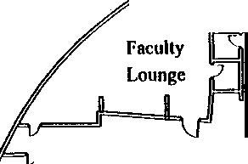

,,
Kitchen n
I

0
j 00 O0o
Serving Line

Pillar[.) 0 0 ll . 0

0 0 0 0 Pillar 0
00 ooo ooo

0 0 0
O 0 • 0 0
C) (·)· Stairs

0 0 Pillar O () 0
0
0
0 0 0 0 Pillar ()
0 O O 7
"-=o _{O}
0.
CAFETERIA Food Cart
Student Store

Nicholas Bondar
JC- 001-001322

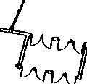

BROWN, Q.

JC-001-001323

JCSO #99-7625
Control #
Interview: Quentin Brown OOB/100280 Address: 6650 S Jay Drive
Littleton. CO 80123
Home phone 303-798-3978 Senior at Columbine High School

Interview with Quentin Brown on 05-06-99 by Inv Jill Reuteler, Colorado State Patrol. at approx. 9·30am
at his residence. Present in the room with us was Mrs Brown, Quentin's mother

Quentin Brown said that he had B Lunch. He said he was in the Math Hall with Ms. Layman who was helping another student, Lisa Strunk and another female student. He said that around 11:20 am he heard some students running down the hall and someone opened the door and said 'there is a shooting'. He said that the fire alarm went off and the students ran out the doors by the Math Hall and across Pierce Street into Woodmar Park He said he could hear gunshots from the school.

Quentin Brown said that he has a navy blue colored backpack on the table in the math hall, containing a TI85 calculator, a history book and another book called “Cold Mountain"

I asked Quentin if he had seen or listened to the Rebel News Network on 04-20-99 He said that he had and the message was '"What a horrible day to come to school''

Quentin said that he knew who Eric Harris was from a Govt/Econ class that they had together last semester He said that the class had to make a video to sell a product. He said that Dylan Klebold. who was not in the class, had helped Harris with the video The product/service that the video was to market, was a hit man service for the nerds at school to call on when they were being picked on by the other students Brown said another student named Erik Veik helped them make the video and played the role of the nerd Brown said in the video, the nerd calls up the hit men, (the role of hit men played by Harris and Klebold). to get rid of the bullies He said that the video showed them with guns in the school in different shots with German techno music playing in the background. Brown said that the class was just surprised and did not find the video very funny. Brown said the instructor for that class was Mr Tonelli. I asked Brown what the other students' projects were like and he said stuff like a doorbell that shocks unwanted salesman, machines that help people change their clothes. something to keep dogs from urinating on mailboxes and stuff like that

Quentin Brown added that Harris was involved in producing Friday feature videos, one was of the soccer team, while German music (Du Haus, Der Haus or something similar) played in the background I asked Brown what that meant and he explained that Harris said it meant 'I Hate You' in German and that the people that made the song, would like the shots of the soccer team. Brown said that he didn't think that Harris liked the jocks real well.

I asked Brown to mark on a diagram of Columbine High School, where he was at the time of the shooting
and his route out of the school He agreed to do this

This interview was concluded

Report prepared by Inv Jill Reuteler #7394 ·
May 11, 1999
Colorado State Patrol
700 Kipling Street, Denver, CO 80215
303-239-4545

JC-001· 001324

.

COLUMBINE HIGH SCHOOL
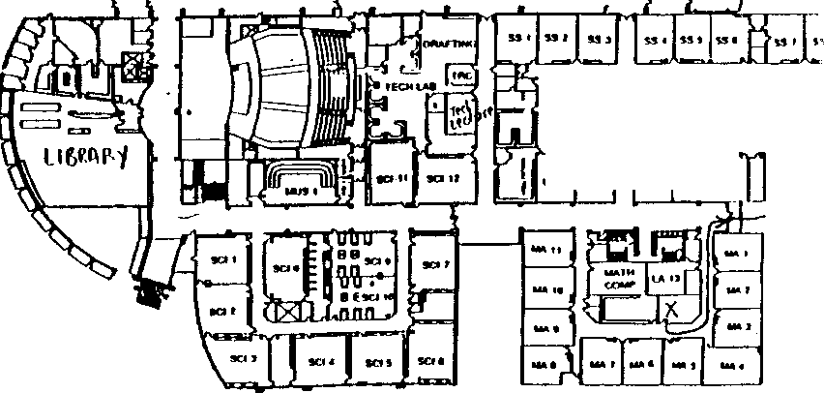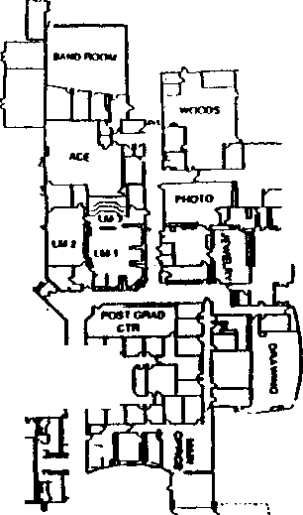982-4400 - MAIN OFFICE
982-4-410 -ATTENDANCE OFFICE

ueo,,

"N'
"'
0
0

N
w E
s
'
0
0
u
'
-·•---· --, ,

I

11
LOWER LEVEL •

[ ··

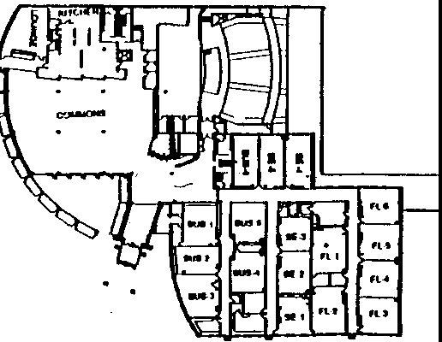Ul-t _{u,)}
.,.., ,.,.. l'"." U• I•

• •

I was in the math hall and ran out the door, down the stairs and across Pierce to Woodmar Park.
JC- 001- 001325

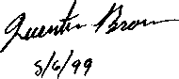

BUCCI, N.

JC-001-001326

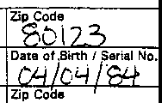
Time

Hours

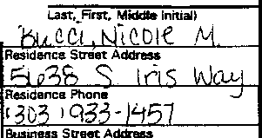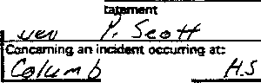Summary of Statement:
Page
of

Denver Police Department
STATEMENT
N,
□ Officer
Making Statement is:/
!!"" Wrtness
Business Pl'lone
Citv
Cauntv
St o
State
□ Pe=n advised
Officiir Taking S·
Serial No.

Oata
; Ye
Location when, statemel'lt taken:
'if?

I arrived at school about 8:20 am. I came in by the teacher’s parking lot. I take “B” lunch 12:05- 12:35. At the time it happened, I was in math class, Ms. Moore. To get to math class I walked through the cafeteria and went up the stairs. I did not see anything unusual. I do not know either Klebold or Harris.
When the incident happened I was in math class. Mr. Ortiz went out to see what was happening. We all went also. We heard 2 popping sounds. We ran down the math hall door and out to Leawood Park.

I have read the foregoing statement and the facts contained therein are true to the best of my knowledge and belief. I do not maintain that it contains all of the facts or details of the incident, but only those facts about which I have been i/Sked.

Transcript of handwritten statement of Nicole Bucci
JC-001-001327

** UPDATED APRIL 28, 1999 **.
TEAM FOUR INTERVIEW GUIDELINE
MINIMAL QUESTIONS TO BE ASKED

- Did you ever see the two large duffel bags in the cafeteria? No
- Did you see anyone carrying or in the possession of those duffel bags, at a previous time? No

- Did you see Eric Harris or Dylan Klebold either on Monday ofTuesday? What were they doing?
What did they say ? Were they with anyone else ? No
- Did you leave anything behind in the cafeteria or anywhere else in the school? Yes
_
- Who were you with in the cafeteria? Where were you sitting? Lindsey Kastanek; walking through

- Did you see or talk to any of the Trench Coat Mafia members on Monday? Tuesday? How about the prior week or weekend? A few, but I don’t know who
- Have you heard anything from anybody else about other suspects, bomb making, gun buying, etc?
Yes
- What were you wearng? Did you have a backpack? What did it look like and/ or have in it?
Black shirt/khaki shorts. Yes, black Eddie Bauer with books and a black purse
- How did you leave the cafeteria or the building? What were the events that made you leave? .
Up main stairs to math during passing period of 4th, exit east side of building from math
- What time did you enter the cafeteria ? Where did you come from (prior to the cafeteria)?

Spanish

- Have them mark where they were sitting. their route out of the building and whom they were with (if
known)?

- How did you exit the building? Where did you go when you got out and what did you see on the ,
Outside of the building? East side, Leawood Park, people running out
- Do you use the lnternet? If so. what is your screen name? Do you have an ICQ (aka: I seek you/
similar to a chat line) account ? No
- Do you know anybody with a "double pierced eyebrow"? No

- Did you see or hear any unusual announcements prior to the shootings? NO Do you know what the
"Thought of the day was" over the Rebel News Network (RNN)? Yes

- Can you provide any further information on the members of the Trench Coat Mafia. No
- Ask the parents if the kids have told them anything else ? Different ?

JC-001-001328
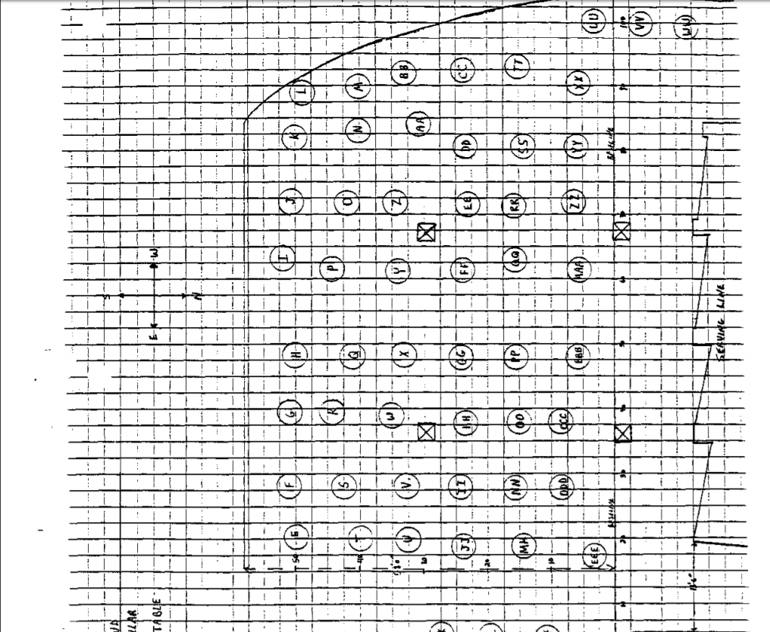
JC- 001-001329

BUCKNER, E

JC-001-001330

1

FEDERAL BUREAU OF INVESTIGATION

Date of transcription O 5 - 0 7 - 9 9

ERIC BUCKNER, date of birth 09-19-81, social security number 522-63-1340, 8000 w. Crestline Apartment #613 Littleton, Colorado, 303-973-8797 was interviewed by Christopher T. Schaefer who identified himself as a Special Deputy United States Marshall currently assigned to the Federal Bureau of Investigation Joint Terrorist Task Force, and Mark Mccomas currently assigned to the Colorado State Patrol Investigations unit.
BUCKNER, after being advised of the identity of the interviewers was told of the FBI's investigative interest in the Columbine High School shootings on April 20, 1999.
BUCKNER advised the following.
BUCKNER was sitting in a math classroom getting help on his homework when he heard a "boom." BUCKNER then heard the fire alarms go off and heard what he believed to be a shotgun blast.
BUCKNER ran outside of the school on the east side and heard two more loud explosions. BUCKNER was on the east side of Pierce St., when he heard a fellow student say that someone had a gun.
BUCKNER did not know either Dylan Klebold of Eric Harris, but does know of a girl by the name of Alex that was frequently with both subjects.
Also present during the interview was Cecilia Buckner, Eric's mother. Ms. Buckner advised that she works at the Vector Bank across the parking lot from where Klebold and Harris used to work. Ms. Buckner advised that on Friday April 9, 1999, Klebold, Harris and Chris Morris had come into the bank to cash their checks. Ms. Buckner remembers that Morris withdrew all of the money from his account, which was approximately $300 to $500. Ms. Buckner stated that every Friday Klebold and Harris would come in the bank to cash their checks.

JC-001-01331

Investigation on O 5 - 0 5 - 9 9 Littleton, Colorado

l 74A-DN-57419
Christopher T. Schaefer
by Mark Mccomas CSP
Date dictated 05- 07-99

BUNDY, RAY

JC-001-001332

COLUMBINE HIGH SCHOOL 99-7625
Summary of Mr. Bundy's 5th Period Algebra I Class Observations

On 062299 I was assigned to interview students of Mr. Bundy's 5th Period Algebra I class reference their observations of the incident at Columbine High School on 042099.

Mr. Bundy's class consists of twenty three students (23). According to the attendance form all but one student were present for class on 042099. I discovered no conflicting information.

I interviewed eighteen (18) students and Mr. B'undy. I also collected information on two (2) students previously interviewed. I have attempted to contact the two (2) remaining students on numerous occasions and have been unable to do so. One ( l) student was previously assigned to another Investigator to interview, but I could locate no report or information through Rapid Start, however the listing of students indicates she has been interviewed.

First indication of problem

Seven (7) students state their first indication of a problem was the fire alarm activating 5 to 15 minutes after class began at 1115 (see leads 4203, 4221, 4206, 4227, 4202, 4257, 171 I). All students and Mr, Bundy indicate having heard the alarm prior to exiting the class, except for one (see lead 4205).

Four (4) students state their first indication of a problem was a scream, occurring 5 to 20 minutes after class began at 1115 (see leads 4217, 4204, 4232, 3235). Additionally three (3) other students reported hearing screams while in the school (see leads 4205, 4208, 4224).

Five (5) students state their first indication of a problem was an explosion, boom, or bang, occurring 3 to 15 minutes after class began at 1115 (see leads 4205, 4207, 4208, 4224, 4237).

One (1) student and Mr. Bundy state their first indication of a problem was a commotion, or shouting, occurring 5 to 10 minutes after class began at 1115 (see leads 4200, 4246).

One (1) witness states their first indication of a problem was a popping noise, occurring 5 minutes after class began (see lead 4210).

Two (2) students stated their first indication of a problem was a teacher, identified also as Coach Ortiz, telling them to get out of the school, 5 to l 0 minutes after class began at 1115 (see leads 4209, 4211). Most other students and Mr. Bundy indicate that Coach Ortiz (also identified as Mr. Ortiz or an unknown male teacher) came to their room and told them to get out very near the time of the fire alarm.
J C -001-001333

Other inside observations

One (1) student reported hearing someone outside the classroom say, "He's got a gun", 6
minutes after class began at 1115 (see lead 4237).

One (1) student believes she saw an injured student by the name of Stephanie Munson (see lead 4224), who was bleeding from the leg, and walking through the math hall with the other students exiting the school.

Two (2) students report seeing smoke in the main south hall, while exiting the building (see leads 4202, 4217).

Two (2) students report hearing fireworks or popping while in the halls (see leads 421 l, 3235).

Outside observations

All students and Mr. Bundy indicate they exited the school near the math hall, and crossed Pierce Street to Leawood Park. were there for a period of time before they ran into the surrounding neighborhoods.

One (1) student reports seeing a female student fall in the street outside Leawood Park, with a through and through wound to her lower left leg, believing this to have occurred at that location (see lead 235).

Twelve (12) students and Mr. Bundy heard gunshots. "clinking", "ping", or popping noises while in Leawood Park (see leads 4200, 4206, 4207, 4208, 4209, 4210, 4211, 4224, 4232, 4246, 4203, 3235, 1711). Three (3) students believed it to be coming from the main/teacher entrance, or coming out the front of the school (see leads 4209, 4224, 4203).

Five (5) students and Mr. Bundy heard explosions, or booms while in Leawood Park (see leads 4200, 4205, 4209, 4232, 4237, 4246).

One (l) student heard screaming coming from the school, while in Leawood Park (see lead 4210).

No one in this classroom saw any gunmen.

2

JC-001- 001334

Harris/Klebold

One (1) student states he saw Klebold in the cafeteria on 042099 at about 0820 sitting by himself
(see lead 4206).

Eight (8) students recognized Klebold, but did not see him on 042099 (see leads 4227, 4207, 4208,4221, 4224, 4232, 4246, 4203).

Seven (7) students recognized Harris, but did not see him on 042099 (see leads 4207, 4208,
4221, 4224, 4232, 4246, 4203).

3
JC-001-001335

7/15/99 Exterior Witness: Summary: Algebra I

DN 4200 Bundy, Ray Teacher

4201 | Ashton, Adam
4202 | Biehl, Benjamin
4203 | Cain, Hannah
4204 | Cartaya, Lauren
4205 | Defilippis, Jonathan
4206 | Deidel, Brian
I71I | Doherty, Kristen
4207 | Downey, Shaun
4208 | Green, Sarah
4209 | Grengs, Nathan
4210 | Harrison, Jessica
3235 | Jones, Jason
4211 | Lajoie, Christopher
4217 | Micek, Katie
4221 | Most, Elyssa
4224 | Muscolino, Alayna
4227 | Pinkham, Holly
4232 | Slater, Makiala
4237 | Stouffer, Samantha
4240 | Turill Steven
4246 . | Welsh, Christopher
4251 | Wiegand, Amanda
4257 | Ziccard Zachary

JC-001-001336

NTINUATION □
 | JCSO |  | MOORE,C, | 99-7625-IIII
 |  | Victim. Name Original Report  COLUMBINE |  | Da1e This Report  06-24-99
X FIRST DEGREE MURDER |  |  |  | Recommend Case: Review 0  Closure

SUPPLEMENT y

ADDITIONAL WITNESS:

RAY BUNDY, DOB/02-01-45
2471 West Wolfensberger Rd.
Castle Rock., CO
303-660-92!3
Work: Columbine High School

INVESTIGATION:

On 06-22-99, I was assigned Lead #4200 to interview Ray Bundy, a Columbine High School teacher on 04-20-99.

On 06-23-99, I contacted Ray Bundy at the listed home phone number, 303-660-9213. I told Bundy that I was contacting him, as well as the students registered for his fifth hour Algebra I class, reference the incident on 04-20-99. Bundy stated that he arrived at the school on 04-20-99 at about 0700 hours and entered through the teacher's lot and main entrance. I asked him if at any point during the day he had been into or through the cafeteria or lower commons area. He stated the only time that he ever went to that part of the school was on Fridays when he had duty. He stated that he had not been in that area on 04-20-99.

I told Mr. Bundy that I understood fifth period started at about 1115 hours. I asked him to tell me about what happened. He stated that he was giving a quiz and the door was shut. He stated possibly fifteen minutes into the quiz, he heard a commotion, but could not tell what it was. Mr. Bundy stated that Robin Ortiz, the baseball coach, was coming down the ball and yelling, "Get out, get out." He stated he believed this was simultaneous to the fire alarm going off. Mr. Bundy stated that Mr. Ortiz had been team teaching with Alma Moore, a teacher in the adjacent classroom.

I asked Mr. Bundy about the location of his class. He stated that it is in the math hall, in the center of the south side of that hall, directly across from the math office. I asked how he and the class exited the building. He stated that once out of the classroom,

JC-001-001337

CONTINUATION SUPPLEMENT | JCSO |  | MOORE, C. | Case Report No  99-7625-IIII
 |  | Victim Name Original Report  COLUMBINE |  | Date This Report:  06-24-99
X FIRST DEGREE MURDER |  |  |  | Recommend Case: Review □  Closure □

they took a right to the south ball, and then out the south ball through the east exit I asked if once exiting the classroom he either had seen or heard anything. He stated that people were running. He stated his major concern was that people were going to get trampled. He stated that he attempted to slow some of the people down. He stated that once outside, people were telling them not to stay on the grounds, but to go across the street to the park, which they did He stated that once in the park. they ended up going toward the end of the park. I asked him if he bad seen or heard anything outside. He stated that he heard what he believed to be gun fire and explosions, although at the time "we truly had no idea what it was."

I asked Mr. Bundy if he knew either Dylan Klebold or Eric Harris. He stated he did not. I asked him if they were anyone he recognized and he stated they were not. He stated that he knew Robyn Anderson. I asked him what bis reaction was when he heard through the media that she might be involved in buying the guns. He stated that he was shocked, but after teaching for thirty years, nothing shocks him. He stated that during the last school year Anderson had been one of his top students and was
very sharp.

I asked Mr. Bundy if there was anything he had heard or seen either prior to or since the incident, which be thought might be of assistance to us. He stated there really was not.

DISPOSITION: Open, pending further investigation.

JC-001-001338

BUSCHMANN, JOHN

JC-001-001339

CONTINUATION □  .SUPPLEMENT | JCSO |  | PETERSON | 99-7625-SSSS
 |  | Victim Ncne Original Report  COLUMBINE H.S. |  | Date This Report  7-13-99
X 1/MURDER |  |  |  | Recommend Case: Review 0  Closure 0

WITNESSES
JOHN EUGENE BUSCHMANN, DOB/7-16-84 I 0693 WEST ONTARIO AVE.
LITTLETON, CO 80127
303-979-3132
STUDENT COLUMBINE H.S.

JANET M. BUSCHMANN
SAME ADDRESS/PHONE AS JOHN WORK: ST. JOSEPH'S HOSPITAL 18TH AND FRANKLIN ST. DENVER, CO 80210
HONE: UNK

JOHN M. BUSCHMANN
SAME ADDRESS/PHONE AS ABOVE WORK: JEFFCO PLANNING DEPARTMENT I 00 JEFFERSON COUNTY PARKWAY GOLDEN, CO 80401
303-271-8729

INVESTIGATION
On 7-13-99, at about 1700 hours, I responded to 10693 West Ontario Avenue, to contact and interview John Eugene Buschmann, who is a student at Columbine H.S. This interview was in reference to the shooting that occurred at Columbine H.S. on 4-20-99.

John Eugene Buschmann was interviewed at his residence with his father, John M. Buschmann, present John Buschmann said on 4-20-99, he arrived at Columbine H.S. for his scheduled classes, at about 06.50 hours. Due to the fact John had first hour class

JC-001-001340

CONTINUATION □  SUPPLEMENT | JCSO |  | Reporting Officer  PETERSON | Case Report No  99-7625-SSSS
Connecting Case Report No. |  | Victim Name Orisinal Report  COLUMBINE H.S. |  | Date This Repon  7-13-99
X 1/MURDER |  | D |  | Recommend Case: Review D  Closure D  s \ I V ue I a aue

off, he went to the lower level of Columbine H.S. and into the cafeteria/commons area. John said he selected a table to sit at which was the table he usually sits at. John indicated on the diagram of the Columbine H.S. cafeteria, the table he selected was "LL." Table "LL" is next to the stairway, and is in the middle of the cafeteria/commons area from north to south. John said he sat down at the table, and was facing the stairway which would be in an easterly direction. John said there were several other students at and around table "LL." I showed John the photographs of the duffel bag and the propane tank, that were later recovered in the Columbine cafeteria/commons area. John said he did not see either item on 4-20-99, either prior to or during the shooting incident He did indicate he saw people carrying bags, but he believed the bags he saw being carried were smaller than duffel bags, and said he could not remember what color the bags being carried were. John said on 4-20-99, at approximately 0820 hours, he went to second hour class which is on the upper level of Columbine H.S. and near the main door and administrative offices. John said for third hour class from 0915-1015 hours he was in his french class on the lower level of Columbine H.S. From 1015-1110 hours, John said he was in his science class located on the upper level of the school. From this class John said he went to fifth hour geometry class. This class is on the upper level of Columbine H.S.. and is from 1115- 1205 hours. John reported that on 4-20-99, after getting to his geometry class, at about 1138 hours he heard people running in the hallway outside of his class room. John said he didn't think much about it because he believed it was the result of a senior prank taking place. John said he then heard people screaming in the hallways, and then heard "two pops" which he said it sounded like they were coming from the direction of the cafeteria/commons area. and said they sounded close to his location in his class room. John said one of his teacher's, Mr. Ortiz (the other teacher was Ms. Moore), went outside of the class room into the hallway to see what was occurring. He said Ms. Moore was trying to lock the door between the class room and the hallway. He said while Mr. Ortiz_was gone from the class room, he heard three more shots fired. Mr. Ortiz then returned to the class room before Ms. Moore could get the doors locked. John said Mr. Ortiz told the students to get down under their desk and said there were "guys with guns" in the school. John said the students were on the floor, under their desk for only a few seconds, when Mr. Ortiz told them to get out of the school quickly. John said he got up and exited his class room and began running down the hallway. John said as he ran past other class rooms, he was opening the other class room doors and telling everyone inside the rooms to get out. John said while running down the hallway he believes he heard "pings" that sounded like gunshots ricocheting off students lockers. John said he did not see any of the shooters, however. John told me exited Columbine H.S. through the doors on the east side of the school, and south of the main entrance/administrative offices. John said he ran eastbound, across South Pierce Street and into Leawood Park after exiting the school. John said while he was in Leawood Park he heard several
JC-001-001341

CONTINUATION □  SUPPLEMENT | Reporting Agency  JCSO |  | Reporting Officer  PETERSON | Case Report No  99-7625-SSSS
Connecting Case Report No. |  | Victim Name Original Report  COLUMBINE H.S. |  | Date This Rcport  7-13-99
X 1/MURDER |  |  |  | Recommend Case: Review □  - Closure □

more gunshots and approximately five explosions that he described as sounding like they were coming from the west side of Columbine H.S. near the cafeteria/commons area. John said he looked towards Columbine H.S. when these noises were heard, however, he did not see any suspects, or possible suspects outside of the school. John said he did not see any suspects through the Windows, nor did he see anyone through the glass in the doors. John said he stayed in Leawood Park for approximately 30 minutes with a friend of his by the name of Kyle Ashton. John told me someone said the shooters had exited Columbine H.S., and although he didn't see anyone, he ran with Kyle Ashton. away from Leawood Parle. He said they ran until a friend's mother saw them and picked them up. John could not remember this person's name. He said they were taken to the church located at West Ken Caryl Avenue and South Kendall Blvd., where he called his father, John M. Buschmann. This call was made at 1220 hours, on 4-20-99.

I asked John E. Buschmann what he knew about the Trench Coat Mafia. the Trench Coat Mafia students, and in particular Dylan Klebold and Eric Harris. John said he had seen Dylan Klebold in the hallways of Columbine H.S. and described Klebold as
“goofy looking." John said he remembers Dylan Klebold because he was tall (estimated 6'5" tall) and skinny. He remembered Dylan Klebold being alone in the hallways, and said Klebold would wear dark clothing and a trench coat that hung below his knees. John said he had seen Eric Harris in the hallways of Columbine H.S. also, and said Eric Harris looked "mean and feisty." John said on the Friday before the shooting, 4-16-99, Columbine H.S. had their prom assembly. John said Brooks Brown got some type of an award for what he believed was for literature. The only other thing he could tell me about Brooks Brown was that he wore jeans with holes in them, and wore T-shirts with words on them, however, he did not know what these words were.

I asked John E. Buschmann if he had ever seen Isaiah Shoels being racially harassed or racially intimidated. John said he has never seen any harassment or racial intimidation towards Isaiah Shoels, and said in fact Isaiah Shoels was "funny" and "everyone liked Isaiah Shoels."

John E. Buschmann said he did not know if it was related to the shooting on 4-20-99 or if it involved Dylan Klebold, Eric Harris, or the Trench Coat Mafia students, but he said one and half to two weeks prior to the shooting, numerous students lockers at Columbine H.S. were broken into and then "super glued" shut. He also told me that a teacher by the name of Mr. Tallaco, who

JC-001-001342

CONTINUATION SUPPLEMENT
 | JCSO |  | Reporting Officer  PETERSON | Case Report No  99-7625-SSSS
 |  | Victim Name Original Report  COLUMBINE H.S. |  | Date This Report  7-13-99
- MURDER |  |  |  | Recommend Case: Review □  Closure □
1Wo' I Quumty I 8,-1Name I Description I Serial No |  |  |  | Va " lue 1 Val  ! ft D maged

S\.Jt'PLEMENT "

teaches wood shop class, gave Dylan Klebold or/and Eric Harris keys to the school because they were in a video productions class. John said on 4-20-99, he saw what the "thought of the day" was on the Rebel News Network (RNN). He said it was something to the effect of''you wished you weren't here today."

John E. Buschmann said he believed more than two suspects were involved in the shooting on 4-20-99, at Columbine H.S. however he could not provide any additional names of any suspects, nor could he provide any evidence that would support this belief. He said he has not heard of anyone, nor has he heard any rumors of anyone who may be manufacturing explosive devices and/or possessing or selling firearms.

I asked John E. Buschmann, and his father, John M. Buschmann, how the family has been coping with the incident on 4-20-99 John E. Buschmann said he has been doing well, however, his father indicated that everyone in their family has taken it hard. and have had periods of not being able to sleep, and having nightmares while sleeping. John M. Buschmann said up to this point they have not tried to find any counseling and/or therapist. I gave my business card to John M. Buschmann and advised him that if in the future he felt their family needed to speak with a JCSO Victim Advocate to contact me and I would make the necessary arrangements for them.

DISPOSITION OPEN, PENDING FURTHER INVESTIGATION

JC-001-001343

JC-001-001344

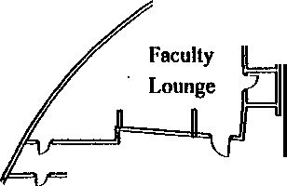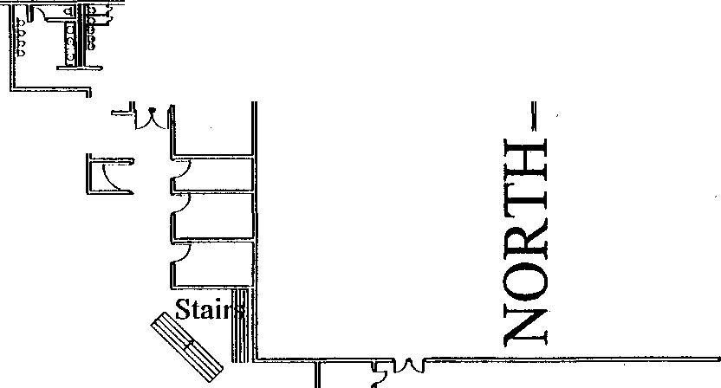

..,
0

0

Kitchen 0

'
I
0
- oo Oon

I 00
o oPil0lar 0 0
ci o
Pillar ••

00°
0 0 0
0 0
0 0 () 0 () ()

0 ()
0 0 0 □Pillar O O _{Cl} _0
0 0 0 0 0 Pillar 0
0 O 0
o

"--- -0
=0
I \_r=== F
CAFETERIA

Food Cart

Student
Store
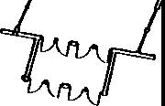

--··-·--·-· J
------
-- -·-

....

L_

- -ILL--₁₋•-
,1_-1--- --

....•..•
-- --

---1- --

_,_

L

:,...
- 6 ,----- -
--

-

- ,_,
_ _J -- ---

-t--1--1-.
-1Fcr=ll= c=1:= -=--1----._.•.-..:-.=- --

I_
' --l-..!...

- --- ,
L
--· -fu

' ..

" '--
' ..
'

1_ -1--

JC-001-001345 _

-
'

_,_

L. ,_ - -_

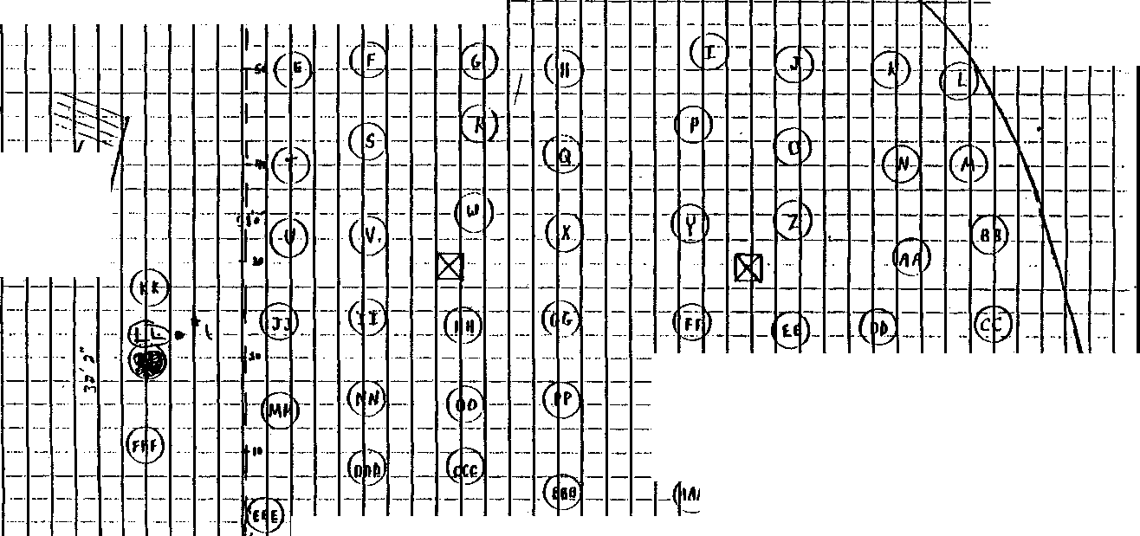

CAIN, HANNAH

-

JC-001-001346

-
CONTINUATION □  SUPPLEMENT | JCSO |  | MOORE,C. | 99-762S-WWWW
 |  | COLUMBINE H.S. |  | Date This Report  6-30-99
X FIRST DEGREE MURDER |  |  |  | Recommend Case: Review 0  Closure 0  I

ADDITIONAL WITNESS
HANNAH CAIN, DOB/4-6-83 5061 SOUTH STUART COURT LITTLETON, CO 80123 (303)347-8252

INVESTIGATION
On 6-22-99, I was assigned lead #4203, to interview Hannah Cain a Columbine student on 4-20-99, who was assigned Mr.
Bundy's fifth hour algebra one class.

After leaving several messages at the listed home phone number (303)347-8252, on 6-30-99, I received a phone call from a
female identifying herself as Hannah Cain. I told Cain I was contacting Columbine H.S. students reference the incident on 4-20- 99. I told her I understood she was assigned to Mr. Bundy's fifth hour algebra one class. She stated she had been in school on 4-20-99, and had been in Mr. Bundy's class. I told her it was my understanding that fifth period started at 1115 hours. I asked her what the first indication was to her that something was wrong. Cain stated about fifteen minutes after class started she heard the fire alarm and everyone started getting up and walking out. when a male teacher came in stating, "Run, get out of the building as fast as you can." Cain stated she did not know the teacher nor what he taught, but described him as being in his forties. 5'7" to 5'8", chubby, with dark brown hair, wearing unknown clothes. I asked Cain if she could recall who was sitting near her in class, and she stated she could not I asked her how she exited the class room. She stated once out of the class room she turned to the right, then turned to the left at the end of the hall, and then turned right in the next hallway, going out of the building. I asked her if she saw or heard anything once in the hallway. She stated everyone was running which seemed unusual, but she did not hear anything. She stated they then went out the door and were directed by the teachers across Pierce Street to Leawood Park. Initially they were at the fence and then were told by the teacher to climb the fence, and then told to move further back, and ended up in the playground area. Cain stated they bad been in the park about ten minutes when she heard what she believed to be gunshots. She stated it sounded to her like "bullets repelling off brick” I asked Cain if she could tell where the sound was coming from. She stated it sounded like it was coming from the front entrance. She stated she did not hear any windows
-

JC-001-001347

'- .
CONTINUATION  SUPPLEMENT | JCSO |  | MOORE, C. | 99-7625-WWWW
 |  | Victim Name Original Report  COLUMBINE H.S. |  | Dau: This Report  6-30-99
X FIRST DEGREE MURDER |  |  |  | Recommend Case: Review □  Closure □

breaking, and thinks it was coming from outside the building. I asked her if she could tell in what direction the bullets or gunshots were going. She stated she could not She stated she was frantic and wanted to go to Clement Park in order to find her friends. She stated the teachers later told them to run into the neighborhood

I asked Cain if she had been into or through the cafeteria at any point during the day. She stated she has fourth period off. She stated she spent the majority of the time in the cafeteria and commons area. She stated she was there from the beginning of fourth period, until ten or fifteen minutes before fifth period began, when she went upstairs. I asked her if she saw anything unusual in the cafeteria. She stated she had not. I asked her if there was anything unusual in the way of bags or back packs. She stated
she did not notice anything.

I asked Cain if she knew either Eric Harris or Dylan Klebold. She stated she sort of knew Klebold, but they were not close. I asked her if she had seen him on 4-20-99, and she stated she had not I asked her if she knew Eric Harris. She stated she had seen him around, but had never actually spoken with him. I asked her if she had seen him on 4-20-99. She stated she had not.

I asked Cain if there was anything she had either heard or seen, prior to or since the incident, that she thought might be of assistance to us. Cain stated she had heard from someone that Klebold did not commit suicide. that Harris had actually killed him. I asked Cain who she had heard that from, and she stated she couldn't recall. Cain stated she also heard a rumor that Klebold liked Rachael Scott a lot and be freaked out when he killed her. Cain stated she had no further information.

DISPOSITION Open, pending further investigation.

JC- 001- 001348

.

CAMPBELL, MEGHAN

JC-001-001349

UNCLASSIFIED
INFORMAT/ON CONTROL

Case ID: Priority: Source: Affiliation:

174A-DN-57419
PRIORITY Clarification: UNCLASSIFIED
WEBB, RICH SGT JCSO
Control Number: DN4343

Phone Number: (303) 271-5605
Prepared by: WEBB, RICHARD
Information Received Date: 06/08/1999 Time: 11;00 AM
JEFFCO SO
{Component/Agency)

Event Narrative: MEGHAN MARIE CAMPBELL IN 5TH HOUR ALGEBRA. (HAVENS) SEE 4339
FOR REPORT

Event Date:
Categories:

Event Time: References:
INTERVIEW STUDENT· CHS

Event Reviewed by: SL Lead Required? YES

Lead:
Lead Control Number: DN4343
DETERMINE OBSERVATIONS. MEGHAN MARIE CAMPBELL. 797-7559

Assigned To: TRAVER, MATT Date: 06/23/1999 Time: 10:32 AM

Disposition: MEGHAN CAMPBELL TAKING TEST, HEARD BOOM, HEARD & SAW PEOPLE RUNNING, HEARD 2ND BOOM, THEN FIRE ALARM WENT OFF. WENT OUT DOOR. SOMEONE GRABBED HER HAND AND STARTED TO PULL HER ALONG "RUN FASTER". RAN ACROSS STREET. FRIENDS TOLD HER THAT THERE WAS A GUY IN SCHOOL WITH A GUN. WENT ACROSS THE STREET TO PARK KEPT BEING TOLD ABOUT GUY WITH GUN. STAYED AT LEAWOOD PARK FOR A WHILE, THEN RAN HOME.

Lead Reviewed by: SL Lead Completed? Date: 07/06/1999

JC-001-001350

Printed on 10/8/1999 at 8:58 AM UNCLASSIFIED Page 1

CARTAYA, LAUREN

JC-001-001351

CONTINUATION □  SUPPLEMENT | Reporting Agency  JCSO |  | MOORE,C. | Case Report No  99-7625-AAAA
 |  | Victim Name Original Report  COLUMBINE |  | Date This Repon  06-22-99
X FIRST DEGREE MURDER |  |  |  | Recommend Case: Review □  Closure □

ADDITIONAL WITNESS:

LAUREN MARIE CARTAYA. DOB/04-14-83
9622 West Brandt Place Littleton, CO 80123
303-973-3440

INVESTIGATJON:

On 06-22-99, I was assigned. Lead #4204 to interview Lauren Cartaya, a Columbine High School student on 04-20-99, who was assigned Algebra I class with Mr. Bundy.

On 06-22-99. at 1259 hours, I contacted the listed phone number for Cartaya. 303-973-3440. A female answered who identified herself as Lauren Cartaya. I told her that I was calling the Columbine High School students who were assigned Mr. Bundy's fifth hour Algebra I class. I asked her if she was at school on 04-20-99 and she stated that she was. I asked her if she had attended Mr. Bundy's class and she stated that she had. I asked Lauren Cartaya what the first thing was, after class began at 1115, that she knew something was occurring. Lauren Cartaya stated that she believed it was actually about twenty minutes into the class. although "I don't know" that she heard a scream. She stated that it was "not a scary scream, it was a playful scream." Lauren Cartaya stated that one to two minutes later she heard the fire alarm. I asked if she heard anything unusual after that and she stated she did not She stated the next thing was Mr. Ortiz came in from the class next door, stating that it was not a joke and to get out. Lauren Cartaya stated they went out of the classroom, took an immediate right to where some doors were twenty to thirty feet away and went outside. I asked her if she had heard anything outside and she stated she did not. I asked if she saw anything outside. She stated she did not Lauren Cartaya stated that she believed that something was actually on fire. She stated the teachers made them cross the street across Pierce instead of staying immediately outside where they normally did after a fire alarm. Lauren Cartaya stated they went to Leawood Park, to a playground area. Lauren Cartaya stated that she did not see or
hear anything, but suddenly someone was running and then everyone else began running.

JC-001-001352

-"-"""
CONTINUATION  SUPPLEMENT | JCSO |  | MOORE,C. | Case Report No  99-7625-AAAA
. |  | COLUMBINE |  | 06-22-99
X FIRST DEGREE MURDER

'

I asked Lauren Cartaya if she knew either Eric Harris or Dylan Klebold and she stated she did not. Lauren Cartaya stated that she stayed away from "people like them". I asked her if they were anyone she recognized from hallways and she stated she did not I asked Lauren Cartaya if there was anything she had either heard or seen either prior to the incident or since the incident that she thought be of assistance and she stated there was not

DISPQSmON: Open, pending further investigation.

JC-001-001353

CASEY, M.

JC-001-001354

Denver Police Department
Metro Gang Task Force

Date: 05-03-99
To: The Jefferson County District Attorneys Office
From: Detective Terry Demmel 78007-Assigned With The Columbine Law Enforcement Task Force

Supplementary Report

Ref: Interview with Columbine High School Sophmore Michael Casey DOB 08-16-82

On 05-03-99 at 10:45 A.M. Denver Detective Terry Demmel. who is assigned with the Columbine Law Enforcement Task Force, contacted Columbine High School sophmore Michael Casey by phone at (303] 972-9355. Michael stated to Det. Demmel that he was in Ms.
McWilliams 5th hour math class when he heard kids running down the hall and then heard what
he described as two shotgun blasts. He stated that the whole class as a group then left the class room and went out a north door to join several other class's that were on the soccer field.

Michael reported that while on the soccer field he met and talked with another student whom he knows as Terry [ unknown last name ][editor note- this is likely Terry Lawson] who is a junior and was reportedly in the Commons when the shooting started. The person whom Michael knows as " Terry " told them that the shooting was being done by Dylan and Eric. When Det. Demmel asked Michael how" Terry "knew who the responsible parties were he stated that" Terry " had met Dylan a couple of weeks ago and gotten to be friends with him. Michael added that he did not know Dylan or Eric and that he did not see anybody with a gun or do any shooting and did not see any bombs go off.

The only information that Michael had as to who was involved in the shooting and bombing that day was told to Michael by the person he knows only as " Terry ".

JC-001-001355

LAKEWOOD
HOMICIDE
SCOTT
1173 STEFFES, TIMOTHY
1197 GIRSON
P O L I C E DEPARTMENT

99038856 05/20/99

S U P P L E M E N T

---------------------------------------------------------------------------

ASSOCIATED CASE REPORT NUMBERS,
Jefferson County Sheriffs Office C.R.: 99-7625 FBI control number: 174A-DIV-57419

SUBJECT,

PARENTS,
CASEY, Michael John DOB, 08/16/82
8836 West Prentice Avenue Littleton, CO. 80123
(303) 972-9355

MOTHER, FATHER,
Julie Casey Brian Casey

OBSERVATION/ INVESTIGATION,
On May 17, 1999 I was assigned an interview with Mike Casey, a Columbine High School student, who may have been in the cafeteria on April 20, 1999. On May 19th I spoke to Julie Casey and made an appointment to interview Mike on May 20th at 0800. ·
On May 20, 1999, at 0800, I arrived at 8836 West Prentice Avenue and contacted Julie and Mike Casey.
Mike stated that he had been in the cafeteria between 0700 and 0730 on April 20th. He continued to say that he was seated at the table identified

as II WW" with:
Andrew Thomas
Nick Thomas
John Savage
John Gonnea (spelling unknown)
Tyler Chenoweth

Mike said that he did not see any type of a duffel bag in the cafeteria while he was there and he does not recall anyone carrying such a bag into the cafeteria.
Mike advised that after leaving the cafeteria he went to spanish class which is his first class of the day. Mike continued to say that he was in math class when the shooting started. Mike indicated the class in on the main level, in the south-east corner of the building. Mike continued to say that the first indication of trouble occurred when students came

JC- 001-001356

LAKEWOOD CO PD Pg 2 of 2
Supplement 05/20/99 1173 STEFFES, TIMOTHY
CIUI 99038856

running by the room screaming. Mike related that the class exited the room by way of the emergency exit and went down the hill into the student parking lot. From there they went to Leawood Park, across Pierce Street from the school. They remained the park for about fifteen minutes and then made their way through the Leawood neighborhood to Leawood Elementary School. Mike said that while he was moving down the hill to the parking lot he heard two shotgun blasts that sounded like they came for the commons area on the outside of the building. Mike stated that because of his position he could not see who was shooting. Mike advised that during the morning, preceding the shootings, he encountered no one with guns. Mike believed it was about 11:20AM when he heard the shots. He also said that he observed no one in the parking lot at the time of the shots.
Mike related that between 10:15 and 10:20AM he walked past both Eric Harris and Dylan Klebold on the outside east end of the building between the main and south hall exits. Mike reported that Dylan was wearing a black trench coat and had his right hand in the pocket while the left hand was at his side. Eric was wearing black fatigue type pants, a white shirt, and was carrying a black trench coat in his right hand. Mike stated that he did not observe either subject carrying a gun or duffel bag. Mike said that they did not even have their back packs. Mike continued to say that neither Harris or Klebold said anything to him as they passed and he said nothing to them. He said that they did not appear or act any differently than they normally did.
Mike advised that he had worked on a school play with Harris and Klebold last year, and during conversations he had with them at the time they told him that Harris used the names of 11Rebs" or 11Gibbs" on the internet, and Dvlan used the name of "Vodka” • Mike stated that he was not personally familiar with Harris's website and had not corresponded with either on the net. He related that since the play he has had no contact with either Harris or Klebold. He does not personally know any of the other members of the Trench Coat Mafia. Mike said that he has not had any problems with either Harris or Klebold.
Mike reported that he had heard no rumors about impending trouble at school prior to April 20th. The only rumors circulating concerned a national drug day.

Mike advised that he had told no one that Robert Perry had been one of the shooters or involved in the bombings. He reported that after the incident he and other students had been talking about who was involved in the shootings and the names Eric Harris, Dylan Klebold, and ------ came up as the most likely people involved. Mike has no personal knowledge that ----------- is involved.
Mike had no further information and the interview concluded at 0818.

---------------------------------------------------------------------------
1173 STEFFES, TIMOTHY Printed, 05/20/99 09:48

- ----------------------------------
-------------*EOR*

JC-001-001357

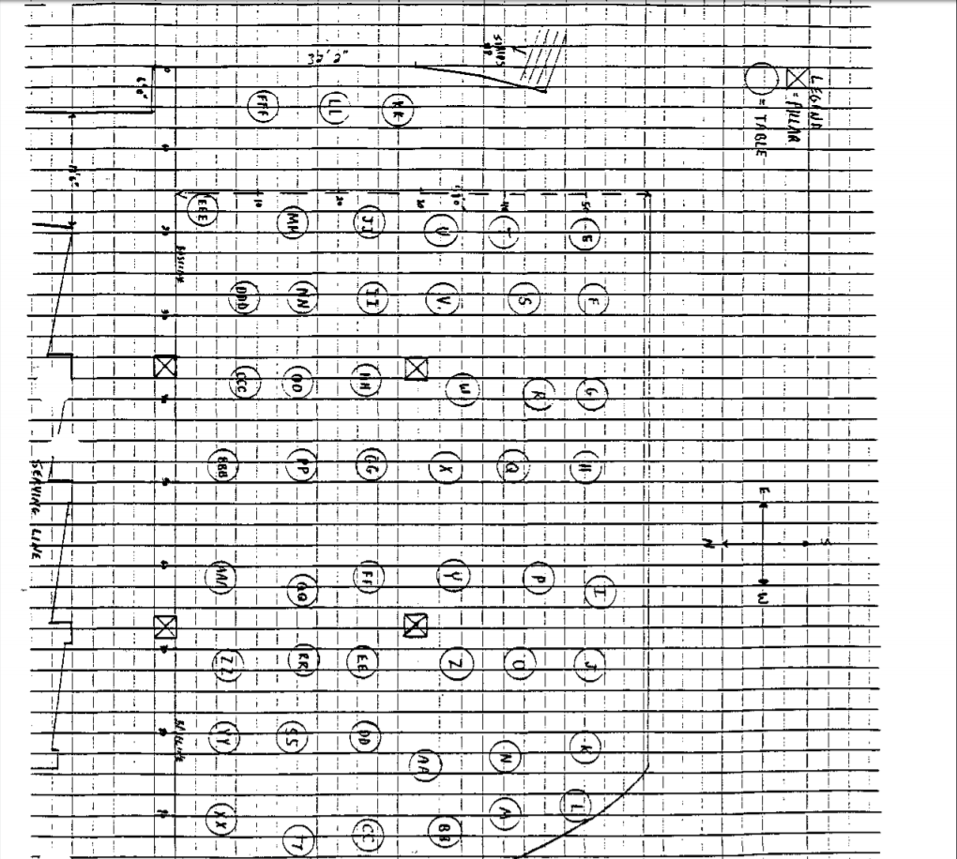JC-001-001358

UPPER
LEVEL
- Library
and cafeteria
B Auditorium
,wtl choir room
D Classrooms
- Corridors
B Stairwell

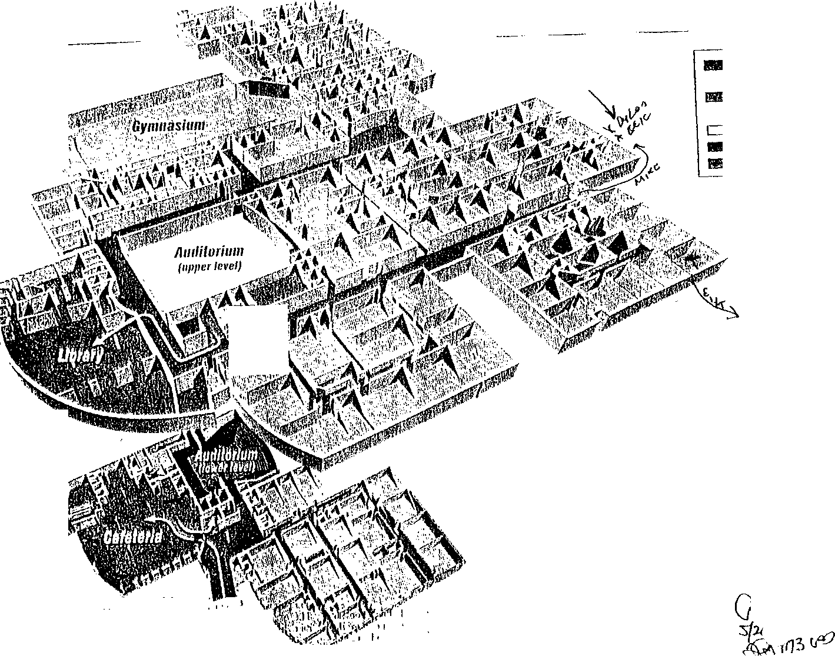

LOWER LEVEL

"
'
JC- 001- 001359

CASPERSON, KERRY

JC-001- 001360

Case 10: Priority: Source: Affiliation:
UNCLASSIFIED
INFORMATION CONTROL
Control Number: DN4841
174A-DN-57419
PRIORITY - Classification: UNCLASSIFIED
I
Method of Contact
O ln Person O Telephone/Radio
O Observation Written
LUCIANO, STEVE JCSO

Phone Number: (303) 271-8865 Information Received Date: D7109/1999 Time: 10 00 AM

Prepared by:
LUCIANO, STEVE
l&l/JEFCO SO
(Component/Agency)

Event Narrative: KERRY CASPERSON IS STUDENT IN TRIG/MATH CLASS.

Event Date: Categories:

INTERV!EW

Event Time:

References: DN#4829

STUDENT· CHS

Event Reviewed by: SL Lead Required? YES

Lead:
Lead Control Number: DN4841
INTERVIEW/DETERMINE OBSERVATIONS. KERRY CASPERSON. 11TH 6483 S. VANCE ST. LTN, 80123. 979-4827/723-1322/979-4827.

Assigned To: BROWN, LARRY Date: 07/15/1999 Time: 9:05 AM

Disposition: KERRY CASPERSON WAS UNAVAILABLE FOR CONTACT BUT SEVERAL OTHER STUDENTS CONFIRMED SHE WENT TO LEAWOOD PARK WITH THE REST OF THE CLASS. SEE ON#4829 FOR REPORT.

Lead Reviewed by: SL Lead Completed? 0 Date: 08/18/1999

JC-001- 001361

Printed on 10/12/1999 at 4:19 PM UNCLASSIFIED Page 1

CATT, JECOA

JC-001- 001362

CONTINUATION □  SUPPLEMENT |  | JCSO |  | PETERSON | 99-7625-YYYY
 |  |  | Victim Name Original Repol1  COLUMBINE |  | Date This Report  07-20-99
X FIRST DEGREE MURDER |  |  |  |  | Recommend Case: Review D  Closure □

WITNESS:

JECOA SHERAD CATT, DOB/09-19-82
5944 West Indore Place Littleton, CO 80128
(303)973-3141
Student-Columbine High School

MICHELLE D. YATES
Same as above.
Work: Automotive Titling Corporation
1989 East Arapahoe Road, Suite #320
Englewood, CO 80110
(303) 267-0779

INVESTIGATION:

On 07-20-99 at approximately 1300 hours, I contacted Jecoa Catt by telephone who is a student at Columbine High School. This was in reference to the shooting on 04-20-99 at Columbine High School.

Jecoa Catt said on 04-20-99, he arrived at Columbine High School for his scheduled classes, at approximately 0728 hours. Jecoa said that when he arrived at Columbine High School, he entered the building through the main doors on the east side of the school. He said his first hour class began at 0730 and was a Biology class. This class lasted until 0820 hours, and then Jecoa said he went to his second and third hour class, which is a combined Language Arts and then a study hall class. This lasted until approximately 1015 on 04-20-99. Jecoa said when he walked to his second and third hour classes, he walked from the upper level of Columbine High School, down the stairway, and through the east side of the Columbine High School cafeteria/commons 1rea. Jecoa said he did not see any duffle bags or propane tanks while going through the cafeteria/commons area, such as those

JC- 001- 001363

CONTINUATION  SUPPLEMENT | JCSO |  | Reporting Officer  PETERSON | Case Report No  99- 7625-YYYY
 |  | Victim Name Original Report  COLUMBINE |  | Date This Report  07-20-99
X FIRST DEGREE MURDER |  |  |  | Recommend Case; Review □  Closure □

items later recovered in the Columbine High School cafeteria. Jecoa said he did not remember if he saw any of the Trench Coat Mafia students during this time frame in the cafeteria or commons area on 04-20-99. Jecoa said when his second and third hour classes were over, he went to his fourth hour Social Studies class until approximately 1115 hours. He then went to his fifth hour Geometry class. Jecoa said approximately ten minutes after arriving in this Geometry class, while he was up front at the board, he heard what he described as "at least three loud booms" and then heard girls screaming in the hallways outside of his classroom. Jecoa described the "booms" that he heard as sounding like somebody hitting the hallway lockers very hard. Jecoa said Ms. Moore and Mr. Ortiz exited the classroom into the hallway to see what was taking place. Jecoa said shortly after the teachers exited the classroom, Ms. Moore returned to the classroom and locked the doors between the classroom and the hallway with the students inside. Jecoa said Ms. Moore told all the students to get down on the floor. He said a short time later, Mr. Ortiz returned to the classroom, however, he could not get into the room because the doors were locked, according to Jecoa Catt. Jecoa said Mr. Ortiz knocked on the window from outside of the classroom, and yelled for everybody inside the room to get out. Jecoa said he ran from the classroom out into the hallway/then exited the school through the east doors that are south of the school's main doors and administrative offices. He said other students were with him when they ran out of the school, then ran east bound across South Pierce Street and Into Leawood Park. Jecoa said while he was in Leawood Park. he heard approximately five gunshots and approximately two to three "booms" that he said sounded like to him were coming from Columbine High School in the area of the west side, near the cafeteria/commons. Jecoa said when he looked toward Columbine High School from Leawood Park, he may possibly have seen someone shooting, but he said he may not have seen this person either. Jecoa said with everything going on, he does not know if he saw this or if his mind was playing tricks on him. When I first asked. Jecoa said he did not see any shooters or suspects with guns or explosive devices, but then later told me he may have seen a male suspect wearing black clothing, located up by the commons area of Columbine High School with a shotgun. Jecoa said this male suspect was pointing the shotgun toward Leawood Park and shooting in that direction. however, he said he did not see any smoke from the barrel of the weapon, nor did he see the shotgun recoil when shot. Jecoa said he did not see this suspect's face, and told me he would not be able to identify this person if he saw him again. I asked Jecoa how many shots this suspect fired and he said he did not know because he did not stay in Leawood Park long enough to find out. Jecoa said he ran out of Leawood Park and to a friend of his house, which is close to Leawood Park. This friend's name is "Emma" (unknown last name). Jecoa said he called his parents from Emma's house. He said he then went to Leawood Elementary School to look for a missing friend of his
by the name of Tara. Jecoa said this was at approximately 1600 hours on 04-20-99.

JC-001- 001364

CONTINUATION
 | JCSO |  | Reporting Officer  PETERSON | Case Report No.  99-7625-YYYY
, |  | Victim Name Original Report  COLUMBINE |  | 0aie This Report  07-20-99
X FIRST DEGREE MURDER |  |  |  | Recommend Case: Review □  Closure 0

SUPPLEMENT

I asked Jecoa Catt what he knew about the Trench Coat Mafia. the Trench Coat Mafia students and in particular Dylan Klebold and Eric Harris. Jecoa said he did not know any of the Trench Coat Mafia students by name prior to the shooting on 04-20-99. Jecoa said at an unknown length of time prior to 04-20-99 (approximately one week prior) he saw one of the Trench Coat Mafia students (name unknown, but he described this Trench Coat Mafia student as 6'4" to 6'5" tall, wearing a black baseball hat on backwards and wearing a black trench coat that hung down past his knees in length) in the parking lot of Columbine High School. Jecoa said he asked this Trench Coat Mafia student for a cigarette and the suspect said he would give him one for 50 cents. Jecoa said this made him angry and said he has despised the Trench Coat Mafia students since then. Jecoa said he would not have any problems getting into a physical fight with any of the Trench Coat Mafia students and said he "would like to beat them up." Jecoa said that he has seen the Trench Coat Mafia students in the hallways of Columbine High School, and in the cafeteria/commons area of the school. Jecoa said he would consider the Trench Coat Mafia students to be "Gothic," and said he believed they were “Satanic." I later asked Jecoa how he and his family had been handling the incident since 04-20-99, he told me that they were doing well.

Jecoa Catt advised me that he does not know of anybody nor has he heard rumors of anybody who may be manufacturing explosive devices and/or buying or selling guns. Jecoa also said that he has not heard about any other suspects that may have been involved in the shooting on 04-20-99.

DISPOSITION: Case remains open, pending further investigation.

JC-001- 001365

CHRISTENSEN J

JC-001- 001366

CONTROL NUMBER 3809

FBI CASE NUMBER 4-DN-57419 CBI CASE NUMBER - 991-0185
JEFFERSON COUNTY SO NUMBER 99-7625

REPORTING AGENT:
LINDA R. HOLLOWAY
690 KIPLING
DENVER, COLORADO 80215
(303) 239-4211

WITNESS:
JENNIFER LEE CHRISTENSEN DOB 02/08?83
ADDRESS: 7506 WEST OTTAWA PLACE LITTLETON, COLORADO
PHONE (303) 932-0196
MOTHER= DONNA CHRISTENSEN

ACTION TAKEN:
On June 1, 1999 at 3:30 p.m. the Reporting Agent, Linda R HOLLOWAY obtained information on the whereabouts of Jennifer CHRISTENSEN on April 20, 1999. She drove herself to Columbine High School on that morning arriving just prior to her first period class which is Spanish. After 4th period., she went to the cafeteria where she met with a friend, Kristin DOHERTY (unknown spelling). She could not recall where she was seated. She did not see anything suspicious, such as large duffel bag or anyone carrying large bags into the cafeteria She normally has B lunch, however, she ate while she was in the cafeteria and went upstairs to her 5th period mathematics class.

She was in math when she heard the fire alarms. A teacher instructed her and the other students in the class to run from the building. She was unaware at the time that she ran out a side door and across Pierce street to a play area that there had been shots fired. She was under the impression when she left the school that it was just a fire alarm.

She does not know any of the Trench Coat Mafia associates and would not recognize them The only rumor that she has heard from friends is that there was a third period involved. She heard that Dylan.and Eric yelled the name '"JOE" during the incident. She associated that with Joe STAIR who is known as a TCM member.

She did not have any other significant information to share.
.
LINDA R. HOLLOWAY, CBI

JC-001-001367

CORNELL, KIMBERLY

JC-001- 001368

I
CONTINUATION □  SUPPLEMENT | JCSO |  | Reporting Officer  PETERSON | Case Report No  99-7625-BBBBB
Connecting Case Report No. |  | Victim Name Original Report  COLUMBINE H.S. |  | Date This Report  7-22-99
X 1/MURDER |  |  |  | Recommend Case: Review □  Closure □

WITNESSES,
KJMBERLY LYNN CORNELL, DOB/6-23-81 2832 SOUTH SAULSBURY ST.
DENVER. CO 80227
303-985- I859
STUDENT COLUMBINE H.S.

JENNIFER A. CORNELL
SAME ADDRESS/PHONE AS KIMBERLY WORK 303-628-2862

RODNEY M. CORNELL
SAME ADDRESS/PHONE AS KIMBERLY WORK: 303-62-6000

INVESTIGATION:
On 7-22-99, at approximately 1700 hours, I met with Kimberly Lynn Cornell at 2832 S. SAULSBURY Street, which is her residence. The purpose for my meeting with her there was for a pre-arranged interview about the shooting that occurred at Columbine H.S. on 4-20-99. Kimberly is a student at Columbine H.S. Kimberly's parents Jennifer & Rodney Cornell were present when l spoke with Kimberly.

When I began talking to Kimberly Cornell about the shooting incident, she indicated that she did not want to talk to me about the incident. Kimberly said she has not opened up to anybody about all of the sequence of events that she remembered from 4-20
99. Kimberly's parents told me she has not talked to them about the events either. Kimberly told me when I contacted her to make the appointment for this interview, it brought back bad memories she has about the shooting incident. She said that this really bothered her. It should be noted: That when the appointment with Kimberly Cornell, she did not tell me or indicate in any way that it was bothering her.

JC-001-001369

!
CONTINU ATION □  SUPPLEMENT X | Reporting Agency  JCSO |  | PETERSON | Case Report No  99-7625-BBBBB
. |  | Victim Name  COLUMBINE H.S. |  | Date This Report  7-22-99
X I/MURDER |  |  |  | Recommend Case: Review □  Closure □

I asked Kimberly Cornell if she has seen a counselor or therapist about her emotions since the incident on 4-20-99, and she said no she had not seen anybody. Her mother, Jennifer Cornell, said that she believed Kimberly needed counseling, however Kimberly said no she did not need any counseling. I gave Kimberly Cornell and her parents, each one my business card and asked them to contact me if any family members wanted to speak with a JCSO victim advocate in the future. l advised them I would make the necessary arrangements for them at that time.

DISPOSITION, OPEN.

JC-001-001370

'

COWLES M.

JC-001-001371

LAKEWOOD POLICE DEPARTMENT SUPPLEMENTAL REPORT
REPORTING AGENT: GEORGE MCGLYNN CASE NUMBER: 99-38856 VICTIM: COLUMBINE HIGH SCHOOL DATE OF REPORT: 04-30-99 OFFENSE: AOA/COLUMBINE HIGH SCHOOL TASK FORCE/ JEFFCO SHERIFF'S OFFICE INFORMATION CONTROL NUMBER: DN1601, FBI: 174A-DN57419, JCSO: CR #99-7625

SUSPECTS:
ERIC HARRIS DYLAN KLEBOLD
WITNESS:

  - COWLES, MICHELLE NICOLE, DOB: 06-23-82
5634 West Leawood Drive, Littleton, CO 80123, 720-283-0864
Mother: Mickey Cowles, 5634 West Leawood Drive, Littleton, CO 80123, 720-283..0864, work: 303-788-8790
Father: Stevan Cowles, 5634 West Leawood Drive, Littleton, CO 80123, 720-283-0864,
work: 303-972-0916

INVESTIGATION:
On 04-29-99 I was assigned Information Control Number DN1601 for follow up investigation. The Information Control narrative stated that Michelle Cowles had been in the cafeteria at the time that the incident began. This source of this information was Elisha Encinias, another Columbine High School student.
On 05-03-99 at 0930 hours I interviewed Michelle Nicole Cowles. Michelle Cowles indicated that she was not in the cafeteria at the time the incident began but had been there during fourth hour. She said while she was in the cafeteria she couldn't recall where she sat but did not notice anything unusual or out of place in the cafeteria.
She said that fifth hour, which it the time of the "A" lunch, she was in her math class on the upper level. She believed it was in room 5 or 7. Mrs. Moore is the instructor in the class. She said that she recalls the time being approximately 1130 hours because she had been informed that they were going to have a quiz and she checked the clock to see how much time she had to prepare. She said at that point, 1130 hours, she and the other students and the teacher heard screaming outside in the hallway. She said that they went to the door to see what was going on and Mr. Ortiz told them to get down and then yelled "never mind, get out. He evacuated them

Page 1 of 2
JC-001- 001372

LAKEWOOO POLICE DEPARTMENT SUPPLEMENTAL REPORT
REPORTING AGENT: GEORGE MCGLYNN CASE NUMBER: 99-38856 VICTIM: COLUMBINE HIGH SCHOOL DATE OF REPORT: 04-30-99 OFFENSE: AOA/COLUMBINE HIGH SCHOOL TASK FORCE/ JEFFCO SHERIFF'S OFFICE INFORMATION CONTROL NUMBER: DN1601, FBI: 174A-DN57419, JCSO: CR #99-7625

through the south main entrance on the east side of the school. Cowles said that they went out the door and ran across the street to the park. She said that as she was running she could hear people screaming and could hear gunshots or explosions. She couldn't be sure which one. She said that once they got across the street, the students gathered together. They heard more shots and someone yelled at them to run into the neighborhoods, which they did.
Cowles said that she had heard of the "trench coat mafia in school and would see its members every once in awhile. She said that on occasion she would pass ERIC HARRIS in the hallways but would not consider him a friend or even consider telling anyone that she knows him other than to see him by sight. Cowles said that she does not use the Internet and does not have Internet access at home. She also said that she has not heard of any
students talking about manufacturing bombs or using guns prior to or since the incident occurred.
As I spoke with Michelle Cowles, her father told me that his son, Christopher Cowles, (DOB: 09-09-80) had
spoken to several police officers the day of the incident and told them that he had to use a phone approximately three or four days prior to the incident at the school. It was after hours and he saw outside the school what he thinks was one of the members of "trench coat mafia". Christopher Cowles was not available for an interview at this time.

Page 2 of 2

JC-001-001373

CRANDALL, CHAD

JC-001-001374

- I -
FEDERAL BUREAU OF INVES'TIGATION

05/01/99
Chad Alan Crandall, white male, date of birth May 3, 1983, 6330 South Fenton Court, Littleton, Colorado, telephone number (303) 797-0734, was advised of the identity of the interviewing Agent and the purpose of the interview. Also present during the interview were Crandall's parents. Crandall provided the following information:
Crandall is a freshman at Columbine High School (CHS).
Crandall does not personally know Eric Harris nor Dylan Klebold.
On April 20, 1999, Crandall went to school at approximately 8:15 a.m. and he attended his second, third and fourth hour classes. At 11:10 a.m., Crandall went to his fifth hour math class. Approximately five to ten minutes into class, Crandall heard students running and screaming outside of his classroom. Crandall's teacher instructed the students to get out of the building. Crandall ran out the east doors, adjacent to the math classrooms, and ran across Pierce. Crandall then ran to the park. Crandall waited approximately ten minutes at the park and then he went to Eric Long's house. Crandall then returned home.
Crandall could not provide any additional information regarding the incident. Crandall did not see the suspects nor anyone else carrying duffle bags into the school.

Investigation on 04/27/99 at Littleton, Colorado

File# l 74A-DN-57419
by SA Jon Michael Barnett
Date dictated

JC-001-001375

COXALL, EMMA

JC-001-001376

CONTINUATION □  SUPPLEMENT | JCSO |  | PETERSON | 99-7625-WWWWW
Connecting Case Report No. |  | Victim Name Original Rqicn |  | Dale Toil; Report  09-01-99
X First Degree Murder |  |  |  | Recommend Case: Review □  _{Closure □}  l Vovele I aa e

WITNESSES:

EMMA JANE COXALL, DOB/09-26-83
5382 West Fair Drive Littleton. Colorado 80123
(303) 797-0736
Student: Columbine High School

JANICE COXALL
Same as above
Bus: (303) 794-8743

TERENCE COXALL
Same as above
Bus: (303) 971-1299

INVESTIGATION:

On 09--01-99, at approximately 1600 hours, I responded to 5382 West Fair Drive to contact and interview witness Emma Jane Coxall, who is a student at Columbine High School. This interview was in reference to the shooting that occurred at Columbine High School on 04-20-99. This interview was conducted with Emma's father, Terence Coxall, present.

Emma Coxall told me on 04-20-99, her father, Terence Coxall, dropped her off at Columbine High School for her scheduled classes between 0700 hours and 0720 hours. Emma said she was dropped off in the faculty parking lot, which is on the northeast side of the school. Emma said while she was walking from the parking lot up to the school she did not see anything unusual, nor did she see anybody who she could remember that looked suspicious to her. Emma said she entered Columbine
High School through the main doors on the east side of the school by the administrative offices. She said she walked to her first

JC-001-001377

i
-
CONTINUATION □  SUPPLEMENT | Reporting Agency  JCSO |  | PETERSON | Case Report No  99-7625-WWWWW
Coonecti.ng Case Report No. |  | Victim Name Original Report |  | Date This Report  09-01-99
First Degree Murder |  |  |  | Recommend Case: Review □  Closure

hour class, which was a Teen Living class, located on the upper level of Columbine High School. Emma said she did not see anything unusual or out of the ordinary while walking from the main doors to this Teen Living class. She said this class began at 0730 hours on 04-20-99. Emma said after her first hour class, she next went to her second hour Science class, which was also on the upper level of the school. Emma said while at Science class, she recalled the Rebel News Network (RNN) being turned on for the ''thought of the day," however, she said she did not remember what the thought of the day was. Emma said she did not remember the "thought of the day'' being strange or suspicious. Emma said after her second hour class she next went to her third hour Gym class, which was on the upper level of the school. After third hour class, Emma said she walked down the stairway from the upper level of Columbine High School to the lower level and into the cafeteria/commons area. Emma said the reason she went into the cafeteria/commons area, was to get something to eat out of the vending machines. located near the bottom of this stairway. She said she did not walk into the cafeteria where the tables, chairs, etc. were located. I showed Emma the photographs of the duffle bag and the propane tank that were later recovered in the Columbine High
school cafeteria, Emma said she did not remember seeing either item. or any items of a similar description. She said she also did not remember seeing anybody carrying items of that description on 04-20-99 or prior to that date. Emma said she did not see any of the Trench Coat Mafia students or the Trench Coat Mafia associates in the cafeteria/commons area on 04-20-99, however, she did say that she saw some of them in the hallways prior to the shooting on that date. Emma said she knew that the Trench Coat Mafia students would gather in the commons area because she had seen them gather there during the school year. Emma said after getting something to eat, she then walked back up the stairway to the upper level of the school. and to her fourth hour Jewelry class. After the Jewelry class, Emma said she went to her fifth hour Geometry class, located in the Math department on the upper level of Columbine High School. Emma said the two teachers for this Geometry class were Mr. Ortiz and Ms. Moore. She said she arrived at this class on 4-20-99, at about 11 10 hours, and said she got her homework out and sat down. Emma said she then went to the chalk board at the front of the class and was writing on the board, when she heard what she described as "three bangs,'' Emma said that it sounded like to her the bangs were muffled, and said she believed they came from inside of a rest room, and said she believed a toilet had been blown up. Emma did not describe these bangs as sounding like gunshots. I asked Emma if she had ever shot a firearm or been present when one had been discharged, and she said she had and therefore was familiar with the way a gunshot would sound. Emma said Ms. Moore, upon hearing the three bangs. said something to the effect of, "That didn't sound good," and then Mr. Ortiz went out of the classroom into the hallway to see
,what had happened Emma said she could hear girls screaming outside of her classroom and then Mr. Ortiz came back into

JC-001-001378

CONTINUATION SUPPLEMENT | JCSO |  | Reporting Officer  PETERSON | .  99-7625-WWWWW
 |  | Victim Name Origmal Report |  | Date This Report  09-01-99
. X First Degree Murder |  |  |  | Recommend Case: Review □  Closure □

the room from the Math hallway, and told everybody to run. Emma said she ran out of the classroom, into the hallway, and then ran out of the school through the doors located on the east side, and south of the main school doors by the administrative offices. She said she ran eastbound from Columbine High School, across South Pierce Street, and into Leawood Park. Emma said while she was in Leawood Park she heard several "big bangs" that sounded like to her were coming from inside Columbine High School and in the area of the commons. Emma said a friend of hers by the name of John (possible spelling of last name as Behunin) gave her a ride from Leawood Park and away from Columbine High School in his vehicle.

I asked Emma Coxall what information she could provide to me about the Trench Coat Mafia, the Trench Coat Mafia students, and in particular what information she could provide to me about Dylan Klebold and Eric Harris. Emma said she did not know Eric Harris, however, she said she had talked very briefly on one occasion to Dylan Klebold during the fall semester of 1998
after bumping into him in the hallway at Columbine High School. She did not remember if Dylan Klebold was wearing a trench coat at that time, but said she had seen him wearing one in the halls previously. Emma said she only remembered apologizing to Dylan Klebold for bumping into him.

Emma Coxall said that there was a student in her Jewelry class by the name of ''Mike" (unknown last name) who she said would associate with the Trench Coat Mafia students. She said Mike did not wear a trench coat, however. She also said she was familiar with who Brooks Brown was because Brooks Brown was friends with Jason Cornelius, who was an acquaintance of Emma's. She said she did not see Brooks Brown wear a trench coat, and said she knew nothing further about him.

Emma Coxall told me she has not heard of anybody who may have been involved with Dylan Klebold and Eric Harris on 4-20 99, other than the fact that she said some students say they believe there was a third person involved. Emma said she did not hear any names of these students who may have been involved. She said she has not heard any names of anybody, nor has she heard any rumors of anybody who may be manufacturing explosive devices and/or selling, buying or possessing firearms.

I asked Emma Coxall and her father, Terence Coxall, as well as her mother, Janice Coxall, how the family has been doing since the incident on 4-20-99. They all said that they are doing well, and when Emma Coxall said she has been doing fine, her father Terence, also said that he believes Emma is doing well. I gave them my business card and asked them to contact me in the

JC-001-001379
CONTINUATION  SUPPLEMENT | JCSO |  | PETERSON | 99-7625-WWWWW  -
- |  | Victim Name Original Report  u- |  | Date Thi$ Report  09--01-99
X First Degree Murder |  |  |  | Recommend Case: Review □  Closure □

future if anyone in her family wants to speak with a JCSO Victim Advocate. I advised them I would make the necessary arrangements for them at that time.

DISPOSITION: Case is open, pending further investigation.

JC-001-001380

DARIAN, DERIC

JC-001- 001381

UNCLASSIFIED
INFORMATION CONTROL

Case 10: Priority: Source:

174A-DN-57419
PRIORITY Classification: UNCLASSIFIED
WEBB, R.
Control Number: DN4322

Affiliation: JCSO
Phone Number: (303) 271-5605
Prepared by: WEBB, RICHARD

Information Received Date: 06/07/1999 Time: 12:00 PM
Method of Contact
O Jn Person 0 Telephone/Radio
( ) Observation O Written
I&1/JEFCO SO
(Component/Agency)

Event Narrative: DERIC ANDREW DARIAN, 798-8716, STUDENT, 5TH HOUR INT. MATH I (TANK)

Event Date:
Categories:

Event Time: References:
INTERVIEW STUDENT - CHS

Event Reviewed by: KE Lead Required? YES

Lead: INTERVIEW DERIC ANDREW DARIAN
Lead Control Number: DN4322

Assigned To: ERZEN, LARRY Date: 06/30/1999 Time: 11:08 AM
---------------------------------------

Disposition: DERIC DARIAN WAS IN MR. TANK’S 5TH HOUR CLASS. CLASS WAS ORDERED OUT OF THE SCHOOL BY MR. TANK. THEY RAN TO LEAWOOD PARK. DIDN'T SEE ANY GUNMEN. HEARD GUNSHOTS OR EXPLOSIONS ONCE THEY GOT TO THE PARK. NO FURTHER INFO TO PASS ON. SEE 4319 FOR REPORT.

Lead Reviewed by: SL Lead Completed? Date: 07/21/1999
Printed on 7/21/1999 at 9:05 AM UNCLASSIFIED JC-001-001382 Page 1

DEFILIPPIS, J.

JC-001- 001383

CONTINUATION □  SUPPLEMENT |  | JCSO |  | MOORE, C. | Case Report No  99-7625-CCCC
Connecting Case Report No. |  |  | Victim Name Original Re;,art  COLUMBINE |  | Date This Report  06-22-99
 | X FIRST DEGREE MURDER |  |  |  | Recommend Case: Review □  Closure □
1\.'Fo I I Brand Nam• I-., I-"' |  |  |  |  | ¥ Rec al ered o l ,,

ADDITIONAL WITNESS:

JONATHAN DEFILIPPIS, D0B/12-28-82
6876 West David Avenue Littleton, CO 80128
303-933-7988

INVESTIGATION:

On 06-15-99, I was assigned Lead#4205 to interview Jonathan DeFilippis, a Columbine High School student on 04-20-99, who
had fifth hour Algebra I class with Mr. Bundy.

On 06-22-99, at about 1303 hours, I contacted the listed home phone number for Jonathan DeFilippis, 303-933-7988. A male answered and identified himself as Jonathan DeFilippis. I told Jonathan DeFilippis I was contacting Columbine High School students who had fifth hour Algebra I class with Mr. Bundy. I asked Jonathan DeFilippis if he was at school on 04-20-99 and he stated that he was. I asked him if he had attended Mr. Bundy's class and he stated that he had. I asked him what the first indication was that something was wrong, after the 1115 bell indicating class was starting. He Stated that Mr. Bundy was giving them a math quiz. He stated that he heard a loud boom. ten to fifteen minutes after class started. He stated they all stopped taking the test and then continued. Jonathan DeFilippis stated that a couple of girls ran by their door screaming. He stated this was immediately after the boom. I asked Jonathan DeFilippis if he recognized these girls and he stated he did not. He then stated that a teacher ran in immediately after that, telling them to leave the classroom. He stated the teacher was a white male, of an unknown age, more than six feet tall, medium build with black hair. He stated the teacher told them "get the Hell out of here. someone's shooting." Jonathan DeFilippis stated they still weren't sure what was going on and didn't actually leave very fast. Jonathan DeFilippis stated they left the classroom turning right, then taking a left and going immediately out a door. I asked
him if he saw or heard anything in the hall and be stated be had not. I asked him if he heard a fire alarm and be stated be' s not sure he really did, although people have told him since the incident that it had gone off. I asked Jonathan DeFilippis where he

JC-001-001384

-
CONTINUATION  SUPPLEMENT | JCSO |  | MOORE, C. | 99-7625-CCCC
. |  | Victim Name Original Report  COLUMBINE |  | Date This Report  06-22-99
X FIRST DEGREE MURDER |  |  |  | Recommend Case: Review 0  Closure 0

went from there. He stated they went across Pierce to the park. I asked him if he had seen anything outside and he stated he had not He stated that after arriving in the park, be heard "booms" and people began running again. I asked Jonathan DFilippis if he remembered who he had been sitting with in the classroom prior to the incident. He stated he did not recall.

I asked Jonathan DeFilippis if he knew either Dylan Klebold or Eric Harris and he stated he did not. I asked him if they were anyone he recognized from the hallways, and he stated he did not I asked him if there was anything he had either heard or seen prior to or since the incident which he thought might assist us in the investigation and he stated there was not.

I asked Jonathan DeFilippis if he had been in the cafeteria at all during the day. He stated that he believed he had been during third period. I asked him if there was anyone in the cafeteria. He stated there are never many people in the cafeteria at that time. I asked him if he noticed any unusual backpacks or bags and he stated there was nothing unusual, nothing big at the time. I asked Jonathan DeFilippis if there was anything he thought might assist us and be stated there was not.

DISPOSITION; Case open, pending further investigation.

JC- 001- 001385

DEIDEL, B,

JC-001- 001386

CONTINUATION □  SUPPLEMENT | JCSO |  | MOORE,C. | 99-7625-ZZZ
Connecting Case Report No. |  | Victim  COLUMBINE |  | Date This Report  06-22-99
X FIRST DEGREE MURDER |  |  |  | Recommend Case: Review □  Closure □

ADDITONAL WITNESS:

BRIAN PATRICK DEIDEL, DOB112-01-82
6942 South Webster Way Littleton., CO 80123
303-971-0690

INVESTIGATION:

)n 06-22-99, I was assigned Lead #4206 to interview Brian Deidel, a Columbine High School student on 04-20-99, who had fifth hour Algebra I class, with Mr. Bundy.

On 06-22-99, at about 1312 hours, I contacted the listed home phone number for Deidel, 303-971-0690. The phone was answered by a male who did identify himself as Brian Deidel. I told him that I was contacting Columbine High School students who had fifth period class with Mr. Bundy. I asked him if he was at school on 04-20-99. He stated that he was. I asked him if he had attended Mr. Bundy's Algebra I class and he stated that he had. Deidel stated that class started at about 1115 hours. I asked him what the first indication was that something was different. Deidel stated that at about 1123 or 1124, the fire alarm had gone off, but they thought it was a regular fire drill until Mr. Ortiz, a teacher, came yelling through the hall, opened their door and yelled in and stated they needed to hurry up and get out I asked Deidel how he exited the classroom. He stated that he walked out into the hall, took an immediate right and then an immediate left. He stated they went out the doors which head toward Pierce and crossed the street into Leawood Park. I asked Deidel what he saw in the halls, once he exited the classroom. He stated that everyone was running and that there were papers and books on the floor. I asked him if he heard anything at that time and he stated that he did not. Deidel stated that he did not hear anything until he got to Leawood Park, at which point he heard what he thought to be four gunshots and everyone began running again. I asked Deidel whom he had been sitting with in class and he stated it was Jason Jones.
-

JC-001-001387

--
COTINUATION □  SUPPLEMENT |  | -JCASO - |  | Reporting Officer  MOORE, C. | Case Report No  99-7625-ZZZ
Connecting Case Report No. |  |  | Victim Name Original Report  COLUMBINE |  | Dale This Report  06-22-99
 | X FIRST DEGREE MURDER□ |  |  |  | Recommend Case:

I asked Deidel if he knew either Eric Harris or Dylan Klebold and he stated he did not. I asked him if he recognized either one of them and he stated, ''No, not really." He then stated be didn't believe he had ever seen Harris, but stated that Klebold stood out and that he had seen him.

I asked Deidel if he had been to the cafeteria at all on 04-20-99. He stared that after first hour, at about 0820, he and about fifteen other kids from his weight lifting class would go to the cafeteria for breakfast. He stated on 04-20 99. be noticed that Klebold was sitting in a back corner in the cafeteria by himself. I asked him what Klebold was wearing and he stated he was wearing his trench coat and a hat, which was backwards. I asked him if he could see any other clothing and he stated he could not. I asked him if there was anyone with him and be stated he was sitting by himself. I asked him if he noticed anything unusual in the way of bags or backpacks in the cafeteria and be stated he did not. I asked Deidel if there were other people in the cafeteria and be stated there were. He again stated there were about fifteen people from bis weight lifting class eating.

I told Deidel that I wanted to meet with him to show him diagrams of the school. He indicated that be had both basketball and baseball tournaments all this week and did not have time. Deidel agreed to let me know when he found out what time his tournaments were, so that we could possibly get together.

DISPOSITION: Open, pending further investigation.

JC-001- 001388

DEINES, INEZ

JC-001- 001389

CASE NUMBER 99-7625 SUPPLEMENT REPORT
REPORTING AGENCY: JEFFERSON COUNTY SHERIFF'S OFFICE REPORTING OFFICER: S.K. WYGANT
DATE OF THIS REPORT: 081899 CASE STATUS: OPEN

WITNESS INFORMATION CONTROL NUMBER 4999

Inez Deines DOB 012243 Phone: 303 455 4841
Substitute Teacher: Columbine High School

INVESTIGATION

On 081899, I telephonically interviewed Inez Deines, a substitute teacher at Columbine High School. April 20, 1999, was Inez's third time at CHS as a substitute. Inez as teaching a pre-calculus class in Math Room 3 when the fire alarms sounded. She instructed her class to exit the school using the appropriate exits. She exited at the same time. As she was exiting the school she heard another teacher tell her students to run. This was not the norm according to Inez. It was at this time that she knew something more was wrong than a fire. When she got outside of the school she heard a student asking for a coach and that a girl had been shot. Inez then took students to Leawood Park. She began to hear that there was a shooter in the school.
Inez did not know the above listed teacher's name, or any of the students. She did not know Eric Harris or Dylan Klebold. She reported to having no prior knowledge of this incident.
When she was at Leawood Park, she talked with a boy who said the shooter could have
been Eric Harris. She did not know the boy's name. She said he had on a pair of jeans, a
polo shirt and was carrying a notebook that zipped up.

DISPOSITION: CASE OPEN

Jc-001-001390

DENDORFER, MATTHEW

JC-001-001391

CONTINUATION □  SUPPLEMENT | Reporting Agency  JCSO |  | Reporting Officer  OBBEMA | Case Report No  99-7625-FF
Connecting Case Report No. |  | Victim Name Original Report  COLUMBINE |  | Date This Report  07-19-99
X FIRST DEGREE MURDER |  |  |  | Recommend Case: Review □  Closure □  : VoVf I a lue

WITNESS

MATTHEW DENDORFER, DOB105-19-84
1944 South Routt
Lakewood. CO 80227
(303) 980-6984

INVESTIGATION,

I contacted Matthew Dendorfer by phone. Dendorfer is a student at Columbine High School. He stated that on 04/20/99 he never saw bullets being fired. He went from his Geometry class into the Math hallway and then out of the building. He stated he did not see any suspects or weapons.

DISPOSITION: Open.

JC-001-001392

DEYLE, L

JC-001- 001393

JEFFERSON COUNTY DISTRICT ATTORNEY'S OFFICE

SUPPLEMENTAL REPORT

Defendant: Date:

Deputy D.A.:
Columbine Shooting April 28, 1999
Docket Number:
Case Number: 99-7625
174A-DN7419 DN1598
Investigator: Lauck

********************************************************************

Deyle, Lyndsie 7018 w. Frost PL.
Littleton, co., 80123
303/978-9128 IHI
303/979-1151, step-parents CHS student

Lyndsie Deyle advised this investigator that she was not in the cafeteria during this incident. She stated that she was in her math class and had not seen anything.

Nothing further.

'

JC-001- 001394
1

DIMANNA, MICHELLE

JC-001-01395

CONTINUATION  SUPPLEMENT | JCSO |  | ESTER | Case Report No  99-7625-K
 |  | Victim |  | Date This Report  07-01-99
X First Degree Murder |  |  |  | Recommend Case; Review □  Closure □

WITNESS

DIMANNA, MICHELLE, DOB/10-19-70
4433 South Devinny Street
Morrison, Colorado (303) 697-1401
Work: Columbine High School/math teacher

INVESTIGATION,

On Thursday, July 1, 1999, at approximately 1200 hours, I contacted witness Dimanna by telephone and informed her that I was contacting staff and faculty members to provide any additional pertinent information relative to this incident. Witness Dimanna provided me with the following information.

She advised that during fifth hour. on April 20, 1999, she was in her office talking to another teacher, Lori McMullin (unknown spelling on her first name) when she heard yelling and walked into the hallway area of the commons. where she overheard somebody yell, "He's got a gun." She also indicated the fire alarm sounded off at that time. She, with the assistance of several other teachers, whose identity are unknown, began evacuating kids from the math classrooms. She advised that she noticed the fire doors adjacent to her room were closed and students were exiting the double doors on the southeast corner of the building onto South Pierce Street. She advised that she was in the building four to five minutes after the fire alarm sounded, helping evacuate students and teachers from the area. She said after that time she went over to the Leawood Park area across Pierce and heard several ‘popping" noises, approximately five to six times, from the back side of the building or the west side of the school. She said she observed a police car parked on the street of the southeast comer of the student parking lot and was assisting in escorting students across South Pierce Street over to the Leawood Park area. She, along with Stephanie Munson, stayed with numerous students on the southeast comer of West Fair and South Pierce Street. She said Stephanie Munson was a student that had been injured and it is unclear as to how she arrived at that particular location. Witness Dimanna said she stayed with Stephanie until the paramedics arrived. at which time she was transported by ambulance. Witness Dimanna said she walked along

JC-001- 001396

CONTINUATION SUPPLEMENT
 | JCSO |  | Reporting Officer  ESTER | Case No  99-1625-K
 |  | Victim. Name Original Report |  | Date This Report  07-01-99
X First Degree Murder |  |  |  | Recommend Case: Review □  Closure: □

South Pierce Street trying to maintain students, and also at the same Time was trying to find her sister, whose name is unknown, all the time, watching students and faculty running eastward from the school main entrance, as well as other entrances along that particular side of the building. She said that she eventually ended up on a house possibly in the 6800 block of South Lamar Street after locating her sister. She indicated this was approximately 1145 hours. She said that she had gone down to Leawood Elementary, where the school was in lock down, and stayed there until approximately 1230 to 1245 hours, when her parents came and picked her up. Witness Dimanna could provide no further information.

JC-001- 001397

DOHERTY, K

JC-001-001398

Denver Police Department
STATEMENT

Case No.

SUMMARY OF STATEMENT

Transcript of handwritten statement by Kristen Doherty

I was in the cafeteria during 4th hour. I arrived at 10:20 am. I ate with my friend Jenny Christensen. We walked up to the math lab and I went into Mr. Bundy’s class at about 11:10 am. We were about 10 minutes into a class test when the fire alarm went off. Our teacher was surprised and then Mr. Ortiz came in and told us to get out of class. We went outside and across the street to the park (across Pierce). Kids started arriving and then we could hear shots. No shots were heard inside because of the sound of the fire alarm. While in the cafeteria I never saw any large duffel bags. Where we were sitting as marked on the chart ‘AAA’ or maybe “BBB’

JC-001-001399

TEAMFOUR INTERVlEW GUIDELINE
MINIMAL QUESTIONS TOBE ASKED

1. Did you ever see the two large duffel bags in the cafeteria? NO

  - Did you see anyone carrying or in the possession of those duffel bags, at a previous time ? NO

  - Did you see Eric Harris or Dylan Klebold either on Monday of Tuesday ? 'What were they doing 7
What did they say? Were they with anyone else? No, I didn’t even recognize their photos from TV.

  - Did you leave anything behind in the cafeteria or anywhere else in the school ?

No. My backpack is in the math room. Also my calculator was on top of the desk

  - Who were you with in the cafeteria ? Where were you sitting? Jenny Christensen

6. Did you see or talk to any of tbe Trench Coat Mafia members on Monday ? Tuesday ? How about the prior week or weekend? No, but I’ve seen them in school. I do not know any of their names. :

7. Have you heard anything from anybody else..about other suspects, bomb making, gun buying, etc.? Just what is on TV

- What were you wearing ? Did you have a back pack? What did it look like and/ or have in it ?
Blue jeans- Blue Catalina t-shirt.
- How did you leave the cafeteria or the building ? What were the events that made you leave ?
I left before there were any problems.
IO. What time did you enter the cafeteria ? Where did you come from (prior to the cafeteria) ?

- Have them mark where they were sitting, their route out of the building and who they were with (if
known)

- Can you provide any further information oo the members of the Trench Coat Mafia? No

- Ask the parents if the kids have told them anything else? Different?

JC-001-001400

,-,c-,-,-,- -1-1-1--i----1-,i-·I-HH--t-t-t---i---1-r ·-

' ..
; ' , L ,I ' r •
-.'-[".)
'

--- -- -- -- -- -- ₋₋₋ - --- - - ----r- - -- -
..
- -

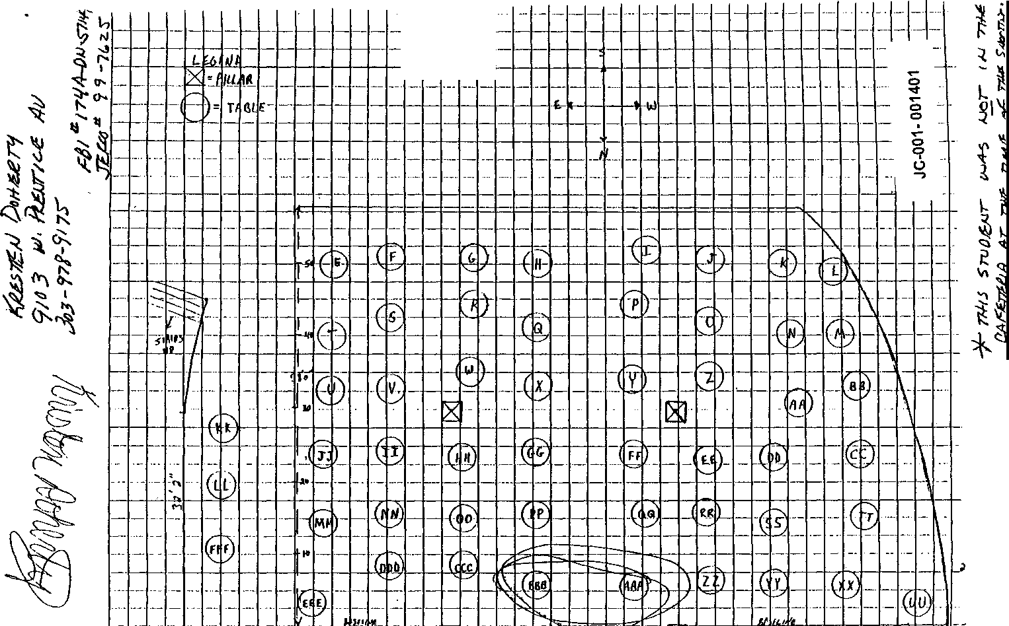,-- -
- -- - -- --'-j 1-'
JC-001-001401

'

DOWNEY, S.

JC-001-001402

CONTINUATION  SUPPLEMENT |  | JCSO |  | MOORE,C. | Case Report No  99-7625-KKKK
. |  |  | Victim Name |  | Date This Report  06-24-99
 | X First Degree Murder |  |  |  | Recommend Case: Review □  Closure 0

ADDITIONAL WITNESS:

SHAUN LAWRENCE DOWNEY, DOB/02-09-82
24 Fairway Lane
Columbine Valley, Colorado 80123 (303) 798-2207

INVESTIGATION:

On 6-22-99, I was assigned lead #4207 to interview Shaun Downey, a Columbine High School student on 4-20-99, who had Mr.
Bundy's fifth hour Algebra I class.

On 6-23-99, at 1515 hours, I contacted the listed home phone number for Downey, (303) 798-2207, and spoke with a male who identified himself as Shaun Downey. I told him that I was contacting Columbine High School students reference the incident on 4-20-99. He Stated That he had been present on the school that day and had been in Mr. Bundy's fifth period Algebra I class. I asked Downey what the first indication was to him that something was wrong. He stated that about three to four minutes after class started he heard a loud bang. About one minute later he heard the fire alarm. He Stated the class then began exiting the classroom. As he entered the hall he heard people yelling to run. Downey stated he walked to the park across the street. At that location he heard someone say that someone at the school had a gun. Downey stated that about ten minutes after arriving at the park he heard a couple of "clinking" sounds and everyone believed that they were being shot at so they all scattered. I asked Downey what he had seen or heard in the hall. He stated that he had not seen or heard anything, although it felt unusual and more
different than a regular fire alarm. I asked what direction he went after he exited the classroom and entered the hall. He stated that he turned right and then turned right again and out the doors. Downey stated that once you exit those doors you're looking directly at Pierce Street I asked Downey who was sitting near him in the classroom and be stated that he didn't know. I asked Downey if he had been into or through the cafeteria or lower commons area during the day. He stated during fourth period class he walked through that location with Corey DePooter. I asked him if he noticed anything unusual at that time, and he stated he

JC-001-001403

CONTINUATION □  SUPPLEMENT | JCSO |  | MOORE, C. | Case Report No  99-7625-KKKK
 |  | Victim Name |  | Date This Report  06-24-99
X First Degree Murder |  |  |  | Recommend Case: Review □  ,...

did not. He stated there were the normal people there. I asked him if he noticed any unusual bags or backpacks and he stated he did not I asked him if he knew either Dylan Klebold or Eric Harris and he stated he did not I asked him if these were people be recognized, and he stated be did, but had not seen them on 4-20-99.

I asked him if there was anything he had either heard or seen. prior to or since the incident., which be believed might help us. He stated that his friend, Austin Eubanks, and himself had been talking. He stated they were discussing the fact that the Rebel
News Network. something that Klebold and Harris both worked on frequently, seemed unusual on 4-20-99. I asked him what he meant. He stated there was a big 4:20 on the screen and the screen itself would shake. Downey stated that other than that he had no further information.

DISPOSITION: Open, pending further investigation.

JC-001-001404

_DURAN, DOMONIC

JC-001-001405

SUPPLEMENT HOMICIDE 99-7625 REKER

Interview with Domonic Duran
7090_W. Walker Ave.
Littleton Colo. 80231
303-979-3388
On 8-18-99 Inv. Reker did contact Duran via phone and Duran States that he was in math class on 4-20-99 and the fire alarm went off and the entire class then evacuated the building via the east entrance and then went to Leawood park.
Duran states that he did hear explosions but did not see anything and did not see any gunman.
The interview was terminated at this time.

JC-001- 001406

ESTERAK, DANA

JC-001-001407

CONTINUATION SUPPLEMENT

Transcript of handwritten statement for Dana Esterak

Investigation:
In a response to a note stating (W) Esterak could identify a third shooter I conducted a phone interview with her. (W) Esterak said she had no first hand knowledge or personally did not see a third shooter. However, her friend Tiffany Lien told her that she (Tiffany) and some friends saw -------- at the scene as a third shooter.
I then reviewed Control Number 2011- the interview of Tiffany Lien by Investigator McFadden conducted on 5/3/99. He also displayed 14 different photo line ups of which she could not positively identify -----------. She also stated she is not as sure now as she was on 4/20/99 that it was --------------.

Dispo: Open

JC-001- 001408

"

FOUST, MARLA

JC-001- 001409

Colorado State Patrol Investigative Services Section

Columbine High School Incident

Date of Report: 0 5 /0 3 /9 9 Control Number: DN2005

Interviewed Marla on 04/29/99 at her home.

Marla stated the following:

She joined the TCM at the beginning of the school year in 1997
Just hung out during school. Did not hang out after school
Did know Dylan. He asked her to this years prom, but she already had a date. Would have went if she did not already have a date.
Did not know Eric.
Dylan and Perry were not accepted into the group last year, but did dress like them
When I was in math class I was told about the shooting and heard shots and told to leave. As I left the room and turned to run to right, I looked left and saw someone dressed black wearing a trench coat and holding a weapon (do not know what kind) I thought it was -------- I was later told I was wrong by other students and told it was Dylan. they look alike
Dylan best friend was Jack (unknown last name)
Group just fell apart after last year. This is when Eric, Perry and Dylan got into the group. Group picture in year book are not all TCM members, some were not pictured
Said as a group they played cards at lunch time and talked about swords and knifes. Never saw any of the group
with a sword
Zack Heckler was best friends with Dylan
Was with Zack and Dylan the weekend before prom. nothing was said about what happened at school on the 20th
Robyn Anderson was Dylan’s date for the prom She is a good girl
If she had to guess who would do something like this she would say ---- No one in the TCM last year did any dope
Last year the group used to got somewhere in the mountains to drink, but she never went with them
Devon Adams is the ex-girlfriend of Dylan

JC-001-001410

FEILER, ZACHARY

JC-001- 001411

UNCLASSIFIED
INFORMATION CONTROL

Case ID: Priority: Source:
Affiliation:

174A-DN-57419
PRIORITY Classification: UNCLASSIFIED WEBB, R.
JCSO
Control Number: DN4323

Phone Number: (303) 271-5605 Information Received Date: 06/07/1999 Time: 12·00 PM
Method of Contact
O In Person O Telephone/Radio
O Observation O Written

Prepared by:
WEBB, RICHARD
I&1/JEFCO SO
(Component/Agency)

Event Narrative: ZACHARY JOHN FEILER, 932-0186, STUDENT 5TH HOUR !NT MATH I (TANK)

Event Date:
Categories:

Event Time: References:
INTERVIEW STUDENT· CHS

..) Event Reviewed by: KE Lead Required? YES

Lead Control Number: DN4323
Lead: INTERVIEW ZACHARY JOHN FEILER

Assigned To: ERZEN, LARRY Date: 06/30/1999 Time: 11:09AM

Disposition: ZACHARY FEILER WAS IN MR. TANK'S 5TH HOUR CLASS. CLASS WAS ORDERED OUT OF THE SCHOOL BY MR. TANK. THEY RAN TO LEAWOOD PARK. DIDN'T SEE ANY GUNMEN. HEARD GUNSHOTS OR EXPLOSIONS ONCE THEY GOT TO PARK. NO FURTHER INFO TO PASS ON. SEE 4319 FOR REPORT.

Lead Reviewed by: SL Lead Completed? Date: 07/21/1999
JC-001-001412
Printed on 7/21/1999 at 9:06 AM UNCLASSIFIED Page I

FISHER, BENJAMIN

JC-001-001413

CASE NUMBER 99-7625 SUPPLEMENT REPORT
REPORTING AGEBCY: JEFFERSON COUNTY SHERIFF'S OFFICE REPORTING OFFICER: S.K. WYGANT 1001
DATE OF IBIS REPORT: 083099
CASE STATUS: OPEN

WITNESS INFORMATION

CONTROL NUMBER 5026
BENJAMIN FISHER DOB 082383 6664 w. HAMILTON DRIVE LAKEWOOD, COLORADO 80227
PHONE 3030984 9363
STUDENT: COLUMBINE IDGH SCHOOL

INVESTIGATION

On 083099, I telephonically interviewed Benjamin Fisher, a student at Columbine High School. Benjamin told me that he never heard that
committed the shooting or the bombing at CHS on 042099. Benjamin said that he had a "Gut instinct'', that it was ------. Benjamin told me that he had nothing to back up his statement, it was just a thought he had.

DISPOSITION: CASE OPEN

Was in Hazelwood’s math class

JC-001-001414

FLEMING, TARAN

JC-001-001415

UNCLASSIFIED
INFORMATION CONTROL

Case ID:
Priority:
Source:
Affiliation:

174A-DN-57419
PRIORITY Classification: UNCLASSIFIED
WEBB, R.
JCSO
Control Number: DN4324

Phone Number: (303) 271-5605 Prepared by: WEBB, RICHARD
Method of Contact
In Person Telephone/Radio Observation Wrttten
lnformation Received Date: 06/07/1999 Time: 12:00 PM
I&1/JEFCO SO
(Component/Agency)

Event Narrative: TARAN LEE FLEMING, 933-0828, STUDENT 5TH HOUR INT MATH I (TANK)

Event Date:
Categories:

Event Time: References:
INTERVIEW STUDENT • CHS

Event Reviewed by: KE Lead Required? YES

Lead Control Number: DN4324
Lead: INTERVIEW TARAN LEE FLEMING

Date: 06/30/1999 Time: 11:10AM
Assigned To: ERZEN, LARRY
---------------------------------------
Disposition:

TARAN FLEMING WAS IN MR. TANK’S 5TH HOUR CLASS. CLASS WAS ORDERED OUT BY MR. TANK. THEY RAN TO LEAWOOD PARK. DIDN'T SEE ANY GUNMEN HEARD GUNSHOTS OR EXPLOSIONS ONCE THEY GOT TO PARK. NO FURTHER INFO TO PASS ON. SEE 4319 FOR REPORT.

Lead Reviewed by: SL Lead Completed Date: 07/21/1999

' JC-001-001416

Printed on 7/21/1999 at 9:09 AM UNCLASSIFIED Page 1

FOGARTY, T.

JC-001-001417

CONTINUATION SUPPLEMENT | JCSO |  | Reporting Officer  PETERSON | Case Report No  99-7625-LLL
Connecting Case Report No. |  | Victim Name Original Report |  | Date This Report  06-16-99
First Degree Murder |  |  |  | Recommend Case: Review □  - Closure □

WITNESSES:

TRISTA FOGARTY, DOB/10-11-83
6236 West Roxbury Place Littleton, Colorado 80123
(303) 933-6014
Student: Columbine High School

MARSIE MASCIANTONIO
Same as above
Bus, (303) 933-7184

BOB FOGARTY
Unknown address in Las Vegas. Nevada
(702) 254-5440, bus: (702) 240-3100

INVESTIGATION:

On 6-15-99, at about 1700 hours, I responded to 6236 West Roxbury Place to contact and interview Trista Fogarty, who is a student at Columbine High School. This interview was in reference to the shooting that occurred on 4-20-99 at Columbine High School.

Upon arrival at the residence of Trista Fogarty, I interviewed her in the presence of her mother, Marsie Masciantonio Trista Fogarty said that on 4-20·99 she ditched her first hour class at Columbine High School so she could work on homework for another class. Trista said she went into the Columbine High School library on 4-20·99, arriving at approximately 0745. Trista said she was in the library for approximately ten minutes. Upon my asking her, Trista told me she did not see anything unusual. She did say she saw a suspicious female working at one of the computers in the library, that Trista said may have possibly been

JC-001-001418

CONTINUATION  SUPPLEMENT | Reporting Agency  JCSO |  | Reporting Officer  PETERSON | Case Report No  99-7625-LLL
Connecting Case Report No |  | Victim Name Original Report |  | Dale This Report  06-16-99
First Degree Murder |  |  |  | Recommend Case: Review a  Closure a

Alex Marsh, however she was not positive. I asked Trista why she felt this person was suspicious and the only reason she could give was the way that the female had looked at her in the library. Trista said she left the library after about ten minutes and proceeded from the library, down the stairway to the cafeteria where she selected a table next to the stairway. The table selected. may have possibly been table "LL" on the Columbine High School cafeteria diagram. Trista said she was with the following students who were at or in the vicinity of table "LL.': Kiera O'Dell, Tony Sonderby, Elsa (last name unknown), Bo Baribeau.
Britney Gillette, Trent Carney, Steve Dixon, and Amanda Hennings. Trista said she remained in the Columbine High School
cafeteria until 0823 on 4-20-99. She said she remembered looking at the clock in the cafeteria when they left. and saying to one of her friends that they only had two minutes to get to their English classroom. Trista said she proceeded to leave the cafeteria and went up the stairway to the second level of Columbine High School. She said when she got to the top of the stairway she walked down the science and math hallway to her school hallway locker. Trista said this locker number is either #587 or #588 She said she then went into her English class with Ms. Abbott. who is her English class teacher. Trista said that it is her job in this class to turn the Rebel News Network (RNN) on for the class. Trista said she remembered the "thought of the day"' to be something to the effect of "You wished you weren't here today," and said it also contained the date of 4-20. Trista described a pattern that was on the monitor during this announcement, and she described it as being a Tie-die type pattern. Trista said she heard that Dylan Klebold and/or Eric Harris had keys to gain access to the classroom where the "thought of the day” is produced. Trista said she next proceeded to Mr. Mosier's class in or near the science hall. Trista said her next class after this one was gym. She said when she left Mr. Mosier's class she walked down the hallway, past the Columbine High School library. Trista advised that at that time she did not see any suspicious people or items that were in the area of the library as she passed by. She then turned eastbound onto the main hallway to go to her gym class. Trista said her gym class played football on 4-20-99. Trista said when she was walking back into the school, she saw Steve Curnow for the last time. Trista went into the girls locker room, got dressed. then exited the locker room and walked towards her school hallway locker. She said while en route to her locker she stopped to talk to friends of hers in the hallway and then proceeded on. Trista said she went to her math class, and while in this class she said she was sitting next to Tyson Knapke, and said they were closest to the door leading into the hallway. Trista said suddenly she heard the sound of several people running in the hallways outside of her classroom, and said she then heard people screaming. Trista said she heard someone yell something to the effect of, "He has a gun," and Trista said Tyson Knapke exited the classroom to see what was going on. He returned and then told the teacher that everyone in the class should exit the classroom and run. Trista said at this time she did not know the reason for Tyson Knapke telling everybody to run. Trista said about this

JC- 001-001419
CONTINUATION □  SUPPLEMENT | JCSO |  | Reporting Officer  PETERSON | Case Report No  99-7625-LLL
Connecting Case Report No |  | Victim Name Original Report |  | Date This Report  06-16-99
First Degree Murder |  |  |  | Recommend Case: Review □  Closure □

point in time, the fire alarm went off inside the high school. Trista said she heard noises that sounded like firecrackers going off and said she ran out of Columbine High School through the east doors, across south Pierce Street and into Leawood Park. Trista said she still did not know what was taking place. While running away from the high school, she did not know about the shooting incident until she arrived in Leawood Park. Trista said that she was one of the first students to get out of Columbine High School on 4-20-99. She said while she was at the gazebo at Leawood Park. about 20 minutes after arriving, she heard approximately 30 gunshots that she said were being shot in short bursts. Trista said she could hear shots ricocheting off of the gazebo. Trista said these shots began just as she had turned her back to Columbine High School to talk to a friend and to get something from this friend, who had been standing behind her. Trista said she did not see anyone outside of Columbine High School. nor did she see anyone inside the school through the windows or the door windows shooting, or who may have possibly been the shooters. Trista said she also heard four to five explosions during this time frame and said to her it sounded like they were being detonated on the other side of the school (west side), possibly outside of the cafeteria. Trista said she ran from Leawood Park. after jumping over a fence. and then went to Eric Long's house, who apparently lives in the neighborhood near Columbine High School. She said while running, she continued to hear "booms." Trista said a short time later she went to Chad's house (unknown last name, address or phone number) and went inside. She said they locked all the doors to the house due to the fact that she had heard there was a suspect somewhere outside of Columbine High School in the surrounding neighborhoods that was shooting people. It was unknown where Trista received this information.

I showed Trista Fogarty the photographs of the duffle bag and propane tank that were later recovered in the Columbine High School cafeteria. Trista said she did not see either of these items either prior to or during the incident. Trista said she did not see anyone carrying either item or any items that may have resembled one of these items, either prior to or during the incident. on
4-20-99.

I asked Trista Fogarty what she knew about the "Trench Coat Mafia" and/or the "Trench Coat Mafia" students. Trista said when she first began attending Columbine High School her friends advised her to avoid the "Trench Coat Mafia" students. Trista said she was told the reason to avoid the "Trench Coat Mafia" was that they were "satanic", that they used drugs together, and "they all have sex together." Trista could not elaborate further on the information she had received about the "Trench Coat Mafia having sex together, but said she did not believe it meant that Dylan Klebold and Eric Harris were having a homosexual

JC- 001-001420
CONTINUATION □  SUPPLEMENT | Reporting Agency  JCSO |  | Reporting Officer  PETERSON | Case Report No  99-7625-LLL
 |  | Victim Name Original Rcport |  | Date This Report  06-16-99
X First Degree Murder  Reclassification □ |  |  |  | Recommend Case: Review □  Closure □

relationship together.

Trista Fogarty said that a friend of hers by the name of Leanne Clark was in the cafeteria on 4-20-99 when the shooting started. Trista said Clark told her that she saw who did the shooting in the cafeteria, and said that Clark identified ------ as a gunman. Trista said she is afraid of ---------- and said when she returned to her school classes at Chatfield High School after the shooting incident, she saw ----------------- at Chatfield High School and Trista said she "freaked out" Trista said the "Trench Coat Mafia" students have scared her since she saw them. and said she bumped into one of them in the hallway of Columbine High School on 4-20-99, at approximately 0920 hours. outside of her English class. Trista said she pulled back and away quickly from this "Trench Coat Mafia" student, however. she said she did not know what this student's name was.

Trista Fogarty said a person she knows only as "Scott" said that on 4-20-99 he saw Eric Harris go through the custodian's roof access at Columbine High School and then go out onto the roof of the school. Trista said Scott's last name is unknown, but said he is a sophomore at Columbine High School.

Trista Fogarty said that she believed Nicole Markham is or was Chris Morris' girlfriend. Trista said a female by the name of Jamie Thurman associates with Brooks Brown and goes over to Brooks Brown's house. She said that Jennie Neffy goes along with Jamie Thurman to Brooks Brown's house because Jennie Neffy "has a crush" on Brooks Brown's brother, Ian Brown. Trista was not positive of Brooks Brown's brother name. however, she believed it was Ian. Trista said that Jamie Thurman told her that Brooks Brown "is a nice guy."

ADDITIONAL INFORMATION:

Trista Fogarty told me that she fully believes that there were more than four people involved in the incident on 4-20-99. Trista said that most of the people that she has talked to believe there were more than two shooters and said that friends of hers believe that ------ may have been one of the shooters involved on 4-20-99.

Trista Fogarty advised me that since the incident on 4-20-99 at Columbine High School she has had trouble dealing with the

JC-001-001421
CONTINUATION □  SUPPLEMENT | JCSO |  | PETERSON | Case Report No  99-7625-LLL
Connecting Case Report No. |  | Victim Name Original Report |  | Date This Report  06-16-99
X First Degree Munier  □ |  |  |  | Recommend Case: Review □  Closure □  I I

situation and in fact has been seeing a counsel/therapist Her mother Marsie Masciantonio confirmed that Trista has been seeing this therapist. I gave both of them my business card and advised them that if they wished to talk with a Victim Advocate in the future to contact me and I would make the necessary arrangements for them. I also asked Trista to contact me in the future if she remembers any more information that may be pertinent to this case.

DISPQSITION; Case remains open, pending further investigation.

JC-001-001422

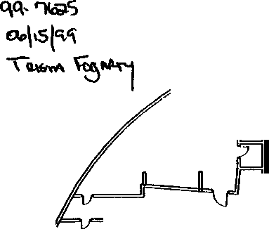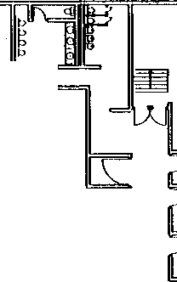
Faculty
Lounge
Kitchen
Serving Line
I
I•
0
00
0 0
O0 o
Pillar(;) 0
0
0 - Pillar
D 0
•
o
OOO
0
Oo
o
oOo
O
000
oo
o O
Stai
0 0
-0--0-
0
O □PIllar 0
0 0
0
[l _o
a,
0
0
0
0 O
Pillar
0 0
Food Cart

JC-001-001423

CAFETERIA

Student
/ =.Store

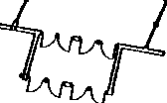

0z

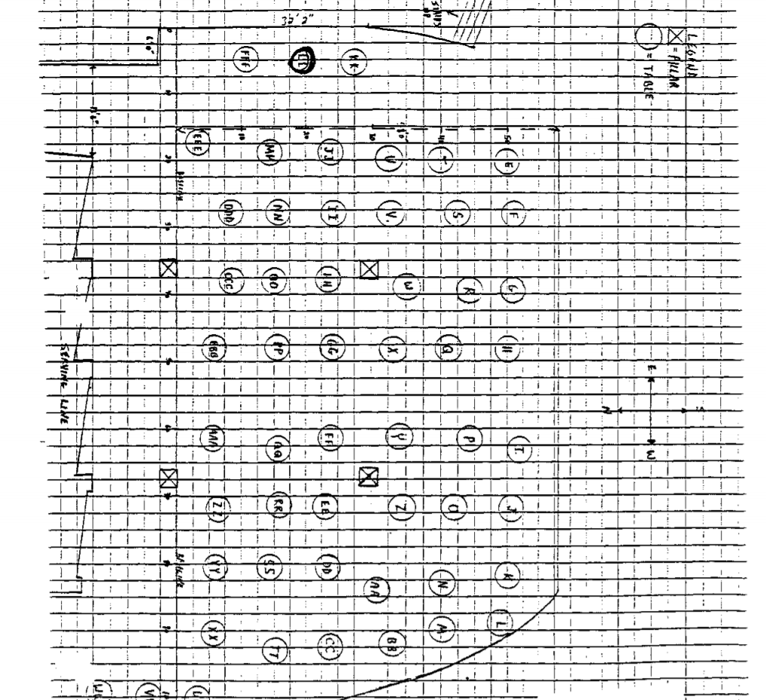
JC-001-001424

FULLER, JACOB

JC-001-001425

UNCLASSIFIED
INFORMATION CONTROL

Case ID:
Priority:

174A-ON-57419
PRIORITY Classification: UNCLASSIFIED
Control Number: DN4326

Source: WEBB, R.
Affiliation: JCSO
Phone Number: (303) 271-5605
Prepared by: WEBB, RICHARD

Information Received Date: 06/07/1999 Time: 12:00 PM
Method of Contact
O In Person O Telephone/Radio
O Observation O Written
I&I/JEFCO SO
(Component/Agency)

Event Narrative: JACOB RAY FULLER, 933w3929, STUDENT, 5TH HOUR INT MATH l (TANK)

Event Date: Categories:

Event Time: References:
INTERVIEW STUDENT· CHS

Event Reviewed by: KE Lead Required? YES

Lead Control Number: DN4326
Lead: INTERVIEW JACOB RAY FULLER

Assigned To: ERZEN, LARRY Date: 06/30/1999 Time: 11:11 AM

Disposition: JACOB RAY FULLER WAS IN MR TANK'S 5TH HOUR CLASS. CLASS WAS ORDERED OUT OF SCHOOL BY MR TANK THEY RAN TO LEAWOOD PARK. DIDN'T SEE ANY GUNMEN. HEARD GUNSHOTS OR EXPLOSIONS ONCE THEY GOT TO THE PARK NO FURTHER INFO TO PASS ON. SEE 4319 FOR REPORT

Lead Reviewed by: SL Lead Completed? Date: 07/21/1999

JC-001-001426

Printed on 7/21/1999 at 9:17 AM UNCLASSIFIED Page 1

,
GREEN, S

C,

JC- 001-001427
0

CONTINUATION □  SUPPLEMENT | JCSO |  | MOORE, C. | Case Report No  99-7625-LLLL
 |  | Victim Original Report |  | Date This Report  06-24-99
'  X First Degree Murder |  |  |  | Recommend Case: Review 0  Closure 0

ADDITIONAL WITNESS:

SARAH JAYNE GREEN, DOB/01-15-83
5474 South Hoyt Street
Littleton, Colorado 80123
(303) 904-1508

INVESTIGATION:

On 6-22-99, I was assigned.lead #4208 to interview Sarah Green. a Columbine High School student on 4-20-99, who was assigned Mr. Bundy's fifth hour Algebra I class.

On 6-24-99, at about 1100 hours, I received a call from a female identifying herself as Sarah Green. I had previously exchanged phone messages with Green, after leaving a message at her listed home phone number of(303) 904-1508. I told Green that I was contacting Columbine High School students reference the incident on 4-20-99. She stated she had been at the school and had been in Mr. Bundy's class. I told her my understanding was the class started at 1115 and asked her what the first indication was that somethmg was wrong. She stated that about five to six minutes after class started they were taking a test when she heard a big bang. She stated that she looked towards the classroom door, which was closed, and could see kids running through the window in the door. She stated that next Coach Ortiz came into the room and yelled, "Run, get out of the school as fast as you can." Green stated that once they left the classroom they turned right in the hall, left in another hall, and right in another hall, going out a door which faces Pierce Street I asked her what she heard or saw once she got into the hallway. She stated that she could hear people screaming. She stated that after going outside they went immediately past Pierce Street, into the park. near the fence. She stated after a couple of minutes people were yelling to get back. She stated that they moved farther into the park. She heard unknown girls saying that Mr. Sanders had been shot After they moved into the tree area she heard three to four gunshots,
-
which she believed to be outside, as she believed them to be too loud to be inside. She described them as being "pops." She stated she felt as if the gunfire was coming in their direction and she and the other kids began running into the neighborhoods.

JC- 001-001428

-
CONTINUATION  SUPPLEMENT |  | JCSO |  | MOORE, C. | Case Report No.  99-7625-LLLL
 |  |  | Victim Name Onginal Report |  | Date This Report  06-24-99
 | x First Degree Murder

I asked Green if at any point during the day she had been into the cafeteria or commons area. She stated that in the morning she and her sister, Laura Green, arrive at school together. She stated that on 4-20-99 they arrived at about 0710 hours and went to the cafeteria for a while. I asked her if she had seen anything unusual, and she stated she had not I asked her if it was crowded at that time, and she stated it was not crowded, but there were a few people. I asked her if there were any unusual bags or backpacks and she stated there were not. I asked her if she knew either Dylan Klebold or Eric Harris. She stated she did not know them, although she had seen them. I asked her if she had seen them at any point during the day on 4-20-99, and she stated she had not.

I asked Green if she-could recall who she was sitting with in the classroom prior to this incident. She stated that Brian Deidel was in front of her, Elyssa Most was also in front of her. She said they had recently changed seats, as they do every three weeks. and she could not recall who else was sitting near her. I asked her if there was anything she had either seen or heard, either prior
or since the incident, which she thought might be of assistance to us. She stated there was not

DISPOSITION; Open, pending further investigation.

JC-001-001429

GREER, LINDSAY

JC-001-001430

Case ID: Priority: Source:

UNCLASSIFIED
INFORMATION CONTROL
Control Number: DN4327
174A-DN-57419
PRIORITY Classification: UNCLASSIFIED WEBB, R.
Method of Contact
0 In Person 0 Telephone/Radio
O Observation O Written

Affiliation: JCSO
Phone Number: (303} 271-5605
Prepared by: WEBB, RICHARD

Information Received Date: 06/07/1999 Time: 12:00 PM
I&I/JEFCO SO
(Component/Agency)

Event Narrative: LINDSAY GREER, 948-8846, STUDENT 5TH HOUR INT MATH l (TANK)

Event Date:
Categories:

Event Time: References:
INTERVIEW STUDENT • CHS

Event Reviewed by: KE Lead Required? YES

Lead: INTERVIEW LINDSAY GREER
Lead Control Number: DN4327

ERZEN, LARRY Date: 06/30/1999 Time: 11:12 AM
Assigned To:
---------------------------------------

Disposition: LINDSAY GREER WAS IN MR TANK’S 5TH HOUR CLASS. CLASS WAS ORDERED OUT OF THE SCHOOL BY MR TANK. THEY RAN TO LEAWOOD PARK. DIDN'T SEE ANY GUNMEN. IT WASN'T UNTIL THEY GOT TO THE PARK THAT THEY HEARD GUNSHOTS OR EXPLOSIONS. NO FURTHER INFO TO PASS ON. SEE 4319 FOR REPORT.

Lead Reviewed by: SL | Lead Completed? 1i'.l Cate: 07/21/1999
Printed on 7/21/1999 at 9:20 AM | UNCLASSIFIED | JC-001-001431  Page I

GRENGS, N.

JC-001-001432

CONTINUATION  SUPPLEMENT | JCSO |  | MOORE, C. | Case Report No.  99-7625-lTIT
 |  | COLUMBINE |  | Date This Report  06-30-99
X FIRST DEGREE MURDER |  |  |  | Recommend Case: Review □  Closure □

ADDITIONAL WITNESS:

NATHAN JOHN GRENGS, DOB/10-10-82
3335 S. Holly Street Denver, CO 80222
303-756-8724

INVESTIGATION:

On 06-22-99, I was assigned Lead #4209, to interview Nathan Grengs, a Columbine High School student on 04-20-99, who was
assigned Mr. Bundy's fifth hour Algebra I class.

After several attempts to reach Grengs, on 06-29-99, at 1652 hours, I was able to contact him at the listed home phone number. 303-756-8724. I told Grengs that I was contacting Columbine High School students reference the incident at the school on 04- 20-99. I asked him if he was at school. He stated that he was and was in attendance of Mr. Bundy's fifth hour class. I told him my understanding was that fifth hour started at 1115. I asked him what the first indication was to him that something was wrong He stated they were taking a math quiz and it had been ten minutes or so since class started, when Coach Ortiz came in yelling at them to get out of the school. He stated immediately after that, the fire alarm went off. Grengs stated that he thought it was normal. He stated as he exited the classroom, he turned right in the ball, to the end of the hall, turning left into that hall and right out the main hall and out of the building. He stated that once in the halls be could tell that it was more serious and heard talk of guns, although nothing specific. I asked him if he had seen anything in the halls. He stated that there was more of a hurry than normal and the teachers seemed much more intent on getting them out of the school. Grengs stated that outside they went across Pierce Street to Leawood Park. He stated after ten minutes of being in Leawood Park, he heard what he believed to be an explosion inside the school and then heard some gunshots which sounded as if they were outside. He stated the gunshots sounded as if they were coming from the teacher or main entrance. I asked him if he could tell what direction they were pointed toward and he stated he could not, but that everyone began running.

JC-001-001433

CONTINUATION SUPPLEMENT | JCSO |  | MOORE, C. | Case Report No  99-7625-TTTT
 |  | Victim Name  COLUMBINE |  | Date This Report  06-30-99
X FIRST DEGREE MURDER |  |  |  | Recommend Case: Review 0  Closure 0

I asked Grengs if he had been into or through the cafeteria at all on 04-20-99. He stated he had not. He then stated that he had come up from Spanish class on the lower level, which is his fourth period class. He stated that he truly didn't pay attention to the cafeteria, although nothing seemed abnormal.

I asked Grengs if he knew either Dylan Klebold or Eric Harris and he stated he did not. I asked him if they were anyone he recognized from the hall. He stated he did not.

I asked Grengs whom he had been sitting with in Mr. Bundy's class. He stated there was someone named Chris in front of him. Hannah Cain was to his left. He stated there was no one to his right He stated in the row he was sitting in was Carl Ashton, Zach Ziccardi and Chris (unknown last name). He stated that Kristen Doherty was sitting behind Cain.

I asked Grengs if there was anything he had either heard or seen. either prior to or since the incident, which he thought might
be of assistance to us. He stated there was not.

DISPOSITION: Open, pending further investigation.

\

JC-001-001434

HARRIS, ESTER

JC-001-001435

CONTINUATION  .., SUPPLEMENT | JCSO |  | Reporting Officer  PETERSON | Case Report No.  99-7625-EEEEE
 |  | Victim Name Original Report |  | Date This Report  07-27-99
X First Degree Murder |  |  |  | Recommend Case: Review D  Closure D

WITNESSES:

ESTHER MARJE HARRIS, DOB/02-27-84
8165 South Quay Court Littleton, Colorado 80128
(303) 932-7823
Student: Columbine High School

GLORIA HARRIS
Same as above
Bus; LGC Management 5200 South Broadway
Englewood, Colorado 80120
(303) 789-6728

COLBERT HARRIS
Same as above Bus: Burt Buick
5850 South Broadway
Littleton. Colorado 80121
(303) 794-5390

INVESTIGATION:

On 7-27-99, at approximately 1700 hours, I responded to 8165 South Quay Court to contact and interview Esther Marie Harris, who is a Columbine High School student. This interview was in reference to the shooting that occurred at Columbine High School on 4-20-99.

JC- 001-001436
CONTINUATION SUPPLEMENT | Reporting Agency  JCSO |  | PETERSON | Case Report No  99-7625-EEEEE
Connecting Case Report No |  | Victim Name Original Report |  | Date This Report  07-27-99
X First Degree Murder |  |  |  | Recommend Case: Review 0  Closure □  I I

Upon arrival, I contacted Esther Harris and her mother, Gloria Harris, who was present during the interview. Esther Harris told me on 4-20-99, she arrived at Columbine High School for her scheduled classes for that day. Esther said she arrived just in time to get to her locker, which is just around the comer from the library, and down the main hallway on the upper level of the school, and then go to her first hour English class that started at 0730 hours. Esther said she did not remember anything being out of the ordinary while she was walking to her classes on 4-20-99. Esther said after her first hour English class. she went to her second hour science class, which is on the upper level of the school. She said for her third hour class, she went to her Spanish class, located on the lower level of Columbine High School. Esther said to get to this Spanish class, she had to walk down the stairway from the upper level of the school to the lower level, the stairway leads into the cafeteria/commons area. Esther said when she got to the lower level on the stairway, she turned to her left to go to her class. Esther said she therefore walked along the eastern side of the cafeteria/commons area. I showed Esther the photographs of a duffle bag and the propane tank that were later recovered in the Columbine High School cafeteria. She said she did not see either item. nor did she see any items of a similar description as those on4-20-99. Esther said she did not know who the Trench Coat Mafia or the Trench Coat
Mafia students were prior to the shooting, so she therefore did not see any Trench Coat Mafia students or associates in the cafeteria/commons area or any other location in Columbine High School on 4-20-99. Esther said after Spanish class she went back up the stairway to the upper level of the school and to her gym class. which was a dance combo class. After gym class. Esther said she went to her fifth hour geometry class on the upper level of Columbine High School. Esther said after arriving at her geometry class. the students were checking their homework when she said she suddenly heard people in the hallways outside of her classroom screaming and heard people running in the hallways. Esther said she thought all this activity was from a senior prank. Esther said Mr. Ortiz, who was one of her teachers, went out of the classroom and into the hallway to see what was taking place. She said her other teacher, Ms. Moore, stayed in the classroom. She said Ms. Moore then exited the classroom also into the hallways. Esther said Ms. Moore then quickly returned to the classroom saying, "Oh gosh, oh gosh” while she went to her desk in the classroom to get her keys out, so she would be able to lock the classroom doors between the classroom and the hallways. Esther said Mr. Ortiz returned to the classroom after being gone a few minutes, and entered before Ms. Moore could get the doors locked. Esther said when Mr. Ortiz returned, he told all the students in the classroom to run, possibly telling them to run outside and away from the school, however, Esther could not remember for sure. She said she ran out of the classroom into the hallway, where she saw several students running. Esther said she then ran out of Columbine High School through the east side doors that are located south of the main school doors and the Columbine High School

JC- 001- 00143
CONTINUATION SUPPLEMENT | Reporting Agency  JCSO |  | PETERSON | Case Report No  99-7625-EEEEE
Date This Report
07-27-99
X First Degree Murder |  |  |  | Recommend Case. Review 0  Closure 0

Administrative offices. Esther said after she had exited the school, she ran eastbound from the school, across South Pierce Street and into Leawood Park. Esther said up to that point she had not heard any explosions or gunshots and did not know what was taking place. She said while she was in Leawood Park, she heard two to three either gunshots or explosions, but did not know which. Esther said she did not see any smoke, nor did she see anybody with a firearm or explosive device at any time during the incident on 4-20-99. Esther said she was in Leawood Park for an estimated 20 to 30 minutes when she heard two to three shots or explosions and she, along with other students, believe the gunshots may have been discharged toward the students in Leawood Park so she ran with friends of hers by the name of Sarah Green, Anna Taylor, and Allison Reardon. She said they ran to Eric Long's house, which backs up to Leawood Park. Esther said Eric Long's mother then took them to Leawood Elementary School, where she eventually met with her mother, Gloria Harris.

Esther Harris said that prior to the shooting at Columbine High School on 4-20-99, she did not know who the Trench Coat Mafia or any of the Trench Coat Mafia students were. She said she knew the name only of Eric Harris because they had the
same initials and this caused her to have to change her computer password at Columbine High School for her keyboarding class during the first semester of 1999.

Esther Harris said she knew who Isaiah Shoels was and told me that everybody liked him. She said she never saw any racial harassment or racial intimidation directed towards Isaiah Shoels. She said she never saw any racial harassment or intimidation directed towards any of the Columbine High School's minority students.

Esther Harris said she has not heard about anybody other than Dylan Klebold and Eric Harris who may have been involved in the shooting on 4-20-99 at Columbine High School. Esther said she does not know of anybody, nor has she heard any rumors of anybody, who may be manufacturing explosive devices and/or possessing or selling firearms. Esther said she does not know of anybody that has a double pierced eyebrow. Esther said she does know what the Rebel News Network (RNN) is, and what the "thought of the day'' is, however, she did not know what it was for the day of 4-20-99.

Esther Harris said on 4-20-99, when she ran out of Columbine High School, she left her backpack and contents in her geometry class. This backpack was described by Esther as a navy blue Jansport with contents. Esther said she has since gotten the

JC- 001-001438
CONTINUATION | Reporting Agency Reporting: Officer  JCSO PETERSON |  | Case Report No  99-7625-EEEEE
Connecting Case Report No Victim Name Original Report |  |  | Date This Report  07-27-99
X First Degree Murder |  |  | Recommend Case: Review □  Closure □

backpack and contents back from the school.

I asked Esther Harris how she and her family have been doing since the incident on 4-20-99. Both her and her mother, Gloria. told me that there have been some rough times, however, they feel they are doing well at the present time. I gave both of them one of my business cards and asked them to contact me in the future should anybody in their family want to talk with a JCSO Victim Advocate. I advised them I would make the necessary arrangements for them at that time.

DISPOSITION: Case is open, pending further investigation.

JC-001-001439

0

HARRISON

JC-001-001440

CONTINUATION SUPPLEMENT
 | JCSO |  | MOORE, C. | 99-7625-CCC
Connecting Case Report No. |  | Victim Name |  | 06-14-99
X FIRST DEGREE MURDER |  |  |  | Recommend Case: Review □

ADDITIONAL WITNESSES:
Jessica Harrison, dob/04-27-83 6376 South Newland Court Littleton, Colorado 80123
(303)730-2598

INVESTIGATION:
On 06-14-99, I was assigned lead numbers 3976 and 3977 to interview Jerilyn and Jonathan Harrison. Columbine High School students. Upon contacting the Harrison residence at 6376 South Newland Court.. I learned of additional siblings attending Columbine High School, including Jessica Harrison. I then spoke with Jessica Harrison at the residence on 06-14-99. at about 1410 hours.

Jessica Harrison stated she was at Columbine High School on 04-20-99. She stated she had been in Mr. Bundy's math class taking a quiz. She stated the class had only been going on for about five minutes when she began hearing popping noises. Jessica Harrison estimated this was at about 1115 hours. She stated the door of the classroom was shut. Jessica Harrison said a minute or less later, the fire drill went off and at about the same time an unknown male math teacher ran into their classroom, ducking down and shouting "run for your life." Jessica Harrison stated she did not know the teacher's name. She described him as being a white male, in his 40’s, with black hair, tall. medium build. Jessica Harrison stated the teachers were pushing them out of the school. She stated some students tried to stay behind to ask what was going on, and the teachers pushed them out the door
Jessica Harrison stated she believes the classroom number was MA8, and they went out the door directly next to that. She stated they all went across the street to the park. She stated she was in the park and was worried for her brothers and sisters who attend the high school. She stated she heard people talking about the Trench Coat Mafia shooting at people. and that she did hear _{a} few additional shots. and what she believed to be screaming coming from within the school. Jessica Harrison stated she was with Michelle Shoels. Isaiah Shoels' sister.. and that Michelle Shoels was praying for her brother and was concerned about him. I asked Jessica Harrison if she had either heard or seen anything prior to the incident or since the incident that she thought may be of help. She stated she did not.
JC-001-001441

CONTINUATION  SUPPLEMENT | JCSO |  | MOORE,C. | 99-7625-CCC
 |  | Original Report |  | Date This Report  06-14-99
X FIRST DEGREE MURDER |  |  |  | Recommend. Case: Review □  Closure □

Upon returning I found a lead had been set to interview Jessica Harrison, lead number 4210.

DISPOSITION: Open, pending further investigation.

JC-001-001442

HAVENS, T

JC-001-001443

 | DEPARTMENT OF THE TREASURY  BUREAU OF ALCOHOL, TOBACCO, ANO FIREARMS  REPORT OF INVESTIGATION |  | Page 1 of  l Pages
Special Agent in Charge Phoenix Field  Division |  | MONITORED INVESTIGATION INFORMATION:
TITLE OF INVESTIGATION:

Columbine High school Shooting/Bombing

Case Number

785030 99 0009
TYPE OF REPORT:
Report#

38

X | REPORT OF INVESTIGATION |  | COLL.ATERAL REPLY
 | REPORT OF INTELLIGENCE
SUBMITTED BY (Name)  Matthew C. Traver |  | SUBMITTED BY (Title and Office)  SA/Denver |  | SUBMITTED BY (Date)  07/01/99
REVIEWED BY (Name)  .Robin King |  | REVIEWED BY (Title and Office)  RA.C/Denver II |  | REVIEWED BY (Date)
APPROVED BY (Name)  Christopher Sadowski |  | APPROVED SY (Title and Office)  SAC/Denver |  | APPROVED BY (Date)
DESCRIPTION or ACTIVITY:
Interviews with Terry Havens 5th hour Algebra class, pertaining to 4/20/99.
SYNOPSIS,
Between 15/22/99 and 7/1/99 the students in Terry Havens' 5ch hour Algebra class, and Mr. Haven were interviewed by phone. The class meets in Math Room 10. The following is a composite description of what was gleaned from the interviews with Mr. Haven and his 5<h hour students
NARRATIVE:
1. On 4/20/99, the students were taking a test. All the students were present except for Landin LeBlanc, who skipped class because of the test and was playing video games at Joe Orr's house LeBlanc who also has 4th hour free was later notified about the shooting when contacted by his father. Also, Kristin Kuiken, who had been marked as absent, was present. She arrived at class about 10 minutes late due to a Marketing class banquet.
2 Most of the students reported hearing a loud noise, bang, or explosion. Mr. Havens
stated that he heard two gunshots One student Ann Behounek, stated that she did not recall hearing any noise, but was first alerted to students running by the classroom and yelling
- The majority of the students report that after hearing the noise, they saw or heard
students yelling and running by the classroom.
- At this point some students claim they heard additional explosions or loud noises, while some say it was not until after the fire alarm went off, that they heard
additional explosions or gunshots.
- Havens got about ½ way to the door to investigate the commotion in the hall, when
the fire alarm went off, and instructed all the students to exit the building.
6 Some students ran, some describe just casually walking out of an exit on the eastside of the building. Mr. Havens stated that he was the last one out of the classroom and

JC-001-001444

-
DEPARTMENT OF THE TREASURY
BUREAU OF ALCOHOL. TOBACCO. AND FIREARMS
REPORT OF INVESTIGATION - Continuation Sheet
Page 2 of
2 Pages

'OF JNVESTIGA.TION:

CASE NUMBER:
REPORT NUMBER;
turned off the lights. He also went to the classroom to the north of his and told them to get out of the building. By the time he got across Pierce Street to Leawood Park he did not see any of his students.
- As Mr.Havens crossed the street he saw a girl with a gunshot wound to the leg. He stopped to administer aid. He ended up running down the street to get an ambulance for the injured girl.
- All the students stated that after exiting through an exit on the east side of the building, they went across Pierce Street to Leawood Park. The students congregated around the front part of the park until a point were some thought they heard gunshots or explosions, or were told by teachers that shots were being fired into the park and to run, at which time the students scattered and ran into the subdivision around the park.
9. Some of the students went to friends homes located nearby, while others ran into Samaritans' homes, who opened their homes to the students.
- At this time most of the students made calls to their families, went home, or went to Leawood Elementary School to try and find friends or meet up with family.
- Brenton Hooker claims that while looking for his girlfriend, after exiting the
school with his classmates, he saw a tall, skinny guy, dressed in black, come out of the front entrance of the school and heard four shots fired. He claims he was about
?100 yards from the gunman. After he witnessed this he ran down Fair Street to a home owned by a law enforcement officer that he knows.
- None of the other students or Mr. Havens reported seeing any gunman, or anyone
lighting or throwing any type of explosive device or bomb.
- Mr. Havens stated that after getting the first ambulance for the injured girl, he stayed by another ambulance at Fair and Pierce and eventually instructed them on how to get around to the cafeteria area. Havens stated that he was eventually told by police to take all the students to Leawood Elementary School.
- The only student not interviewed by SA Traver was Tom Harris. Harris was in Phoenix
with a baseball team. SA Traver did however talk to his mother. After recounting the incident as he understood it from interviews with the other students and Mr. Havens, to Mrs. Harris, she stated that the events described were the same as those described to her by her son. She stated that Tom had said that once he was at the park, he thought they were being shot at in the park. He ran to a Samaritans' house. The woman that owned the home had all the kids who ran into her home call their parents. Tom did call his mother at that time.
- All of the accounts reported by the students were quite similar. Though some described the first noise heard while taking the tests as an explosion, some as gunshots or shotgun blasts, or just a loud noise, all accounts as to what was seen or heard and the order of occurrence are similar None, other than Brenton Hooker, saw any gunman, or any persons with weapons. Also the exit used by this class was not the main School entrance of the east side of Columbine, but was farther to the south of that entrance/exit

ATTACHMENTS

JC-001-001445

HAZELWOOD, G.

JC-001- 001446

Control Number 4123

Interviewing Agent: Larry A. Brown, Colorado Bureau of Investigation, 690 Kipling St., Suite 4000, Denver, CO, 80215, phone (303) 239-421 l

Place of Interview: Telephonic to 1528 W Briarhollow LN., Highlands Ranch, CO, 80126, (303) 683-8096

Person Interviewed: Columbine school teacher Gretchen HAZEL WOOD, 1528 W Briarhollow LN., Highlands Ranch, CO, 80126

Ms. HAZELWOOD stated her fifth period class began at 11:15 am. and there were approximately 24 students in the class. HAZELWOOD said student Amanda ARAPKILES had returned from the restroom and reported that someone had a gun and lots of students were running in the halls. HAZELWOOD said she initially thought a senior prank was being performed. When she looked into the hall and saw the look on the students faces she realized something serious was occurring and ordered her class to leave the building just as the fire alarms started to sound. HAZELWOOD and her students exited the school through the doors that were adjacent to her classroom. HAZELWOOD and her students ran across Pierce street to Leawood Park. According to HAZELWOOD, the hallway of the school looked hazy as
she was leaving the school. HAZELWOOD stated she did not see the gunmen or hear any of the shots being fired. HAZELWOOD said her hearing is not very good and she only heard the sounds of the bombs exploding. HAZELWOOD stated she did not know HARRIS or KLEBOLD and had not heard any rumors of other people being involved in the attack.

Colorado Bureau of Investigation

JC-001- 001447

Reference: Control Number 4123

Interviewing Agent: Larry A. Brown, Colorado Bureau of Investigation, 690 Kipling St., Suite 4000, Denver, CO, 80215, phone (303) 239-421 I

This report is referenced to Control Number 4123.

The following students were telephonically contacted and interviewed: Carly Marie HIEGEL
Vincent M. TONEY Brian Michael TENEYCK
Christine Margaret ROBERTS Paul Thomas CUESTA
April Ruth BORNHOEFT Lanae Deann BRADFORD Allison Rose CARTER Jessica Marie WATSON

All of the above gave similar accounts of their actions on the April 20, 1999, attack on Columbine High School began. They were all in Ms. HAZELWOOD'S fifth hour class when student Amanda ARAPKILES came into the classroom and stated there was a guy with a gun in the school and they all needed to get out quickly. Students gave various accounts of screaming and running by other students in the hallway. The class evacuated the school from an exit next to the class and ran toward Leawood Park, on the east side of Pierce Street.
None of the students saw the gunmen but they all heard the sounds of the gunfire and the explosions from the bombs.

Parents of the following students (students unavailable) were contacted and stated that their children related to them the same set of events:
Elizabeth Lynne KUHN (Mother - Nancy KUHN) Daniel GREER (Mother- Toby GREER)
Russell S. McPHAIL (Mother· Rhonda NIELSEN) Lindsay Marie ROONEY (Mother· Linda ROONEY
Asia Wyn KESSINGER (Mother· Lynellen KESSINGER)

The following students could not be reached but were confirmed by other students to have evacuated the classroom and ran to Leawood Park.
James Matthew SANCHEZ Lindsey Ivy BENGE

Additionally, student April BORNHOEFT said she ran in to the hall and waited for about 15 minutes. She said she saw an individual wearing a white shirt and possibly suspenders. He was standing over a body that was not moving. The distance was approximately 10-15 feet. He had a small gun but did not raise it towards her or her friend, Christine ROBERTS. The two then left the school and ran to Leawood Park

Larry A. Brown, Agent
Colorado Bureau of Investigation JC-001-001448

HECKLER, JOCELYN

JC-001-001449

PIRNARR Arvada Police/Court System Arvada Police Department
NARRATIVE

Page l
06/03/1999

================================================================================

Ref# 99-12067

Type ASSTOA
Reported Date 04/20/1999 Time 12:39:32
Status RTF

Location 6201 S PIERCE ST

DET96 06/02/1999 060199/VONDEROHE/KK

The following supplement will be in reference to Arvada Police Department CR 99-12067 that will correspond with Jefferson County Sheriff's Department CR 99-7625 regarding the Columbine High School shootings/murders that occurred on 04/20/99. IO Detective Jim Vonderohe is a member of the task force that was formed to investigate the Columbine High School shootings and as a result of this investigation, lead sheets are assigned to task force members. This supplemental report will be in regards to lead control #1604 in which a party identified as Monica Lobser spoke with a Jocelyn Heckler during a memorial service on 04/25/99. The information control sheet indicated that Jocelyn Heckler is presently a Columbine High School student and was formerly a student of Monica Lobser's when Ms. Lobser taught at Ken Karyl Middle School. During her conversation with Jocelyn Heckler on 04/25/99, Jocelyn Heckler indicated to Monica Lobser that she was a close friend of Dylan Klebold and had witnessed several changes taking place with him in the days prior before the incident on 04/20/99.

On 05/26/99 IO responded to the Heckler residence, 5880 W. Quarles Drive in Littleton, Colorado, 80128, and met with Jocelyn
Amanda Heckler, DOB 06/08/83. Jocelyn Heckler advised IO that she presently is in the tenth grade at Columbine High School and that their home telephone number is 303-978-0098.

Jocelyn Heckler advised IO that she has known Dylan Klebold since his freshman year, at which time she would have been in the seventh grade. She stated that she initially met him through her brother Zack Heckler and that Dylan Klebold in fact became a good friend of the entire Heckler familv. She further stated that she knew who Eric Harris was but never really talked to him.

In discussing the changes that she observed in Dylan Klebold take place, she stated that the changes began at the beginning of his junior year, during which time she was a freshman at Columbine High School. She stated that Dylan Klebold began wearing a black trench coat but that he never really associated with the Trench Coat Mafia group. She also stated that Eric Harris normally wore blue jeans and a white t-shirt and that she saw him hardly ever wear his trench coat. She stated that she really never knew why Dylan Klebold began wearing a black trench coat other than he was becoming a rebel at that time. She stated that she did know that Dylan Klebold and Zack Heckler, her brother, began believing somewhat in the principles of anarchy. Jocelyn Heckler stated that Dylan Klebold then began getting deeply involved in computers and that he in fact took classes on how to build computers at Columbine High School. She further stated that Dylan Klebold was able to create his own computer program and that by the end of his junior year, he played computer games all the time. She stated that some of the computer games he played included "Wolfenstein" and the game "Doom," which he played briefly. She stated that he then began playing "Duke Nukem" in which the player shot and blew people up.
She further stated that a person is able to play these video games
JC-001-001450

PIRNARR Arvada Police/Court System Arvada Police Department
NARRATIVE
Page 2
06/03/1999

======================================================================
Ref# 99-12067 Reported Date 04/20/1999 Time 12:39:32 Type ASSTOA Status RTF
Location 6201 S PIERCE ST
DET96 06/02/1999 060199/VONDEROHE/KK

with other people on the Internet, which is what Dylan Klebold did. She stated that by his senior year, he became very involved with the video game known as "Quake." She stated that this game is similar to the video game "Duke Nukem" but in "Quake," people that the player kills look more like people rather than like monsters in the other games.

Jocelyn Heckler advised IO that Dylan Klebold would telephone her brother Zack every single night at approximately 2100 hours.
She stated that she personally would talk with Dylan Klebold for approximately five minutes if she answered the phone and then Zack would talk to him and play video games with him. She stated that Dylan Klebold never mentioned anything to her about blowing up the school or hurting or killing people. She further stated that he never was into making bombs that she was aware of. She did state, however, that she knew that even in 1996, that Eric Harris was deeply involved into making pipe bombs but had no knowledge of Dylan being involved in such activity. She further stated that her brother Zack was told by their parents for him not to hang around with Eric Harris because of his bomb making activities during October 1997.

Jocelyn Heckler advised IO that she never noticed anything unusual that really stood out in regards to Dylan Klebold just prior to the tragic incident occurring at Columbine High School on 04/20/99 She did state, however, that on the night of 04/19/99, Dylan Klebold did not call their residence so her brother Zack telephoned Dylan at approximately 2300 hours. She stated that Zack asked Dylan Klebold if he wanted to play the Internet with Dylan Klebold replying that he was tired, that he did not feel like talking and just wanted to go to bed. Jocelyn Heckler stated that this was very unusual for Dylan Klebold to say or do since he and her brother Zack would stay up until 0100 to 0130 hours every night and play the video games over the Internet.

Jocelyn Heckler stated that she was surprised on Tuesday morning in not seeing Dylan Klebold at Columbine High School because she always saw him every morning around 0930 hours. She stated that the two of them would briefly meet at the bottom of the stairs down next to the commons area where they would chit chat for approximately five minutes. She stated that on the morning of 04/20/99, she waited around but Dylan Klebold never showed up. She stated that at that point she just assumed that he was sick since he did not feel like talking the previous night to her brother.
Jocelyn Heckler stated that on the morning of 04/20/99 at 1120 hours she was in her math class which is on the second level of the school and to the rear of the school. She stated that her teacher Miss Hazelwood was teaching the class, at which time the fire alarm went off She stated that at approximately 1140 hours, other students were running out of the classroom and down the hallway yelling to each other to run for their life. Jocelyn Heckler
JC-001- 001451

PIRNARR Arvada Police/Court System Arvada Police Department
NARRATIVE
Page 3
06/03/1999

============================================================================
Ref # 99-12067 Reported Date 04/20/1999 Time 12:39:32 Type ASSTOA Status RTF
Location 6201 S PIERCE ST
DET96 06/02/1999 060199/VONDEROHE/KK

stated that once her fellow students and she got into the hallway, they could hear the gunshots going off, with her believing that they were coming from the science halls based upon her estimation as to where the sounds were originating from. She further stated that she did not see any of the shooters during this incident. She further stated that no one she knows and including herself saw this tragic incident coming from either Dylan Klebold or Eric Harris.
She stated that it was a complete shock to all of them, especially her family.
With Jocelyn Heckler being unable to provide any additional information regarding this investigation, the interview with her was concluded at approximately 0925 hours

JC-001- 001452

HENDERSON, J.

JC-001- 001453

MURDER
sCOTT
LAKEWOOD POLICE
DEPARTMENT

OI.., 99038856
Dat.e: 05/10/99

Agent., 1173 STEFFES, TIMOTHY
lnv Agt: 1197 GIRSON

S U P P L E M E N T
Page: 1 of 2
Key: ll4S3 11u 1173

ASSOCIATED CASE REPORT NUMBERS:
Jefferson County Sheriffs C.R.: 99-7625 FBI control number: 174A-DIV-57419
SUBJECT: HENDERSON, Justin John
DOB, 09/07/83
7786 South Depew Street Littleton, CO. 80123
PARENT: Rita Henderson
OBSERVATION/ INVESTIGATION:
On May 4, 1999 I was assigned to interview Columbine High School student Justin Henderson. I contacted Justin and made an appointment to talk to him on May 10th at 9:00AM. On May 10th at 0900 I went to 7786 South Depew Street and contacted Justin Henderson.
Justin advised that he is in the tenth grade at Columbine, and that he was in school on April 20th. He continued to say that he had been in the cafeteria between 8:20AM and 9:20AM on April 20th. Justin advised that he
was sitting at the table identified as 11w11 • Justin said that he did not
notice anything like a large duffel type bag on the cafeteria floor while he was there, and neither did he observe anyone carry a duffel bag into the cafeteria.
Justin stated that he was in math class, located on the main level at the east end of the school, when the fire alarm went off. He exited the building by way of the south hall exit and went across South Pierce Street to the park east of the school. Justin said that when he entered the south hall way he notice a large amount of smoke at the west end of the hall way near the library. Justin continued to say that while he was waiting in the park he heard what sounded like ten shots and a couple of explosions coming from the school. At this point he was directed to leave the park. Justin advised that he took shelter in a house about one and one-half blocks from the park. He did not know the residents name.
Justin said that he did not see anyone with a gun nor did he see who was doing the shooting.
Justin advised that he does not known anyone associated with the Trench Coat Mafia and has had no dealings with them. He continued to say

JC-001-001454

LAKEWOOD CO PD page 2 _{of} 2
Supplement 05/10/99 1173 STEFFES, TIMOTHY
99038856

that he does not know either Eric Harris or Dylan Klebold and he has had no contact with them. Justin further advised that he is not familiar with the names Harris and Klebold were using on the internet. Justin reported that he had heard no rumors about impending trouble on April 20th.
Justin could provide no additional information and the interview concluded at 0930.

---1--1-7-3--S-T-E-F-F-E-S-,--T-IM--O-T-H-Y-------------------------

JC-001-001455

JC-001-001455

Map of cafeteria

Shows Henderson sat at Table W

Higgins, Joe

JC- 001- 001456

CONTINUATION SUPPLEMENT

Transcript of written statement.
Witnesses:
Beery, Chantel, Marie DOB 083183 Control #4173
8417 So Otis St Littleton, CO 80218 933-9509
Student Columbine HS

Bradbury, Rachel Louise DOB 070683 Control #4177
8161 W Frost Ave Littleton, CO 80213 972- 6484
Student Columbine HS
Brechun, Erik Christian DOB 053083 Control #4178
7949 W Fremont Ave Littleton, CO 80218 973- 9336
Student Columbine HS

Castro, Kenneth Michael DOB 011283 Control #4181
6381 W Elmhurst Ave Littleton, CO 80128 932-9804
Student Columbine HS

Coxey, Megan Kelsie DOB 072083 Control #4185
9696 W Ida Pl Littleton, CO 80128 979-5089
Columbine HS Student

Christensen, Jennifer Lee DOB 020883 Control # 4184
7506 W Ottawa Pl Littleton, CO 80218 932- 0196
Student Columbine HS

Bowen, Amanda Suzanne DOB 091782 Control #4174
7242 So Yukon St Littleton, CO 80218 979-0783
Student Columbine HS

Ford, Aaron Joseph DOB 060583 Control # 4187
7669 W Frost Dr Littleton, CO 80128 933-0610
Student Columbine HS

JC- 001-001459

CONTINUATION SUPPLEMENT

WITNESSES:
Vinton, Elizabeth, Jane DOB 051083 Control #4215
5830 W Plymouth Dr. Littleton, CO 80218 933-3984
Student Columbine HS

Warde, Casey Ryan DOB 120282 Control #4216
7282 So Yarrow Wy Littleton, CO 80127 971-0399
Student Columbine HS

JC- 001-001460

CONTINUATION SUPPLEMENT

Transcript of handwritten statement

INVESTIGATION:
I spoke with Joe Higgins who is the Algebra teacher. I asked if he had heard or seen anything reference the shooting at Columbine High School on April 20. He said that he was in class with his students. He did not see or hear anything. I asked him how they left the school. He told me that they left through the math hallway doors which are on the southeast side of the school by the math classes, They crossed S. Pierce St, and went to Leawood Park. Joe said that he did not see anyone shooting or throwing bombs.
I spoke with the students that were in Joe Higgins Algebra class. I asked them if anyone had seen or heard any shots or bombs. They all said that they did not hear or see anything. They left the school through the doors that are at the end of the math hallway on the southeast side of the school. They then went to Leawood Park.
I asked the students if any of them had been in the cafeteria anytime that day. They all said they were not in the cafeteria anytime that day.

JC- 001- 001461

"

HIGH, ANNA

JC-001-001462

UNCLASSIFIED
INFORMATION CONTROL

Case ID: Priority: Source: Affiliation:

174A-DN-57419
PRIORITY Classification: UNCLASSIFIED
WEBB, R.
JCSO
Control Number: DN4329
Method of Contact
O In Person O Telephone/Radio
O Observation O Written

Phone Number: (3Q3) 271-5605 Information Received Date: 06/07/1999 Time: 12:00 PM

Prepared by:
WEBB, RICHARD
l&l/JEFCO SO
(Component/Agency)

Event Narrative: ANNA M HIGH, 933-1261, STUDENT, 5TH HOUR INT MATH MR. TANK

Event Date:
Categories:
Event Time: References:
INTERVIEW STUDENT - CHS

Event Reviewed by: KE Lead Required? YES

Lead Control Number: DN4329
Lead: INTERVIEW ANNA M. HIGH

Assigned To: ERZEN, LARRY Date: 06/30/1999 Time: 11.13AM Disposition: ANNA HIGH WAS IN MR. TANK'S 5TH HOUR CLASS CLASS WAS ORDERED
---------------------------------------
OUT OF THE SCHOOL BY MR. TANK. THEY RAN OVER TO LEAWOOD PARK.
DIDN'T SEE ANY GUNMEN. HEARD GUNSHOTS OR EXPLOSIONS ONCE THEY GOT TO PARK. HAD NO ADDITIONAL INFORMATION TO PASS ON. SEE 4319 FOR REPORT.

Lead Reviewed by: SL Lead Completed? Date: 07/21/1999

JC-001-001463
Printed on 7/21/1999 at 9:22 AM UNCLASSIFIED Page I

HOOKER, BRENTON

JC-001-001464

_

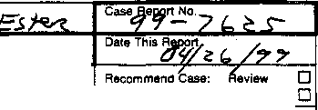CONTINUATION

SUPPLEMENT

,'Y\ tr_,;

.
Closure

.

Transcript of handwritten statement for Brenton Hooker-

At the request of Sgt West, I contacted (W) Hooker at his residence on 4/20/99 at about 0045. Present during the interview was his mother and father, as well as Deputy Scott Helvesen.
B. Hooker states he was in math class at about 1100 hours on 4/20/99. He heard two explosions which shook the moveable wall in the classroom.
His teacher said to leave the building and he exits with the rest of his class out the east doors south of the main entrance to the school.
He stated he ran east towards Leawood Park and jumped the chain link fence. He stayed in the area and observed three ambulances driving on So Pierce St (unknown direction).
B Hooker said he observed a tall kid with black trench coat and a baseball cap (on backwards) with curly hair and a half- mask on exit the same east doors.
He stated the person shot in the direction of him (Hooker) and the ambulances. He said he didn’t hear the shots but noticed the dirt blow up in front of him. Hooker could not remember how many times.
B. Hooker said he could not identify the shooter but felt it might be an associated named ----------.

JC- 001-001465

Brenton James Hooker
DOB 07/10/82
7320 So Webster St Littleton, CO 80123
Student- Columbine HS
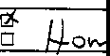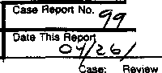CONTINUATION
SUPPLEMENT

HOMICIDE

Narrative cont.

B. Hooker said he knew ---------------- previously; He knew he was associating with the Trench Coat Mafia and knew he had the “mindset” to commit these acts.
When asked, B Hooker was not specific to ---------------- “mindset”
B Hooker did not provide any further information

JC- 001-001466

CONTINUATION □  SUPPLEMENT | JCSO ERZEN |  | Case Report No  99-7625-FFFF
Connecting Case Report No Victim Name Original Report  DN 5074 COLUMBINE |  |  | Date This Report  10-11-99
·  X FIRST DEGREE MURDER |  |  | Recommend Case: Review □  Ctosure.: □

INVESTIGATION:

On l0-11-99, between the hours of 1235 and 1250, I had an opportunity to re-interview Brenton Hooker, DOB/07-10-82 Brenton had originally reported in a previous interview, Control Number 2146, that he observed a gunman in Columbine High school on 04-20-99 and he had identified that gunman as being----------- Upon contacting Brenton. he stated that he made a mistake in his identification of --------- telling me that he had spoke with ---------- father who told him that he ·was not Columbine High School on the incident date, that he was at home with his parents. Brenton stated that he, in fact, believes that the individual he saw was Dylan Klebold. at which time I showed him still photographs numbers 44, 47, 52, and 53, those photos were recovered from the videotape taken of the cafeteria on the incident date. Once Brenton was shown the photographs, he immediately identified Dylan KJebold as being the shooter he saw at Columbine High School.

Brenton was provided a business card and instructed if he had any additional information to contact me.

ADDITIONAL INFORMATION: FBI Case Number: 4-DN-57419, DN 5074.

DISPOSITION: Case open, pending further investigation.

JC-001-001467

ITALIANO, GREG

JC-001-001468

CONTINUATION SUPPLEMENT | Reporting Agency  JCSO |  | PETERSON | Case Report No  99-7625-QQQQ
 |  | Victim Name Original Report |  | Date This Report  07-13-99
First Degree Murder |  |  |  | Recommend Case : Review □  Closure □  I j

WITNESSES,

GREG MICHAEL ITALIANO, DO8/03-31-83
6985 West Polk Avenue
Littleton, Colorado 80123
(303) 979-5795
Student: Columbine High School

LEILANI ITALIANO
Same as above
Pager: (303) 609-7666

GREG ITALIANO
Same as above
Bus: Environmental Control Systems 1270 South Lipan Street Denver, Colorado 80216
(303) 744-2188 / pager: (303) 599-1240

INVESTIGATION:

On 7-13-99, at about 1300 hours, I contacted witness Greg Italiano by phone. Greg is a student at Columbine High School and this interview was in reference to the shooting at Columbine High School on 4-20-99.

Greg Italiano told me that on 4-20-99, he arrived at Columbine High School at approximately 0700 hours for his scheduled classes. Greg said that between 0700 and 0730, when his first class begins, he was in the commons/cafeteria area with a friend of his by the name of Bo Lockwood. Greg told me that he and Bo were sitting at a table that is located in the commons area

JC-001-001469

CONTINUATION  SUPPLEMENT | Reporting Agency  JCSO |  | Reporting Officer  PETERSON | Case Report No  99-7625-QQQQ
Connecting Case Report No |  |  |  | 07-13-99
FIRST DEGREE MURDER |  | Offense Status, Open ' Exceptionally Cleared □  Cleared by Arrest □ Unfounded □ |  | Recommend Case: Review □  Closure □

directly across from the "Rebel Comer." Greg said that he was sitting at this table facing the "Rebel Comer," which would be looking in an easterly direction. Greg said that Bo Lockwood was sitting at the table facing toward the interior of the cafeteria. which would be in a northern direction from the table. I asked Greg if he recalled seeing any duffle bags or a propane tank similar to those items that were later recovered in the Columbine High School cafeteria. Greg said that he did not see either item either prior to, during, or since the shooting on 4-20-99. I asked Greg if he recalled seeing any of the "Trench Coat Mafia'' students in the cafeteria or commons area of Columbine High School on 4-20-99, and he said he did not see any of them on that date

Greg Italiano said that this first hour class on 4-20-99 is a wood shop class that began at 0730 hours. Greg said that this classroom is on the upper level of Columbine High School, near the front main doors and the administrative offices. He said after his first hour class, he went to his second hour class, which began at approximately 0820. This class is a computer creativity class and is located on the lower level of Columbine High School. Greg said that after his creative computer class, he went to his third hour class that began at 0920. This is an English class and is located on the upper level of Columbine High School. Greg said after his English class he went to his jewelry class that began at approximately l020 hours and is located on the upper level of Columbine High School. Greg said his fifth hour class began at approximately 1110 and is a geometry class that is located in the math area at the east end of Columbine High School on the upper level. Greg said the teachers for this class are Ms. Moore and Mr. Ortiz.

Greg Italiano said that shortly after getting into his geometry class on 4-20-99, at approximately 1115 hours, he heard what he described as three to four gunshots and then screaming in the hallway outside of his classroom. Greg said after this he heard two more gunshots and more screams in the hallway. It is unknown where these gunshots were coming from at that time. Greg said the screaming, however, was coming from the hallway outside of his geometry class. Greg said that Mr Ortiz exited the classroom into the hallways to see what was going on, while Ms. Moore was trying to lock the classroom doors. Greg said Mr. Ortiz was gone approximately one minute and he then came back into the classroom and told the students to get out of the school. Greg said the students did not know why, nor did they know what was taking place at this time. Greg said that he exited the geometry classroom just as the fire alarm went off in the school. Greg said that he ran out of Columbine High School through a door on the east side of Columbine High School, just south of the main entrance/administrative offices. Greg said this door exits onto a stairway on the exterior side of the school. Greg said when he exited the school, he went down the stairs and ran

JC-001-001470
CONTINUATION SUPPLEMENT | JCSO |  | PETERSON | Case Report No  99-7625-QQQQ
 |  | Victim Name Original Report |  | Date This Repon  07-13-99
First Degree Murder |  |  |  | Recornmend Case: Review 0  Closure 0  ! I

eastbound, across south Pierce Street and into Leawood Park. Greg said he was in Leawood Park for approximately 30 minutes and then someone told him that a gunmen had exited Columbine High School and had a firearm. Greg said while he was in Leawood Park, he also heard two explosions that sounded like they were coming from inside of Columbine High School and in the same area as the commons/cafeteria. Greg said that when he heard a gunmen had exited the school and had a firearm. he ran out of Leawood Park into the Leawood area, where he went to a house of an unknown person, who let him and other students into their house. Greg said at no time during the incident on 4-20-99 did he see any of the suspects and/or anyone with a firearm that was involved in this incident.

I asked Greg Italiano if he had any information in reference to the "Trench Coat Mafia” or the ·'Trench Coat Mafia" students. and in particular Dylan Klebold and Eric Harris. Greg said that he did not know either Dylan Klebold or Eric Harris prior to the shooting on4-20-99. Greg said that other than the type of clothing that the “Trench Coat Mafia" students are known to wear, he did not know anything about them. I asked him if he has heard anything about any other suspects who may have been involved either prior to, during, or since the shooting on 4-20-99. Greg said that the only thing he's heard was that a male "Trench Coat Mafia" student had turned himself into JCSO. Greg said he did not know this person's name, however, he described him as a white male, approximately 6' tall. thin build. 150 to 200 pounds, with dark hair, and wore a dark colored trench coat that hung past the knees and was possibly made out of leather. Greg said this person also wore dark colored pants. dark shoes, and a black baseball cap with a red bill that this subject wore backwards. Greg said that he has not seen this male subject since Halloween of 1998, and said he remembers him from Halloween due to the fact that this male painted his face to look like "Marilyn Manson" for Halloween l998. Greg said this was the last time that he saw this subject.

Greg Italiano told me that he has not heard of anybody, nor has he heard rumor of anybody who may be manufacturing explosive devices and/or possessing or selling firearms. Greg said that he does not know anybody with a double pierced eyebrow. Greg also said that he knows what the "'thought of the day" is that is broadcasted over the Rebel News Network (RNN), however, he did not know what the thought of the day was on 4-20.99.

Greg Italiano advised me that since the incident on 4-20-99 he has been doing well dealing with the incident. Greg said his
family is also doing well. I gave him my name and phone number and asked him to contact me in the future if he or any of his

JC- 001-001471
CONTINUATION SUPPLEMENT | JCSO |  | PETERSON | 99-7625-QQQQ
 |  | Victim Name Original Report |  | Date This Report  07'13-99
X First Degree Murder |  |  |  | Recommend Case: Review □  Closure □

family members want to speak with a JCSO Victim Advocate. I told him I would make the necessary arrangements for them at
that time.

DISPOSITION: Case remains open, pending further investigation.

JC- 001- 001472

JONES, J.

JC-001-001473

JEFFERSON COUNTY DISTRICT ATTORNEY'S OFFICE

SUPPLEMENTAL REPORT

Defendant: Date: Deputy D.A.:
(Columbine shooting)
051399
Docket Number: 99AO62 (EE) Case Number: 99-7625 Investigator: Mike Heylin

···································································
WITNESS:

Jason Jones DOB: 012883
10727 W. Roxbury Ave.
Littleton, CO 80127
303-973-0728
c/o mother; Sheryl Jones (w) 303-982-4766 father; Richard Jones (w) 303-982-5540
-CHS student; was walking in from the junior parking lot through south canopy entrance just prior to shooting; was in math class when shooting started; ran out of school via east door from math hall; saw unknown female student wounded in lower left leg and thought that occurred in street by Leawood Park; heard unknown students say that a suspect was on the roof of the school; heard unknown students saying that they saw a suspect in the main hallway with a white
- shirt, black vest and a ball cap on backwards; did not see any suspects or duffle bags; knew that student Dustin Gordon was a good friend of Nate Dykeman

INVESTIGATION:

On May 12 1 1999 at 1901 hours I contacted Jason Jones at his home

for an interview. following:
His parents were present. Jason then told me the

JC-001- 001474

1

* _{He}
attends
is a sophomore at Columbine High.
Columbine but was off campus for
His brother Landon also
lunch when the shooting

occurred.

    - When asked about Eric Harris, he said he did not know him or
the name.

    - When asked about Dylan Klebold, he said that he has seen Dylan
in the hallways of school at times but did not know his name. He learned the name after seeing the news accounts of the shooting. He said that Dylan would wear a black trench coat, black pants, black military boots, black backpack, and wore a black ball cap. He used to see Dylan last semester as he was coming out of his history class.
- When asked, he did not know -------- or -------------.
* When asked about -------------------- he said that -------- was in his gym class last semester. He said that ------- was a normal student who did
not hang out with anyone at the beginning of the year. He said it was around November last year that he started hanging around other trench coat students. He said that ------ would wear a trench coat but would not have on all the other dark clothing with it.

He would semester.
also see -------- walking to a black BMW for lunch our last

- He thought there were about 9 to 10 students in the trench coat
group. Last semester he used to see a few of the trench coat
students in the cafeteria playing "magic cards” Referring to the diagram, he said that they would play with those cards at table WW by the west door and the pop machines. He thought the "magic cards" were cards about the devil and about power.

- He then said that a student named Dustin was a best friend of
-----. He could not remember Dustin’s last name but showed me a newspaper photograph of him. The photograph was from the April 21, 1999 edition of the Denver Rocky Mountain News on paqe 12A. The
2 JC-001-001475

photo showed a male student sitting on the ground crying with a
police officer standing nearby. The student was wearing a dark ball

cap on backwards,
a white t-shirt, and light colored military

fatigue pants. pants often but
He said that the student named Dustin wore those did not dress like the trench coat students. Upon

looking at a class photograph and a year old yearbook, he identified
the student as Dustin Gorton.

* He did not associates. He
know the names of any other trench coat students or heard about the name, “Tr en c h Coat Mafia," during

school last year. He thought it was just a name for a group.

- He
the day
did not see any trench coat student or associate at school of the shooting. When asked, he saw no suspicious objects

at school that day. When asked specifically, he saw no duffle bags.

* On the day of the shooting, he left for home after his 3rd hour science class. He had been going home recently to feed a new puppy .
He remembered being on the phone with his father at around ll:04
a.m. He was running late and drove to school and parked in his

brother's space in the curb line of that lot.
junior lot. He thought
This space was along the south he got to school around 11:17 or

11:18 a.m. He entered the school via the south canopy entrance and ran up to his math class, Mr. Bundy's class, and started taking a
test with the rest of the class.

- He did not see anything while running from the lot to his class.

- He said he screaming. He
was only in thought some
the class about a minute when he heard girl was arguing with a teacher about

being thrown out of class. He then looked out the classroom door
window and saw students running. He said the fire alarm then went off. Mr. Bundy told the class they were going to stay taking the test. He said Coach Ortiz then came running in the math class and told everyone to “ g e t out.” He said Coach Ortiz grabbed him and others and was physically throwing people out of the classroom. He

3 JC-001-001476

thought at first it was some timed test for how long it would take them to get out during a fire drill.

* He said he heard, very faint pops like a book hitting a table. He ran east down the math hallway and out to Pierce St. via the east door for that hallway. He then went out to Leawood Park.

* When outside he heard some very faint pops again. He said that a girl was outside Leawood Park in the street and that she fell. She was helped up by two students and he saw that she had a through and through wound to her lower left leg. he said the hole looked large. He thought that she was shot there in the street because he saw her fall.

- While running out, he heard other unknown students say that a suspect was in the main hallway wearing a white t-shirt, black vest, and a ball cap turned backwards.

" While outside, he also heard unknown students talking about a gunman on the roof.

- When he heard those faint muffled shots while at the park, he took off again to a home in the neighborhood were a lot of other students were. He waited in line to call his mother.

This concluded my interview with Jason Jones.

JC-001-001477
4

KINTGEN, MICHAEL

JC-001-001478

PIRNARR Arvada Police/Court System Arvada Police Department
NARRATIVE
Page 1
07/14/1999

==============================================================================

Ref # 99-12067
Type ASSTOA
Reported Date 04/20/1999 Time 12:39:32
Status RTF

Location 6201 S PIERCE ST
DET122 07/12/1999 071299/BOATRIGHT/KK

Connected to Jefferson County Sheriff's Department case number 99-7625.
On 05/12/99 at approximately 0945 hours Detective Boatright (IO) had just completed an interview with Mark Kintgen. The aforementioned interview occurred at 6859 West Quatro Place, Littleton, Colorado. Present for the above referenced interview were Mark Kintgen's parents, identified as Dale and Kay Kintgen. Once the interview was concluded with Mark Kintgen, IO was requested by Dale and Kay Kintgen to interview their other son, identified as Michael Kintgen. IO was informed Michael Kintgen is the twin brother to Mark Kintgen. It should be further noted Michael Kintgen was located in a math room identified as "MA9" at the time the incident occurred. IO later obtained ON #3338 reference the interview with Michael Kintgen.
On the date and time indicated above, IO met with Michael Kintgen. Also present for the interview were the forenamed's parents, Dale and Kay Kintgen. During the interview, IO confirmed with Michael Kintgen his full name is Michael Todd Kintgen, age 17, DOB 05/30/81 (twin brother to Mark Kintgen) Michael Kintgen verified he too resides at 6859 West Quatro Place, Littleton, Colorado, 80128, phone 303-979-3768. Michael Kintgen verified he is presently a junior at Columbine High School.
During the interview, IO initially requested Michael Kintgen to provide an account of his activities on 04/20/99 beginning at the time he arrived at school. Michael Kintgen told IO he normally arrives at school at approximately 0715 hours, as was the case this date. Michael Kintgen clarified he drives to school with his twin brother "Mark." Michael Kintgen stated his assigned parking space is identified as #402 and is located "south of the commons" area.
Pursuant to questioning, Michael Kintgen stated he did not observe any unusual activity when he arrived at school on 04/20/99.

According to Michael Kintgen, after arriving at school, he attended his first hour class which begins at approximately 0730 hours and concludes at approximately 0810 hours. Michael Kintgen identified his first period class as "World History," which is taught by "Mr. Kritzer." Michael Kintgen told IO his "World History" class is located in room "SS7." IO would note classroom SS7 is located on the far east side of the building towards the center.
Michael Kintgen explained he then attended his second period class which begins at approximately 0815 hours and concludes at approximately 0920 hours. Michael Kintgen stated his second period class is "free" and on the date in question, he used that time to study independently in the "library." Pursuant to questioning, Michael Kintgen stated he did not observe any unusual activity in the library during the second hour class.

JC-001-001479

PIRNARR Arvada Police/Court System Arvada Police Department
NARRATIVE
Page 2
07/14/1999

================================================================================

Ref # 99-12067
Type ASSTOA
Reported Date 04/20/1999 Time 12:39:32
Status RTF

Location 6201 S PIERCE ST
DET122 07/12/1999 071299/BOATRIGHT/KK

After completing his second period class, Michael Kintgen stated he then went to his third hour which he identified as "World Studies" taught by "Mr. Meier." Michael Kintgen stated his "World Studies" class is taught in room "LA3" which is located on the east end of the building off the south hall.

Michael Kintgen then explained he attended his fourth period class, which he identified as "Chemistry" which is taught by "Mr. Miller." According to Michael Kintgen, his chemistry class is located in room "SC10" which is located in the science wing on the west side of the building off of the south hall.

In respect to his fifth period class, Michael Kintgen stated it began at approximately 1115 hours and was supposed to conclude at approximately 1205 hours. Michael Kintgen pointed out he has "B lunch," adding, "We never made it all the way through fifth period" (referring to the incident occurring while in that class).
Pursuant to questioning, Michael Kintgen explained his fifth period class is "Algebra II" which is taught by "Ms. Mcwilliams." According to Michael Kintgen, "MA9" is located in the math section of the school which is towards the east side of the building off the south hall. Michael Kintgen was subsequently handed a diagram of Columbine High School and asked to identify classroom "MA9.'' Michael Kintgen complied with IO'S request by circling the room identified as "MA9."

IO next asked Michael Kintgen to explain what occurred during his fifth hour class. Michael Kintgen explained the first 20 minutes of his fifth period class were "normal." Michael Kintgen stated it was approximately 20 minutes after class began that he first noted unusual activity in the school. Michael Kintgen explained during the first 20 minute of his class, Ms. Mcwilliams left the "door open." Michael Kintgen related it was at that point he began to hear "kids screaming." Pursuant to questioning, Michael Kintgen clarified during the first 20 minutes of his fifth period class, he did not make any unusual observations. IO went on to verify with Michael Kintgen his first observation related to this incident began approximately 20 minutes into his fifth period class when he heard "kids screaming." Michael Kintgen stated the screaming was coming from the hallway which prompted Ms. Mcwilliams to close the classroom door.

Michael Kintgen explained he initially thought the screaming was possibly associated with a "senior prank" and did not give the situation much more thought. Michael Kintgen went on to explain moments later he then heard the "fire alarm" activate. According to Michael Kintgen, Ms. Mcwilliams told her class to "ignore" the fire alarm. Michael Kintgen stated it was his assumption Ms.
Mcwilliams had come to the same conclusion he had in regard to a possible senior prank in progress.
Michael Kintgen related approximately one minute after the

JC-001-001480

PIRNARR Arvada Police/Court System Arvada Police Department
NARRATIVE
Page 3
07/14/1999

===============================================================================

Ref II: 99-12067
Type ASSTOA
Reported Date 04/20/1999 Time 12:39:32
Status RTF

Location 6201 S PIERCE ST
DET122 07/12/1999 071299/BOATRIGHT/KK

fire alarm had sounded, "Mr. Ortiz" entered the classroom in a "frantic" manner. At that time Mr. Ortiz shouted to those present, "Get out." Michael Kintgen stated he did not know what had occurred in the school but knew the situation was "serious" based on Mr. Ortiz's demeanor.
Michael Kintgen went on to state after Mr. Ortiz told everyone to "get out," he recalled those present complying with his request. Michael Kintgen stated he did know exactly what happened to Mr.
Ortiz but assumed he moved on to other classrooms in the area advising everyone to leave the building. Michael Kintgen stated to his knowledge, everyone exited the classroom and proceeded to the south exit. Michael Kintgen then drew a line from math room MA9 south down the hall to the point where he along with others in his class exited the school. Michael Kintgen stated from that point, all those present then went east crossing Pierce Street and eventually ended up in "Leawood Park"

Michael Kintgen stated soon after arriving in Leawood Park, he began to hear what he thought were "explosions" coming from the area of the school. Michael Kintgen could not be more specific concerning that point. Michael Kintgen did relate approximately five to ten minutes after he had arrived in Leawood Park, other students were seen leaving the area of the school and coming into the park. Michael Kintgen stated this was the first time he heard any reports about "a shooting." Michael Kintgen stated one of the reports he heard involved ''two kids that were shot and there was blood all over." Michael Kintgen stated he did not know the student's name who made the above statement but believed the student indicated he was somewhere near the "commons" when he made that observation.

Michael Kintgen went on to state approximately 20 minutes after arriving in the park, reports began to circulate that there was a possible gunman either outside the school or on the roof.
Michael Kintgen related those teachers and students who were located in the park then began to run east into the neighborhood area. Michael Kintgen reported it was from that point he obtained a ride home from a friend. Michael Kintgen told IO he did not make any additional observations concerning the incidents occurring at Columbine High School on 04/20/99.

Pursuant to questioning, Michael Kintgen stated he could not recall what time he arrived at home but it was at some point later he learned that his brother had been injured during the incident. Michael Kintgen was unable to provide any additional information regarding this incident. For purposes of clarification, IO verified with Michael Kintgen ac no time did he see any suspects associated with this incident and only heard what he thought were "explosions" coming from the location of Columbine High School.
Michael Kintgen was unable to be more specific concerning the nature or location of the explosions. See the diagram prepared by
JC-001-001481

PIRNARR Arvada Police/Court System Arvada Police Department
NARRATIVE
Page 4
07/14/1999

-----------------------------------------------------------------

Ref # 99-12067
Type ASSTOA
Reported Date 04/20/1999 Time 12:39:32
Status RTF

Location 6201 S PIERCE ST
DET122 07/12/1999 071299/BOATRIGHT/KK

Michael Kintgen for additional details.

JC-001-001482

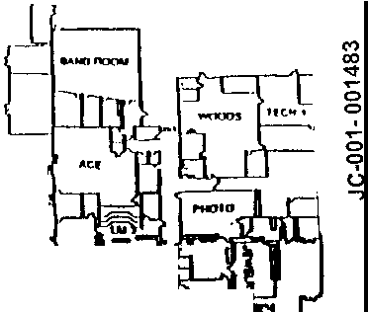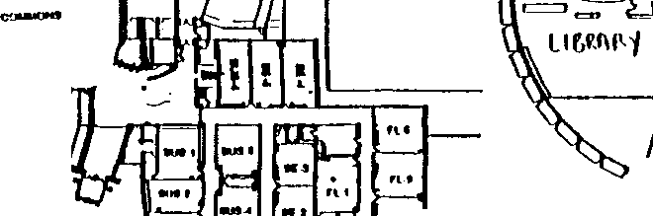COLUMBINE HIGH SCHOOL
902-4400 • MAIN OFFICE
902-4410 • ATTENDANCE OFFICE

N

E
,,,

s
-

l.111 ,., -
t-; i I .-■.. .
I I I L-·- e

' -
C IJ -

-
] II
-"-·

LEVEL
- " .
. . '
- .

- --
rt1lt
=
I_

JC-001-001483 (,

  - :W

J(O}\?. 90.11 " J' -• ,

'" -·
·
'"
. -
.n
-

't;;,
r
Kn
·
-..
- ..
-

- '"
"'
• • \ ~·
kU -
-- I --·
_, -· -·
--··

KIRBY, J

JC-001-001484

DENVER POLICE
STATEMENT

Transcript of handwritten statement from James Kirby

Summary of Statement-

Q: Are you a student at Columbine?
A: Yes, 10th

Q: Were you in school today?
A: Yes, I was.

Q: Did you see the shooting/ bombing?
A: No.

Q: Did you hear who did it?
A: I heard one names from several friends, they said it was -------- and last name starts with a -------.

Q: Who did you hear this from?
A: Ben Fisher, 10th grade
Nick Thomas, 10th grade
Michael Casey, 10th grade

Q: Did they say they say anything?
A: Not today, but they knew him before this.

JC- 001-001485

KISSLER, DAMIAN

JC-001-001486

CONTINUATION  SUPPLEMENT | JCSO |  | PETERSON | Case Report No  99-7625-AAAAA
 |  | Victim Name Original Report  COLUMBINE |  | Date This Report  07-21-99
X FIRST DEGREE MURDER |  |  |  | Recommend Case: Review □  Closure □

WITNESS:

DAMIAN KISSLER. DO8/10-04-81
7610 South Kendall Blvd.
Littleton, CO 80123
()03)932-0919
Student-Columbine High School

JOANNE KISSLER
Same as above.
Work: NASO Regulation
·no 17th Street, Suite 2900
Denver. CO 8020 I
()03) 446-J 100

MIKE KISSLER
Same as above.
Work: Wagner Equipment 18000 Smith Road
Denver, CO 80210 Unknown phone number

INVESTIGATION:

On 07-21-99, I contacted witness Damian Kissler by telephone who is a student at Columbine High School. l contacted him in reference to the shooting that occurred at Columbine High School on 04-20-99.
JC-001-001487

CONTINUATION □  SUPPLEMENT | JCSO |  | PETERSON | Case Report No  99-7625-AAAAA
Connecting Case Report. |  | Victim Name Original Report  COLUMBINE |  | Date This Report  07-21-99
X FIRST DEGREE MURDER |  |  |  | Recommend Case: Review □  Closure □

Damian Kissler told me on 04-20-99 at approximately 0730 hours, he arrived at Columbine High School for his scheduled classes. Damian said on 04-20-99, he had the first hour class off. He said he walked from Clement Park (which is just north of Columbine High School) to "The Pit" to smoke cigarettes. Damian said, “The Pit" is west of Columbine High School. Damian said at approximately 0820 hours on 04-20-99, he left, "The Pit" to go to his second hour Photography class, and told me he entered Columbine High School through a west side door of the school. Damian said this Photography class was from 0820 to approximately 0915 hours and said it was on the upper level of Columbine High School. Damian said when his Photography class was over, he went to his third hour class which was a Relationships in the Family class, that lasted from 0920 to 1010 hours From the third hour class, Damian told me he went to his fourth hour class which was a Learning Lab that lasted from 1015 to 1110 hours. Damian said he then went to his fifth hour Geometry class on the upper level of Columbine High School. Damian said he was not sure what time he arrived for the Geometry class because he was early for this class on 04-20-99. He believed he arrived at approximately 1110 hours. but was not certain. Damian said he remembered one of his teachers by the name of
Ms. Moore asked him to erase the chalkboard. Damian said when he completed erasing the chalkboard, he then sat down at a
desk for the beginning of class. Damian said at about this time his other teacher by the name of Mr. Ortiz, arrived for the class. Damian said a short time later, he heard an unknown number of gunshots. Damian said these gunshots sounded like “a cowboy movie” and said they sounded close to the classroom he was in. Damian said to be more specific, the gunshots sounded like they came from the area between the top of the stairway (the stairway goes from the upper level of the school down to the cafeteria/commons area) and his classroom, which is in the Math hall on the upper level of Columbine High School. Damian said he could also hear screaming from the hallway outside of his classroom. Damian said Mr. Ortiz exited the classroom into the hallway to see what was going on. Damian said a few minutes later, Mr. Ortiz ran back into to this classroom, and told Ms. Moore to get all of the students to hide in the classroom. Damian said then the fire alarm for Columbine High School went off and Mr. Ortiz then told the students in the classroom to run to the outside of the school. Damian said he ran outside of the school through a door on the east side, then ran across South Pierce Street and into Leawood Park. Damian said he was in Leawood for approximately fifteen to thirty minutes when he suddenly saw other students running out of the park, so he ran out as well. Damian said he did not know why everybody was running from Leawood Park, and said he did not hear any gunshots that may or may not have been directed toward Leawood Park. Damian said that prior to the incident on 04-20-99, he did not recall seeing any Trench Coat Mafia students. Damian said that at no time on 04-20-99 did he see any of the gunmen involved
in the shooting. Damian also advised me that he did not see any duffle bags or propane tanks prior to, during or after the shooting

JC- 001-001488
CONTINUATION □  SUPPLEMENT | Reporting Agency  JCSO |  | PETERSON | Case Report No  99-7625-AAAAA
Connecting Case Report No. |  | Victim Name Original Report  COLUMBINE |  | Dale This Report  07-21-99
X FIRST DEGREE MURDER |  |  |  | Recommend Case: Review □  - Closure □

such as those that were later recovered in the Columbine High School cafeteria.

Damian told me prior to the shooting on 04-20-99 he did not know any of the Trench Coat Mafia students' names. He was unable to provide any information about Dylan Klebold, Eric Harris, or the Trench Coat Mafia other than to tell me that the Trench Coat Mafia and Trench Coat Mafia students were thought of as "a joke."

I asked Damian Kissler how he and his family have been doing since the shooting on 04-20-99. Damian said they have been doing fairly well and told me that he has counseling set up for himself in the future. I told him that if he or any of his family members want to talk with a J.C.S.O. Victim Advocate in the future, to contact me and I would make the necessary arrangements for them at that time.

DISPOSITION: Case remains open, pending further investigation.

JC-001-001489

KNAPKE, T.

JC-001-001490

LAKEWOOD P O LICE DEPARTMENT

HOMICIDE
SCOTT
1173 STEFFES, TIMOTHY
1197 GIRSON

S U P P L E M E N T
99038856
05/13/99
Pg•, 1of 2
1145 •1357•1173

-------------------------------------------------------------------------
ASSOCIATED CASE REPORT NUMBERS:
Jefferson County Sheriffs Office C.R.: 99-7625 FBI control number: 174A-DIV-57419
SUBJECT: KNAPKE, Tyson James
DOB, 07 /02/84
7653 West Coal Mine Place Littleton, CC. 80123
(303) 973-8858

PARENTS:
MOTHER: FATHER:

Carol Larry

OBSERVATION/ INVESTIGATION:
On May 11, 1999 I was assigned an interview with Columbine High School student, Tyson Knapke. It had been reported that Tyson had been in the cafeteria during fourth hour. I contacted Ms. Carol Knapke on May 12th and made an appointment to interview Tyson on May 13th at 0800.
On May 13th at 0750 I arrived at 7653 West Coal Mine Place and spoke with Tyson Knapke. Tyson advised that he is a freshman at Columbine High School, and had been in the cafeteria during fourth hour. Tyson said that he had been seated at the table identified as "LL11• Tyson said that he did not see a large duffel bag in the cafeteria while he was there and no one carried that type bag into the cafeteria while he was there. Tyson said that after fourth hour he went to his math class.
Tyson reported that his first indication of trouble came when a large number of people went running by the class room. Someone opened the door to see what was going on, and teachers told the class to leave the building. At this time the fire alarm began to sound. Tyson said that his class left the building and went to Leawood Park across South Pierce Street from the school.
Tyson stated that he did not see anyone with a gun anytime during the morning, and does not know who was involved in the shooting. He continued to say that he had heard nothing about bomb building or gun buying.
Tyson advised that he does not know either Eric Harris or Dylan Klebold, and has had no contact with them. Additionally neither he or any

JC-001-001491

LAKEWOOD CO PD 2 _{of} 2
Supplement 05/13/99 1173 STEFFES, TIMOTHY
99038856

of his friends are associated with the Trench Coat Mafia.
Tyson could provide no further information and the interview ended at 0815.

Agent, 1173 STEFFES, TIMOTHY Printed: 05/13/99 14:34

JC-001-001492

_r-,.,-i--=- .1.. ---1-

-

_
-

,
"n -

e··
__

---, P ••

'
,-:' '!
JC-001-001493

---- -- -·-----· I--

.
,

+-+-! f-1-1- _,_
; --- -·
--1 I--

-

- -

·-

---l r-

' ' -

·

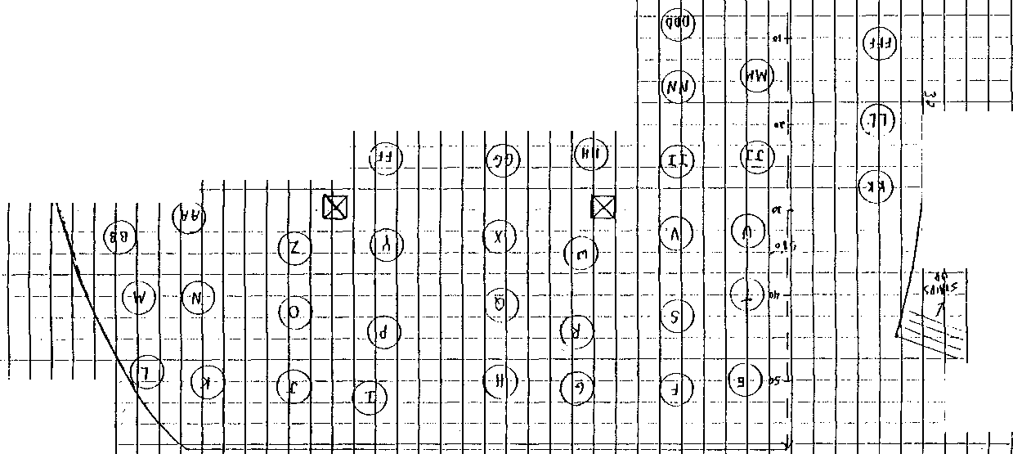
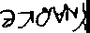

KUENSTLER, MICHELLE

JC-001-001494

Case ID: Priority: Source: Affiliation:

UNCLASSIFIED
INFORMATION CONTROL
Control Number: DN4331
174A-DN-57419
PRIORTY Classification: UNCLASSIFIED WEBB, R.,
Method of Contact
O In Person O Telephone/Radio
O Observation O Written
JCSO

Phone Number: (303) 271-5605 lnformation Received Date: 06/07/1999 Time: 12:00 PM

Prepared by:
WEBB, RICHARD
J&t/JEFCO SO
(Component/Agency)

Event Narrative: MICHELLE MARIE KUENSTLER, 971-0956, STUDENT, 5TH HOUR !NT MATH I (TANK)

Event Date:
Categories:
Event Time: References:
INTERVIEW STUDENT - CHS

Event Reviewed by: KE Lead Required? YES
Lead Control Number: DN4331
Lead: INTERVIEW MICHELLE MARIE KUENSTLER

Assigned To: ERZEN, LARRY Date: 06/3011999 Time: 11:13 AM

Disposition: MICHELLE KUENSTLER WAS lN MR. TANK'S 5TH HOUR CLASS. CLASS WAS ORDERED OUT OF THE SCHOOL BY MR. TANK. THEY RAN OVER TO LEAWOOD PARK. DID NOT SEE ANY GUNMEN. HEARD GUNSHOTS OR EXPLOSIONS ONCE THEY GOT TO THE PARK. NO ADDITIONAL INFO TO PASS ON. SEE 4319 FOR REPORT.

Lead Reviewed by: SL Lead Completed? Date: 07/21/1999

Printed on 7/21/1999 at 9:23 AM UNCLASSIFIED
JC-001- 001495

Page 1

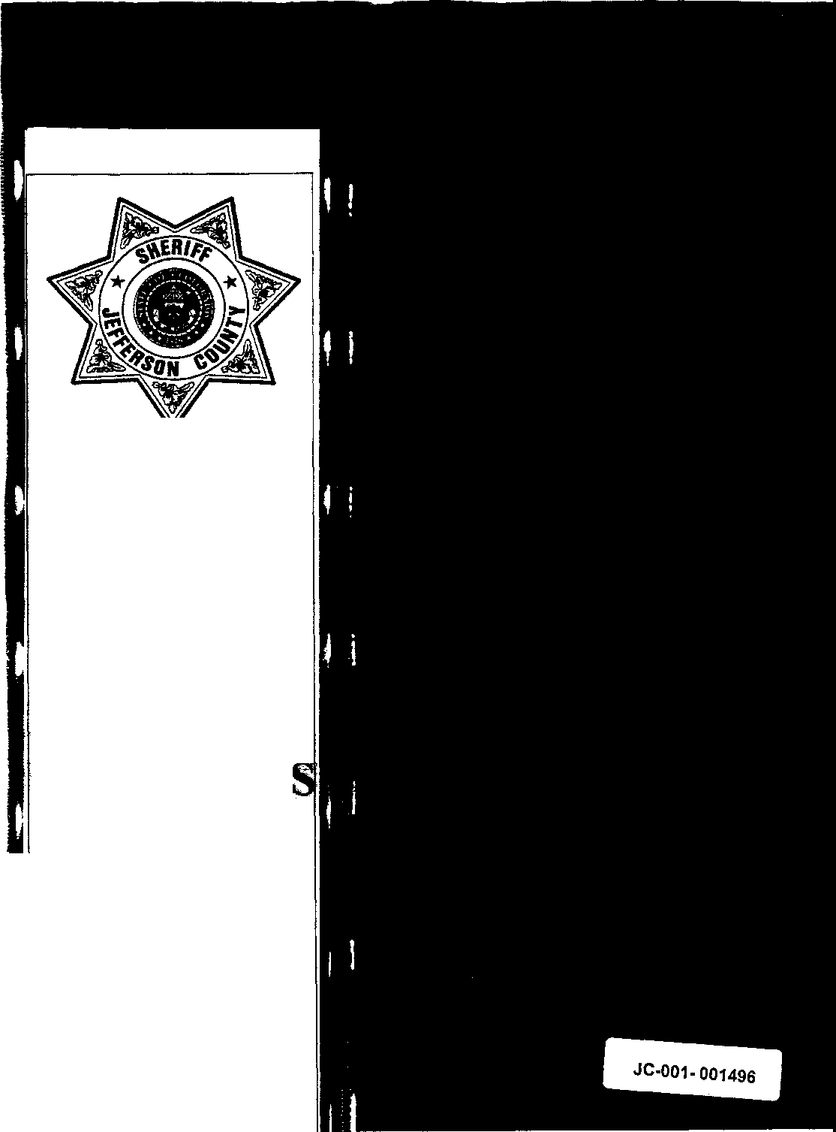

COLUMBINE HIGH SCHOOL

99-7625

MATH

WITNESSE JC-001-001496
". ,.
L-Z

LAJOIE, CHRISTOPHER

JC-001-001497

PIRNARR Arvada Police/Court System
Arvada Police Department
NARRATIVE

Page 1
05/19/1999

=======================================================================

Ref It 99-12067
Type ASSTOA
Reported Date 04/20/1999 Time 12:39:32
Status RTF

Location 6201 S PIERCE ST
DET73 05/18/1999 051799/VONDEROHE/KK 7304

JCSD 99-7625
CONTROL /1:2229

The following supplement will be in reference to Arvada Police Department CR 99- 12067 which will correspond with the Jefferson County Sheriff's Department CR 99-7625, relating to the mass shooting/massacre at Columbine High School on 04/20/99. As a result of this tragic event, a Columbine High School task force was formed and charged to investigate this entire incident. IO, Detective Jim Vonderohe, is a member of this task force whose duties include following up informational investigative leads. The following report is in reference to lead control #2229 in which a subject identified as Christopher W. Lajoie, DOB 05/16/83, may have possible association ties with the Trench Coat Mafia.
Specifically, this lead involves a witness who observed approximately three weeks previous to 04/28/99 two teenage males wearing trench coats in Christopher Lajoie's driveway. This unidentified witness further reported that one of the males in the trench coats was holding an 18 inch copper colored pipe. This unidentified source also stated that Christopher Lajoie and his family were gone from the residence from 04/20/99 until 04/24/99.

On 05/11/99 IO telephoned the Lajoie residence which is located at 7016 South Pierce Court, Littleton, Colorado, 80126, telephone number 303-973-8106. IO was able to speak with Christopher Lajoie, who answered the telephone and who advised IO that both of his parents were presently at work. After introducing IO to him over the telephone, IO advised him of the reason that IO was contacting him in reference to the Columbine High School investigation and more specifically regarding the information that IO had pertaining to two male subjects wearing trench coats in his driveway approximately three weeks ago.
Chris Lajoie advised IO that he was a tenth grader at Columbine High School but that he has never known any of the Trench Coat Mafia members or any of their associates. He further advised IO that all of his friends and the people that he knew claimed that the members of the Trench Coat Mafia were gay and therefore he did not hang around with them. Christopher Lajoie further confirmed during this interview that he did not know either Eric Harris or Dylan Klebold while he attended school at Columbine High School.

Christopher Lajoie further advised IO that he had absolutely no idea about the information IO had mentioned in reference to two males being in his_ driveway with these males wearing trench coats. He further stated that he absolutely has not been with anybody in long dark trench coats, especially in his driveway, and more specifically with anybody holding an 18 inch pipe. He further advised IO that he has never in his life messed around with any explosive devices or bombs.
JC-001-001498

PIRNARR Arvada Police/Court System Arvada Police Department
NARRATIVE
Page 2
05/19/1999

========================================================================

Ref It 99-12067
Type ASSTOA
Reported Date 04/20/1999 Time 12:39:32
Status RTF

Location 6201 S PIERCE ST
DET73 05/18/1999 051799/VONDEROHE/KK 7304

In questioning Christopher Lajoie as to where he was on 04/20/99 when this massacre started, he advised IO that he was in math class and that a teacher came into the room and told them of the attack that was occurring. He stated that this teacher led them out of the school building and over to Clement Park. He further stated that that entire afternoon, he spent with friends in the area of the school. IO then advised Christopher Lajoie that IO would be contacting his mother after our conversation ended just for the sake of letting her know that he had been contacted by IO.

IO then contacted Christopher's mother, Pamela Lajoie, DOB 05/14/60, by telephone at her place of employment. After IO had advised her of why IO had contacted her son, she advised that although her husband and she work during the day time, she is absolutely sure in her mind that no males wearing long trench coats were at her residence approximately three weeks ago. She further stated that she knows her son well enough to know that he is not involved with these type of individuals nor has he ever been involved with any type of explosives or bombs. She further advised IO that the information that IO had in regards to her family including Chris being gone from 04/20/99 until 04/24/99 was totally false. She stated that the entire family stayed at their residence after the school attack occurred. IO then advised Pamela Lajoie that IO felt very comfortable in the fact that her son was not involved in any way in the Columbine High School incident or had any association ties with any of the Trench Coat Mafia members.

With no further investigative information to be developed, this concludes this supplemental report.

JC-001-001499

CONTINUATION □  SUPPLEMENT |  | JCSO |  | MOORE, C. | Cue Report No  99-7625-DDDD
Connecting Case Report No. |  |  | Victim Name Original Report  COLUMBINE |  | Date This Report  06-22-99
 | X FIRST DEGREE MURDER |  |  |  | Recommend Case: Review D  Closure, D

ADDITIONAL WITNESS:

CHRIS LAJOIE, DOB/05-13-83
7016 South Pierce Court Littleton, CO 80123
303-973-8106

INVESTIGATION:

On 06-15-99, I was assigned Lead #4211 to interview Christopher Lajoie, a Columbine High School student on 04-20-99, who
bad fifth hour Algebra I class with Mr. Bundy.

On 06-22-99, at about 1425 hours. I contacted the listed home phone number for Lajoie, 303-973-8!06. A male answered who identified himself as Chris Lajoie. I told him that I was calling Columbine High School students and asked him if he was present at the school on 04-20-99. He stated he was. I told Lajoie that I understood be had Mr. Bundy's fifth hour Algebra I class and he stated he did. I told Lajoie that the class started at 11:15 and asked him what the first indication was that something was wrong or something was happening. He stated that possibly ten minutes after class began, a teacher came in and told the kids to leave. When I asked who this individual was, he stated be believed it was Coach Danelli. Chris Lajoie stated he wasn’t sure how much time had elapsed, but stated they were in the middle of taking a math quiz. I asked Chris Lajoie where he went after he left the classroom. He stated that he exited, turned right, and then turned right into a main hall and went out through the doors at the end of the hall, and across Pierce Street to Leawood Park. I asked him if he had seen or heard anything after he got into the hall. He stated there were a couple of kids who were guessing what had happened, and he heard what he believed to be fireworks. I asked him if he had seen anything in the halls and he sated he had not He stated that after he got into Leawood Park he heard a couple of gunshots. I asked Chris Lajoie whom he had been sitting with in the classroom and he stated he could not recall.

JC-001-001500

